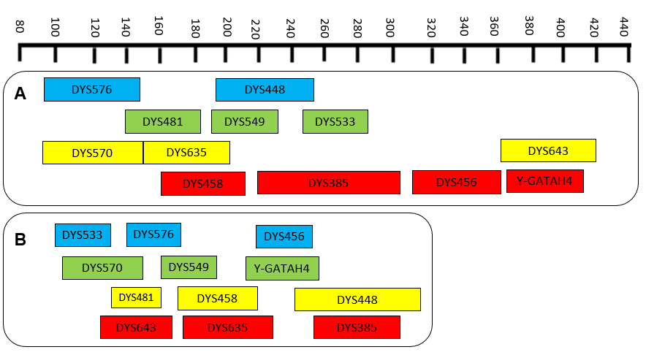
Supplementary Figure S1. Diagram of the fragment size for the DYS533, DYS576, DYS456, DYS570, DYS549, Y-GATAH4, DYS481, DYS458, DYS448, DYS643, DYS635 and DYS385 markers included in the PPY23 (A) and the panel developed in the present study (B).

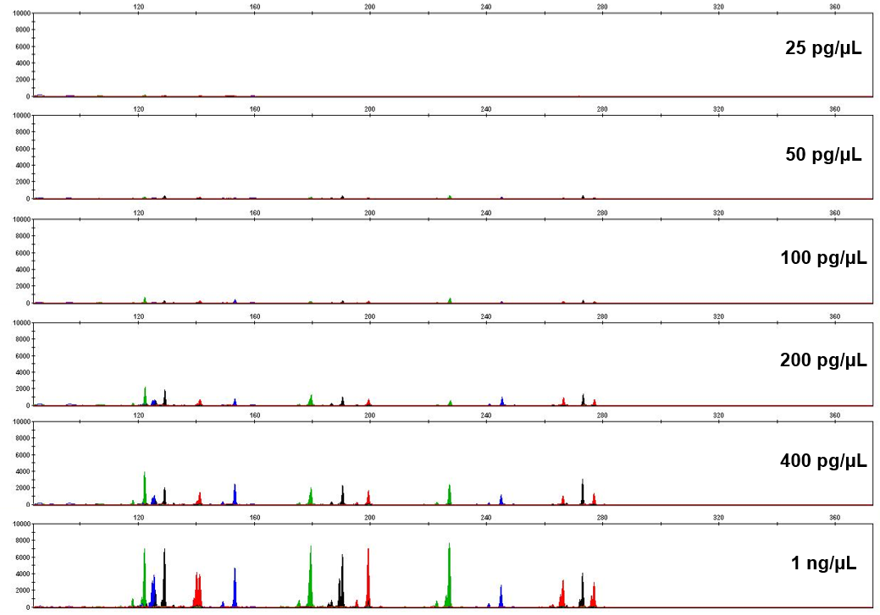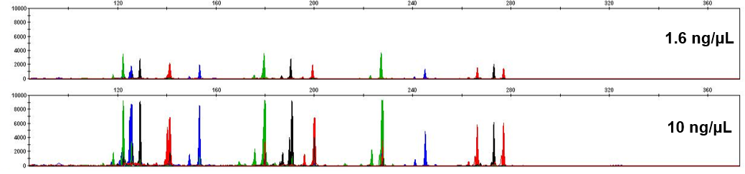
Supplementary Figure S2. Representative electropherograms of the sensitivity study.

A 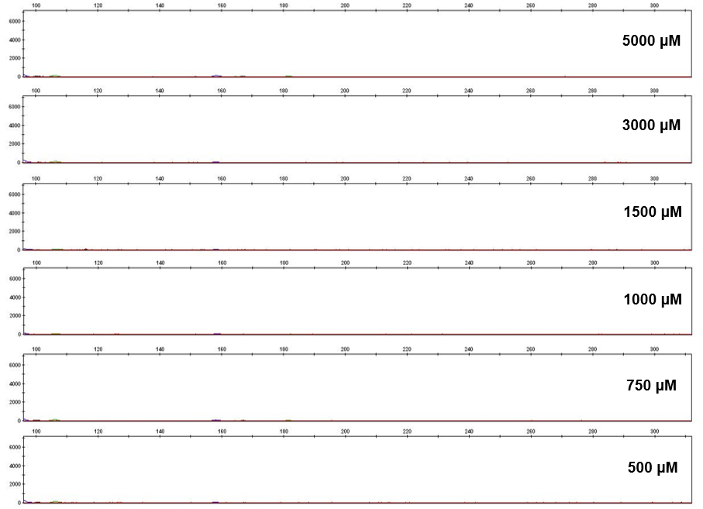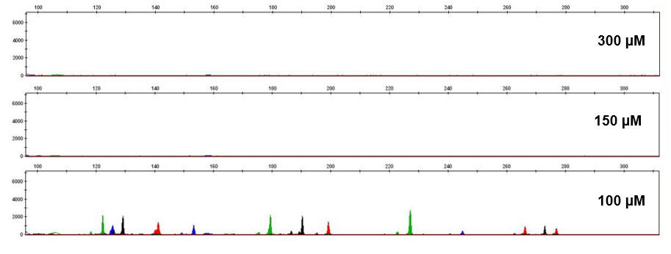

B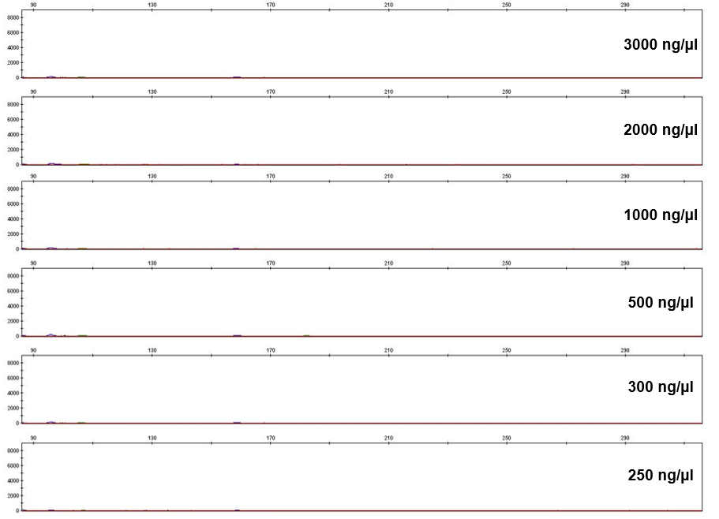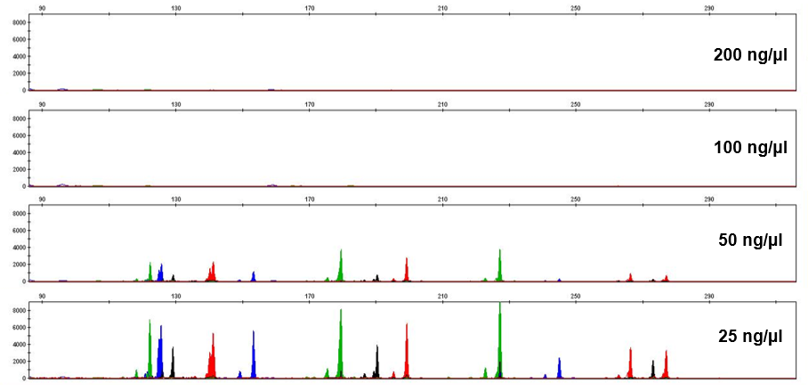

Supplementary Figure S3. Representative electropherograms of the effect of haematin (A) and of humic acid (B) on DNA typing.

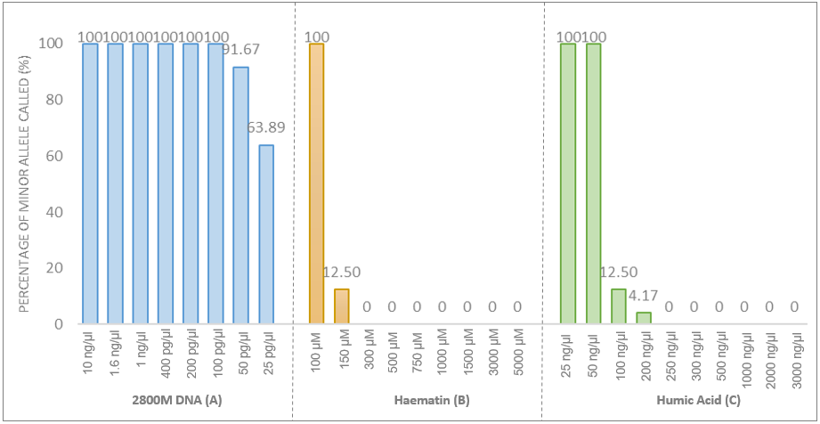
Supplementary Figure S4. Percentages of allele recovery for sensitivity studies through the analysis of positive control 2800M at different concentrations (A), as well as for stability studies including haematin (B) and humic acid (C) as inhibitors.

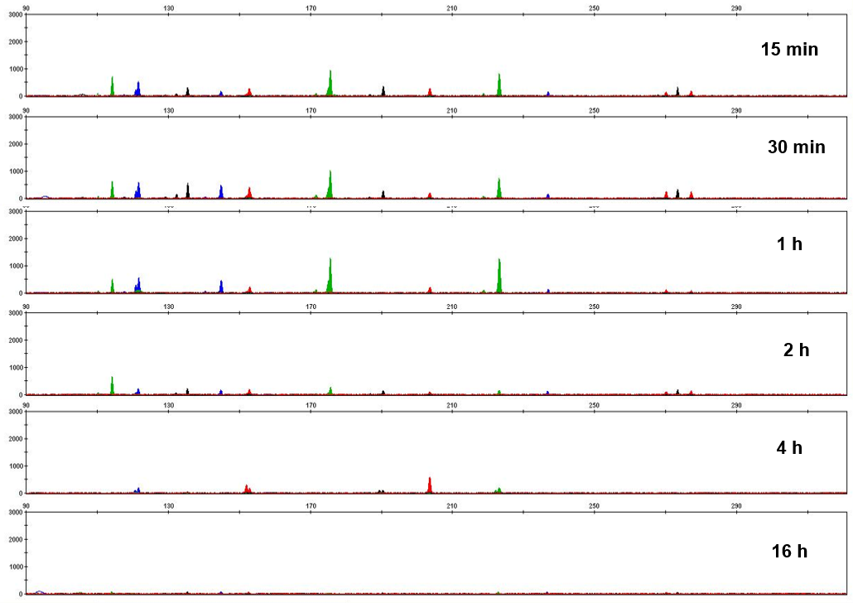
Supplementary Figure S5. Representative electropherograms of the artificially degradation tests performed for different times of digestion with DNase I.
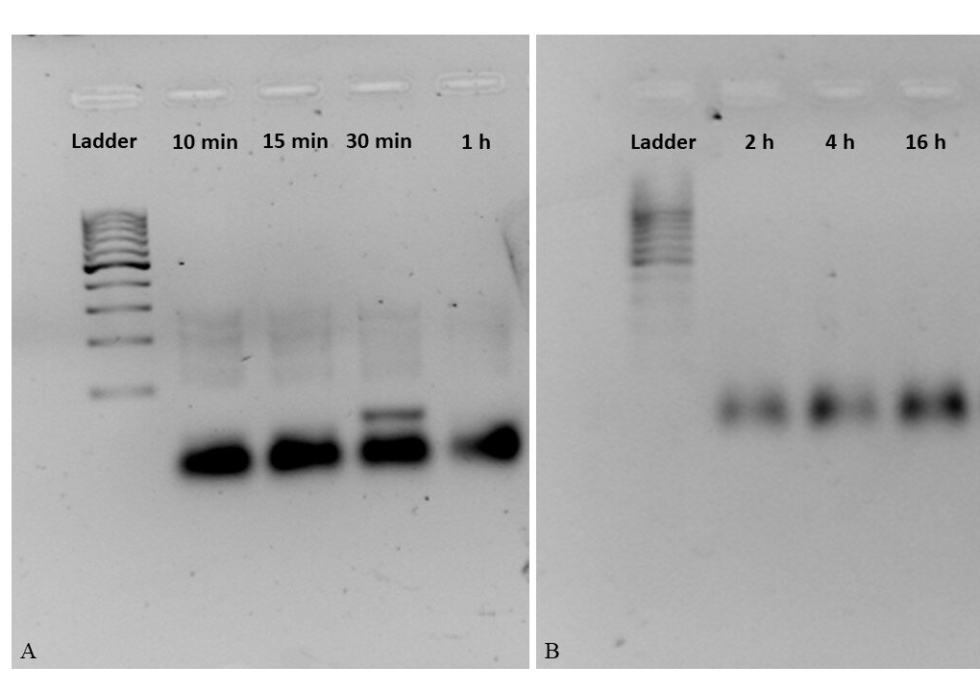
Supplementary Figure S6. Gel electophoresis results after different times of digestion (A: 10 min, 15 min, 30 min and 1 h; B: 2 h, 4 h and 16 h) with DNase I.

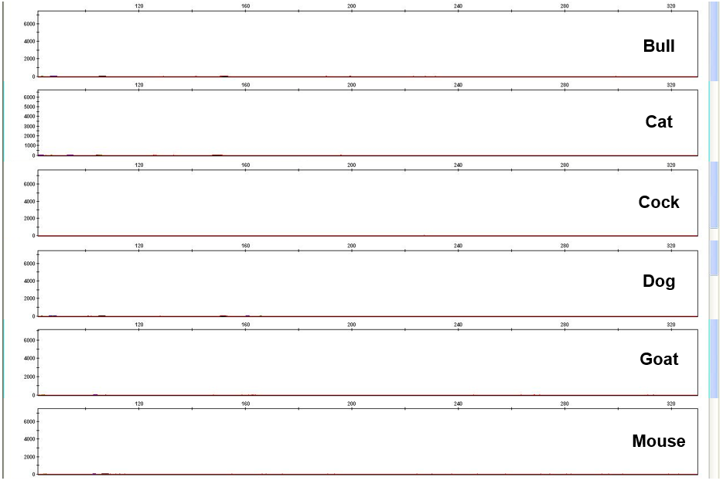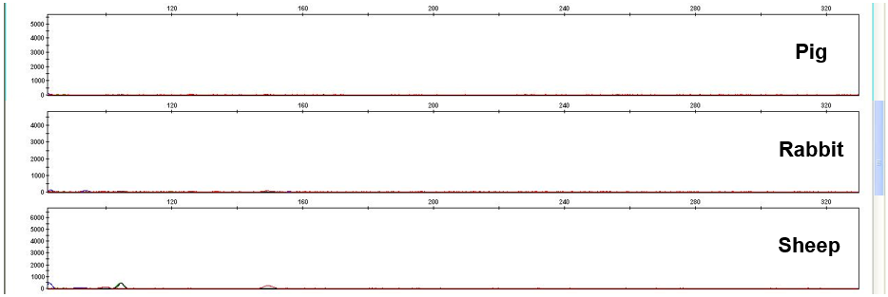
Supplementary Figure S7. Representative electropherograms of different animal species to test human specificity.

A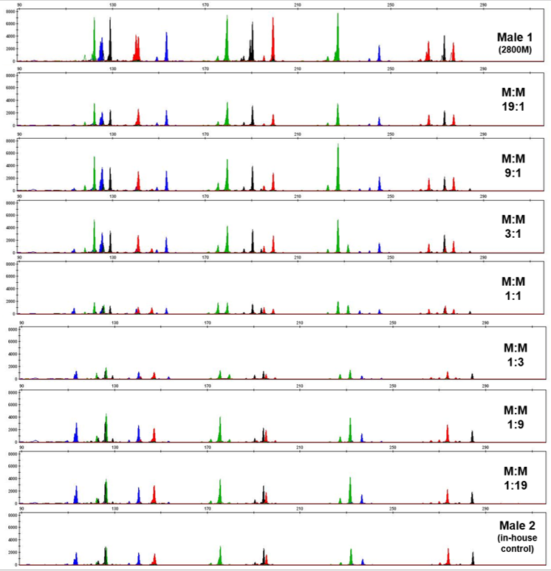

B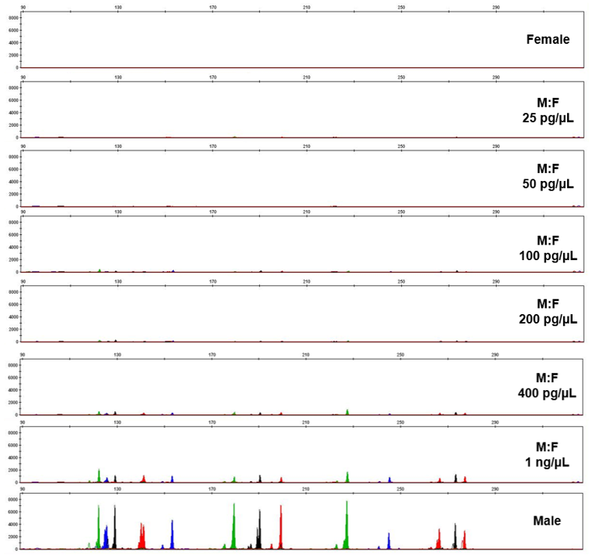
Supplementary Figure S8. Representative electropherograms of the mixture detection tests performed for male:male (A) and male:female (B).

