Title page:
Generation of novel phosphite-mediated weed control system for Brassica napus by expressing PtxD_{Q} from Ralstonia sp.4506
Yuan Zhong^{1,2}, Sijia Li¹, Chaozhi Ma^{1,2}, Gaobing Wu⁴, and Cheng Dai^{1,2}
1. National Key Laboratory of Crop Genetic Improvement, Huazhong Agricultural University, Wuhan 430070, China
2. Hubei Hongshan Laboratory, Wuhan 430070, China.
3. College of Plant Science and Technology, Huazhong Agricultural University, Wuhan, China.
4. State Key Laboratory of Agricultural Microbiology, College of Plant Science and Technology, Huazhong Agricultural University, Wuhan, China
Running title: Novel phosphite herbicide lines in Brassica napus
The authors responsible for the distribution of materials integral to the findings presented in this article in accordance with the policy described in the Instructions for Authors are:
Dr. Cheng Dai (cdai@mail.hzau.edu.cn).
# To whom correspondence should be addressed
Dr. Cheng Dai, Email: cdai@mail.hzau.edu.cn
National Key Laboratory of Crop Genetic Improvement, Huazhong Agricultural University, Wuhan 430070, China
Hubei Hongshan Laboratory, Wuhan 430070, China.

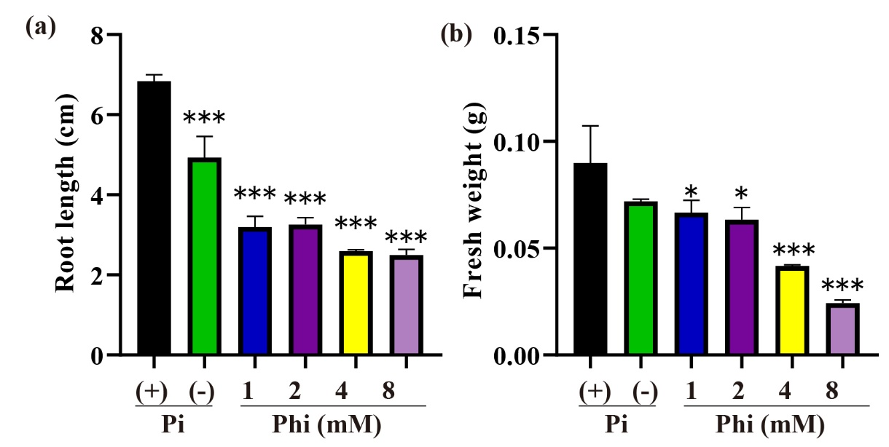
Supplemental Figure S1. The root length and fresh weight of WT (Westar) after Pi, no P, and Phi treatment.
(a) and (b) Bar graphs show the root length (a) and fresh weight (b) of WT (Westar) after Pi, no P, and Phi treatment. The data are shown as means ± SD for three replicates. Asterisks indicate significant differences as compared with WT plants with Pi treatment (Turkey’s test, **p ≤ 0.01, n = 15-20).
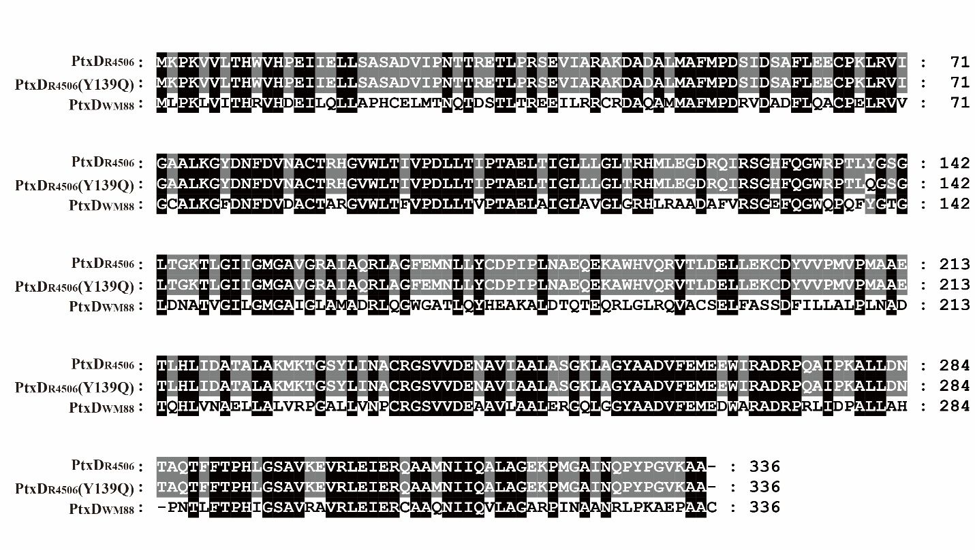
Supplemental Figure S2. The protein sequence alignment of PtxD_{R4506}, PtxD_{R4506} (Y139Q) and PtxD_{WM88}.
Alignment of PtxD_{R4506}, PtxD_{R4506} (Y139Q) and PtxD_{WM88} amino acid sequence. The identical residues were shaded by black, and the similar residues were shaded by gray.
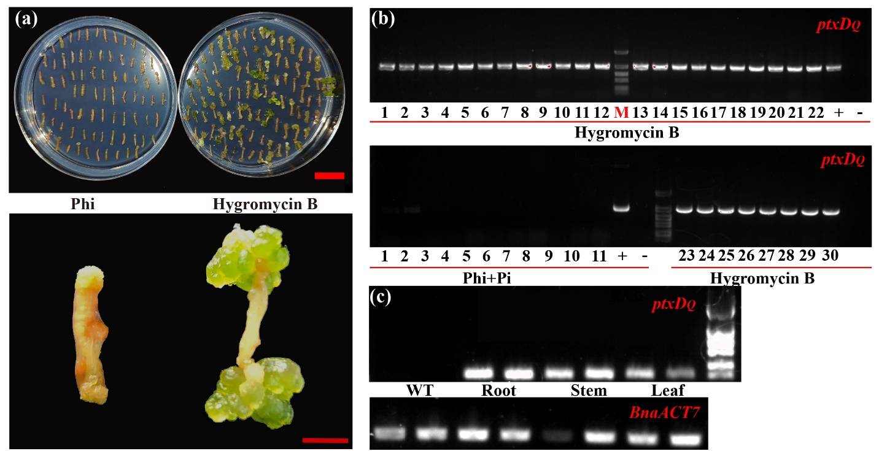
Supplemental Figure S3. The callus regeneration with Hygromycin B or Phi selection on shoot initiation media.
(a) The images show the callus regeneration with 120 µg/mL Hygromycin B or 1.5 mM Phi selection on shoot initiation media. (b) The image shows the PtxD_{Q} insertion in transgenic plants confirmed by PCR using PtxD_{Q} gene specific primers. The transgenic plants were grown on the selection media containing 120 µg/mL Hygromycin B or 0.5 mM Pi + 1.5 mM Phi. (+) and (-) represented the positive control and negative control of PtxD_{Q} gene, respectively. (c) The image shows the expression level of PtxD_{Q} in root, stem and leaf of transgenic plants (L5). ACTIN7 was used as the internal control.

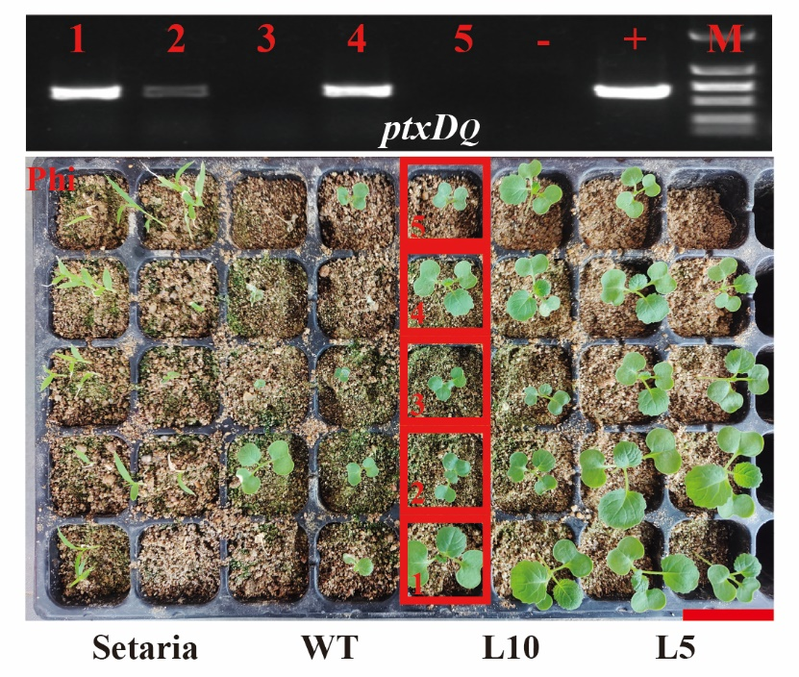
Supplemental Figure S4. Analysis of PtxD_{Q} specific band in T₁ transgenic lines by PCR.
The image shows the PtxD_{Q} specific band in T₁ transgenic plants which were represent in Figure 4a. The PtxD_{Q} specific band was examined by PCR using PtxD_{Q} gene specific primers. The transgenic plants were irrigated by Phi as solo phosphorus source. 1-5, indicated different transgenic plants of L10.

