Supplementary materials
1 | Supplementary Figure 1 | Effects of akebia saponin D on body weight and locomotion of CMS mice
2 | Supplementary Figure 2 | Akebia saponin D regulates the microglial phenotype in LPS stimulation
3 | Supplementary Figure 3 | Akebia saponin D stimulate LPS-treated microglia to release BDNF
4 | Supplementary Figure 4 | Experimental scheme for the assessment of NSPCs proliferation, differentiation and survival during culture in conditioned medium from microglia
5 | Supplementary Figure 5 | Involvement of the BDNF-TrkB pathway in the ASD-induced pro-neurogenic phenotype of microglia
6 | Supplementary Figure 6 | Schematic diagram of how akebia saponin D may restore hippocampal neurogenesis
7 | Supplementary Table 1 | The procedure of chronic unpredictable mild stress (CMS)
8 | Supplementary Table 2 | Genes primers used for real time PCR analyses
9 | Supplementary Table 3 | Details of Antibody and dilution rate for immunofluorescent staining
10 | Supplementary Table 4 | Details of Antibody and dilution rate for western blotting

Fig. S1 Effects of akebia saponin D on body weight and locomotion of CMS mice.
(A) Body weight during 9 weeks in control (Ctrl) mice and mice exposed to chronic mild stress (CMS), as well as ASD or imipramine (IMI).
(B) Body weight of individual mice before ASD or IMI treatment (week 4) and after treatment (week 7).
(C) Effects of ASD on immobility time, number of standings and time in center spent by CMS mice in the open field test.

Data are mean ± standard error of the mean (SEM) (n=8-11). *P < 0.05, **p < 0.01, ***p < 0.001 vs the Ctrl group; #p < 0.05 vs the CMS group based on one-way ANOVA with Tukey's multiple-comparisons test.

Fig. S2 Akebia saponin D regulates the microglial phenotype in LPS stimulation.
(A) Scheme of the experimental procedure for examining microglial anti-inflammatory phenotype. ASD, akebia saponin D; LPS, lipopolysaccharide; qPCR, real-time quantitative PCR; IHC, immunocytochemistry.
(B) Morphology and Arg-1 expression in primary microglia treated with akebia saponin D (ASD) or pioglitazone (Piog), followed by lipopolysaccharide (LPS). Scale bar, 10 μm.
(C) and (D) Levels of mRNAs encoding iNOS, TNF-α, Arg-1, IL-10 and BDNF at 24 and 48 h in microglia treated with ASD or pioglitazone followed by LPS.
Data are mean ± standard error of the mean (SEM) (n=4-6). *p < 0.05, **p < 0.01, ***p < 0.001 vs. control (Ctrl); #p < 0.05, ##p < 0.01, ###p < 0.001 vs. LPS based on two-way ANOVA with Tukey's multiple-comparisons test.
Fig. S3 Akebia saponin D stimulate LPS-treated microglia to release BDNF.
(A) Schematic diagram of the collection of conditioned medium at 0-24 h (“primary”) and 24-48 h (“secondary”) from primary cultures of microglia activated with LPS in the presence or absence of ASD.
(B-E) Quantification of TNF-α, nitric oxide (NO), IL-10 and BDNF in conditioned medium from microglia.
Data are mean ± standard error of the mean (SEM) (n=4-6). *p < 0.05, **p < 0.01, ***p < 0.001 vs. control (Ctrl); #p < 0.05, ##p < 0.01, ###p < 0.001 vs. LPS based on two-way ANOVA with Tukey's multiple-comparisons test.

Fig. S4 Experimental scheme for the assessment of NSPCs proliferation, differentiation and survival during culture in conditioned medium from microglia.
(A) Experimental scheme for the assessment of NSPCs proliferation during culture in conditioned medium from microglia activated with LPS in the presence or absence of ASD.
(B) Experimental scheme for the assessment of NSPCs differentiation during culture in conditioned medium from microglia activated with LPS in the presence or absence of ASD.
(C) Experimental scheme for the assessment of NSPCs and newborn neurons survival during culture in conditioned medium from microglia activated with LPS in the presence or absence of ASD.

Fig. S5 Involvement of the BDNF-TrkB pathway in the ASD-induced pro-neurogenic phenotype of microglia.
(A) Effects of K252a on proliferation of NSPCs cultured in conditioned medium from microglia. Scale bar, 100 μm.
(B) Effects of K252a on neurogenesis and astrocytogenesis from NSPCs cultured in conditioned medium from ASD-induced microglia. Scale bar, 20 μm.
Data are presented as the mean ± standard error of the mean (SEM) (n=4-6), *P < 0.05, **P < 0.01 vs. control microglia conditioned medium (Ctrl-M-CM), ##P < 0.01, ###P < 0.005 vs. LPS-treated microglia conditioned medium (LPS-M-CM), &P < 0.05, &&&P < 0.005 vs. ASD + LPS-treated microglia conditioned medium (ASD + LPS-M-CM) by one-way ANOVA with Tukey's multiple-comparisons test.

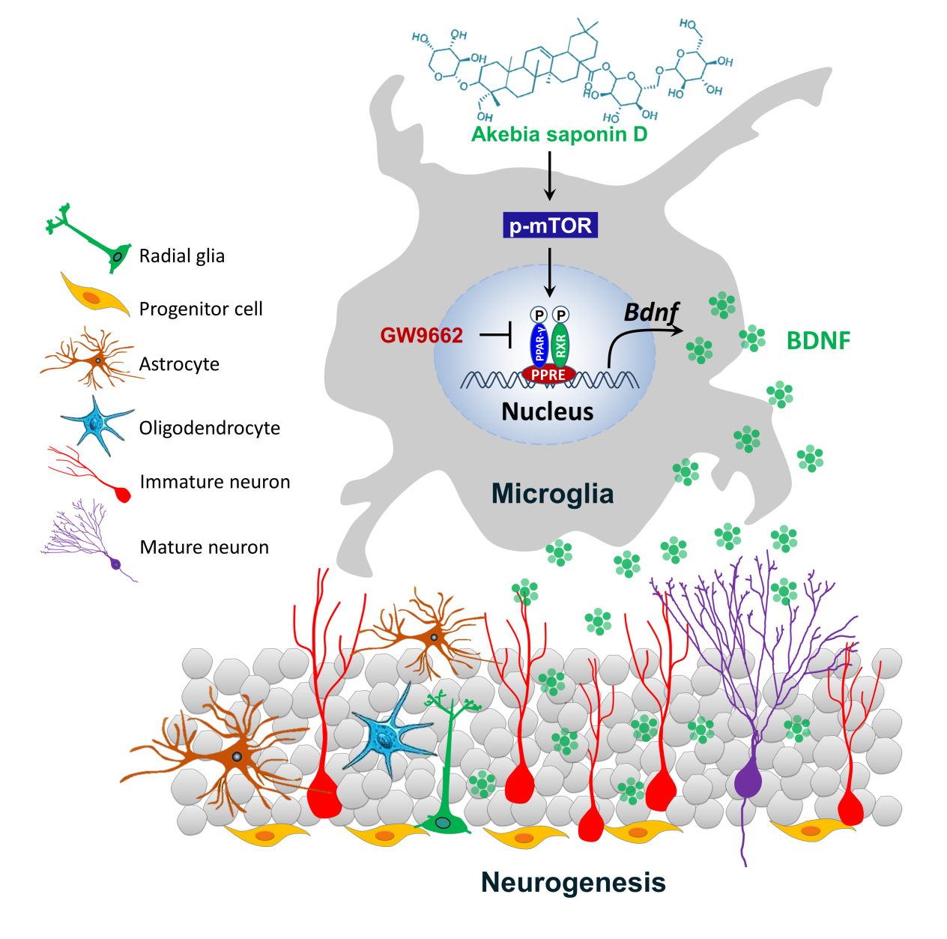
Fig. S6 Schematic diagram of how akebia saponin D may restore hippocampal neurogenesis
Akebia saponin D acts via the PPAR-γ pathway to reprogramme a pro-neurogenic microglial phenotype in dentate gyrus that can increase BDNF expression which to promote NSPC proliferation, survival, and neural differentiation, thus restores hippocampal neurogenesis and ameliorates depression-like behavior in CMS-exposed mice.

Supplementary Table 1. The procedure of chronic unpredictable mild stress (CMS)
 | Monday | Tuesday | Wednesday | Thursday | Friday | Saturday | Sunday
Week -1 | 9-21h Continuous dark  14-14h Cage tilting  21-9h Continuous lighting | 9-9:10h Smell stimulation  14-14h Damp bedding  19-7h Strobe lighting | 9-11h Restraint  14-14h A soiled cage  19-19:15h Tail clipping | 19-19h Food deprivation  7-19h Water deprivation  21-21:10h Smell stimulation | 9-21h Continuous dark  14-14h Cage tilting  19-7h Continuous lighting | 9-9:10h Smell stimulation  14-14h Damp bedding  19-7h Strobe lighting | 9-11h Restraint  14-14h A soiled cage  19-19:15h Tail clipping
Week -2 | 9-21h Empty water bottles  14-15h Cage shaking  19-19h Cage tilting | 9-21h Continuous dark  14-14:10h Smell stimulation  21-9h Continuous lighting | 9-21h Strobe lighting  14-14:15h Tail clipping  21-9h Damp bedding | 19-19h Food deprivation  7-19h Water deprivation  21-21h A soiled cage | 9-9h Cage tilting  14-14:10h Smell stimulation  19-21h Restraint | 9-21h Continuous dark  14-15h Cage shaking  21-9h Continuous lighting | 9-21h Empty water bottles  14-14:15h Tail clipping  19-19h Damp bedding
Week -3 | 9-21h Strobe lighting  14-14h Cage tilting  19-19h A soiled cage | 9-21h Continuous dark  14-15h Cage shaking  21-9h Continuous lighting | 9-21h Empty water bottles  14-14:15h Tail clipping  19-19:10h Smell stimulation | 21-21h Food deprivation  7-19h Water deprivation  21-23h Restraint | 9-9h Cage tilting  14-14h Damp bedding  19-7h Strobe lighting | 9-21h Empty water bottles  14-14h A soiled cage  19-19:10h Smell stimulation | 9-21h Continuous dark  14-16h Restraint  21-9h Continuous lighting
Week -4 | 9-9h Damp bedding  14-14h Cage tilting  19-7h Strobe lighting | 9-9h A soiled cage  14-14:15h Tail clipping  19-7h Empty water bottles | 9-21h Continuous dark  14-15h Cage shaking  21-9h Continuous lighting | 21-21h Food deprivation  7-19h Water deprivation  21-21:10h Smell stimulation | 9-11h Restraint  14-14h Damp bedding  19-19h Cage tilting | 9-21h Empty water bottles  14-14h A soiled cage  19-7h Strobe lighting | 9-21h Continuous dark  14-14:15h Tail clipping  21-9h Continuous lighting
Week -5 | 9-9h Cage tilting  14-14h Damp bedding  19-7h Strobe lighting | 9-21h Empty water bottles  14-14h A soiled cage  19-20h Cage shaking | 9-21h Continuous dark  14-14:10h Smell stimulation  21-9h Continuous lighting | 21-21h Food deprivation  7-19h Water deprivation  21-23h Restraint | 9-9:15h Tail clipping  14-14h Damp bedding  19-19h Cage tilting | 9-10h Cage shaking  14-14h A soiled cage  19-19:10h Smell stimulation | 9-21h Empty water bottles  14-16h Restraint  19-7h Strobe lighting
Week -6 | 9-21h Continuous dark  14-14:15h Tail clipping  21-9h Continuous lighting | 9-9h Cage tilting  14-14h Damp bedding  19-21h Restraint | 9-21h Empty water bottles  14-14h A soiled cage  19-20h Cage shaking | 21-21h Food deprivation  7-19h Water deprivation  21-21:10h Smell stimulation | 9-9h Cage tilting  14-16h Restraint  19-7h Strobe lighting | 9-21h Continuous dark  14-14:15h Tail clipping  21-9h Continuous lighting | 9-9:10h Smell stimulation  14-15h Cage shaking  19-7h Empty water bottles
Week -7 | 9-11h Restraint  14-14h Damp bedding  19-19h Cage tilting | 9-21h Continuous dark  14-14h A soiled cage  21-9h Continuous lighting | 9-9:10h Smell stimulation  14-15h Cage shaking  19-7h Strobe lighting | 21-21h Food deprivation  7-19h Water deprivation  21-21:15h Tail clipping | 9-9h Damp bedding  14-14h Cage tilting  19-21h Restraint | 9-9h A soiled cage  14--15h Cage shaking  21-9h Continuous lighting | 9-21h Continuous dark  14-14:15h Smell stimulation  21-9h Continuous lighting

Supplementary Table 2. Genes primers used for real time PCR analyses
Gene | Primer sequences
β-actin | Forward: 5’-CCGTGAAAAGATGACCCAGATC-3’  Reverse: 5’-CACAGCCTGGATGGCTACGT-3’
Tnf-α | Forward:5’-TACTGAACTTCGGGGTGATTGGTCC-3’  Reverse: 5’-CAGCCTTGTCCCTTGAAGAGAACC-3’
iNOS | Forward: 5’-ACAACAGGAACCTACCAGCTCA-3’  Reverse: 5’-GATGTTGTAGCGCTGTGTGTCA-3’
IL-10 | Forward: 5’-TGGCCCAGAAATCAAGGAGC-3’  Reverse: 5’-CAGCAGACTCAATACACACT-3’
Arg-1 | Forward: 5’-AGACAGCAGAGGAGGTGAAGAG-3’  Reverse: 5’-CGAAGCAAGCCAAGGTTAAAGC-3’
Bdnf | Forward: 5’-GAGCTGAGCGTGTGTGACAG-3’  Reverse: 5’-CGCCAGCCAATTCTCTTTTTGC-3’

Supplementary Table 3. Details of Antibody and dilution rate for immunofluorescent staining
AntiBody | Manufacturer | Product numbers | Dilution Rate
Iba1 (Goat anti-mouse) | Abcam | ab178846 | 1:400
GFAP (Rabbit anti-mouse) | Cell Signaling Technology | 12389S | 1:500
GFAP (Mouse anti-mouse) | Cell Signaling Technology | 3670S | 1:400
BrdU (Mouse anti-mouse) | Cell Signaling Technology | 5292S | 1:400
DCX (Rabbit anti-mouse) | Cell Signaling Technology | 14802S | 1:300
Ki67 (Rabbit anti-mouse) | Abcam | ab21700 | 1:400
BDNF (Rabbit anti-mouse) | Abcam | ab108319 | 1:500
p-TrkB (Rabbit anti-mouse) | Invitrogen | PA5-38076 | 1:50
MAP2 (Rabbit anti-mouse) | Cell Signaling Technology | 4542S | 1:400
Arg-1 (Mouse anti-mouse) | Abcam | ab239731 | 1:200
PPAR-γ (Rabbit anti-mouse) | Cell Signaling Technology | 2435S | 1:300
NeuN (Rabbit anti-mouse) | Cell Signaling Technology | 36662SF | 1:800

Supplementary Table 4. Details of Antibody and dilution rate for western blotting
Antibody | Manufacturer | Product numbers | Dilution Rate
mTOR (Rabbit anti-mouse) | Cell Signaling Technology | 2983S | 1:800
p-mTOR (Rabbit anti-mouse) | Cell Signaling Technology | 5536S | 1:800
TrkB (Rabbit anti-mouse) | Cell Signaling Technology | 4603S | 1:1000
p-TrkB (Rabbit anti-mouse) | Invitrogen | PA5-38076 | 1:500
PPAR-γ (Rabbit anti-mouse) | Cell Signaling Technology | 2435S | 1:800
p-PPARγ (S112) (Rabbit anti-mouse) | ImmunoWay Biotechnology | YP0316 | 1:500
BDNF (Rabbit anti-mouse) | Abcam | ab108319 | 1:800
β-actin (Mouse anti-mouse) | Abcam | ab6276 | 1:1000

