SUPPORTING INFORMATION FOR The quantitative importance of key root traits on radial water loss
Zhiwei Song^{1,#}, Francesco Zonta^{2,#}, Lucas León Peralta Ogorek¹, Viggo Klint Bastegaard¹, Max Herzog¹, Elisa Pellegrini^{1,3,*}, Ole Pedersen^{1*}

¹The Freshwater Biological Laboratory, Department of Biology, University of Copenhagen, Universitetsparken 4, 3rd Floor, Copenhagen 2100, Denmark.
²Institute of Fluid Mechanics and Heat Transfer, TU-Wien, 1060 Vienna, Austria.
³Department of Food, Agricultural, Environmental and Animal Sciences, University of Udine, via delle Scienze 206, Udine, Italy.

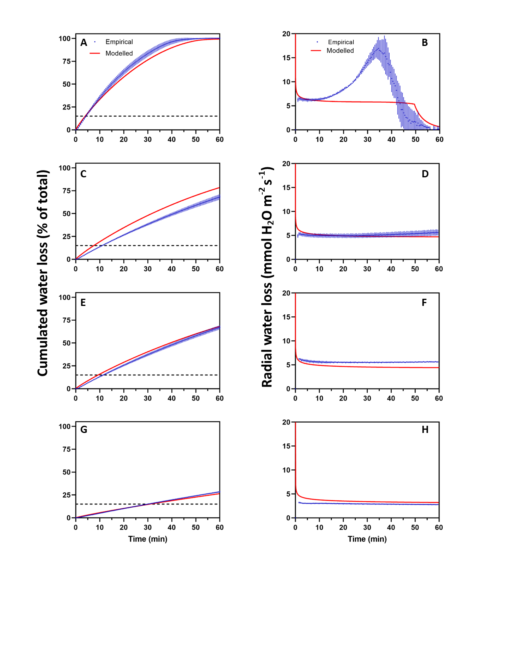

Fig. S1.
Cumulated water loss and radial water loss (RWL) of agar cylinders ranging from 0.8-3.33 mm in diameter during 1-h exposure to dry air (relative humidity 18-30%). 5-8 cm long cylinders (3% agar) were prepared using a syringe with needles ranging from 0.8-3.33 in inner diameter and placed inside the chamber of a 5-digit balance recording loss in mass every 30 seconds. Data are means ± SD (n = 5). A-B, Ø = 0.8 mm; C-D, Ø = 1.25 mm; E-F, Ø = 1.45 mm; G-H, Ø = 3.33 mm. RWL value were extracted at the time at which 15% cumulated water loss had occurred and used for linear regression analysis in Fig. S2.

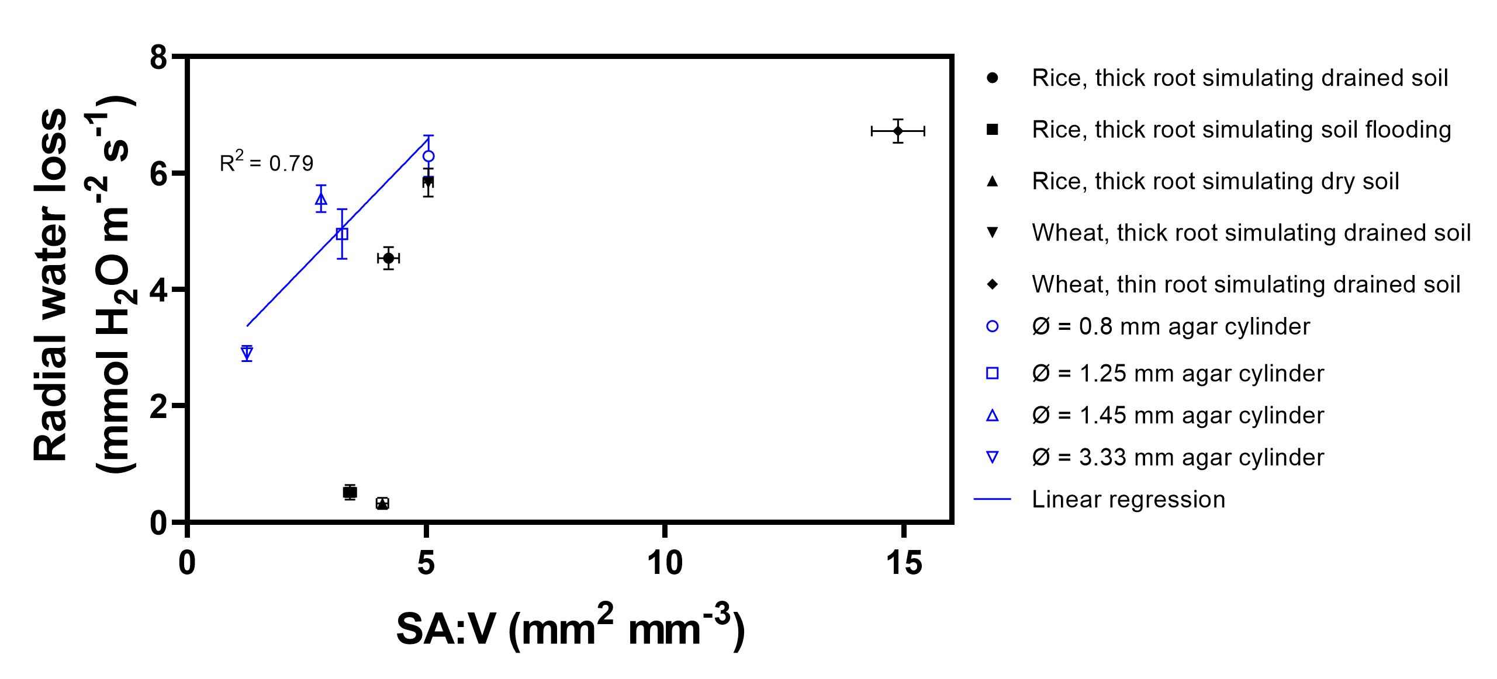

Fig. S2.
Relationship between surface area to volume ratio (SA:V) and radial water loss (RWL) in root segments of rice, wheat and agar cylinders. Plants were grown in aerated nutrient solution (simulating drained soil), stagnant, deoxygenated nutrient solution (simulating soil flooding) and with PEG-6000 nutrient solution (simulating dry soil). Linear regression is only conducted on data from the agar cylinders. Symbols represent means ± SD (n = 5). Some error bars are not shown on symbols due to the error bar being shorter than the size of the symbol. Ø, diameter. P < 0.0001, Spearman Rank with R² indicated in the graph.

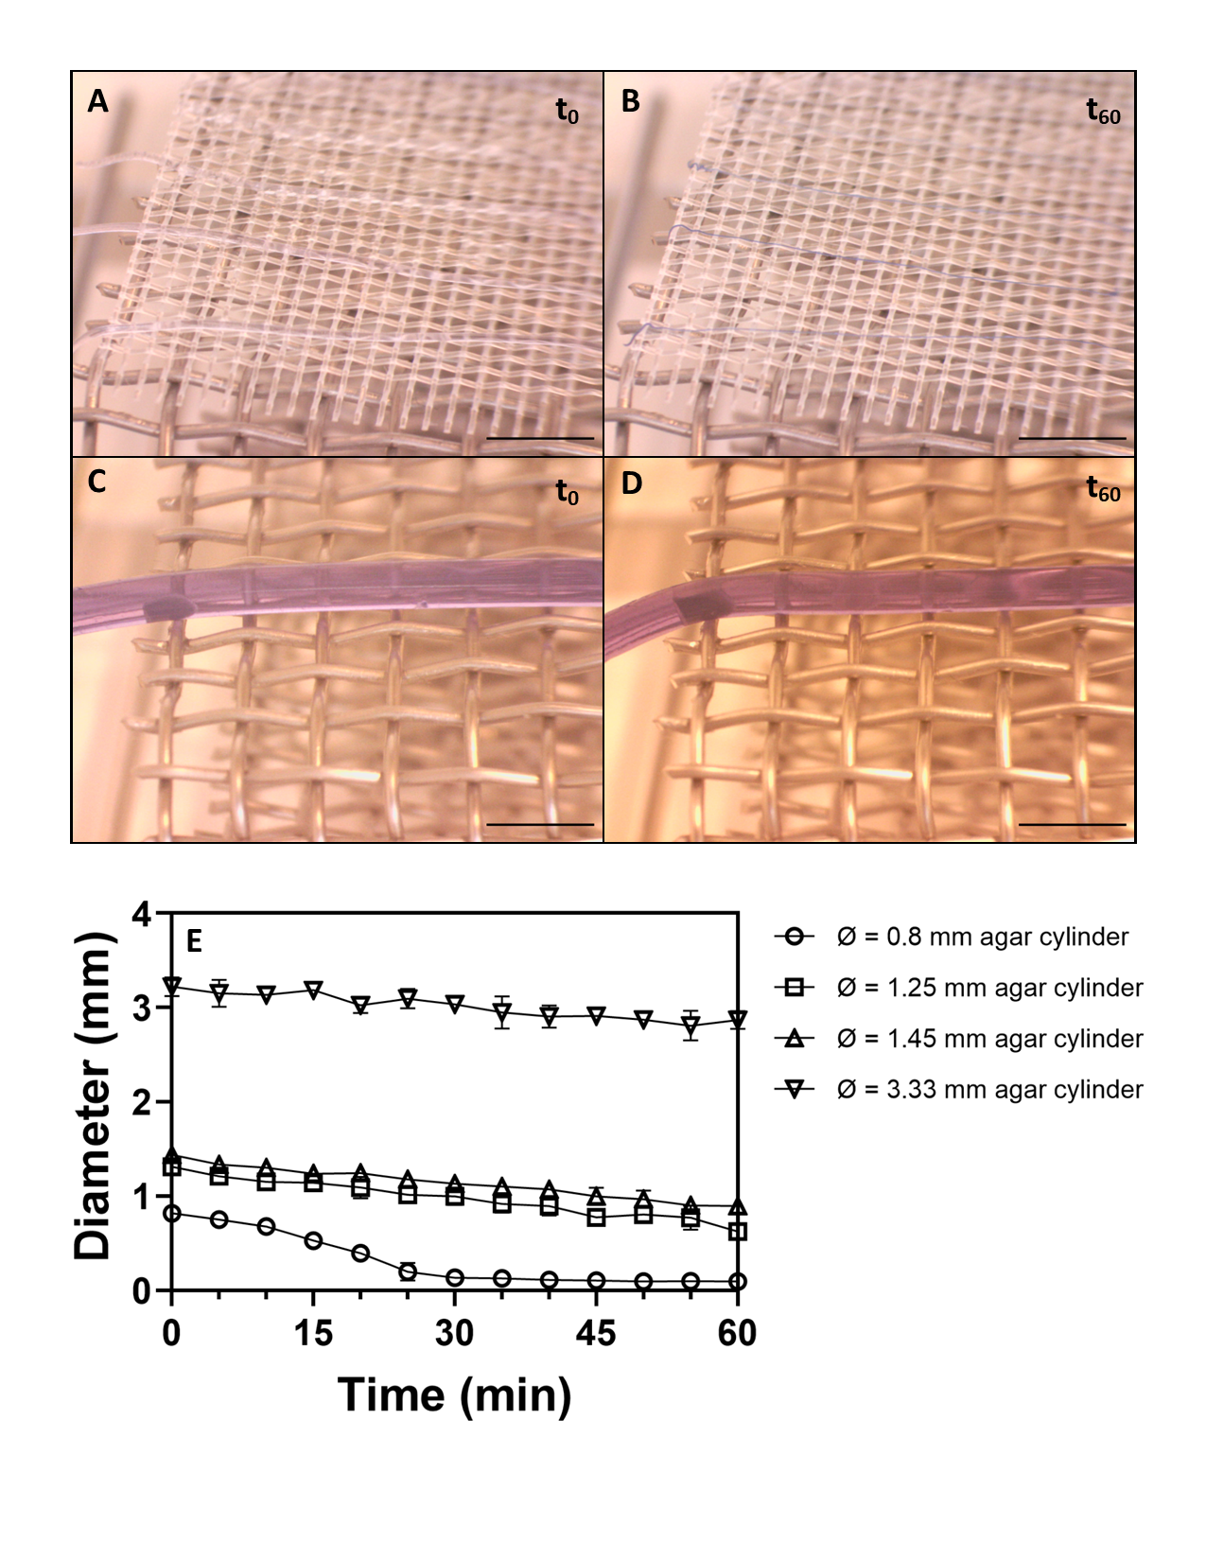

Fig. S3.
Dynamics in diameter with time of desiccation of agar cylinders ranging from 0.8-3.3 mm in diameter exposed to dry air (relative humidity 18-30%). A and B, time-lapse images of 0.8 mm and C, D, of 3.33 mm. E, changes in diameter with time. Symbols represent the mean ± SD (n = 5).
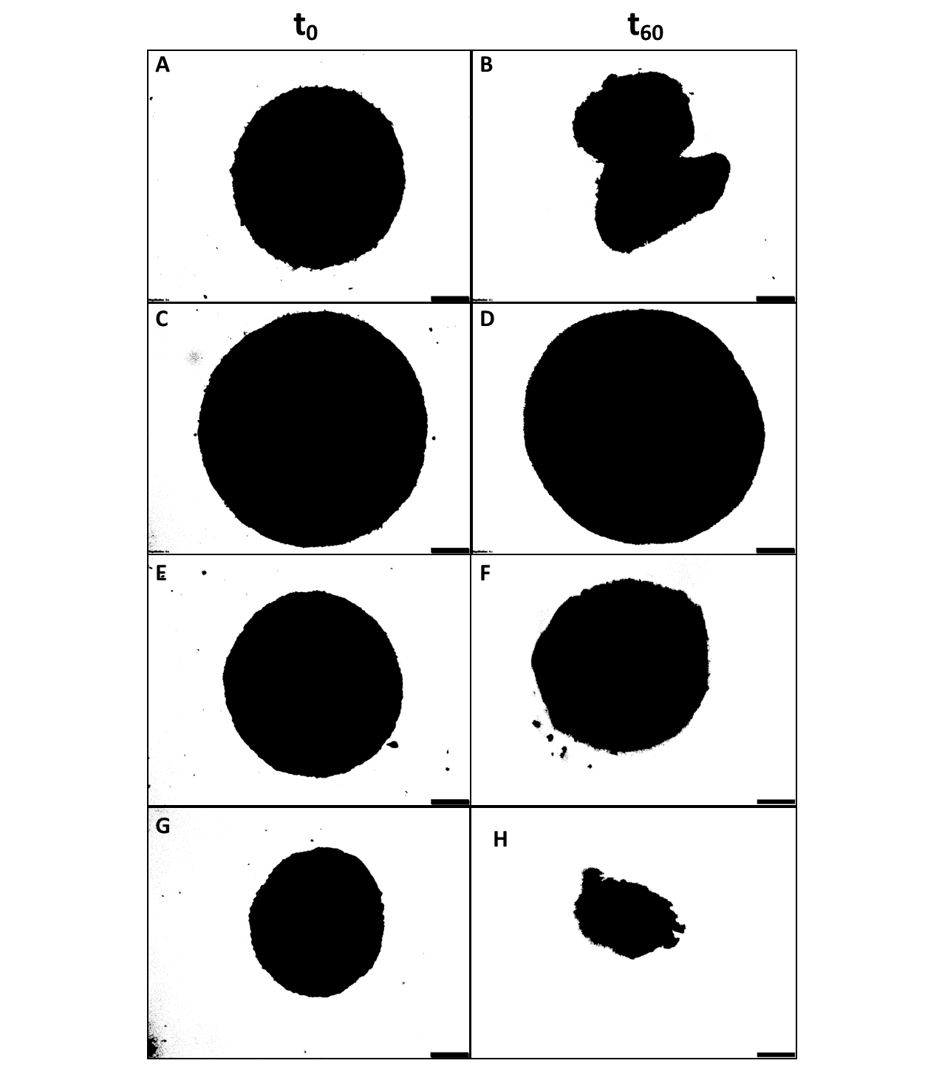

Fig. S4.
Root cross-sections before (t₀) and after (t₆₀) 60 min of tissue desiccation during exposure to dry air (relative humidity 20%). 12-13 cm root segments were harvested from rice grown in aerated nutrient solution (simulating drained soil), stagnant, deoxygenated nutrient solution (simulating soil flooding) and with PEG-6000 nutrient solution (simulating dry soil) as well as thick roots of wheat grown in aerated nutrient solution (simulating drained soil). The most apical 3 cm was discarded and cut ends sealed with Vaseline. Fresh root cross-sections (left) were taken at t₀ and dry root cross-sections (right) were taken at t₆₀. A, B, rice, thick roots simulating drained soil; C, D, rice, thick roots simulating soil flooding; E, F, rice, thick roots simulating dry soil; G, H, wheat, thick roots simulating drained soil. Scale bar = 200 μm.

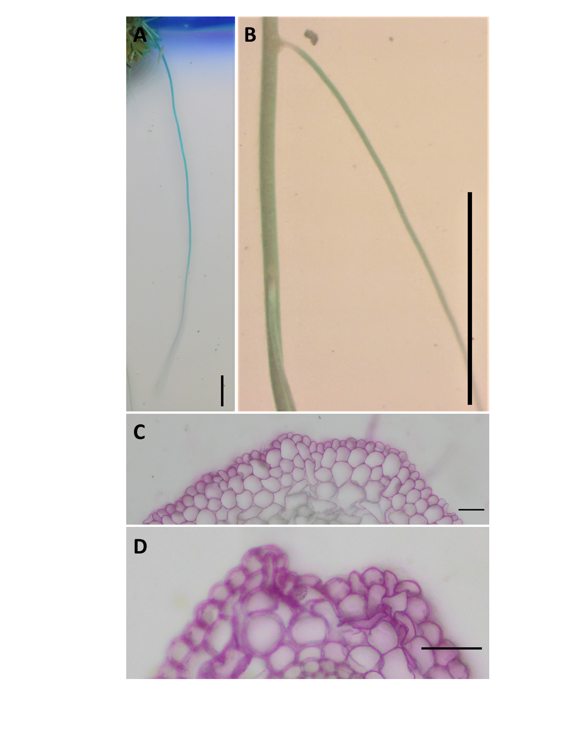

Fig. S5.
Methylene blue (A, B) and periodic acid staining (C, D) of wheat roots. In A, B, blue coloration indicates radial O₂ loss (ROL) and in C, D, purple coloration indicates radial infiltration of the apoplastic tracer. Plants were 28- to 35-day-old and in A, C, thick roots of wheat were grown in aerated nutrient solution (simulating drained soil) and in B, D, thin roots of wheat were grown in aerated nutrient solution (simulating drained soil). Scale bar = 1 cm in A, B and 50 μm in C, D.

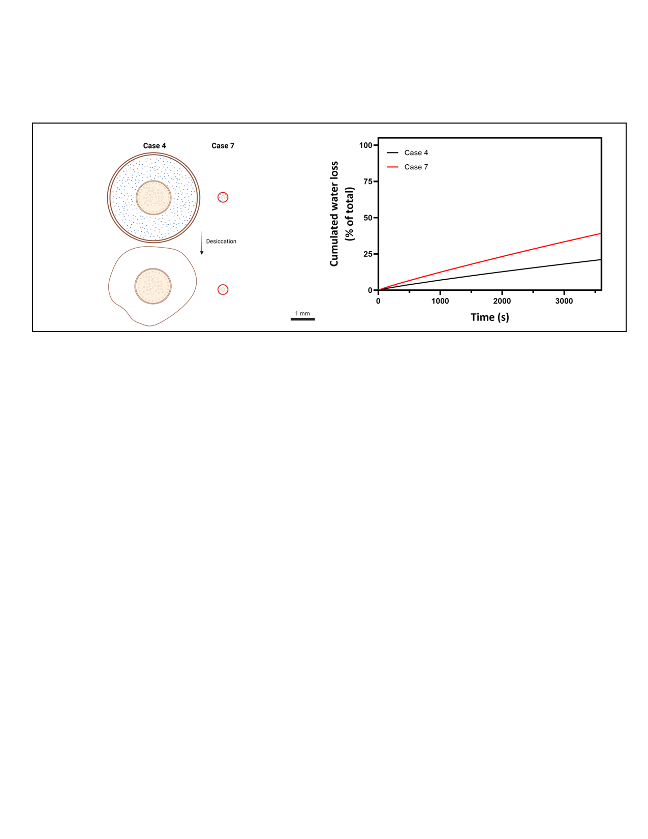

Fig. S6.
Predictions of cumulated water loss from two roots with contrasting key traits. Case 4 has a diameter of 4 mm vs. only 0.5 mm in case 7. In both cases, the gas-filled porosity is only 3%. Moreover, case 7 has a barrier to ROL.

