Supplementary Files
Supplementary File 1. Domain distribution on PJ-1366 cellulases
> CBH1
> CBH2
> CBH3
> CBH4
> EG1
>EG2
> EG3
> EG4
> EG5
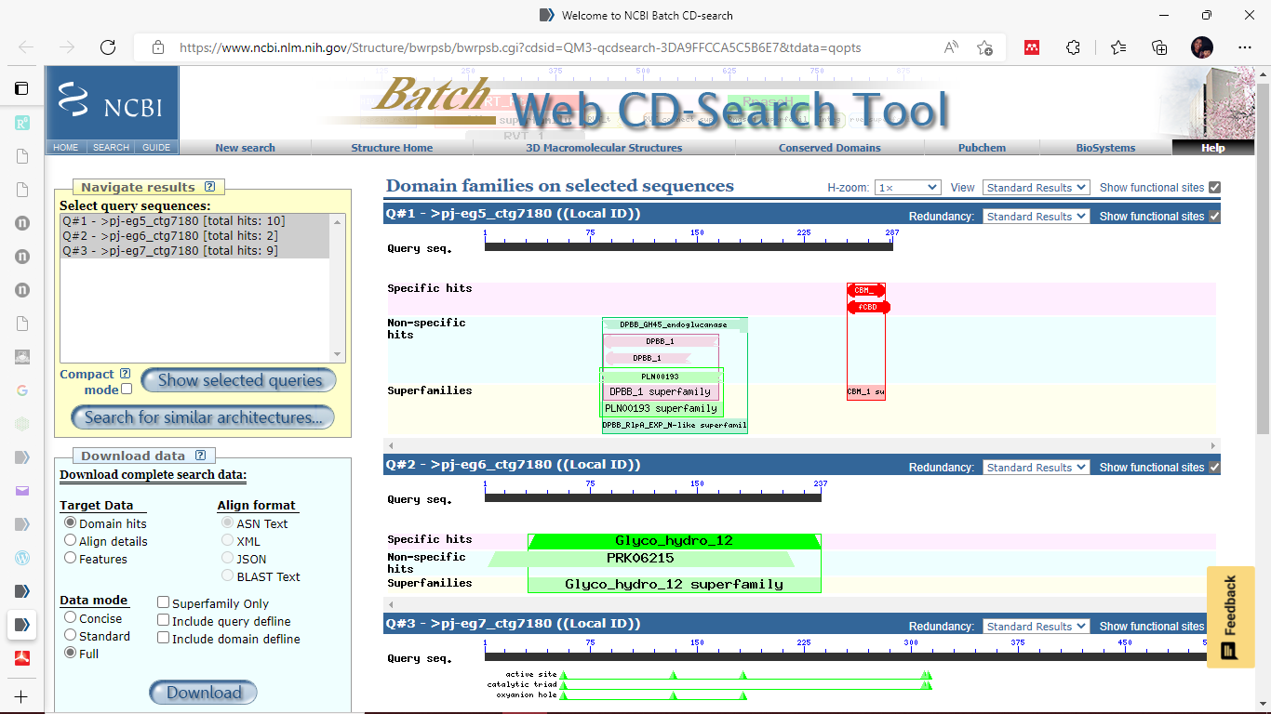
> EG6
>EG7
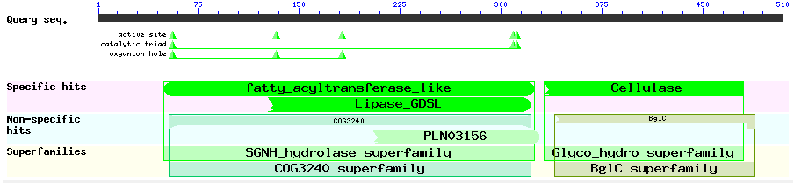

>ctg7180000014236.g84- BGL1
>ctg7180000014474.g297- BGL2

Supplementary File 2. Docking of PJ-1366 BGLs with a. Cellobiose (substrate); b. Gentiobiose (potential inducer), and; c. Glucose (product)
a. | b. | c.
BGL1- Template: 5yot
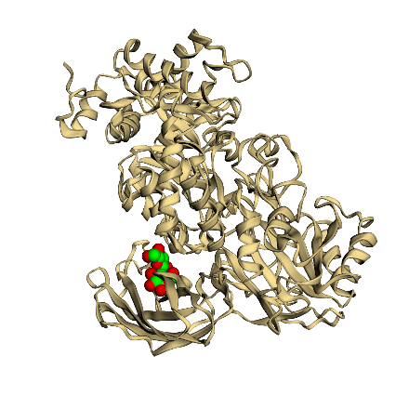 | 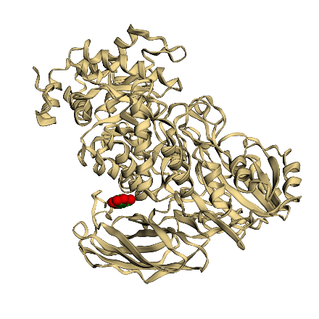 | 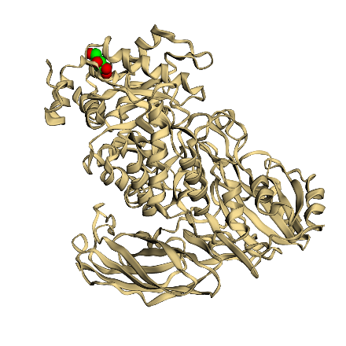
Binding Energy: -39.56 kcal/mol | Binding Energy: -39.95 kcal/mol | Binding Energy: -26.73 kcal/mol
BGL2- Template: 4iid
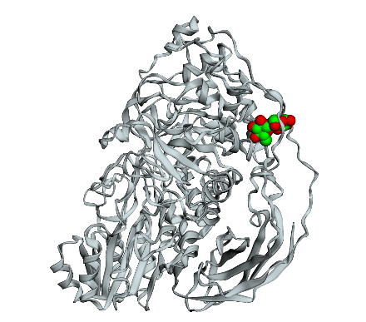 | 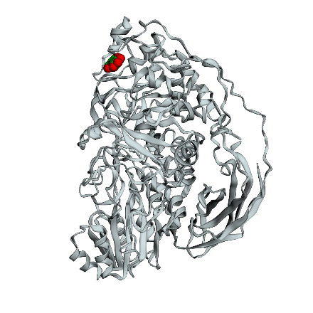 | 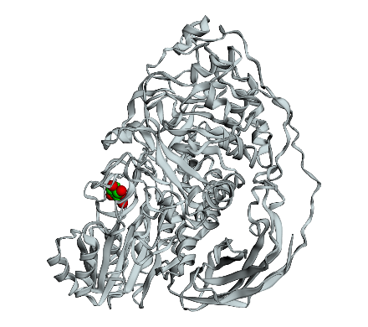
Binding Energy: -39.71 kcal/mol | Binding Energy: -51.69 kcal/mol | Binding Energy: -29.38 kcal/mol

Supplementary File 3. Comparison of the expression levels of TF transcripts on cellulose (y-axis) vs glucose (x-axis)

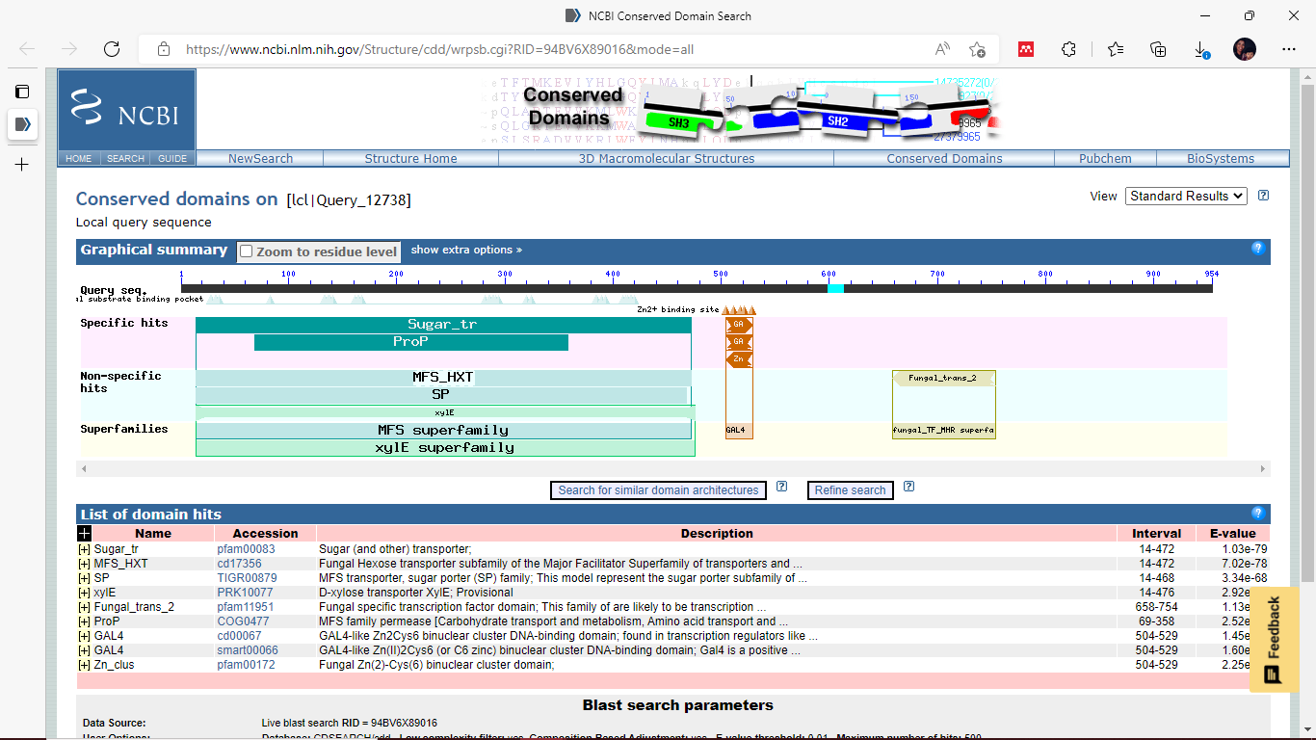
Supplementary File 4. Domain analysis of ctg7180000015228.g98

Supplementary File 5. Ontology analysis of TFs with binding sites on cellulase promoters
32 of the 46 TFs were mapped onto different biological processes

Supplementary File 6. Mapping of predicted early cellulase regulators to the PJ-1366 genome and transcriptome
Factor | UniProt ID | PJ Protein | % Identity | Transcript ID | % Identity2 | G_FPKM | C_FPKM
FACB | O13461 | ctg7180000015115.g238 | 60.85 | TRINITY_DN10653_c0_g1_i1 | 100 | 33.45 | 112.36
CAT8 | P39113
SIP4 | P46954
PDR3 | P33200 | ctg7180000014579.g118 | 26.11 | TRINITY_DN11674_c0_g1_i1 | 100 | 1.69 | 3.7
ROX1 | P25042 | ctg7180000015059.g151 | 46.43 | TRINITY_DN11920_c0_g1_i1 | 100 | 10.8 | 3.76
MATa2 | P0CY08 | ctg7180000014600.g260 | 34.18 | TRINITY_DN12586_c0_g1_i1 | 100 | 4.5 | 4
PHO4 | P07270 | ctg7180000014400.g249 | 34.95 | TRINITY_DN12941_c0_g1_i1 | 100 | 54.2 | 38.86
GCN4 | P03069 | ctg7180000009961.g293 | 29.11 | TRINITY_DN1536_c0_g1_i1 | 95.662 | 707.67 | 1099.07
CPC1 | P11115
TOXE | O74205 | ctg7180000009916.g158 | 29.14 | TRINITY_DN16568_c0_g1_i1 | 100 | 32.46 | 17.14
RAP1 | P11938 | ctg7180000014810.g152 | 36.36 | TRINITY_DN16690_c0_g1_i1 | 100 | 2.36 | 3.04
MIG1 | P27705 | ctg7180000010025.g78 | 52.63 | TRINITY_DN18772_c0_g1_i1 | 100 | 144.93 | 438.18
UME6 | P39001 | ctg7180000015101.g196 | 36.36 | TRINITY_DN2081_c0_g1_i1 | 100 | 12.63 | 6.43
SUT1 | P53032 | ctg7180000015379.g171 | 58.33 | TRINITY_DN21703_c0_g1_i1 | 100 | 11.74 | 25.63
PDR1 | P12383
MCM1 | P11746 | ctg7180000014443.g45 | 74.74 | TRINITY_DN21880_c0_g1_i1 | 100 | 88.73 | 98.18
XBP1 | P40489 | ctg7180000009974.g110 | 46.67 | TRINITY_DN23140_c0_g1_i1 | 100 | 4.17 | 4.01
RPN4 | Q03465 | ctg7180000015229.g190 | 44.3 | TRINITY_DN24330_c0_g1_i1 | 96.779 | 303.23 | 533.27
MAC1 | P35192 | ctg7180000014444.g93 | 47.37 | TRINITY_DN25511_c0_g1_i1 | 100 | 159.47 | 136.41
NIT2 | P19212 | ctg7180000014579.g108 | 39.95 | TRINITY_DN3063_c0_g3_i1 | 99.658 | 18.09 | 34.35
GAL4 | P04386 | ctg7180000015120.g14 | 29.19 | TRINITY_DN4403_c0_g2_i1 | 100 | 33.61 | 31.89
LAC9 | P08657
ADR1 | P07248 | ctg7180000014442.g38 | 50 | TRINITY_DN6309_c0_g1_i1 | 98.739 | 5.42 | 4.72
SKO1 | Q02100 | ctg7180000015244.g235 | 35.37 | TRINITY_DN6578_c0_g1_i2 | 100 | 10.18 | 6.54
CBF1 | P17106 | ctg7180000015126.g146 | 35.1 | TRINITY_DN7135_c0_g2_i1 | 99.202 | 8.82 | 14.48
STE12 | P13574 | ctg7180000015092.g141 | 60 | TRINITY_DN7299_c0_g2_i1 | 100 | 62.98 | 52.79
REB1 | P21538 | ctg7180000015100.g153 | 39.82 | TRINITY_DN7500_c0_g1_i1 | 29.577 | 0.04 | 0.03
LYS14 | P40971 | ctg7180000009927.g33 | 37.84 | TRINITY_DN7740_c0_g1_i1 | 100 | 12.02 | 10.19
TBP | P13393 | ctg7180000014397.g136 | 91.11 | TRINITY_DN8049_c0_g1_i1 | 100 | 258.81 | 208.91
MATa1 | P0CY11 | ctg7180000015122.g49 | 30 | TRINITY_DN8704_c0_g1_i1 | 100 | 15.01 | 15.93
SWI4 | P25302 | ctg7180000010135.g36 | 39.46 | TRINITY_DN9577_c1_g1_i1 | 100 | 13.98 | 9.11
SWI6 | P09959 | ctg7180000015097.g76 | 27.49 | TRINITY_DN9601_c0_g1_i1 | 100 | 10.12 | 8.41
GCR1 | P07261 | ctg7180000014753.g103 | 33.33 | TRINITY_DN9776_c0_g1_i2 | 99.704 | 14.81 | 17.71

