Supplementary Fig. 1

Sample ID: A
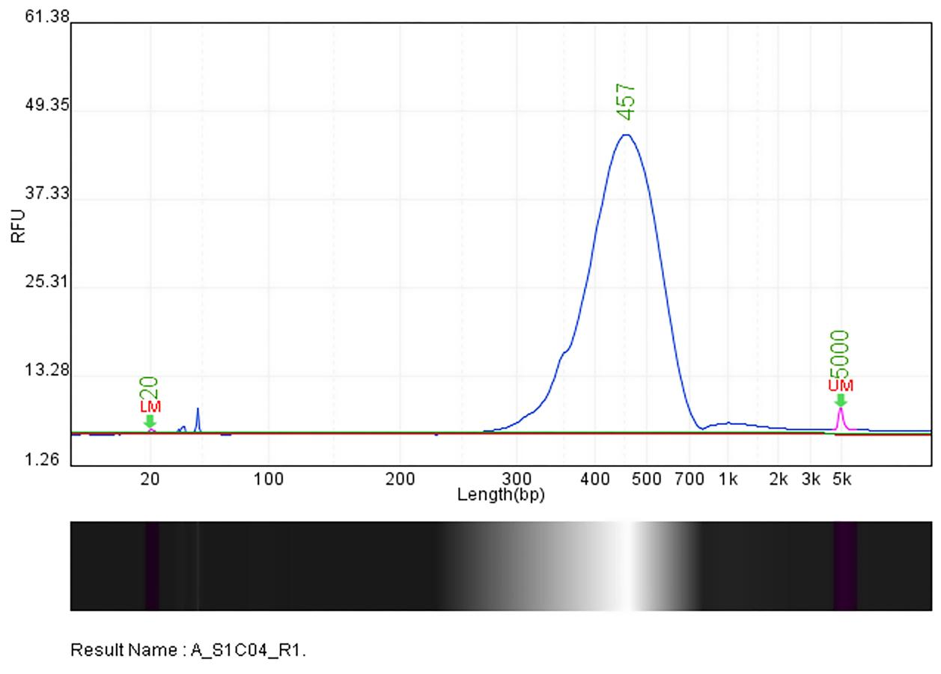

Sample ID: B

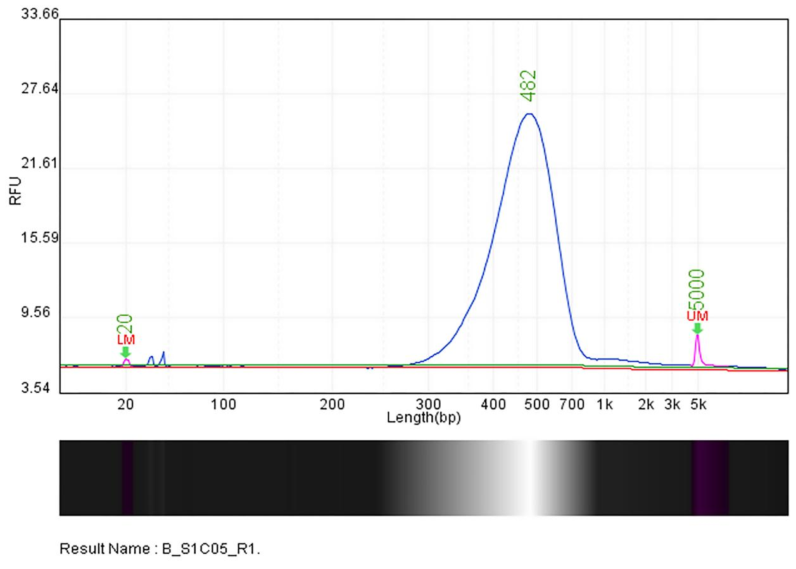
Sample ID: C
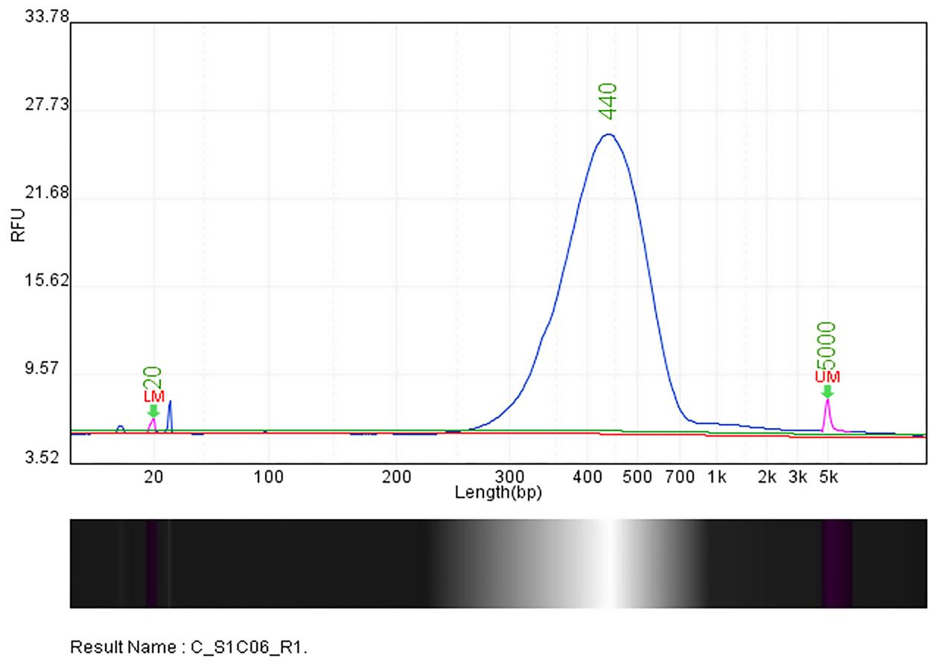

Sample ID: D
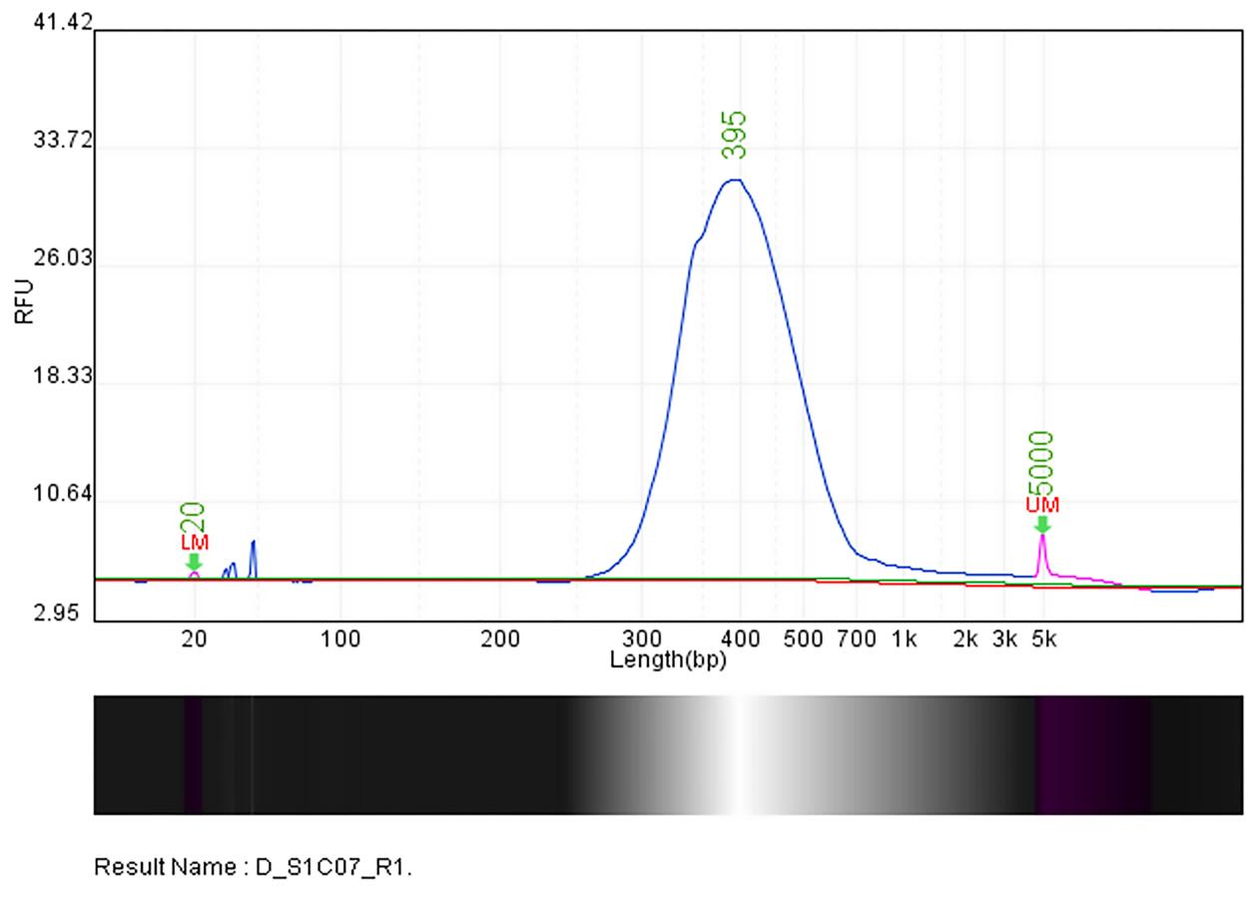

Supplementary Fig.1 Quality control results of four capture field sample A-D libraries.

