Supporting information
Preparation of bimetal modified HMS zeolite and its catalytic effect on phenol degradation
Yaming Pang ^{a,b}, Liguo Gao ª,b,*, Mingxuan Xia ª,c , Yuxiu Fu ^{a,b}, Xiaoli, Song ^{a,b}
ª School of Chemistry and Chemical Engineering, Yulin University, Yulin, 719000, Shaanxi, China
^{b} Shaanxi Key Laboratory of Low Metamorphic Coal Clean Utilization, Yulin, 719000, Shaanxi, China
^{c} College of Oil and Gas Engineering, Southwest Petroleum University, Chengdu, 610500,Szechwan, China

Figure S1. FTIR spectrum of (A)HMS、(B)Ti-HMS、(C)Ce-HMS、(D)Ce/Ti-HMS

Table S1
Box-BehnKen experimental design and results display
NO | Time（min） | Temperature（℃） | Amount of catalyst（g/mL） | Phenol removal rate（%）
1  2  3  4  5  6  7  8  9  10  11  12  13  14  15  16  17 | 210  60  180  180  180  210  60  210  60  210  180  180  180  180  120  60  210 | 60  20  60  20  40  40  40  20  40  40  60  60  60  60  20  60  40 | 0.10  0.10  0.05  0.05  0.10  0.10  0.15  0.10  0.05  0.05  0.10  0.15  0.10  0.15  0.10  0.10  0.15 | 89.9  48.7  72.6  46.6  77.8  78.3  70.4  53.5  52.2  54.7  84.7  83.9  84.7  78.6  60.7  60.6  80.1

Table S2
Significance test of regression equation coefficient
No | Sum of square | Degree of freedom | Mean square | F | P
Model | 3150.93 | 9 | 345.10 | 24.54 | 0.0002
A-Time | 270.73 | 1 | 270.73 | 19.25 | 0.0032
B-Temperature | 558.05 | 1 | 549.97 | 39.10 | 0.0004
C-Agent oil ratio | 549.97 | 1 | 558.05 | 39.68 | 0.0004
AB | 0.74 | 1 | 0.74 | 0.035 | 0.0825
AC | 52.23 | 1 | 52.23 | 3.71 | 0.0095
BC | 40.14 | 1 | 40.14 | 2.85 | 0.0135
A² | 154.67 | 1 | 154.67 | 11.00 | 0.0128
B² | 102.26 | 1 | 102.26 | 7.27 | 0.0308
C² | 149.90 | 1 | 149.90 | 10.66 | 0.0138
Residual | 98.46 | 7 | 14.07
Lack of fit | 84.41 | 5 | 16.88
Pure error | 14.05 | 2 | 7.02
Sum | 3204.39 | 16

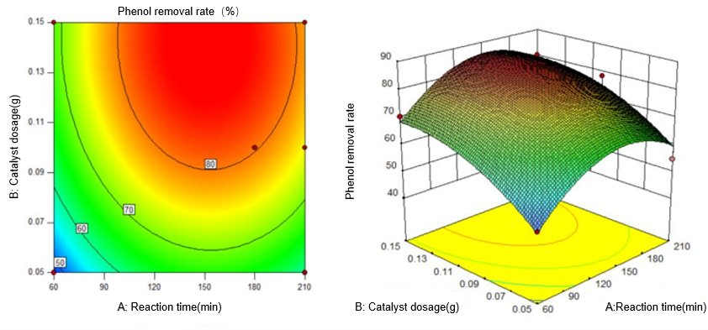
Figure S2. Contour line and response surface of the effect of reaction time and catalyst dosage on Phenol removal rate
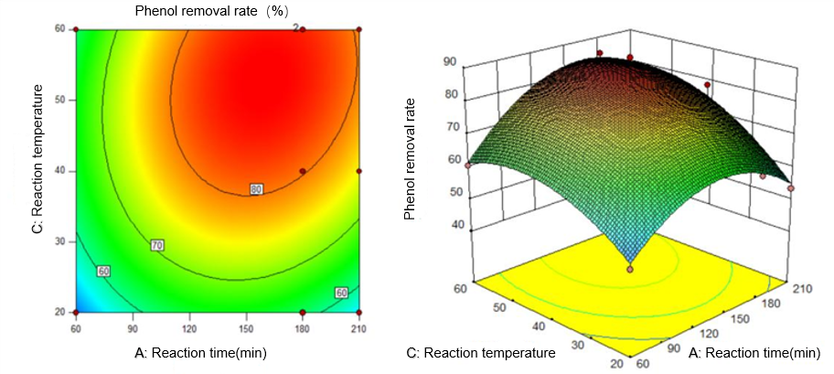
Figure S3. Contour line and response surface of the effect of reaction time and reaction temperature on Phenol removal rate
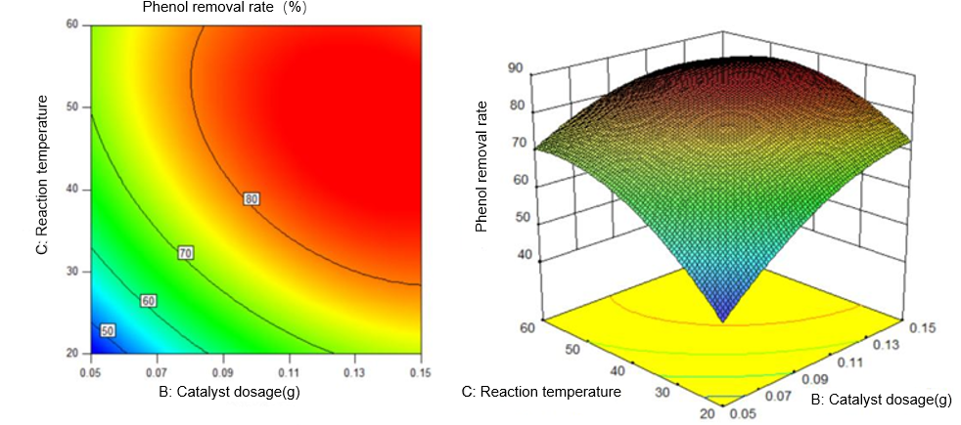
Figure S4. Contour line and response surface of the effect of catalyst dosage and reaction temperature on Phenol removal rate
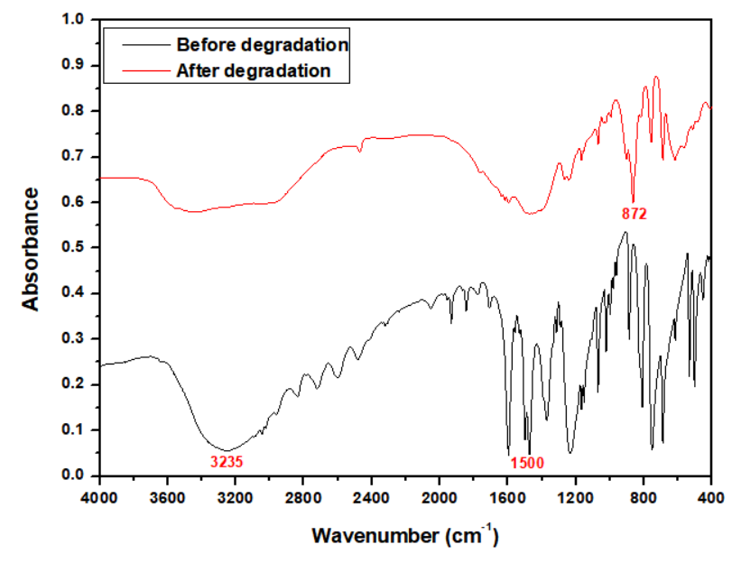
Fig.S5 Infrared spectra of phenol solution before and after degradation
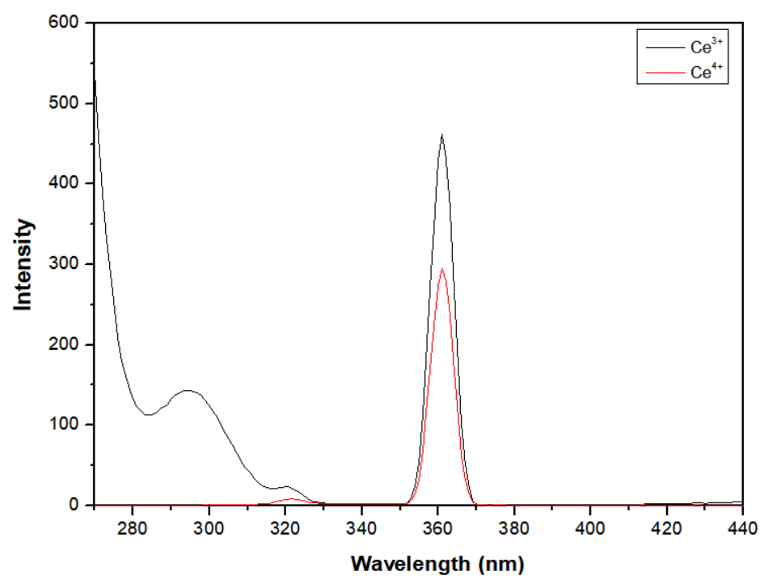
Figure S6 Determination of hydroxyl radicals

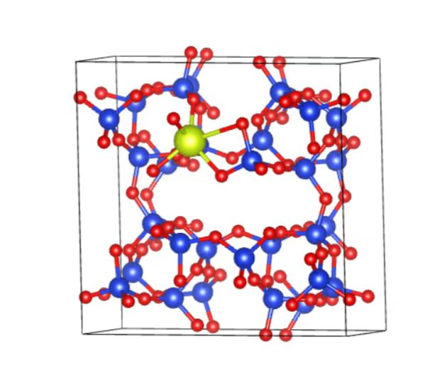
Atom | X/Y/Z coordinate(Angstrom)
Si | 0.169822 | 0.356758 | 0.399061
Si | 0.200672 | 0.392497 | 0.894388
Si | 0.367035 | 0.316598 | 0.596196
Si | 0.133102 | 0.159404 | 0.586121
Si | 0.290818 | 0.106068 | 0.890280
Si | 0.108479 | 0.211369 | 0.078918
Si | 0.340049 | 0.103171 | 0.421491
Si | 0.797890 | 0.395234 | 0.406375
Si | 0.842740 | 0.375001 | 0.891816
Si | 0.894434 | 0.210702 | 0.579142
Si | 0.612032 | 0.294940 | 0.585854
Si | 0.870309 | 0.176296 | 0.082201
Si | 0.666204 | 0.146470 | 0.900972
Si | 0.644658 | 0.360702 | 0.087994
Si | 0.712445 | 0.114979 | 0.391542
Si | 0.283766 | 0.873598 | 0.425578
Si | 0.321246 | 0.862765 | 0.910697
Si | 0.387000 | 0.696212 | 0.603384
Si | 0.103513 | 0.784935 | 0.605162
Si | 0.364147 | 0.665892 | 0.099072
Si | 0.164924 | 0.630242 | 0.908575
Si | 0.127243 | 0.829847 | 0.112495
Si | 0.213729 | 0.600961 | 0.411409
Si | 0.665637 | 0.873217 | 0.408881
Si | 0.704658 | 0.899895 | 0.918915
Si | 0.863272 | 0.834321 | 0.604707
Si | 0.632182 | 0.676125 | 0.597914
Si | 0.886381 | 0.793304 | 0.103745
Si | 0.793024 | 0.617370 | 0.902552
Si | 0.606378 | 0.717860 | 0.094283
Si | 0.832907 | 0.634870 | 0.407519
Ce | 0.405484 | 0.289993 | 0.130218
O | 0.287808 | 0.376489 | 0.736226
O | 0.379020 | 0.180775 | 0.580065
O | 0.273719 | 0.399566 | 0.060533
O | 0.360970 | 0.988180 | 0.886944
O | 0.380212 | 0.203732 | 0.898431
O | 0.403374 | 0.140973 | 0.258825
O | 0.202248 | 0.111695 | 0.422033
O | 0.125634 | 0.295902 | 0.564676
O | 0.111641 | 0.292404 | 0.917972
O | 0.118239 | 0.291293 | 0.243141
O | 0.197197 | 0.111109 | 0.744671
O | 0.999487 | 0.133396 | 0.089147
O | 0.369375 | 0.973469 | 0.444509
O | 0.309715 | 0.345984 | 0.411235
O | 0.215865 | 0.125539 | 0.062658
O | 0.003219 | 0.127909 | 0.588568
O | 0.887365 | 0.300250 | 0.734129
O | 0.793399 | 0.123445 | 0.554116
O | 0.885607 | 0.311385 | 0.058185
O | 0.632392 | 0.017148 | 0.911070
O | 0.802756 | 0.138398 | 0.915597
O | 0.794196 | 0.128323 | 0.230996
O | 0.620093 | 0.218005 | 0.414290
O | 0.709344 | 0.386579 | 0.564152
O | 0.706475 | 0.385834 | 0.913052
O | 0.723309 | 0.389508 | 0.242213
O | 0.623167 | 0.208902 | 0.737679
O | 0.524333 | 0.417414 | 0.116412
O | 0.636702 | 0.004993 | 0.387725
O | 0.888779 | 0.291229 | 0.417685
O | 0.616356 | 0.224234 | 0.060416
O | 0.492564 | 0.362595 | 0.599709
O | 0.370387 | 0.784276 | 0.758262
O | 0.293224 | 0.600841 | 0.577241
O | 0.363427 | 0.802744 | 0.080295
O | 0.123768 | 0.505249 | 0.874380
O | 0.301378 | 0.619064 | 0.931858
O | 0.296808 | 0.611434 | 0.251677
O | 0.118209 | 0.700770 | 0.440251
O | 0.202464 | 0.873704 | 0.589593
O | 0.185514 | 0.877039 | 0.944625
O | 0.197819 | 0.874561 | 0.270370
O | 0.116494 | 0.705090 | 0.761107
O | 0.996434 | 0.867140 | 0.128332
O | 0.142457 | 0.488434 | 0.398581
O | 0.373237 | 0.768597 | 0.435086
O | 0.122020 | 0.693544 | 0.082084
O | 0.992616 | 0.866279 | 0.616237
O | 0.789203 | 0.885415 | 0.759501
O | 0.875568 | 0.698110 | 0.576424
O | 0.785749 | 0.888175 | 0.082037
O | 0.873018 | 0.505232 | 0.884145
O | 0.882793 | 0.716122 | 0.931928
O | 0.876660 | 0.702697 | 0.250288
O | 0.696604 | 0.629349 | 0.428330
O | 0.618520 | 0.812418 | 0.575262
O | 0.611955 | 0.803295 | 0.937276
O | 0.617376 | 0.800468 | 0.255877
O | 0.706699 | 0.631820 | 0.750178
O | 0.497447 | 0.641913 | 0.103970
O | 0.873447 | 0.505011 | 0.405210
O | 0.801789 | 0.876199 | 0.436063
O | 0.709129 | 0.625321 | 0.065872
O | 0.507047 | 0.631437 | 0.613139

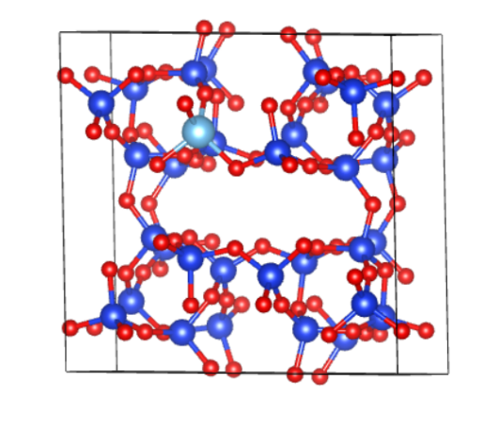
Atom | X/Y/Z coordinate(Angstrom)
Si | 0.165966 | 0.362628 | 0.400137
Si | 0.200482 | 0.390620 | 0.899789
Si | 0.366590 | 0.325270 | 0.593797
Si | 0.133744 | 0.164585 | 0.590060
Si | 0.295310 | 0.108627 | 0.894741
Si | 0.108283 | 0.209726 | 0.086241
Si | 0.340400 | 0.118819 | 0.410167
Si | 0.793979 | 0.393057 | 0.407246
Si | 0.836102 | 0.369671 | 0.899251
Si | 0.891543 | 0.205826 | 0.586756
Si | 0.611293 | 0.297163 | 0.592141
Si | 0.868886 | 0.167867 | 0.089276
Si | 0.665952 | 0.139968 | 0.902823
Si | 0.635959 | 0.348592 | 0.095616
Si | 0.710390 | 0.111407 | 0.399662
Si | 0.288576 | 0.882891 | 0.413811
Si | 0.327042 | 0.864631 | 0.906786
Si | 0.388479 | 0.698321 | 0.597534
Si | 0.108277 | 0.792817 | 0.600622
Si | 0.366737 | 0.663128 | 0.096993
Si | 0.167733 | 0.632514 | 0.905353
Si | 0.129315 | 0.835679 | 0.104462
Si | 0.210703 | 0.604644 | 0.407746
Si | 0.663056 | 0.870478 | 0.408906
Si | 0.702685 | 0.894385 | 0.913649
Si | 0.865138 | 0.832795 | 0.601709
Si | 0.633435 | 0.671828 | 0.598514
Si | 0.888746 | 0.792325 | 0.099409
Si | 0.795968 | 0.613547 | 0.904240
Si | 0.607668 | 0.712982 | 0.096057
Si | 0.836892 | 0.632913 | 0.405177
Ti | 0.397851 | 0.290615 | 0.101143
O | 0.288665 | 0.375914 | 0.744421
O | 0.381879 | 0.187187 | 0.576169
O | 0.276903 | 0.387507 | 0.067728
O | 0.369367 | 0.991473 | 0.887299
O | 0.388659 | 0.207260 | 0.907011
O | 0.396531 | 0.178259 | 0.253444
O | 0.201588 | 0.119620 | 0.422745
O | 0.121051 | 0.302313 | 0.568457
O | 0.108877 | 0.291397 | 0.923296
O | 0.114271 | 0.293024 | 0.246952
O | 0.204447 | 0.117639 | 0.745668
O | 0.000582 | 0.128360 | 0.097353
O | 0.373985 | 0.986216 | 0.409293
O | 0.305276 | 0.360788 | 0.417889
O | 0.217652 | 0.123598 | 0.064409
O | 0.004764 | 0.126417 | 0.597576
O | 0.881075 | 0.294135 | 0.742536
O | 0.792303 | 0.114552 | 0.563000
O | 0.878420 | 0.305210 | 0.066862
O | 0.627360 | 0.010574 | 0.901489
O | 0.803809 | 0.126399 | 0.921771
O | 0.794596 | 0.119852 | 0.240339
O | 0.620723 | 0.217930 | 0.423376
O | 0.709751 | 0.389888 | 0.571311
O | 0.698547 | 0.384893 | 0.924049
O | 0.710638 | 0.388553 | 0.250058
O | 0.623036 | 0.209754 | 0.744323
O | 0.507878 | 0.396082 | 0.114721
O | 0.630261 | 0.003051 | 0.392120
O | 0.883716 | 0.286324 | 0.423307
O | 0.618444 | 0.211024 | 0.067926
O | 0.493388 | 0.369808 | 0.605803
O | 0.373033 | 0.786400 | 0.752865
O | 0.292089 | 0.603778 | 0.572461
O | 0.368733 | 0.801238 | 0.075354
O | 0.124347 | 0.505846 | 0.884803
O | 0.305417 | 0.616121 | 0.928706
O | 0.296186 | 0.612517 | 0.249911
O | 0.119242 | 0.709805 | 0.434861
O | 0.207414 | 0.884157 | 0.580154
O | 0.189781 | 0.882303 | 0.936521
O | 0.200054 | 0.881413 | 0.261039
O | 0.122624 | 0.708282 | 0.754443
O | 0.996945 | 0.871776 | 0.118955
O | 0.132779 | 0.495236 | 0.393330
O | 0.377488 | 0.775576 | 0.431223
O | 0.125108 | 0.697988 | 0.076573
O | 0.994003 | 0.871204 | 0.614921
O | 0.789414 | 0.880222 | 0.756807
O | 0.881070 | 0.695238 | 0.574384
O | 0.783648 | 0.884169 | 0.078141
O | 0.873870 | 0.498853 | 0.888080
O | 0.887838 | 0.712571 | 0.929913
O | 0.882616 | 0.702693 | 0.249468
O | 0.699092 | 0.628154 | 0.428444
O | 0.616641 | 0.809525 | 0.576519
O | 0.609691 | 0.796378 | 0.934815
O | 0.614809 | 0.798212 | 0.255061
O | 0.70872 | 0.627346 | 0.751356
O | 0.500011 | 0.632671 | 0.107531
O | 0.874485 | 0.500879 | 0.396796
O | 0.800853 | 0.874278 | 0.433459
O | 0.713772 | 0.62252 | 0.069786
O | 0.506641 | 0.627302 | 0.610750

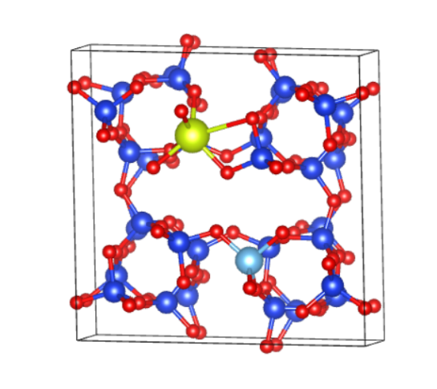
Atom | X/Y/Z coordinate(Angstrom)
Si | 0.168804 | 0.354232 | 0.400805
Si | 0.198909 | 0.391799 | 0.892807
Si | 0.367883 | 0.316376 | 0.596440
Si | 0.136707 | 0.155296 | 0.587061
Si | 0.296171 | 0.102811 | 0.891660
Si | 0.110902 | 0.209065 | 0.079359
Si | 0.345523 | 0.100841 | 0.422543
Si | 0.800531 | 0.399202 | 0.410960
Si | 0.846277 | 0.373787 | 0.894156
Si | 0.898165 | 0.210338 | 0.581911
Si | 0.614060 | 0.302084 | 0.588860
Si | 0.872672 | 0.173872 | 0.085685
Si | 0.668162 | 0.148634 | 0.900712
Si | 0.648236 | 0.360805 | 0.092980
Si | 0.713518 | 0.120801 | 0.396468
Si | 0.285073 | 0.871413 | 0.421301
Si | 0.324258 | 0.857640 | 0.910126
Si | 0.385946 | 0.692387 | 0.600138
Si | 0.101113 | 0.787300 | 0.600924
Si | 0.354791 | 0.655941 | 0.096933
Si | 0.155545 | 0.629796 | 0.904196
Si | 0.124965 | 0.830411 | 0.108721
Si | 0.206684 | 0.598706 | 0.413576
Si | 0.659874 | 0.883362 | 0.420074
Si | 0.702277 | 0.902445 | 0.910995
Si | 0.862947 | 0.841272 | 0.601390
Si | 0.632491 | 0.679199 | 0.599065
Si | 0.884654 | 0.795447 | 0.099429
Si | 0.797643 | 0.614748 | 0.898155
Si | 0.832930 | 0.640583 | 0.406633
Ti | 0.597133 | 0.715242 | 0.098031
Ce | 0.406278 | 0.288006 | 0.130182
O | 0.286611 | 0.374680 | 0.735750
O | 0.383864 | 0.179790 | 0.579881
O | 0.273429 | 0.399665 | 0.057600
O | 0.365820 | 0.983149 | 0.890525
O | 0.385863 | 0.200237 | 0.898318
O | 0.408674 | 0.138930 | 0.260611
O | 0.206584 | 0.109085 | 0.423025
O | 0.126063 | 0.292230 | 0.565491
O | 0.111764 | 0.289943 | 0.918172
O | 0.119993 | 0.289482 | 0.242747
O | 0.202111 | 0.107627 | 0.745641
O | 0.002846 | 0.129648 | 0.091662
O | 0.373340 | 0.969286 | 0.442879
O | 0.309647 | 0.345388 | 0.411688
O | 0.220877 | 0.124235 | 0.063254
O | 0.006270 | 0.124150 | 0.588728
O | 0.890195 | 0.296681 | 0.739104
O | 0.795319 | 0.125510 | 0.558057
O | 0.888456 | 0.309489 | 0.061185
O | 0.629448 | 0.020632 | 0.905316
O | 0.805202 | 0.135023 | 0.919840
O | 0.796873 | 0.128301 | 0.236517
O | 0.623621 | 0.227646 | 0.415693
O | 0.711466 | 0.394024 | 0.568688
O | 0.709319 | 0.387906 | 0.918333
O | 0.727331 | 0.391987 | 0.245620
O | 0.626358 | 0.215066 | 0.739560
O | 0.525526 | 0.413464 | 0.124735
O | 0.631257 | 0.016134 | 0.403922
O | 0.891950 | 0.294047 | 0.423749
O | 0.620545 | 0.224138 | 0.062983
O | 0.491902 | 0.367012 | 0.602458
O | 0.369487 | 0.780713 | 0.754159
O | 0.290751 | 0.598183 | 0.575026
O | 0.369376 | 0.793405 | 0.076385
O | 0.117514 | 0.503314 | 0.870325
O | 0.292313 | 0.617358 | 0.926654
O | 0.283502 | 0.608344 | 0.249155
O | 0.112282 | 0.701048 | 0.438971
O | 0.203110 | 0.872651 | 0.584314
O | 0.187868 | 0.874459 | 0.943091
O | 0.199083 | 0.872273 | 0.265024
O | 0.109714 | 0.706715 | 0.756888
O | 0.993888 | 0.872092 | 0.122494
O | 0.135872 | 0.485820 | 0.405110
O | 0.372624 | 0.763257 | 0.430272
O | 0.113686 | 0.694108 | 0.077220
O | 0.992649 | 0.873615 | 0.609355
O | 0.792628 | 0.892406 | 0.758845
O | 0.875460 | 0.704422 | 0.574633
O | 0.779295 | 0.886690 | 0.078419
O | 0.879791 | 0.502808 | 0.876425
O | 0.884133 | 0.716442 | 0.929558
O | 0.876692 | 0.707748 | 0.249653
O | 0.695157 | 0.638134 | 0.424340
O | 0.617183 | 0.816949 | 0.584007
O | 0.609656 | 0.805156 | 0.917107
O | 0.604516 | 0.817714 | 0.266900
O | 0.709706 | 0.630303 | 0.746636
O | 0.484723 | 0.616572 | 0.105536
O | 0.874391 | 0.510161 | 0.408810
O | 0.797888 | 0.883490 | 0.435687
O | 0.716975 | 0.615362 | 0.063472
O | 0.508468 | 0.629834 | 0.611473

* Corresponding author. Tel: +86-912-3891144; Fax: +86-912-3891144 E-mail address: liguogao2008@163.com

