Synthesis and Cytotoxic Activity Evaluation of Novel Imidazopyridine Carbohydrazide Derivatives

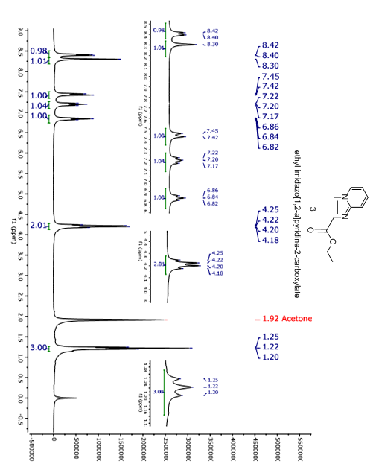
ethyl imidazo[1,2-a]pyridine-2-carboxylate (3)

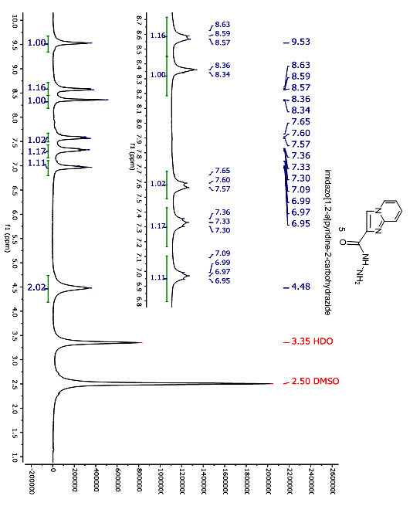

imidazo[1,2-a]pyridine-2-carbohydrazide (5)

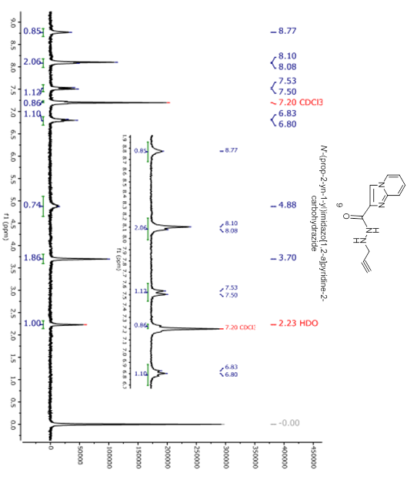
N´-(Prop-2-yn-1-yl)imidazo[1,2-a]pyridine-2-carbohydrazide (9)

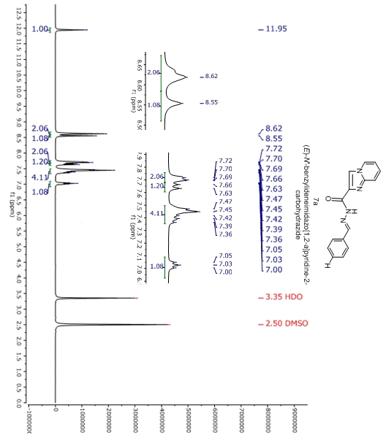
N´-benzylidene imidazo[1,2-a]pyridine-2-carbohydrazide (7a)

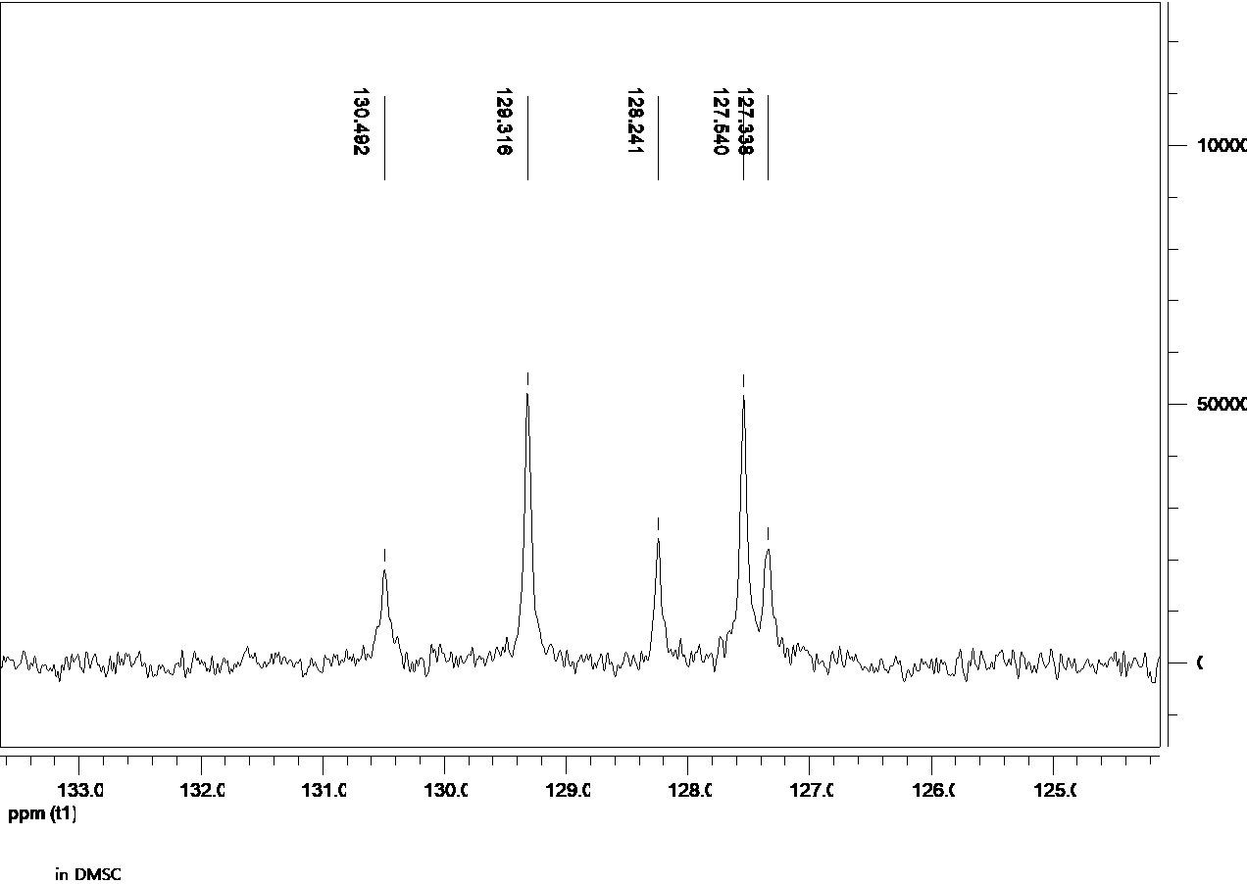

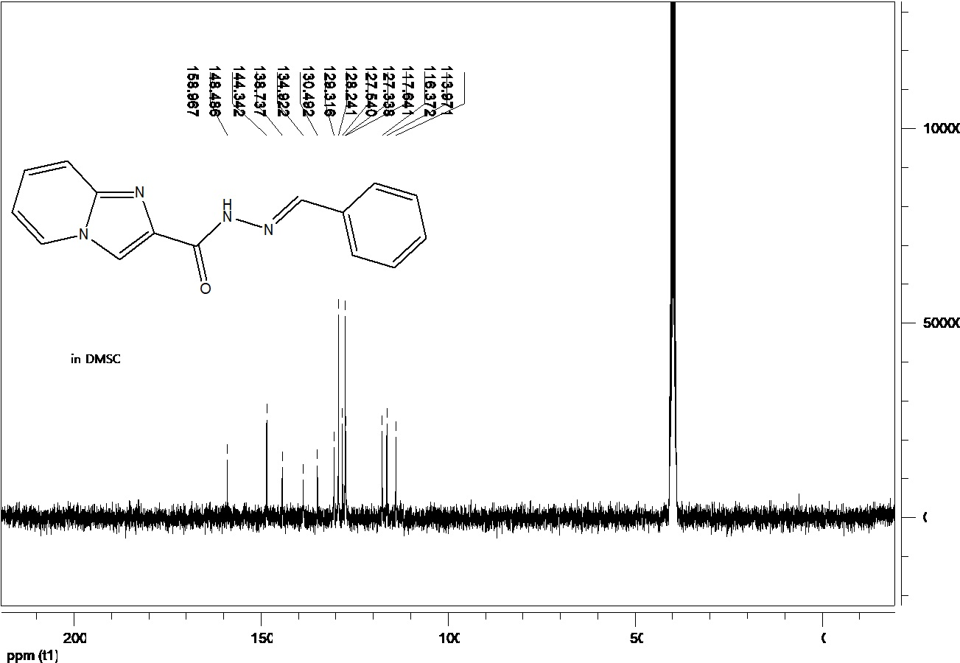
N´-benzylidene imidazo[1,2-a]pyridine-2-carbohydrazide (7a)

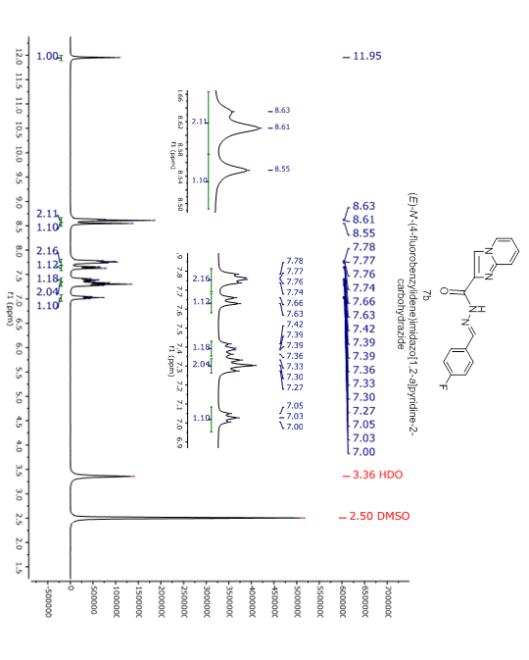
N´-(4-fluorobenzylidene)imidazo[1,2-a]pyridine-2-carbohydrazide (7b)
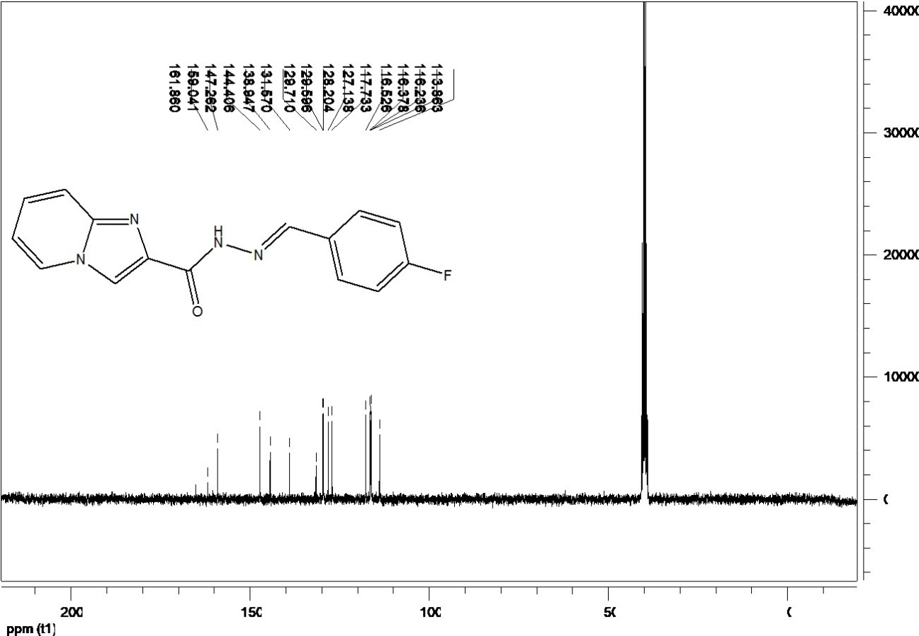
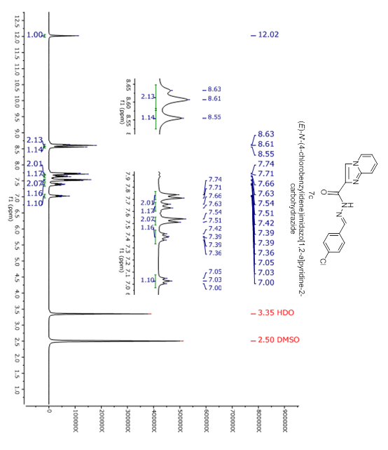
N´-(4-chlorobenzylidene)imidazo[1,2-a]pyridine-2-carbohydrazide (7c)

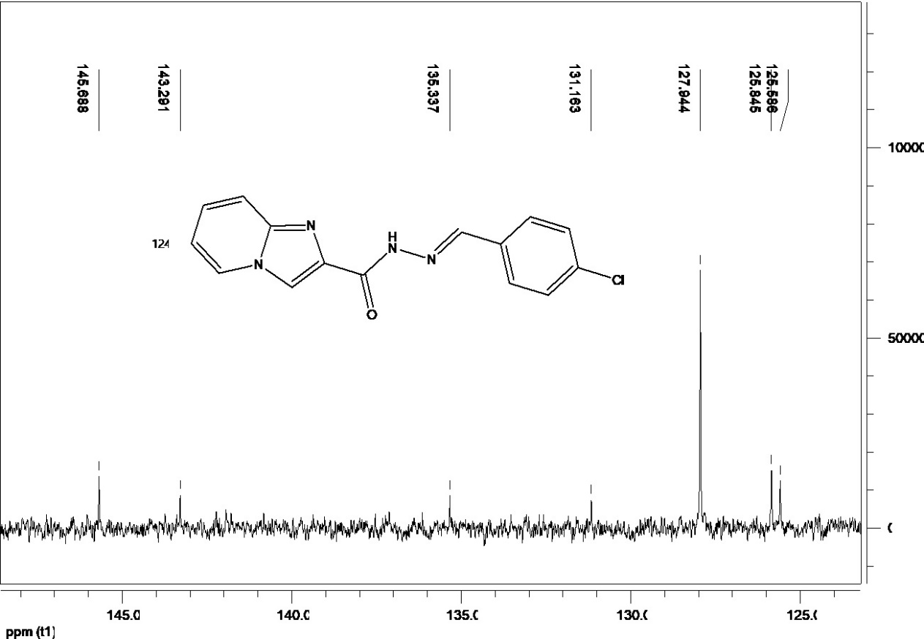

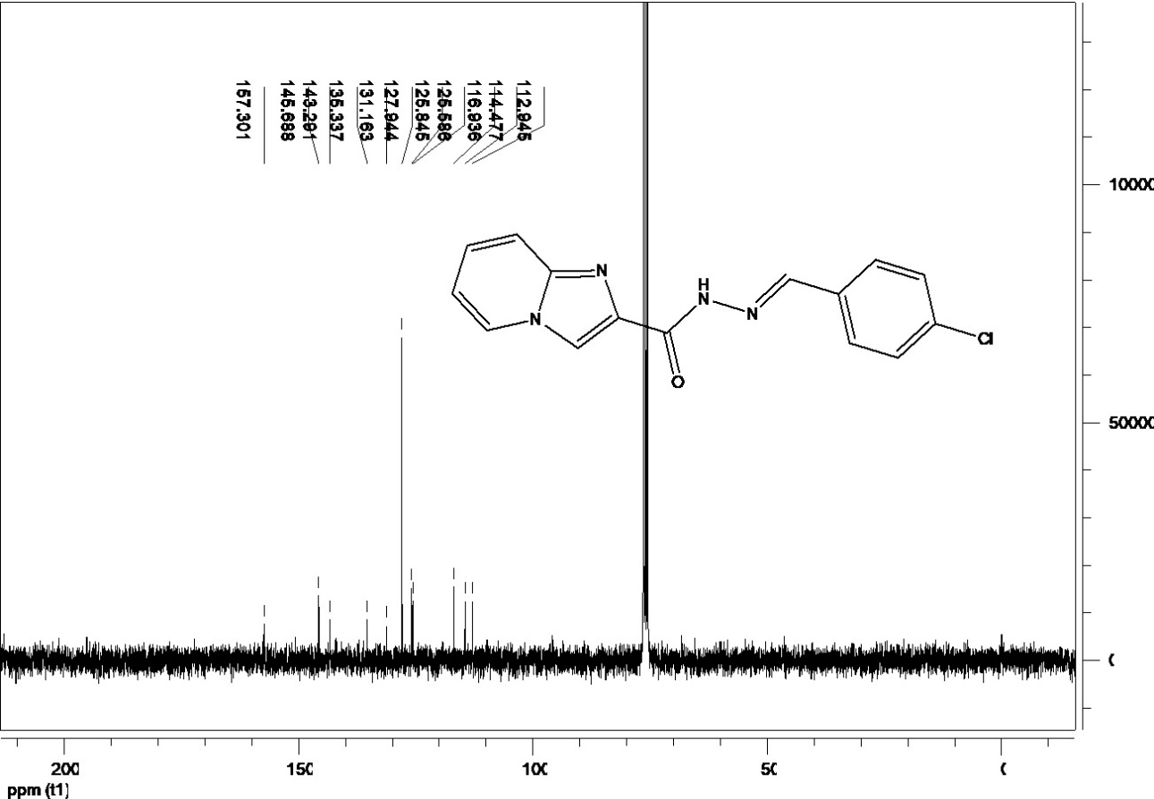
N´-(4-chlorobenzylidene)imidazo[1,2-a]pyridine-2-carbohydrazide (7c)

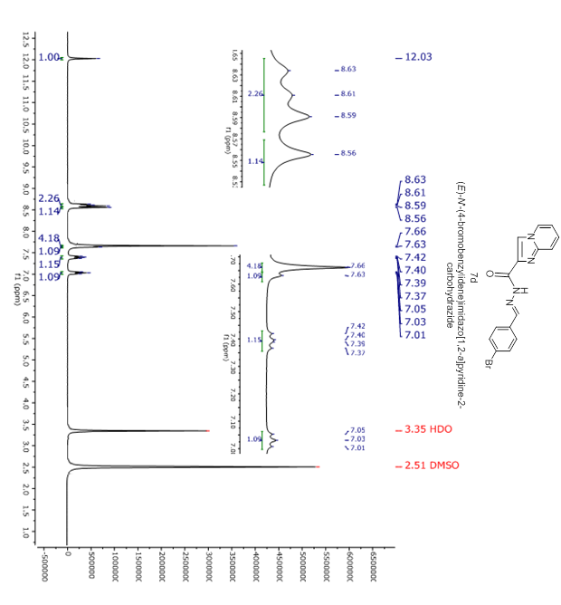
N´-(4-bromobenzylidene)imidazo[1,2-a]pyridine-2-carbohydrazide (7d)

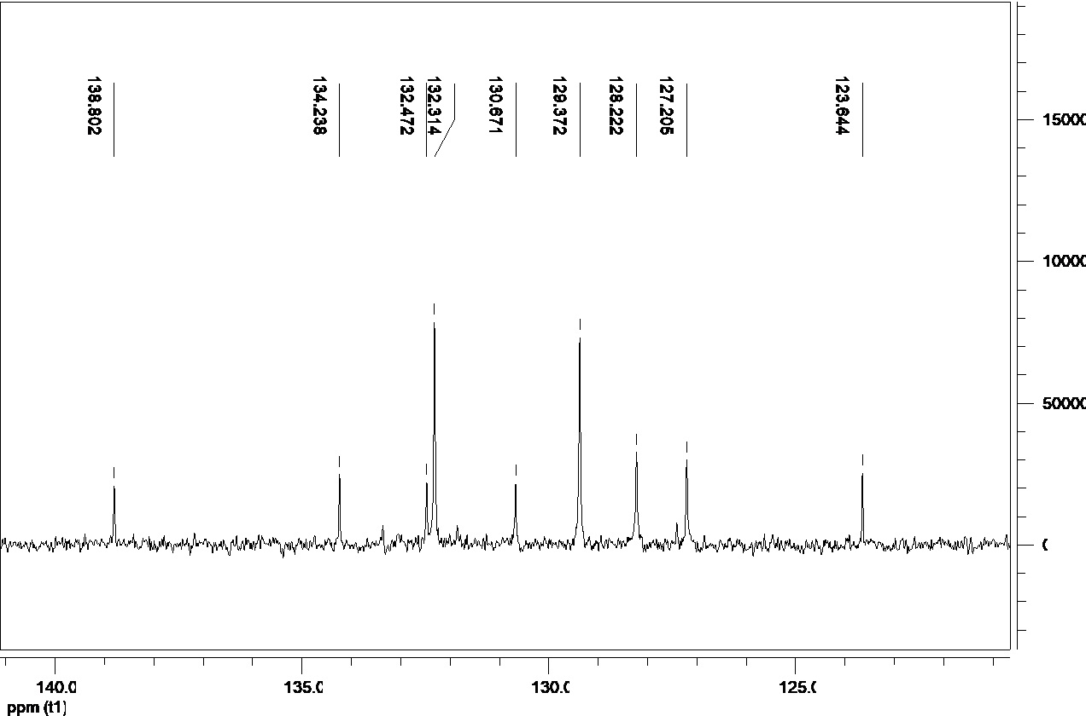

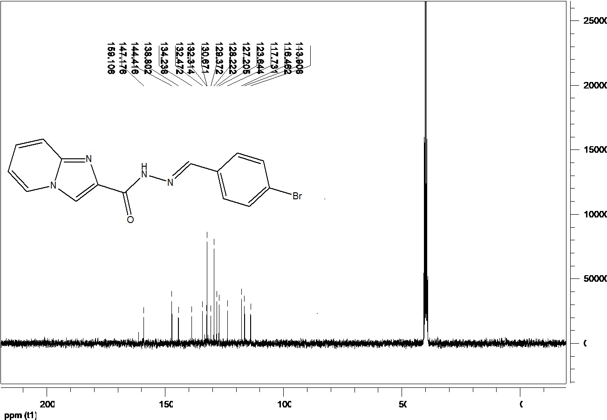
N´-(4-bromobenzylidene)imidazo[1,2-a]pyridine-2-carbohydrazide (7d)

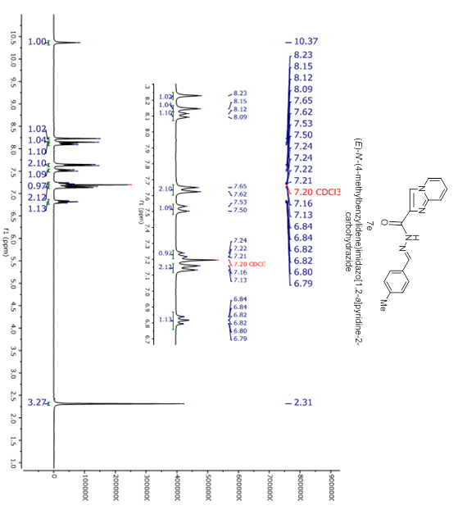
N´-(4-methylbenzylidene)imidazo[1,2-a]pyridine-2-carbohydrazide (7e)

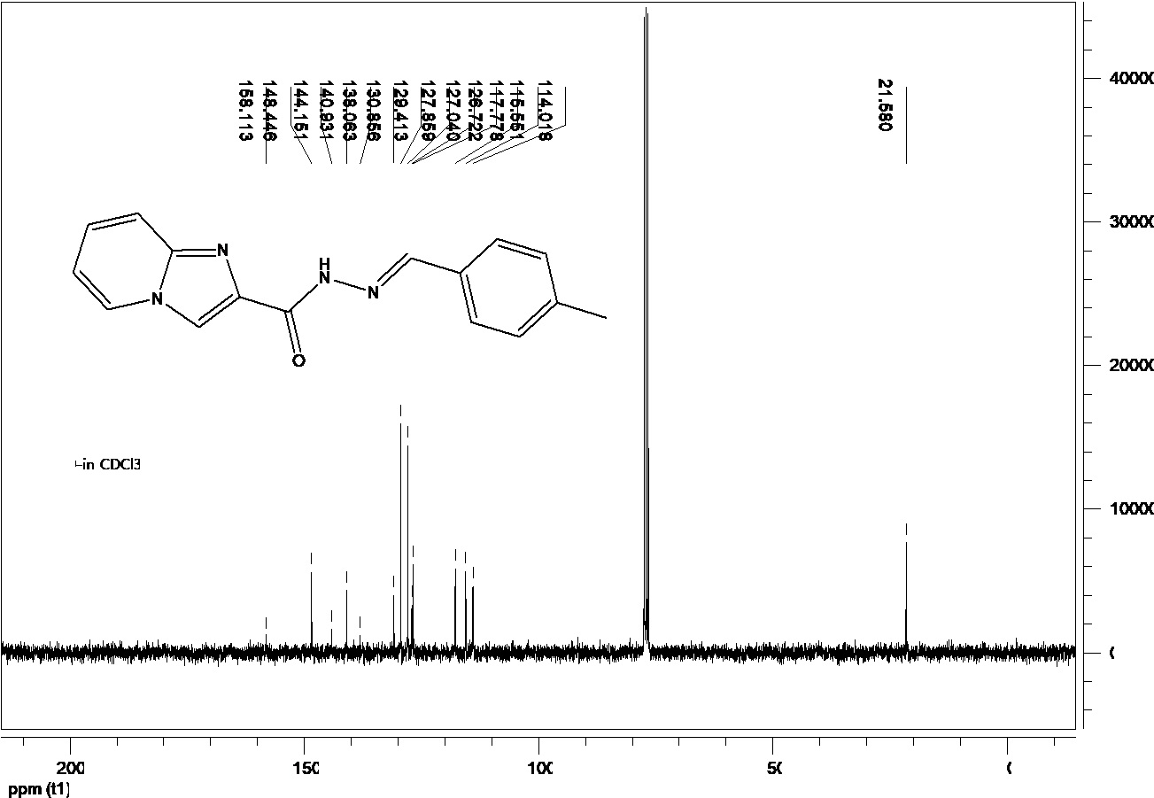
N´-(4-methylbenzylidene)imidazo[1,2-a]pyridine-2-carbohydrazide (7e)

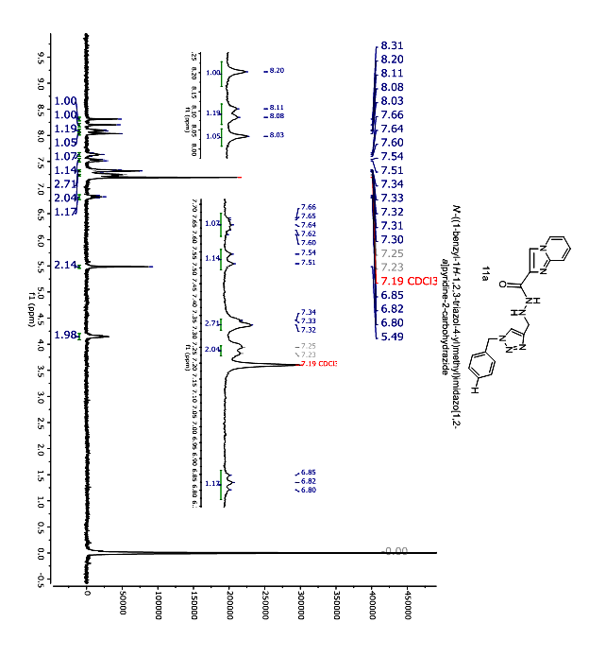
N´-((1-benzyl-1H-1,2,3-triazol-4-yl)methyl)imidazo[1,2-a]pyridine-2-carbohydrazide (11a)

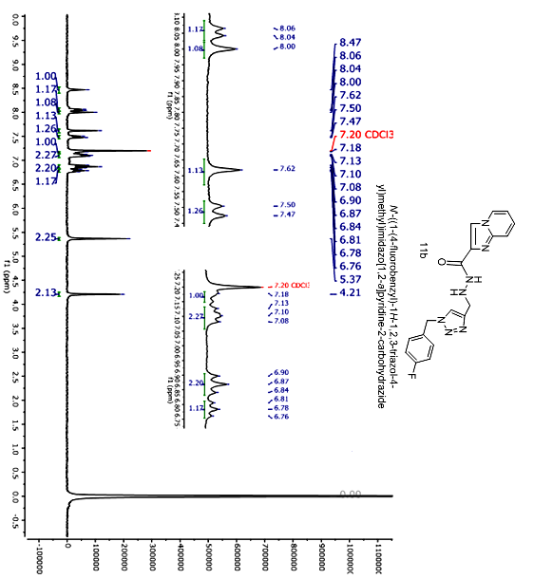
N´-((1-(4-fluorobenzyl)-1H-1,2,3-triazol-4-yl)methyl)imidazo[1,2-a]pyridine-carbohydrazide (11b)

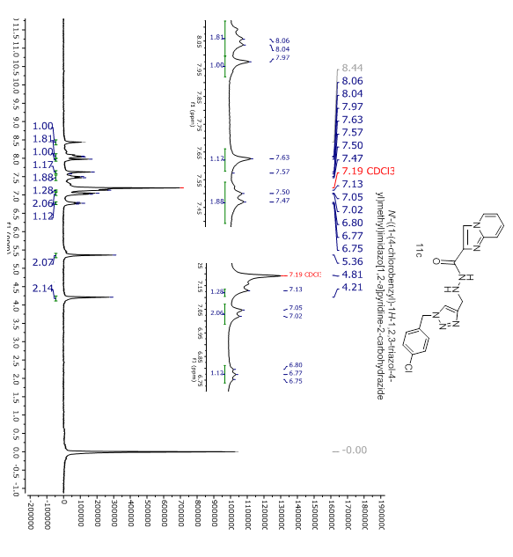
N´-((1-(4-chlorobenzyl)-1H-1,2,3-triazol-4-yl)methyl)imidazo[1,2-a]pyridine-carbohydrazide (11c)

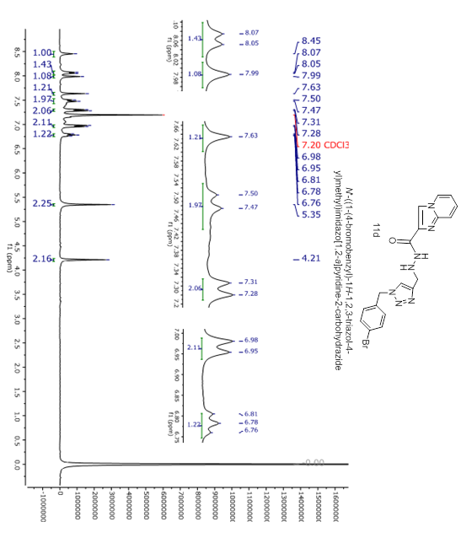
N´-((1-(4-bromobenzyl)-1H-1,2,3-triazol-4-yl)methyl)imidazo[1,2-a]pyridine-carbohydrazide (11d)

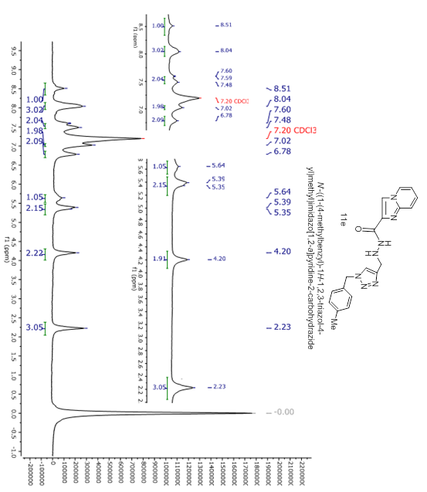
N´-((1-(4-methylbenzyl)-1H-1,2,3-triazol-4-yl)methyl)imidazo[1,2-a]pyridine-carbohydrazide (11e)

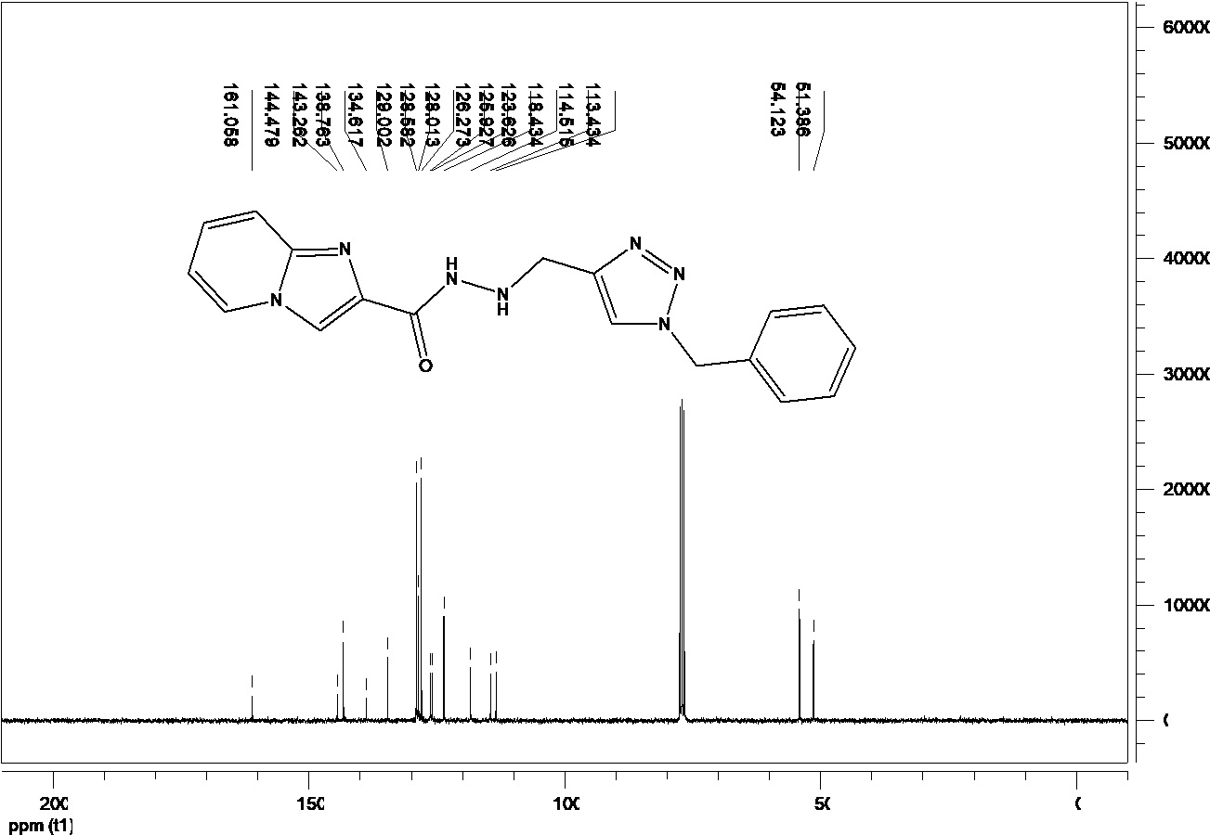
N´-((1-benzyl-1H-1,2,3-triazol-4-yl)methyl)imidazo[1,2-a]pyridine-2-carbohydrazide (11a)

N´-((1-(4-fluorobenzyl)-1H-1,2,3-triazol-4-yl)methyl)imidazo[1,2-a]pyridine-carbohydrazide (11b)

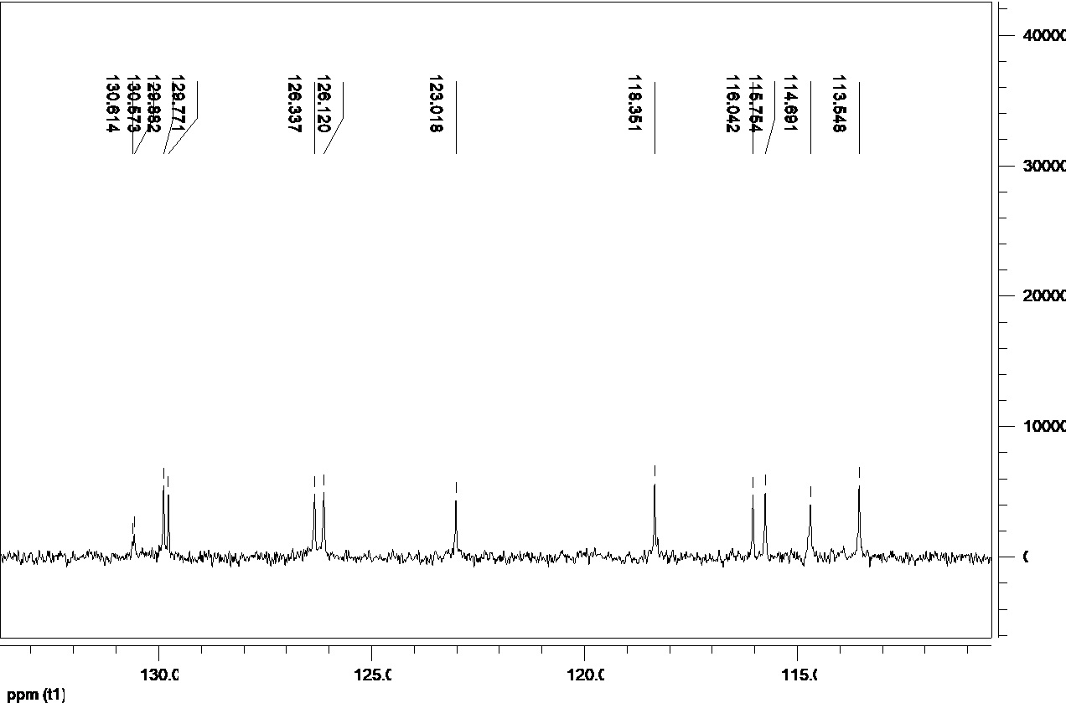

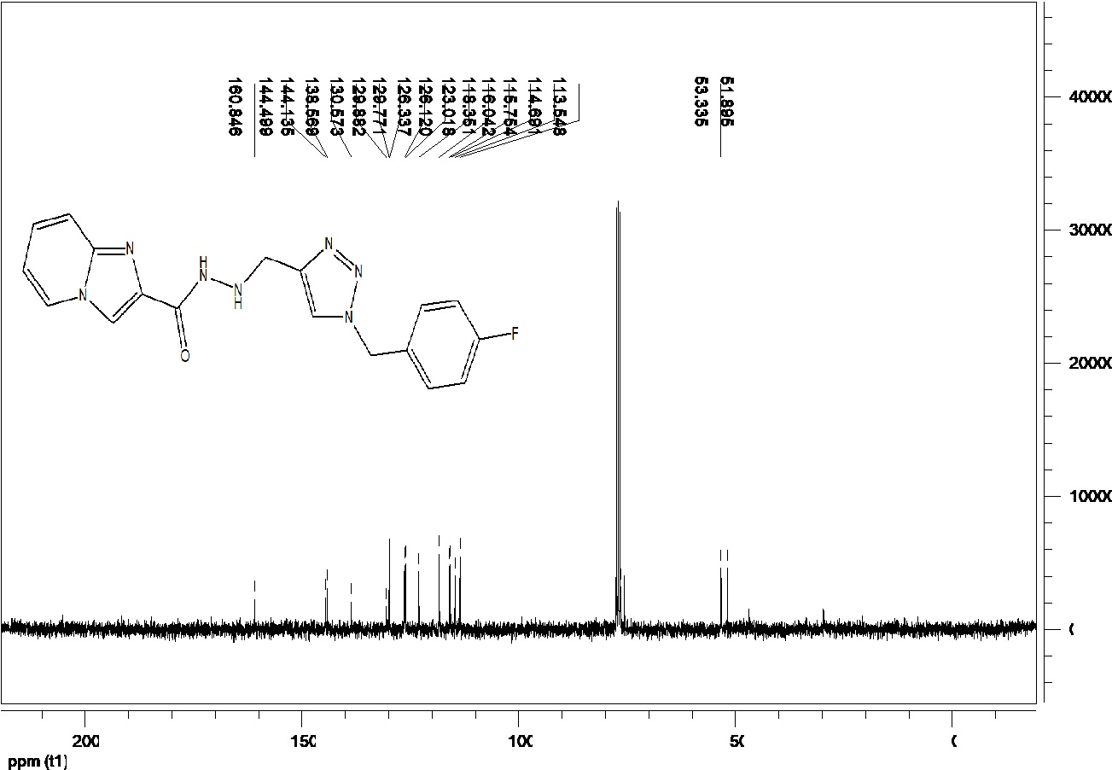
N´-((1-(4-fluorobenzyl)-1H-1,2,3-triazol-4-yl)methyl)imidazo[1,2-a]pyridine-carbohydrazide (11b)

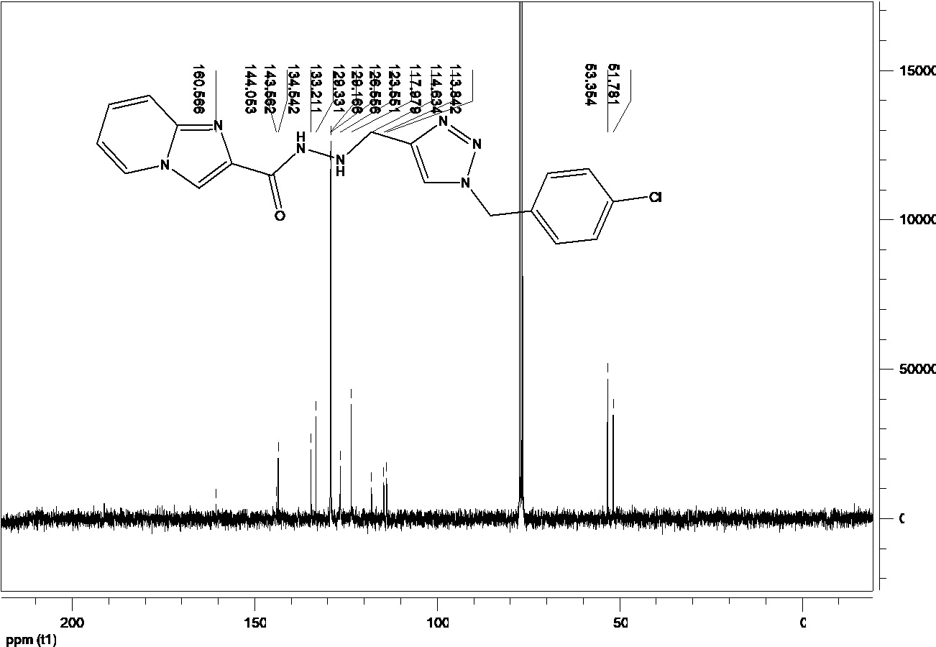
N´-((1-(4-chlorobenzyl)-1H-1,2,3-triazol-4-yl)methyl)imidazo[1,2-a]pyridine-carbohydrazide (11c)

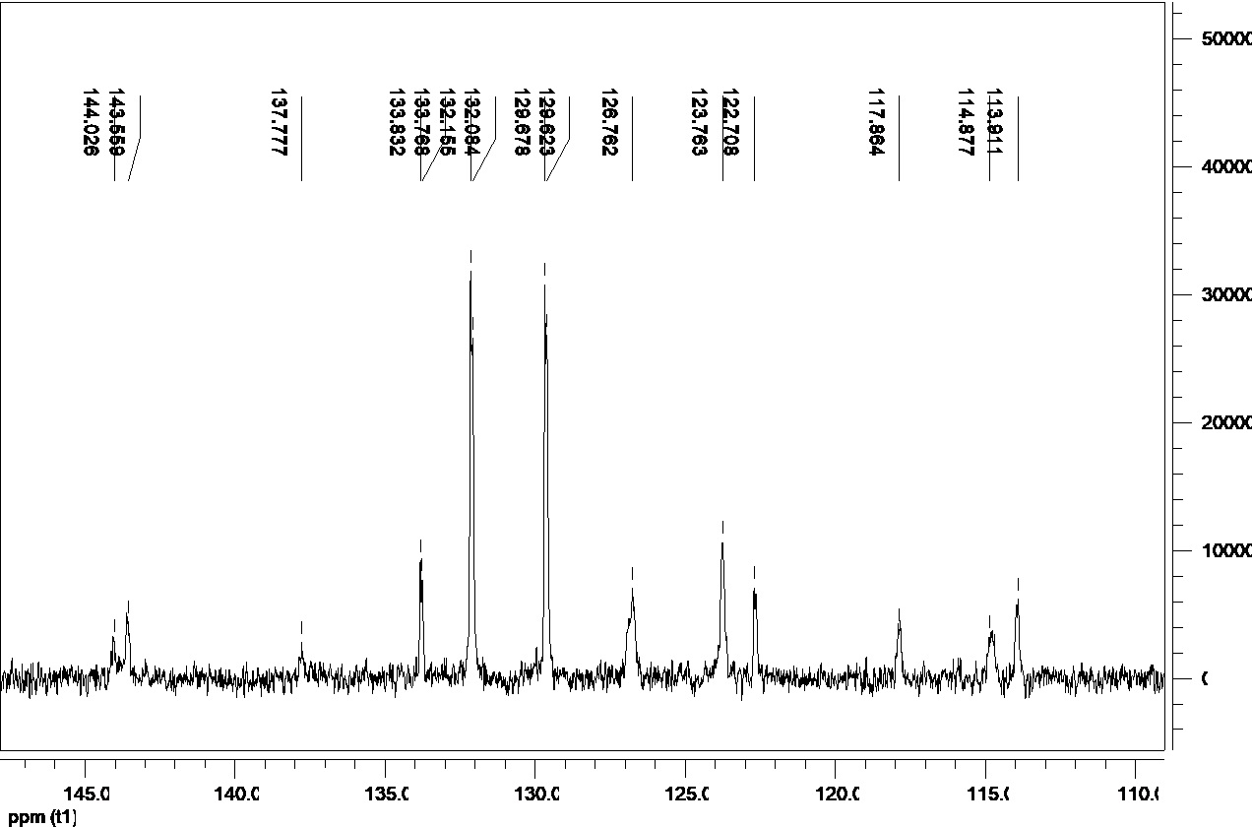

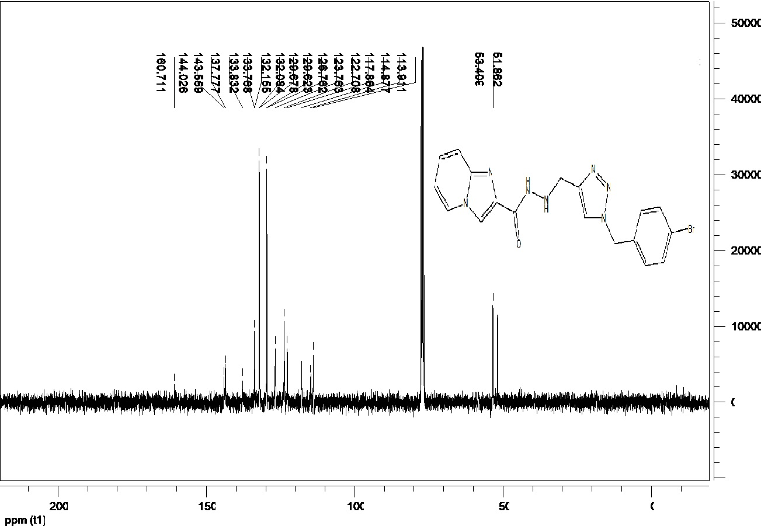
N´-((1-(4-bromobenzyl)-1H-1,2,3-triazol-4-yl)methyl)imidazo[1,2-a]pyridine-carbohydrazide (11d)

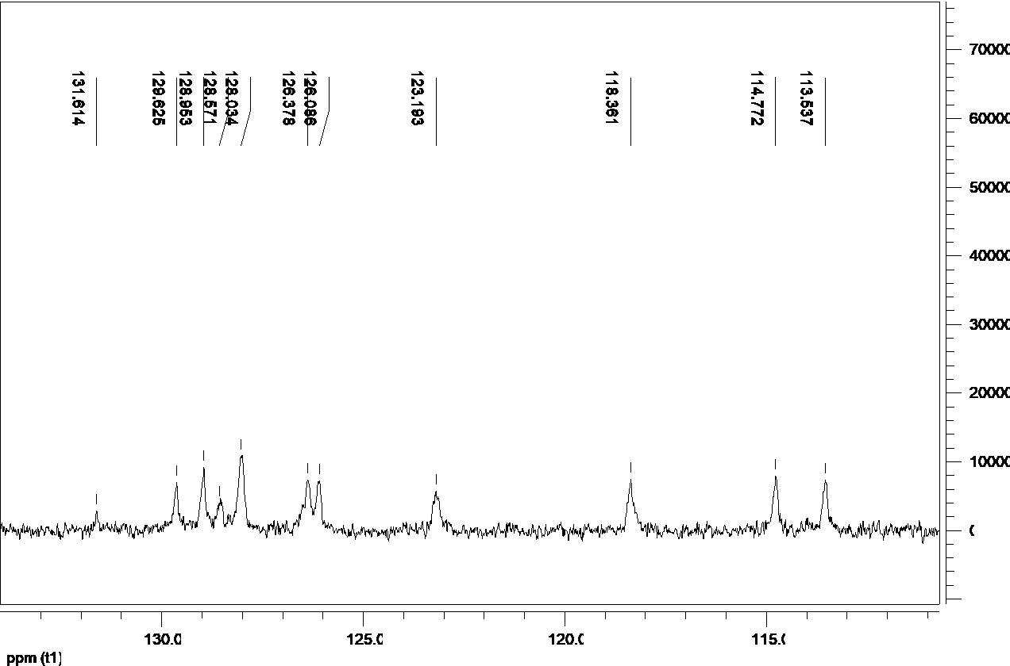
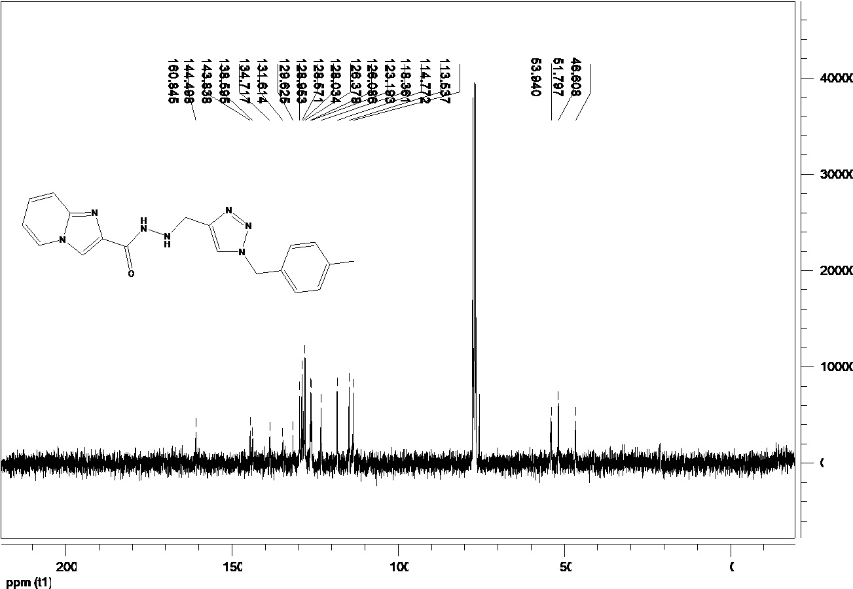
N´-((1-(4-methylbenzyl)-1H-1,2,3-triazol-4-yl)methyl)imidazo[1,2-a]pyridine-carbohydrazide (11e)

