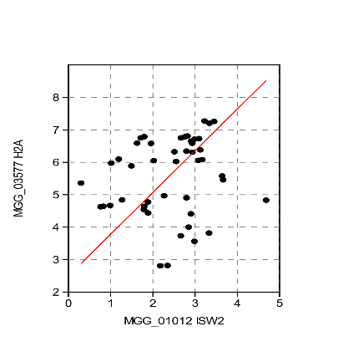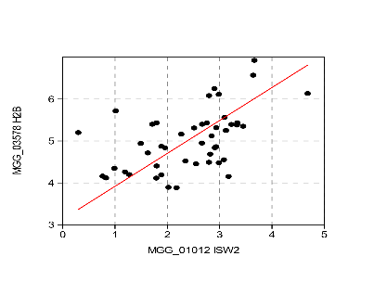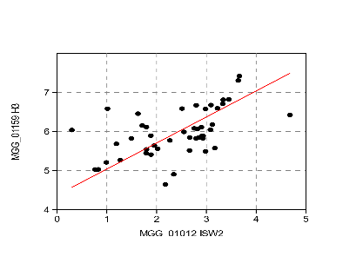
Figure S1. Log2 RMA correlations of a putative MoHIS2a, MoHIS3 and MoHIS2B with expression of MoISW2 (x-axis) in published RNAseq data at different stages of plant infection. (A) MoHIS2a, P(uncorr=0.20 (B) MoHIS3, P(uncorr)=8.94E-5 (C) MoHIS2B, P(uncorr)=3.56E-5.
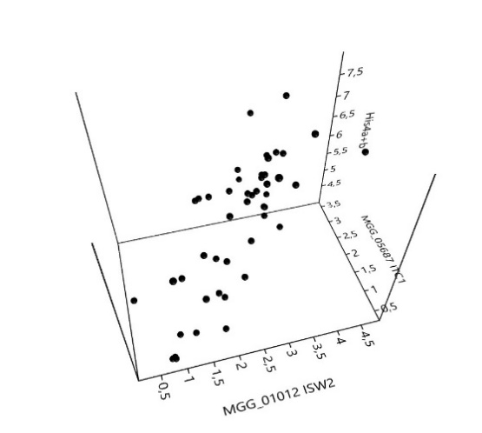
Figure S2. 3D plot showing Log of expression of MoISW2, MoITC1, and MoHIS4a+b that, according to the literature, need to work together to influence nucleosome packing.

Figure S3. Same as Fig. 6 but with 2Log Y-axis to better show that the expression of the DNA binding genes around the MoIsw2 DNA binding site has changed with the DMoisw2 mutation. There are in principle 4 peaks at -300 to 200, -70 to -30, 30 to 100, and 240 to 400. The dotted line shows 3 points moving average to highlight this.

Table S1 Input for Fisher's Exact
 | +8/-8genes from MoISW2 DNA binding |  | Double gene distance MoIsw2 DNA binding
 | Total | Sec met genes | Total | Sec met genes
In selection | 951 | 19 | 1902 | 25
Not in selection | 12233 | 35 | 11282 | 29

