Drumming behavior of a Japanese pygmy woodpecker in Satoyama: Implications of tree felling and human settlement

Supplementary Material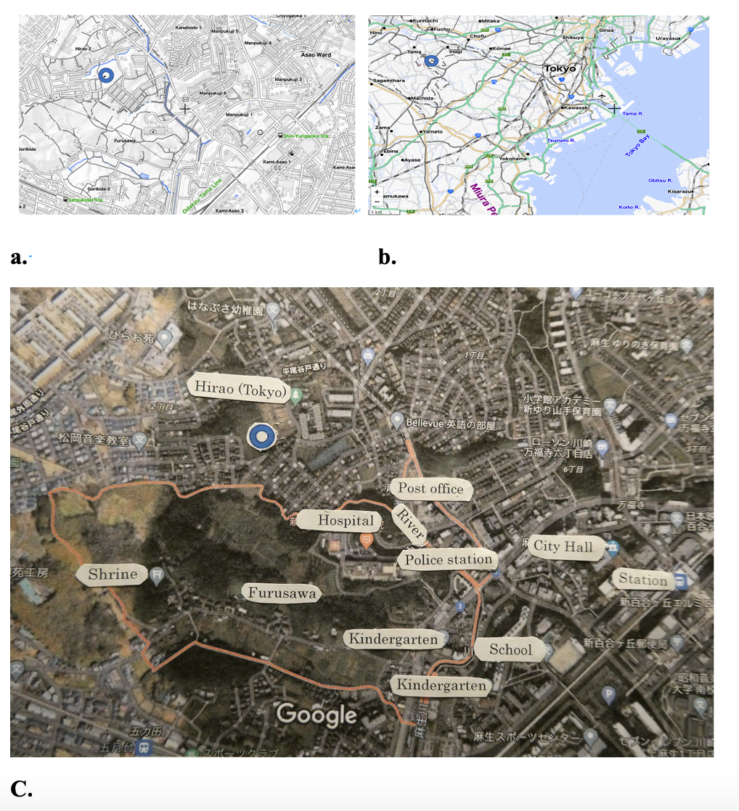

Supplementary Material Figure 1: Research area and observation point (blue circle). A. Roadmap （Source: https://maps.gsi.go.jp/multil/index.html#11/35.528315/139.791412/&base=pale2&ls=pale2%7Chillshademap%2C0.1%7Cchuki_eng&blend=0&disp=111&lcd=chuki_eng&vs=c1), and B. Photographic map (Source: https://www.google.com/maps/place/〒215-0026+神奈川県川崎市麻生区古沢/@35.6037014,139.4880905,2832m/data=!3m2!1e3!4b1!4m5!3m4!1s0x6018fa4f8c6c2101:0x2322945b7d3b9975!8m2!3d35.6033863!4d139.4968256.)

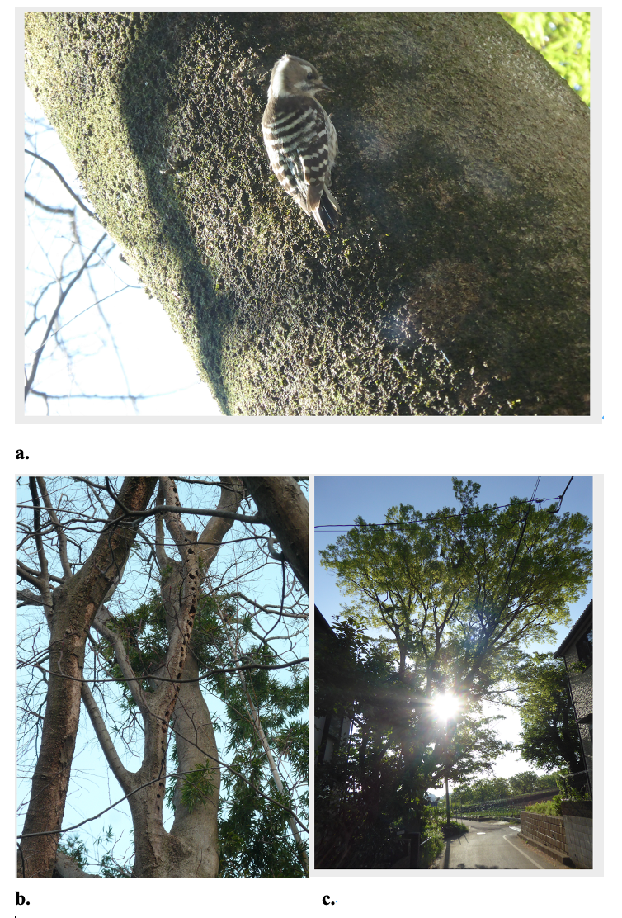

Supplementary Material Figure 2: Pictures of the observation site
A. Japanese pygmy woodpecker (Dendrocopos kizuki), body size 13–15 cm; B. Hackberry tree with holes excavated by woodpeckers;
C. Hackberry tree (left side of the road), which was cut down in 2016, and the cherry tree (right side of the road), which was felled in 2020; pictures were taken on February 15, 2013, March 26, 2015, and May 1, 2015, respectively; picture credit: Setsuko Onoda, Tokyo

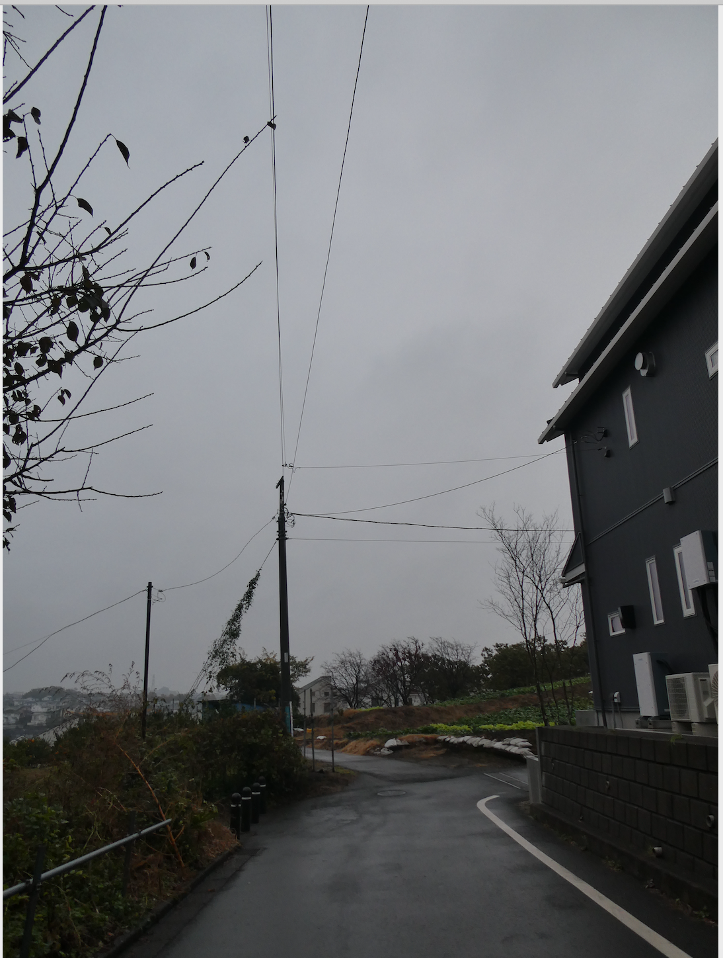
Supplementary Material Figure 3: Picture of landscape after removal of the Hackberry and cherry trees

