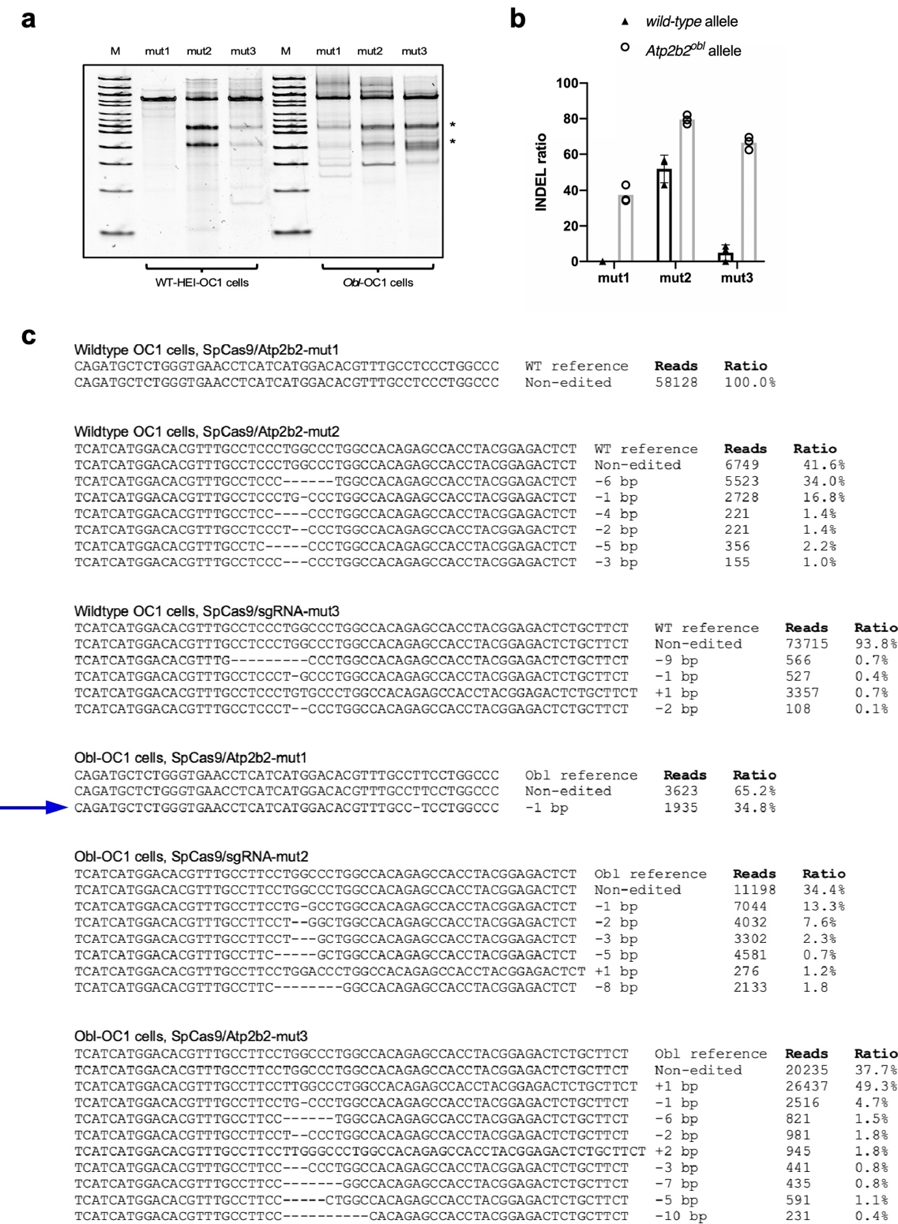
Supplementary Fig. 1.

Allele-selective editing of WT or Obl mutant Atp2b2 gene in OC1 cell line. (a) T7E1 assay of the DNA from the HEI-OC1 and Obl-OC1 cells nucleofected with RNP complexes. The two resulting DNA fragments from cleavage were indicated by asterisks. (b) Distribution of the indels by NGS from the HEI-OC1 and Obl-OC1 cells nucleofected with RNP complexes. Columns and error bars represent the mean ± SD of three or more independent biological replicates. (c) NGS analysis identified indel reads in the WT HEI-OC1 and Obl-OC1 cells nucleofected with three RNP complexes. The arrow points to the major editing event of 1 bp deletion by Atp2b2-Mut1 in the Obl-OC1 cells.

Supplementary Fig. 2
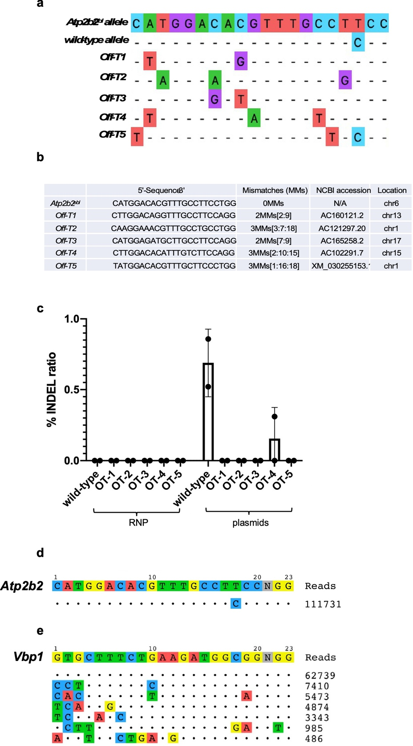

Off-target analysis by computational prediction and GUIDE-seq. (a) WT allele and five off-target sites identified by computational prediction using the CRISPR Design Tool (28). Mismatch positions are indicated counting the PAM as positions 21-23. (b) None of these loci were associated with hearing function. (c) Editing efficiency of predicted off-target loci analyzed by NGS in Obl-OC cells transfected with either RNP or plasmids DNA using a LONZA 4D-Nucleofector. The RNP delivery did not yield any off-target effect whereas the plasmid delivery showed the low-frequency editing at the WT and OT-4 loci. (d) Editing efficiency of predicted off-target loci analyzed by GUIDE-seq in Obl-OC cells transfected with Cas9;Atp2b2-mut1 RNP. Consistent with NGS analysis of computationally predicted sites, no off-target loci were observed by GUIDE-seq method. (E) QUIDE-seq study on control gene Vbp1 in Obl-OC1 cells by RNP delivery of Cas9:Vbp1-gRNA identified multiple off-targets with varying frequencies shown by NGS. Mismatches compared to the on-target site are shown and highlighted in color.

Supplementary Fig. 3

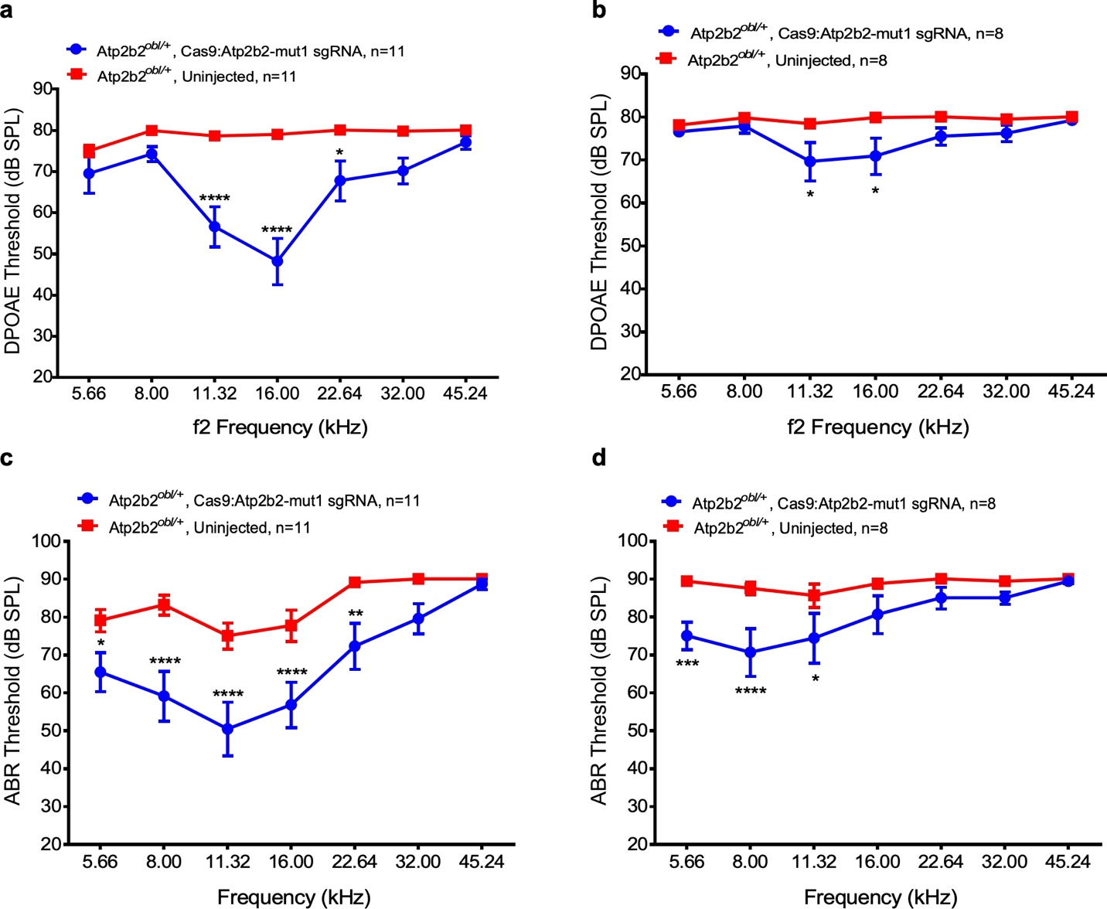

Long term rescue of OHC function and hearing by in vivo lipid mediated delivery of Cas9:sgRNA. Significantly reduced DPOAE thresholds in Atp2b2^{Obl/+} ears injected with Cas9:Atp2b2-mut1:Lipo2000 (blue) and uninjected Atp2b2^{Obl/+}ears (red) at (a) 8 weeks, (b) 16 weeks after the injection. Significantly reduced ABR thresholds in Atp2b2^{Obl/+}ears injected with Cas9:Atp2b2-mut1 sgRNA:Lipo2000 (blue) and uninjected Atp2b2^{Obl/+} ears (red) at (c) 8 weeks, (d) 16 weeks after the injection. Statistical tests were two-way ANOVA with Bonferroni correction for multiple comparisons: **p < 0.01, ***p < 0.001, and ****p < 0.0001. Values and error bars reflect mean ± SEM.

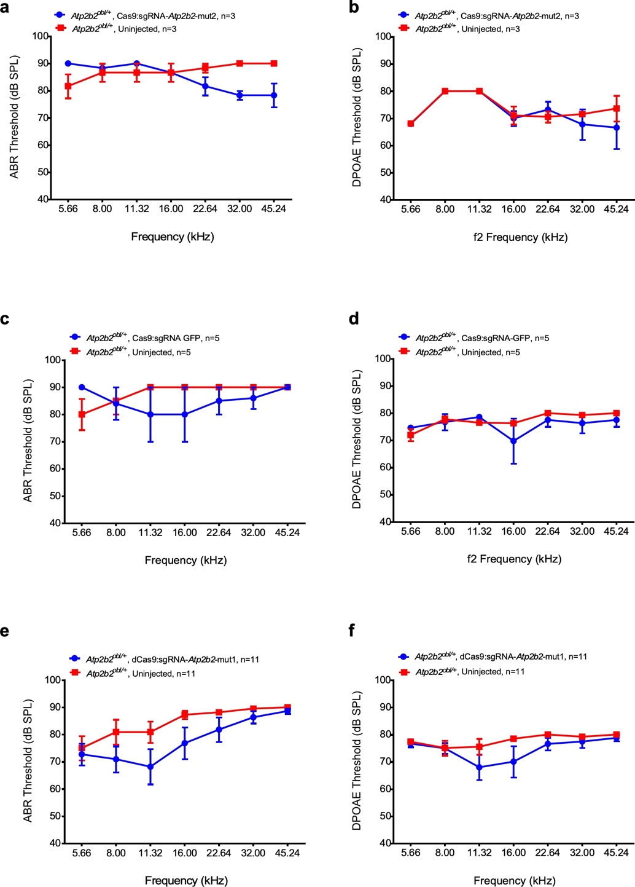
Supplementary Fig. 4

Hearing rescue is gRNA and Obl allele specific and depends on Cas9 DNA cleavage activity. (a) ABR and (b) DPOAE thresholds in Atp2b2^{Obl/+}ears injected with Cas9:Atp2b2-mut2 sgRNA:Lipo2000 (blue) and uninjected Atp2b2^{Obl/+}ears (red) at four weeks. (c) ABR and (d) DPOAE thresholds in Atp2b2^{Obl/+} ears injected with Cas9:GFP-sgRNA:Lipo2000 (blue) and uninjected Atp2b2^{Obl/+} ears (red) at four weeks. (e) ABR and (f) DPOAE thresholds in Atp2b2^{Obl/+} ears injected with dCas9:Atp2b2-mut1 sgRNA:Lipo2000 (blue) and uninjected Atp2b2^{Obl/+}ears (red) at four weeks.

Supplementary Fig. 5
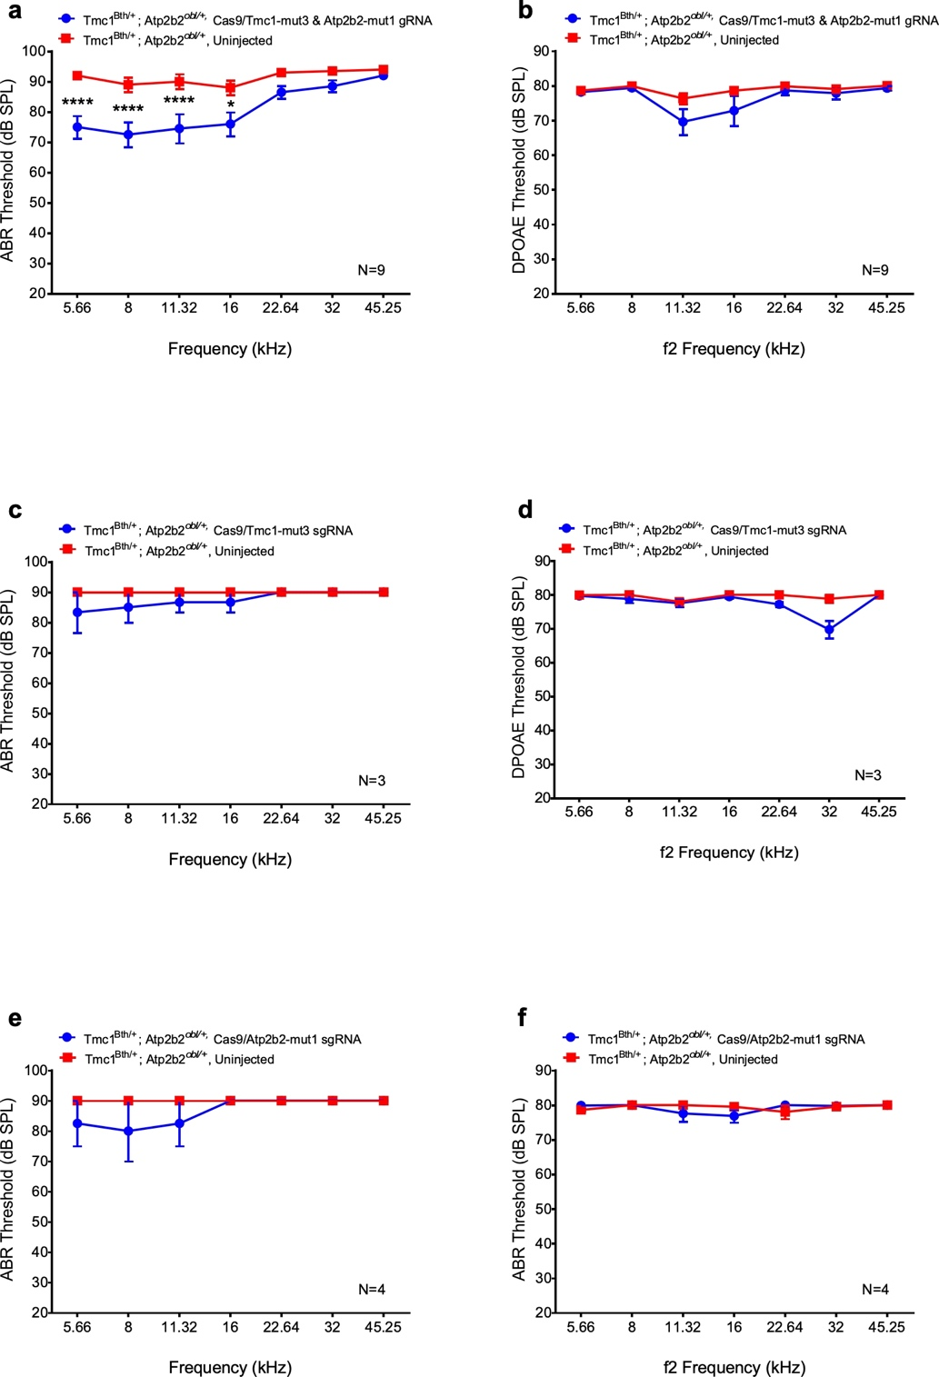

In vivo gene editing partially rescues hearing of digenic mutation origin. (a) ABR and (b) DPOAE thresholds in Atp2b2^{Obl/}:Tmc1^{Bth/+} ears injected with Cas9:Atp2b2-mut1:Tmc1-mut3:Lipo2000 (blue) and uninjected Atp2b2^{Obl/}:Tmc1^{Bth/+} ears (red) at four weeks post injection. (c) ABR and (d) DPOAE thresholds in Atp2b2^{Obl/}:Tmc1^{Bth/+} ars injected with Cas9:Tmc1-mut3:Lipo2000 (blue) and uninjected Atp2b2^{Obl/}:Tmc1^{Bth/+} ears (red) at four weeks. (e) ABR and (F) DPOAE thresholds in Atp2b2^{Obl/}:Tmc1^{Bth/+}ears injected with Cas9:Atp2b2-mut1 sgRNA:Lipo2000 (blue) and uninjected Atp2b2^{Obl/}:Tmc1^{Bth/+}ears (red) at four weeks post injection. **p < 0.01, ***p < 0.001, and ****p < 0.0001. Values and error bars reflect mean ± SEM.

