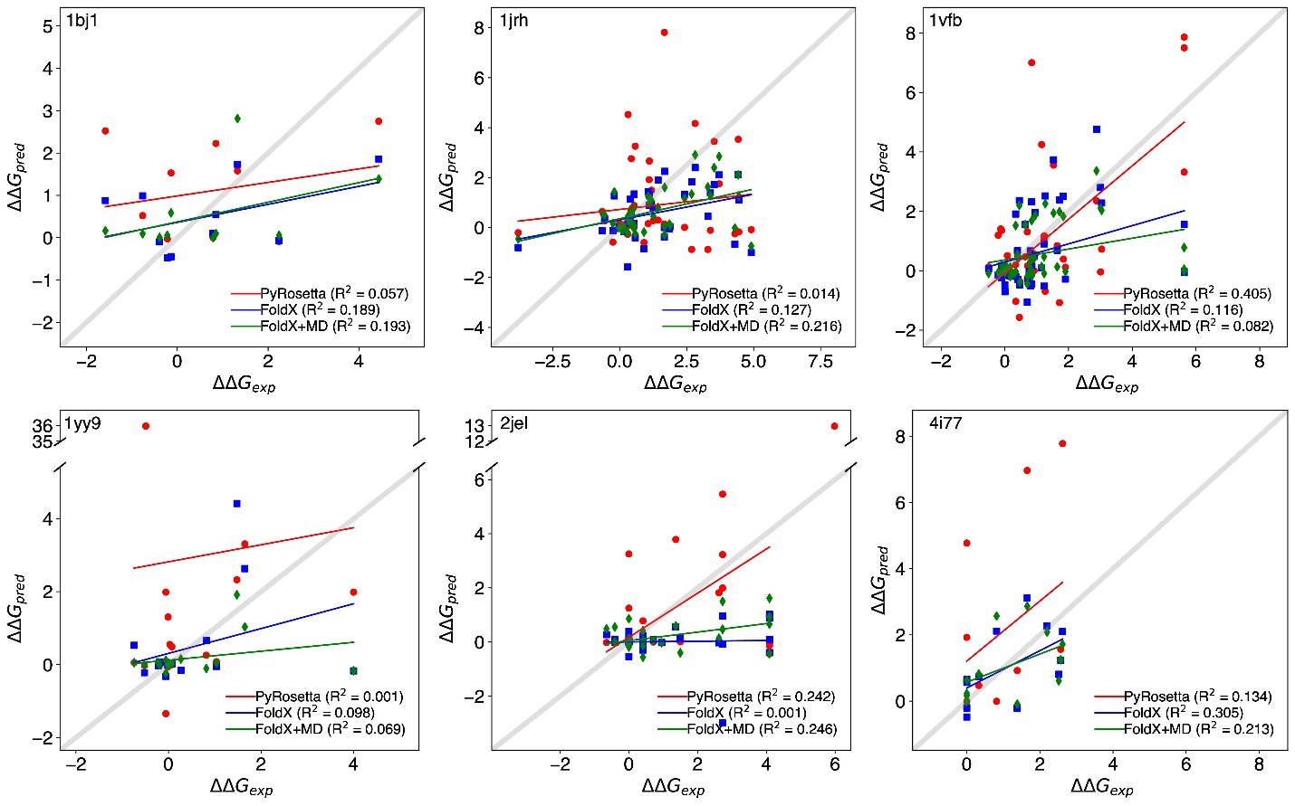
Supplemental Figure S1 – Comparison between FoldX and Rosetta binding affinity predictions for six test systems. The horizontal axis is the experimental data and vertical axis the predicted free energy values. Red indicates Rosetta results, Blue indicates FoldX results, and Green is MD+FoldX results. The grey line is the 1:1 line, if the given methods could predict with perfect accuracy their predictions would fall on this line.

