Supplementary Information

Cost-effective screen-printed carbon electrode biosensors for rapid detection of Microcystin-LR in surface waters for early warning of harmful algal blooms

Stephanie Stoll¹, Jae-Hoon Hwang¹, David W. Fox², Keugtae Kim³, Lei Zhai², Woo Hyoung Lee^{1,}*

¹Department of Civil, Environmental, and Construction Engineering, University of Central Florida, Orlando, FL, 32816, USA
²Nanoscience Technology Center and Department of Chemistry, University of Central Florida, Orlando, FL, 32816, USA
³Department of Environmental and Energy Engineering, The University of Suwon, 17 Wauan-gil, Bongdam-eup, Hwaseong-si, Gyeonggi-do, 18323, South Korea

*Corresponding Author; E-mail: WooHyoung.Lee@ucf.edu

S.1. Materials and Methods

S.1.1. ELISA Procedures
EPA method 546 (Steven C. Wendelken 2016), enzyme-linked immunosorbent assay (ELISA), was used as the accepted accurate standard method to validate the accuracy of the developed biosensor. The Abnova™ Microcystin-LR ELISA Kit was used following the procedures. All materials are removed from the fridge and allowed to warm to room temperature, approximately 2 hours. The wash buffer solution is prepared by diluting the provided buffer solution by 10 times. The desired amount of antibody coated strips was removed from the aluminum pouch, leaving the remaining inside and the pouch was resealed. The wells were rinsed three times with the wash buffer solution, avoiding cross-contamination between the wells. The wells were inverted and tapped on a paper towel to remove any remaining drops. Then 40 μL of the dilution buffer was pipetted into each of the wells being used and then 40 μL of the desired standard or sample was pipetted into the wells. Doubles of each was conducted to reduce errors. The wells were then incubated for 45 minutes at room temperature. Then 20 μL of MC-LR labeled with horseradish (Px-conjugate) was pipetted into each well, this caused the solution to turn a deep blue. The wells are placed on a plate and a shaker was used at 240 rpm for 15 minutes at room temperature. The solution in the wells was dumped into a collection bottle and the wells were rinsed five time with the wash buffer. The wells were again inverted onto a paper towel to remove any remaining liquid. 100 μL of chromogenic substrate (TMB) was added to each of the wells, this solution has a blue tint. The plate was covered with aluminum foil and incubated at room temperature for 20 minutes. The solution was then bright blue. 100 μL of the stop solution was added to each of the wells, the plate was gentle tapped and swirled to ensure complete mixing. The absorbance of the wells was conducted at 450 nm using a microplate reader. A standard curve of the absorbance was developed using the provided stock solutions, concentrations of 0–2.5 μg L⁻¹.

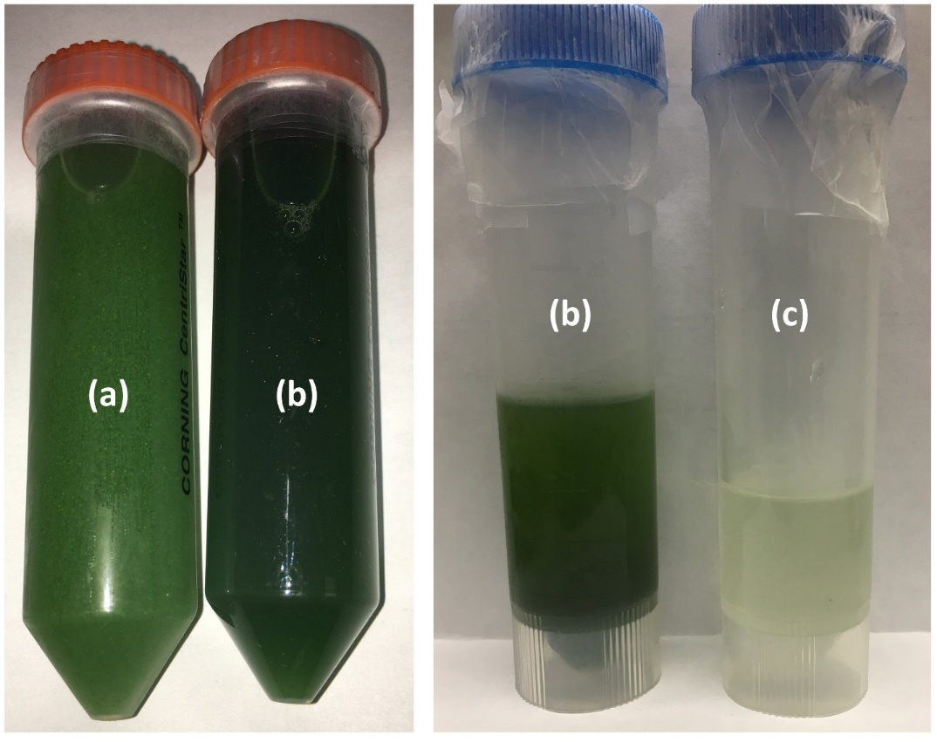

Figure S1. Real surface water sample (a) initial sample; (b) sample after sonication; (c) sample after filtration.
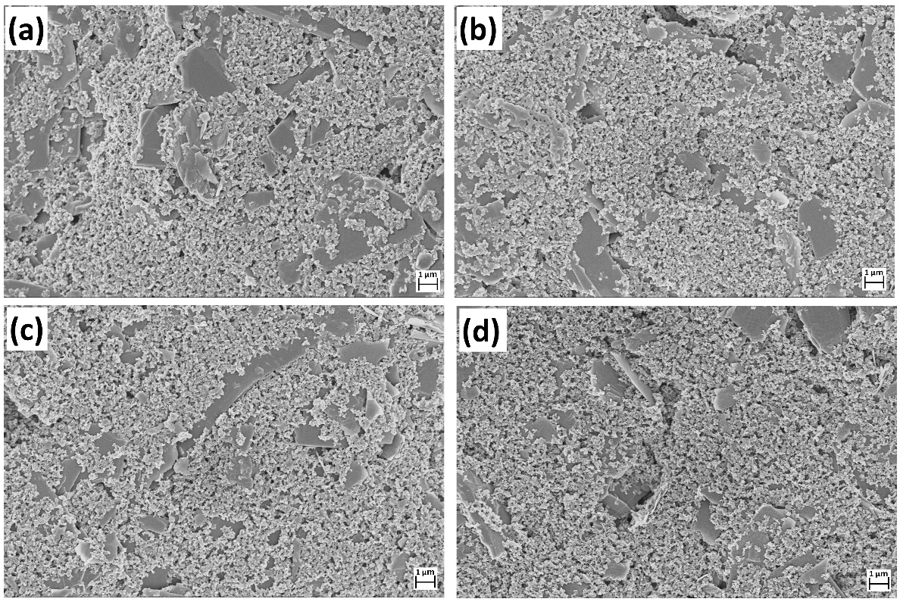
Figure S2. Surface characterization of the development of the SPCE biosensor: (a) bare SPCE (b) Cysteamine/SPCE (c) MC-LR/Cysteamine/SPCE (d) Anti-MC-LR/MC-LR/Cysteamine/SPCE.

References
Steven C. Wendelken PD (2016): Method 546: Determination of Total Microcystins and Nodularins in Drinking Water and Ambient Water by Adda Enzyme-Linked Immunosorbent Assay. In: U.S. EPA OoGWaDW, Standards and Risk Management Division (Hrsg.)

