Supporting information

Room-temperature martensitic actuation profited from one-dimensional hybrid perovskite structure

Bei-Dou Liang, Chang-Chun Fan, Cheng-Dong Liu, Chao-Yang Chai, Xiang-Bin Han* and Wen Zhang*

Jiangsu Key Laboratory for Science and Applications of Molecular Ferroelectrics and School of Chemistry and Chemical Engineering, Southeast University, Nanjing 211189, China.
E-mail: hanxiangbin@seu.edu.cn; zhangwen@seu.edu.cn

Experimental
Table S1. Crystallographic data and structure refinement details for 1 at different phases.
Table S2. Pb-I bond lengths of 1 in LTP, ITP, and HTP.
Table S3. Converted cell parameters for spontaneous strain calculation.
Fig. S1. Experimental and simulated PXRD patterns for powder sample of 1 at HTP.
Fig. S2. TGA measurement of 1. The decomposition begins at about 500 K.
Fig. S3. Single crystal orientation.
Fig. S4. Dielectric constant curves of 1 at different frequencies.
Fig. S5. Hirshfeld surfaces for 1 of [PbI₃]_{n}.
Fig. S6. Order-disorder change of cations during the phase transitions. The NMEA cation in thermal ellipsoid mode with 50% probability.
Fig. S7. Phase boundary moving observed from (100) when crystals transition from the HTP to ITP.

Experimental
Materials and general characterizations
Reagents used were in analytical grade without further purification. Powder X-ray diffraction (PXRD) patterns were obtained on a Rigaku SmartLab X-ray diffractometer at room temperature. The diffraction patterns were collected in the 2θ range of 5−50° with a step size of 0.02°. DSC measurements were performed on a NETZSCH DSC 200F3 instrument under N₂ at atmospheric pressure with a heating/cooling rate of 20 K min⁻¹. Ultraviolet-vis (UV-vis) absorption spectra were measured with Shimadzu UV-2600 equipped with ISR-2600Plus integrating sphere.
Single-crystal X-ray Diffraction
Crystallographic data of the salts were collected on a Rigaku Oxford Diffraction Supernova Dual Source, Cu at Zero equipped with an AtlasS2 CCD using Mo Kα radiation and an XtaLAB Synergy R, DW system, HyPix diffractometer. SHELXL-2018 software package was used to solve the structures by direct methods. All non-hydrogen atoms were refined anisotropically. The positions of hydrogen atoms were generated geometrically.
Dielectric spectra
Temperature-dependent dielectric constant spectra were measured on powdered samples by using a Tonghui TH2828A impedance analyzer at frequencies of 1−1000 kHz with an applied electric field of 1 V.

Table S1. Crystallographic data and structure refinement details for 1 at different phases.
 | LTP-173K | ITP-253K | HTP-333K
Formula | C₆H₂₀N₂I₆Pb₂ | C₃H₁₀NI₃Pb | C₃H₁₀NI₃Pb
Formula weight | 1296.04 | 648.02 | 648.02
Crystal system | Triclinic | Monoclinic | Hexagonal
space group | P-1 | C2/c | P6₃/mmc
a / Å | 8.1501(3) | 9.8984(9) | 9.2432(5)
b / Å | 9.0775(2) | 15.0923(10) | 9.2432(5)
c / Å | 15.8322(3) | 8.0597(5) | 8.1797(4)
α / ° | 83.8690(10) | 90 | 90
β / ° | 84.399(2) | 97.887(7) | 90
γ / ° | 87.646(2) | 90 | 120
V / Å³ | 1158.49(5) | 1192.65(15) | 605.22(7)
Z | 2 | 4 | 2
D_{calc} / g·cm⁻³ | 3.715 | 3.609 | 3.501
μ / mm⁻¹ | 22.495 | 21.851 | 21.527
Reflns. collected | 28600 | 6472 | 6429
Obsd. reflns. [I>2σ(I)] | 5081 | 1133 | 202
R_{int} | 0.0493 | 0.0432 | 0.0777
R₁ª/wR₂^{b} [I>2σ(I)] | 0.0599,0.1654 | 0.0516,0.1512 | 0.0577,0.1694
R₁/wR₂ (all data) | 0.0679,0.1678 | 0.0690,0.1591 | 0.0931,0.1950
GOF | 1.186 | 1.103 | 1.035
Δρ^{c} / e⋅Å^{–3} | 3.247/-3.304 | 2.606/-0.996 | 0.654/-0.995
ª R₁ = Σ||F_{o}| – |F_{c}||/Σ|F_{o}|. ^{b} wR₂(F²) = [Σw(F_{o}² – F_{c}²)²/ΣwF_{o}⁴]^{1/2}. ^{c} Maximum and minimum residual electron density.

Table S2. Pb-I bond lengths of 1 in LTP, ITP, and HTP.
Bond lengths | Length / Å
LTP-173K
I(5)−Pb(1) | 3.4007(10)
I(6)−Pb(1)^{ii} | 3.3409(11)
I(3)−Pb(2) | 3.3741(10)
I(1)−Pb(2)^{i} | 3.3100(11)
I(2)−Pb(2)^{i} | 3.2564(11)
I(2)−Pb(1) | 3.2355(11)
I(4)−Pb(2) | 3.2192(10)
I(4)−Pb(1) | 3.2143(11)
I(5)−Pb(2) | 3.1664(10)
I(3)−Pb(1) | 3.1235(10)
I(1)−Pb(1) | 3.1036(10)
I(6)−Pb(2) | 3.0992(10)
Symmetry codes: (i) −1+x, +y, +z; (ii) 1+x, +y, +z.
ITP-253K
I(2)−Pb(1)^{i} | 3.2394(12)
I(2)−Pb(1) | 3.2227(10)
I(1)−Pb(1) | 3.2047(10)
I(1)−Pb(1)^{i} | 3.2047(10)
Symmetry codes: (i) 1−x, +y, 3/2−z.
HTP-333K
I(1)−Pb(1) | 3.2249(19)
I(1)−Pb(1)^{i} | 3.2249(19)
Symmetry codes: (i) −x, −y, 1/2+z.
Table S3. Converted cell parameters for spontaneous strain calculation.
 | LTP-ITP Transition | ITP-HTP Transition
a / Å | 9.0775(2) | 9.8984(9)
b / Å | 15.8322(3) | 15.0923(10)
c / Å | 8.1501(3) | 8.0597(5)
α / ° | 95.601(2) | 90
β / ° | 87.646(2) | 97.887(7)
γ / ° | 96.310(10) | 90
a₀ / Å | 9.8984(9) | 9.2432(5)
b₀ / Å | 15.0923(10) | 16.0097(9)
c₀ / Å | 8.0597(5) | 8.1797(4)
α₀ / ° | 90 | 90
β₀ / ° | 97.887(7) | 90
γ₀ / ° | 90 | 90

Fig. S1. Experimental and simulated PXRD patterns for powder sample of 1 at HTP.

Fig. S2. TGA measurement of 1. The decomposition begins at about 500 K.

Fig. S3. Single crystal orientation.

Fig. S4. Dielectric constant curves of 1 at different frequencies.

Fig. S5. Hirshfeld surfaces for 1 of [PbI₃]_{n}.

Fig. S6. Order-disorder change of cations during the phase transitions. The NMEA cation in thermal ellipsoid mode with 50% probability.

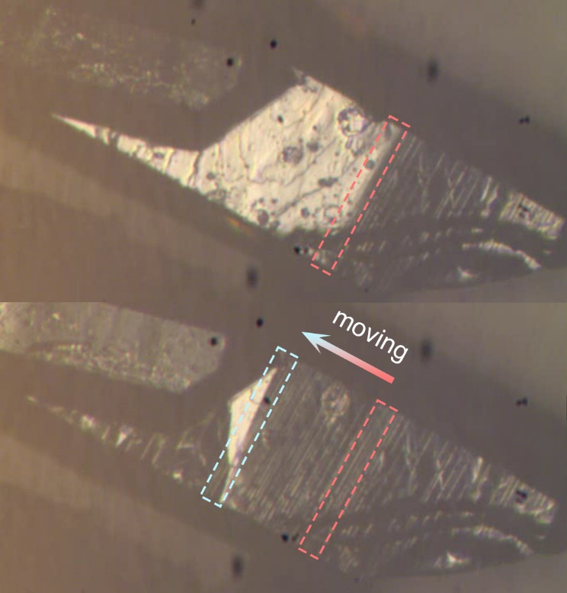
Fig. S7. Phase boundary moving observed from (100) when crystals transition from the HTP to ITP.

