Supplementary information for “Twist-tunable polaritonic nanoresonators in a van der Waals crystal”

Table of Contents
- Far-field characterization…………………………………………………………….….2
- Analysis of the anisotropic PhP resonances in the elliptic $α$-MoO₃ frequency range…..3
- Dispersion surface of the M1_{m} PhP mode above the metal ribbon regions in the $α$-MoO₃ hyperbolic frequency range……………………………………………………...………6
- Dispersion surfaces of the M1_{a} and M1_{m} PhP modes above both the air gap and the metal ribbon regions in the $α$-MoO₃ elliptic frequency range……………………………...….8
- Experimental quality factors of the nanoresonators…………………………...…….…10
References……………………………………………………………………………………...11

In this Supporting Information we will consider the Fabry-Pérot resonances (FBRs) with their origin in: i) the M1 PhP mode propagating in the $α$-MoO₃ flake above the metal region in the hyperbolic frequency range, and ii) the M1 PhP mode propagating in the flake above both the metal ribbon and the air gap regions in the elliptic frequency range.

I. Far-field characterization
The far-field characterization of our samples was carried out by performing FTIR measurements on an $α$-MoO₃ flake with thickness $t = 110$ nm placed on top of Au ribbons with a width $w = 1.48$ μm and a separation $d = 1.23$ μm (FigureS1a). Within the hyperbolic frequency range we have identified the FPRs 1a and 6m, matching the same resonance frequency ($ω= 909.5$ cm⁻¹, see Figure1d of the main text). In contrast, in the elliptic range we have identified the resonances 2m and 4a close to $ω= 995$ cm⁻¹ (Figure1d in the main text). The analysis of the resonances 2m and 4a for different twisting angles $φ$ is presented in FigureS3d of Section II.
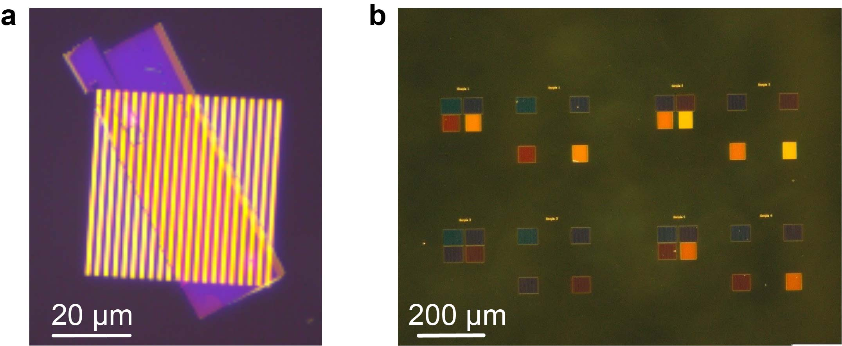
Fig.S1 | Optical images of the metal gratings. a, Au grating with a ribbon width $w = 1.48$ μm and a separation (air gaps) $d = 1.23$ μm. The $α$−ΜοΟ₃ flake placed on top of them has a thickness $t = 110$ nm. b, Sets of Al gratings with different ribbon widths and air gaps. The substrate is in all cases CaF₂.

Additionally, we fabricated Al gratings (as the type of metal does not affect our results in the mid-IR, in some cases we use Al instead of Au for convenience) with different periods (FigureS1b). In this case, the $α$−ΜοΟ₃ flake placed on top had a thickness $t = 127.5$ nm. By varying the twisting angle of the flake with respect to the ribbons axes, we observe the same resonant frequencies as when using Au in both hyperbolic and elliptic frequency ranges (FigureS2a,b, and FigureS2c, respectively). The FPRs modes 1a and 6m in the hyperbolic range appear at $ω= 908.5$ cm⁻¹ (Fig.S2a) and $ω= 911$ cm⁻¹ (Fig.S2b), while the FBRs 2m and 4a in the elliptic range appear at $ω= 991$ cm⁻¹ (FigureS2c). The ribbons and air gaps widths were measured by AFM.
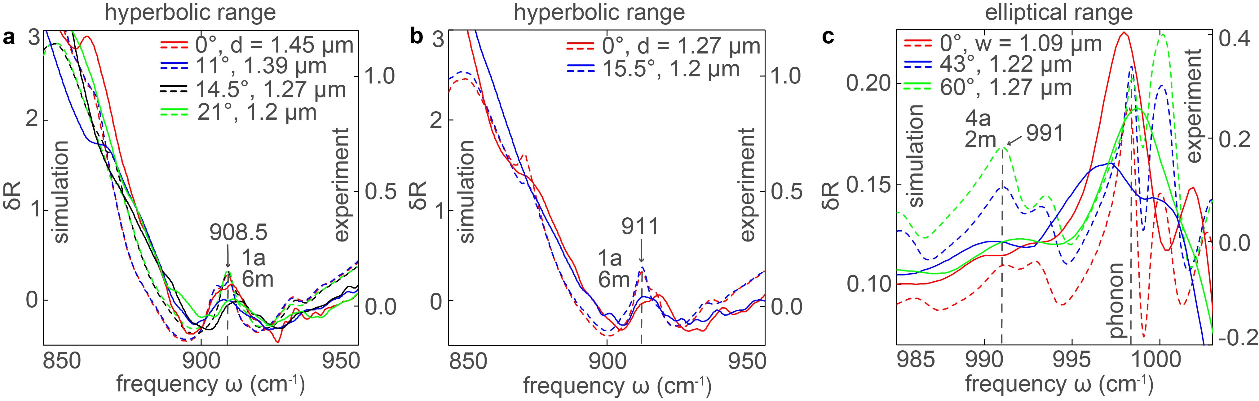
Fig.S2 | Far-field spectra of PhP nanoresonators in the case of using Al gratings. a, Experimental and simulated relative reflection spectra in the hyperbolic range for different air gap widths, $d$, and flake rotation angles, $φ$, showing resonances (FPRs 1a and 6m for the M0 and M1_{m} PhP modes, respectively) at the same frequency, $ω = 908.5$ cm⁻¹. b, Analogous spectra as in (a) for gratings with a resonant frequency $ω = 911$ cm⁻¹. c, Experimental and simulated relative reflection spectra in the elliptic range for nanoresonators defined on gratings with different ribbon widths w and twisting angles $φ$. The nanoresonators show maximum of their relative reflection at the same frequency $ω = 991$ cm⁻¹ (resonances 2m and 4a for the M1_{m} and M1_{a} PhP modes, respectively). Solid and dash lines in (a-c) represent experimental and simulated data, respectively. The thickness of the $α$−ΜοΟ₃ flake in was $127.5$ nm.

Figs.S2a-c show the relative reflection spectra for an $α$-MoO₃ flake placed on top of Al gratings with different air gaps (Figs.S2a,b) and ribbon widths $w$ (Figs.S2c). For all the gratings the flake was rotated by a given angle $φ$ such that the resonances 1a and 6m (Figs.S2a,b) as well as the resonances 2m and 4a (Figs.S2c) take place at the same frequency.

II. Analysis of the anisotropic PhP resonances in the elliptic α-MoO₃ frequency range
The FTIR relative reflection spectra (red dots in FigureS3a), hereinafter referred to as $δR$, of nanoresonators in the elliptic $α$-MoO₃ frequency range was measured for a 110nm-thick $α$-MoO₃ flake placed on top of an array of Au-ribbons (with a period of 2.71 μm and a ribbon width of 1.48 μm, corresponding to $d = 1.23$ μm) at $φ = 0°$. For comparison, full-wave numerical simulations of $δR$ (black curve in FigureS3a) were carried out mimicking the experiment (in both cases using plane wave illumination polarized across the ribbons). Although the agreement between experiment and theory is reasonably good, the spectral resolution in our FTIR measurements (2 cm⁻¹) is too low to capture the TO-phonon along the [100] crystal direction at $ω = 998.7$ cm⁻¹. The colorplot in FigureS3b shows $δR$ as a function of frequency and inversed ribbon width (while the ratio between the ribbon width and the width of the air gap is fixed to 1.48/1.23).
In our system, we consider the FPRs in both regions of the flake (above the metal and above air) as independent (i.e. completely neglecting any coupling between them). In this approximation, we can write the phase matching conditions¹:
$k_{a}d + φ_{a} = πn_{a}$ (1)
$k_{m}w + φ_{m} = πn_{m},$ (2)
where $k_{a}$ and $k_{m}$ are the wavevectors in the regions above the air gaps and the metal ribbons, $φ_{a}$and $φ_{m}$ are the reflection phases from the air/metal and metal/air boundaries, and $n_{a}$ and $n_{m}$ represent the number of polariton wavelengths fitting in the areas above the air gaps and metal ribbons, respectively. We take the wavevectors in Eqs. (1,2) from the analytical equation for the dispersion of anisotropic modes Ml in a thin biaxial slab of thickness $t$, propagating in the plane at an angle $φ$ with respect to the [100] crystallographic direction²:
$k\left(ω\right)= \frac{ρ}{k_{0 }t}$[arctan($\frac{ε_{1}ρ}{ε_{z}}$) + arctan($\frac{ε_{1}ρ}{ε_{z}}$) + πl], $l ∈ Z$ (3)
$ρ=i\sqrt{\frac{ε_{z}}{ε_{x}\cos^{2}φ+ ε_{y}\sin^{2}φ}}$.
In the analytical analysis of the FPR, the reflection phase of the PhPs modes, $φ_{m,a}$, in the $α$-MoO₃/metal and $α$-MoO₃/air regions is taken 0 and π, respectively. For each number $n_{a}$ and $n_{m}$ and fixed relation $w/d,$ the wavevector $k_{m,a}$ is a function of a single parameter, $w$, which we represent by the solid and dashed curves in FigureS3b (labeled as “na” and “nm”, respectively).
Analogously to the case analyzed in the main text for the hyperbolic $α$-MoO₃ spectral range, for the elliptic spectral range we identified the specific FPRs corresponding to the peak positions in the $δR$ spectrum in FigureS3a. To that end we monitor the intersection between a horizontal line representing the inverse ribbon width ($1.48 μm$) and the dispersion curves (Fig.S3b). In the experimental spectrum, the resonant peaks at the frequencies matching $n_{a}= 2n_{m}$ show the highest intensity. This can be explained by the 2 times larger PhP wavevectors of the M1 mode in the areas above the air gaps compared to those above the metal ribbons (due to the effective doubling of the flake thickness caused by the mirror effect of the metal). In contrast, in the hyperbolic range the modes are intrinsically different: while the regions above the air gaps support the M0 mode, the regions above the metal ribbons support the M1 mode. Consequently, the doubling effect is not observed in the hyperbolic frequency range. Note that the M0 mode in the flake above the air gaps in the elliptic range is not supported since the dielectric permittivities $ε_{x}$ and $ε_{y}$ are both positive.
FigureS3c shows the real part of the out-of-plane component of the vertical electric field across the ribbons as a function of frequency. The number of field oscillations across the ribbon coincides with the resonance numbers, $n_{a}$ and $n_{m}$, labelling the resonance peak in Fig S3a. In FigureS3d, we illustrate the measured $δR$ spectra for $φ= 0°, 15°, 30°$and$45°$, in which the positions of the resonances 2m and 4a agree well with the simulated spectra for all angles $φ$ (color plot in FigureS3e). Thus, we also see a strong dependence of the resonant frequencies on the rotation angles within the elliptic range, both in the experiment and theory.
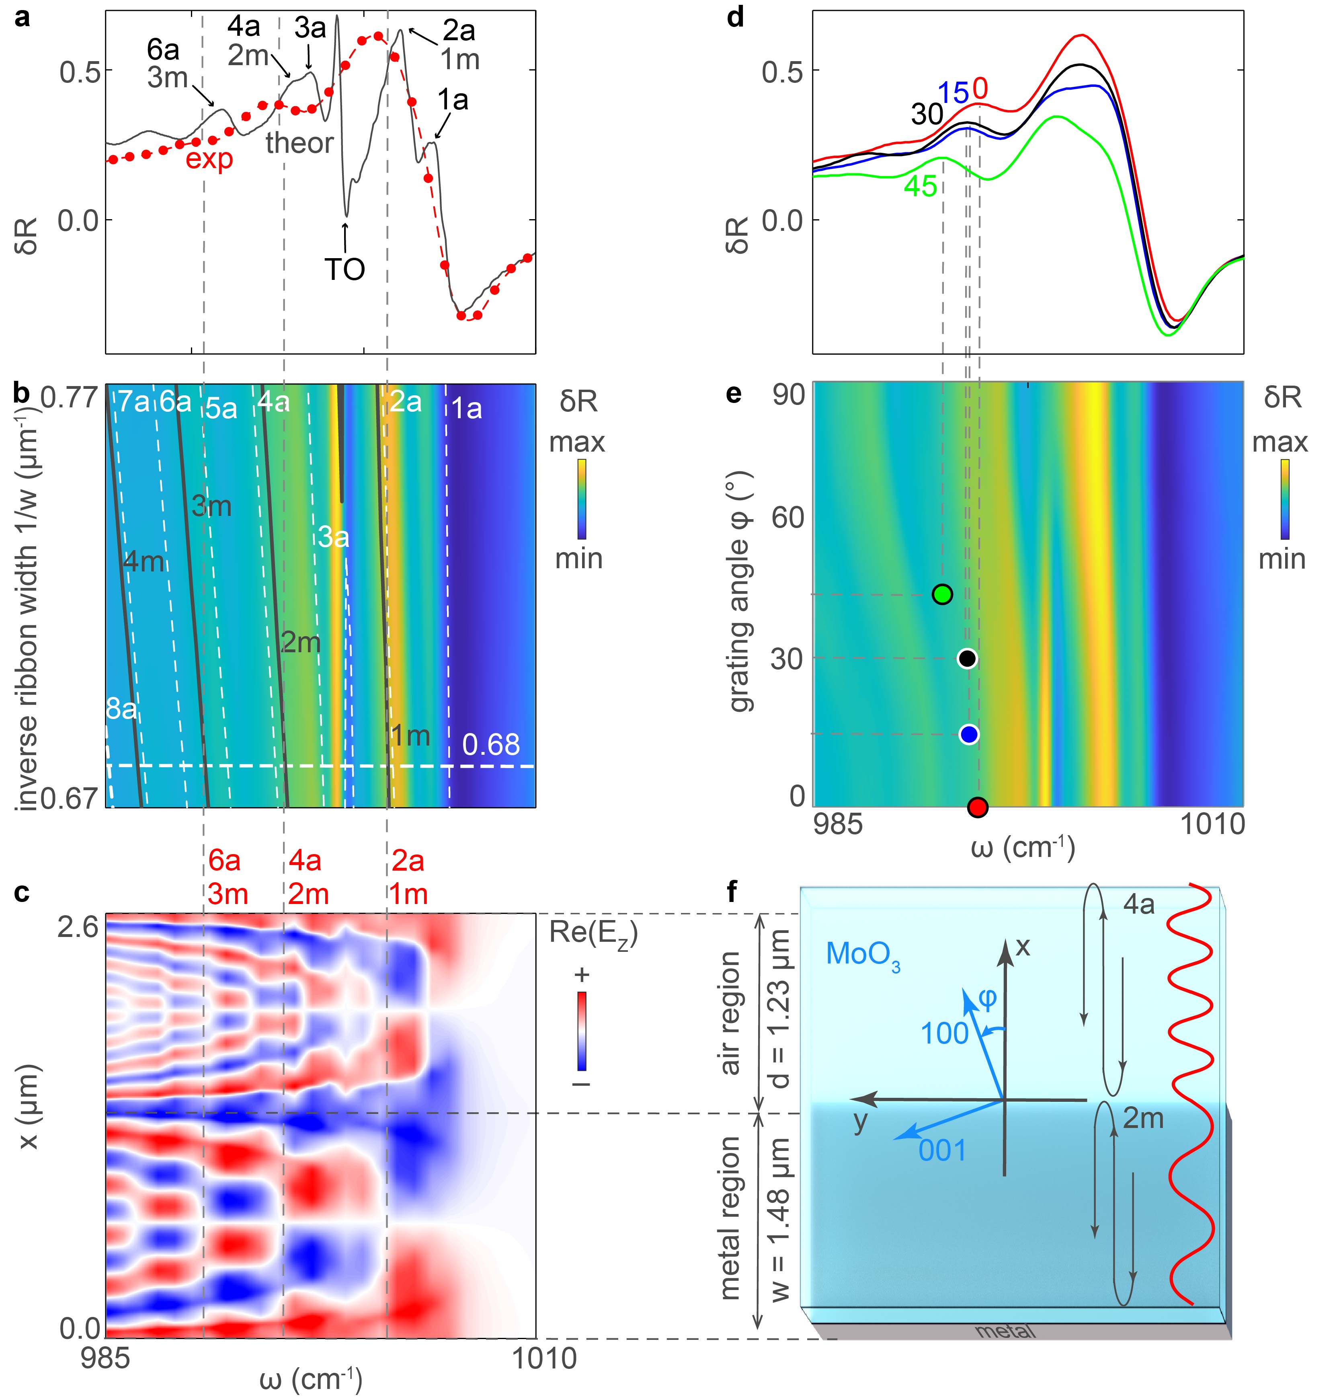
Fig.S3 | Analysis of the PhP FBRs in the elliptical range and their twist-tuning. a, Measured and simulated relative reflection spectra, $δR$ (dash red and solid grey curves, respectively), for a ribbon width $w = 1480$ nm, separation distance $d = 1230$ nm, and twist angle $φ=0°$. b, Simulated $δR$ as a function of frequency $ω$ and the inverse ribbon width, $1/w$, for a fixed ratio $w/d$. c, Simulated field distributions of the M1_{a} and M1_{m} PhP modes in the $α$-MoO₃/air and $α$-MoO₃/Au regions, respectively, as a function of $ω$ and the $x$ coordinate (across the ribbons). d, Measured $δR$ spectra for the twist angles $φ= 0, 15, 30$and$45°$ (red, blue, black, and green, respectively). e, Simulated relative reflection as a function of $ω$ and $φ$. f, Schematics of the top view of one lattice unit cell.

III. Dispersion surface of the M1_{m} PhP mode above the metal ribbon regions in the $α$-MoO₃ hyperbolic frequency range
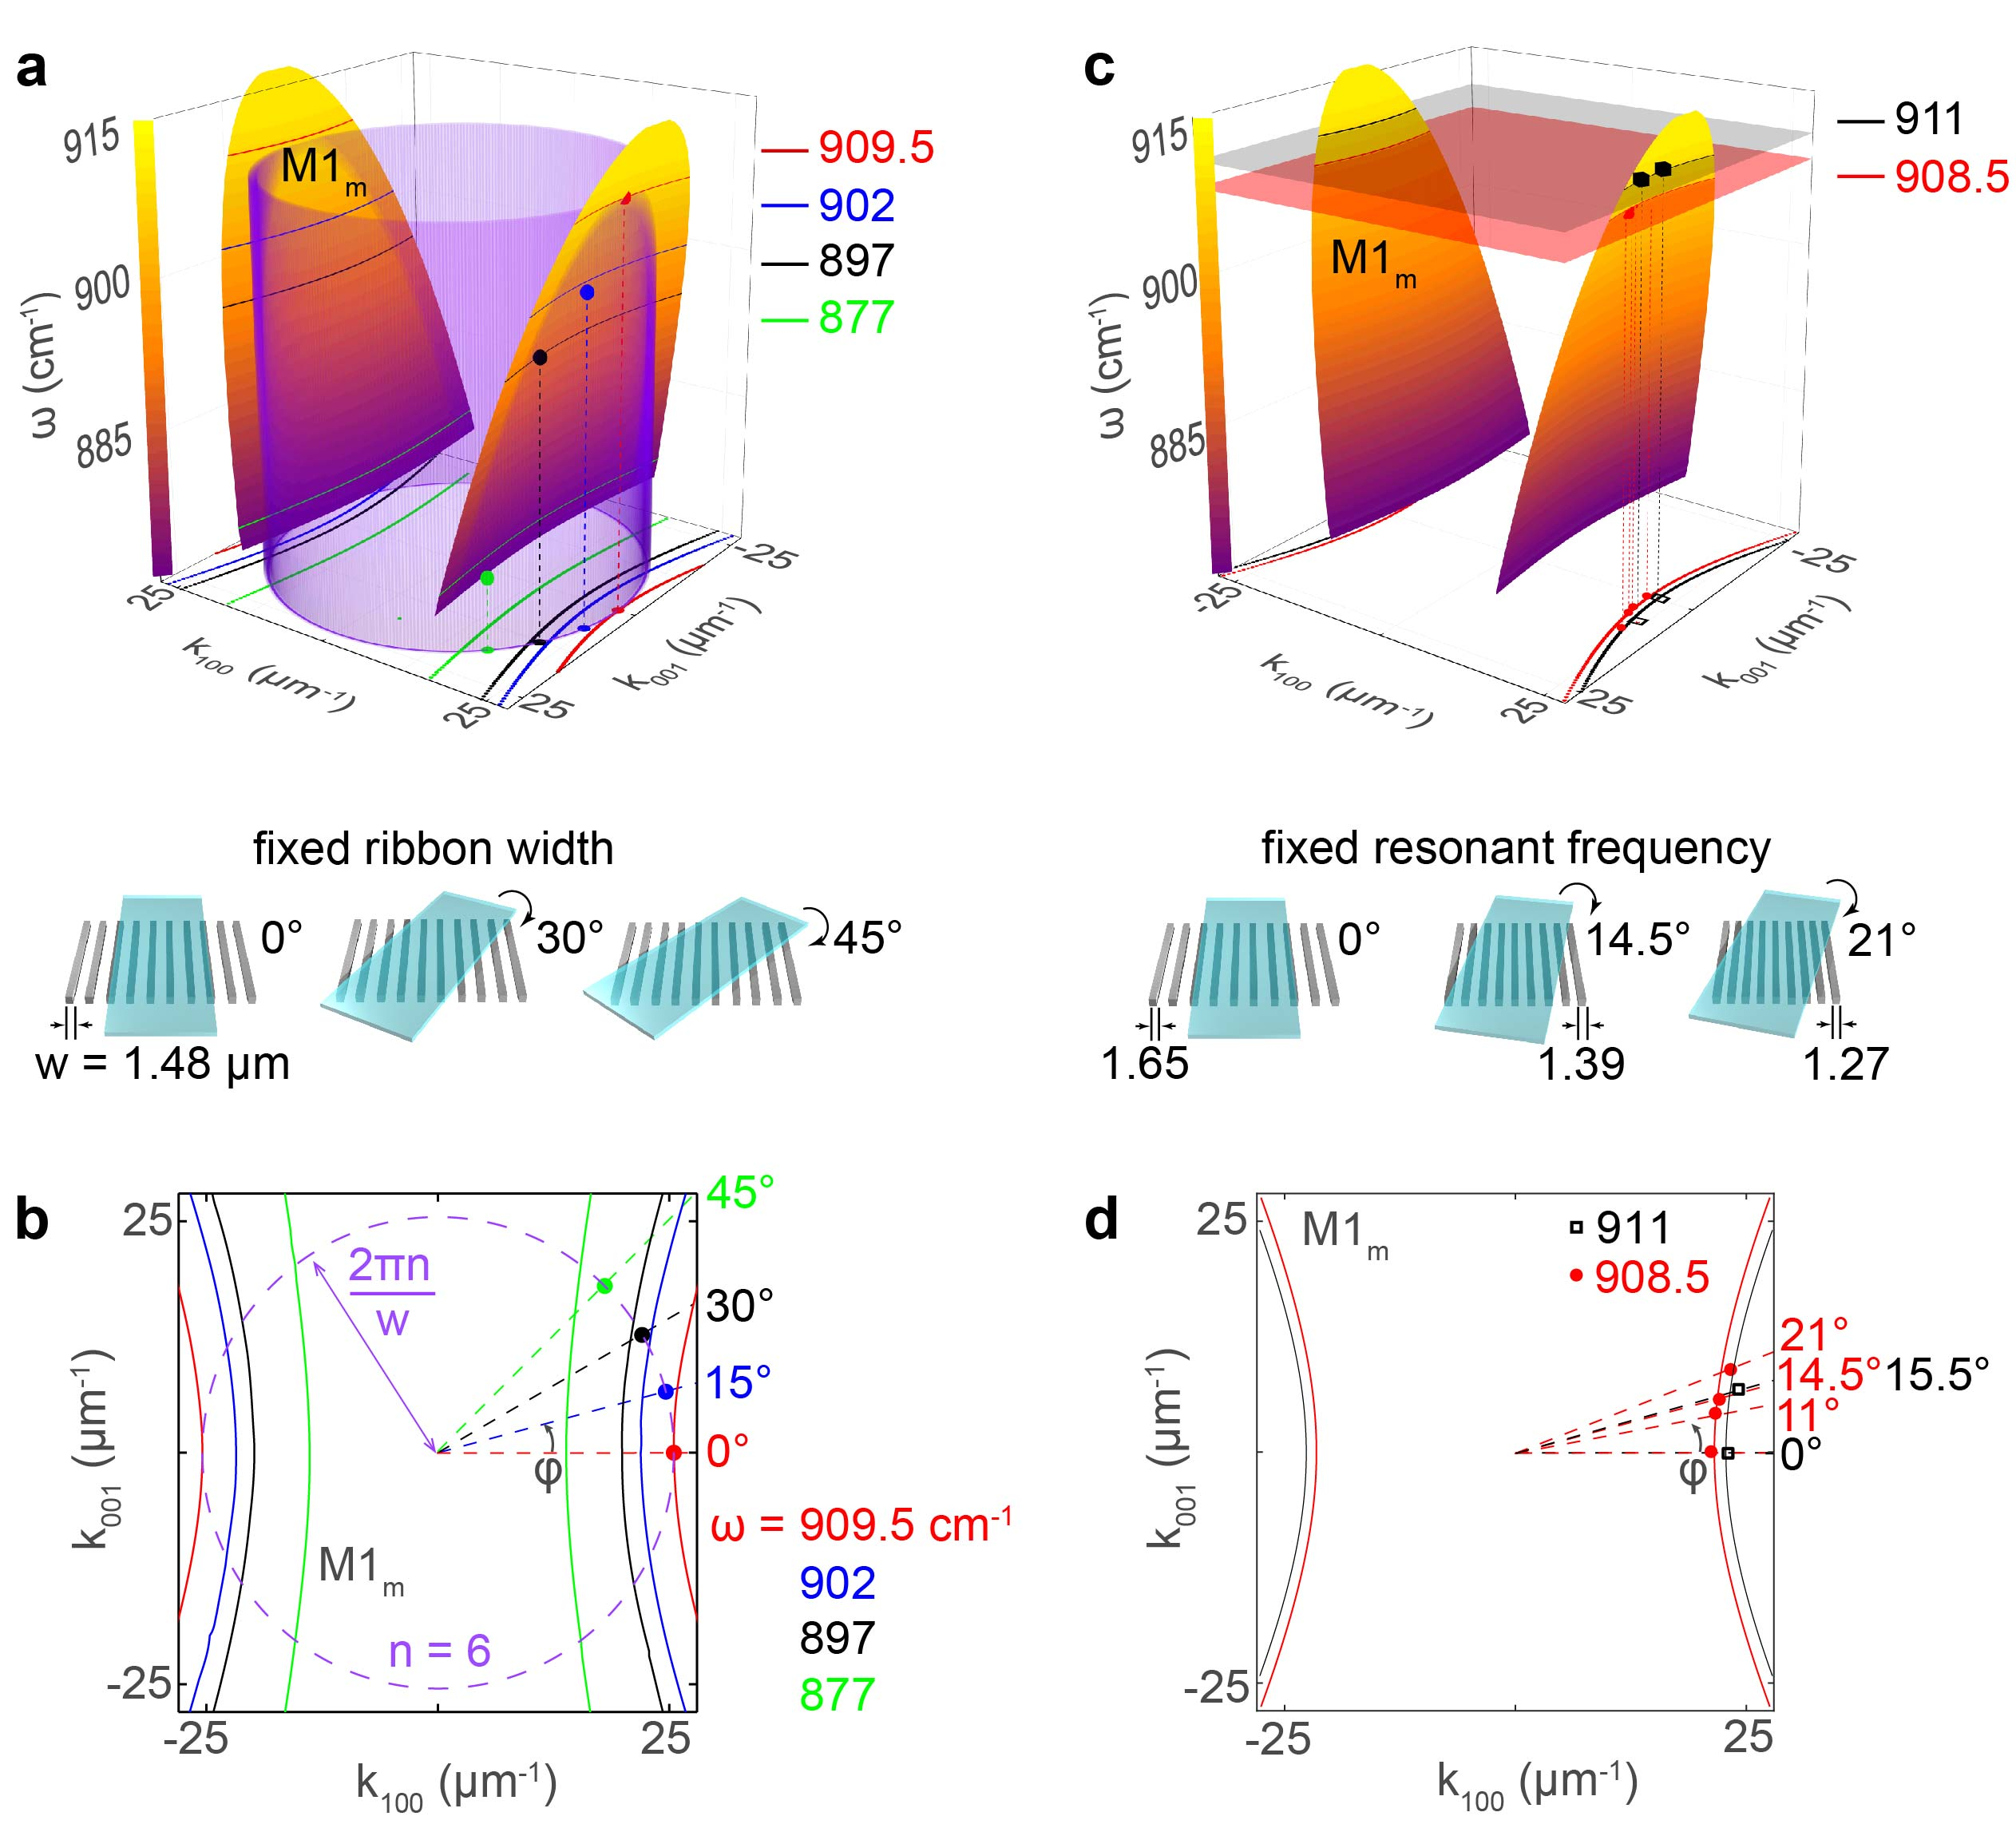
Fig.S4 | Probing the dispersion surface of the M1_{m} PhP mode in the hyperbolic regime. a, Analytical dispersion surface of the M1_{m} PhP mode crossed by a cylinder representing a constant momentum. The color dots represent the positions of the measured resonant peaks 6m in cylindrical coordinates (resonant frequency from Fig.2d, the inverse ribbon width of the grating, $2πn/w, n = 6$, and the twisting angle, $φ$) for the same Au grating twisted at different angles, $φ$. b,d, Isofrequency curves for the M1_{m} mode at different frequencies, $ω$. c, Analogous dispersion surface as in (a), but crossed by the planes of two fixed frequencies ($ω = 908.5$, and $911$ cm⁻¹). The red and black points mark the 6m peaks positions for Al gratings (Fig.S2a and Fig.S2b) in cylindrical coordinates (resonant frequencies, the inverse ribbon width of the grating, $2πn/w, n = 6$, and the twisting angle, $φ$). The thicknesses of the flakes in (a,b) and (c,d) are 110 and 127.5 nm, respectively.

In the main text probing the dispersion surface of the M0_{a} PhPs mode (Fig.4) in the hyperbolic regime is performed for the 1a FBR in the area of the flake above air gaps. At the same time, the resonance 6m (the M1_{m} mode) in the area of the flake above the metal ribbons can also be achieved at the same frequency as the resonance 1a for all twisting angles, $φ$. Thus, the same resonant peaks in the reflection spectra (Fig.2d) can be interpreted both as the 1a FBR of the M0_{a} mode and the 6m FBR of the M1_{m} mode. Here, we perform probing the dispersion surface of the M1_{m} PhPs mode (Fig.S4) in the hyperbolic regime on the example of the 6m FBR in the area of the flake above the metal ribbons. In Fig.S4a the experimentally-measured positions of the FBRs are represented as green, black, blue and red points in cylindrical coordinates (the resonant frequency as a $z$ coordinate, the inverse ribbon width, $2πn/w, n = 6$, as a radial coordinate and the twist angle, $φ$, as the polar angle). The purple cylinder with radius $2πn/w, n = 6$, represent the constant-momentum surface meaning that we perform the measurements for the same grating with fixed ribbon width, $w$, for all twist angles and frequencies, whereas the analytical dispersion surface of the M1_{m} mode is represented by a hyperboloid. The projections of the points from Fig.S4a on the ($k_{x}, k_{y}$) plane are positioned very closely to the intersection points between the analytical isofrequency curves (IFCs) for the corresponding frequencies and the cylinder projection on the ($k_{x}, k_{y}$) plane (Fig.S4b).

An alternative probing of the PhP dispersion surface can be realized by constructing the cross-sections of the hyperboloid by constant-frequency planes (Fig.S4c), i.e. IFCs corresponding to the resonant frequencies in Fig.S2a,b. The projections of the experimentally-measured positions of the resonances, represented in cylindrical coordinates by red and black points in Fig.S4c, fit well the IFCs.

Our results indicate that the dispersion surface of the M1_{m} PhP mode in the hyperbolic frequency range can be experimentally reconstructed by measuring the resonance 6m in the region of the flake above the metal ribbons.

IV. Dispersion surfaces of the M1_{a} and M1_{m} PhP modes above both the air gap and the metal ribbon regions in the $α$-MoO₃ elliptic frequency range
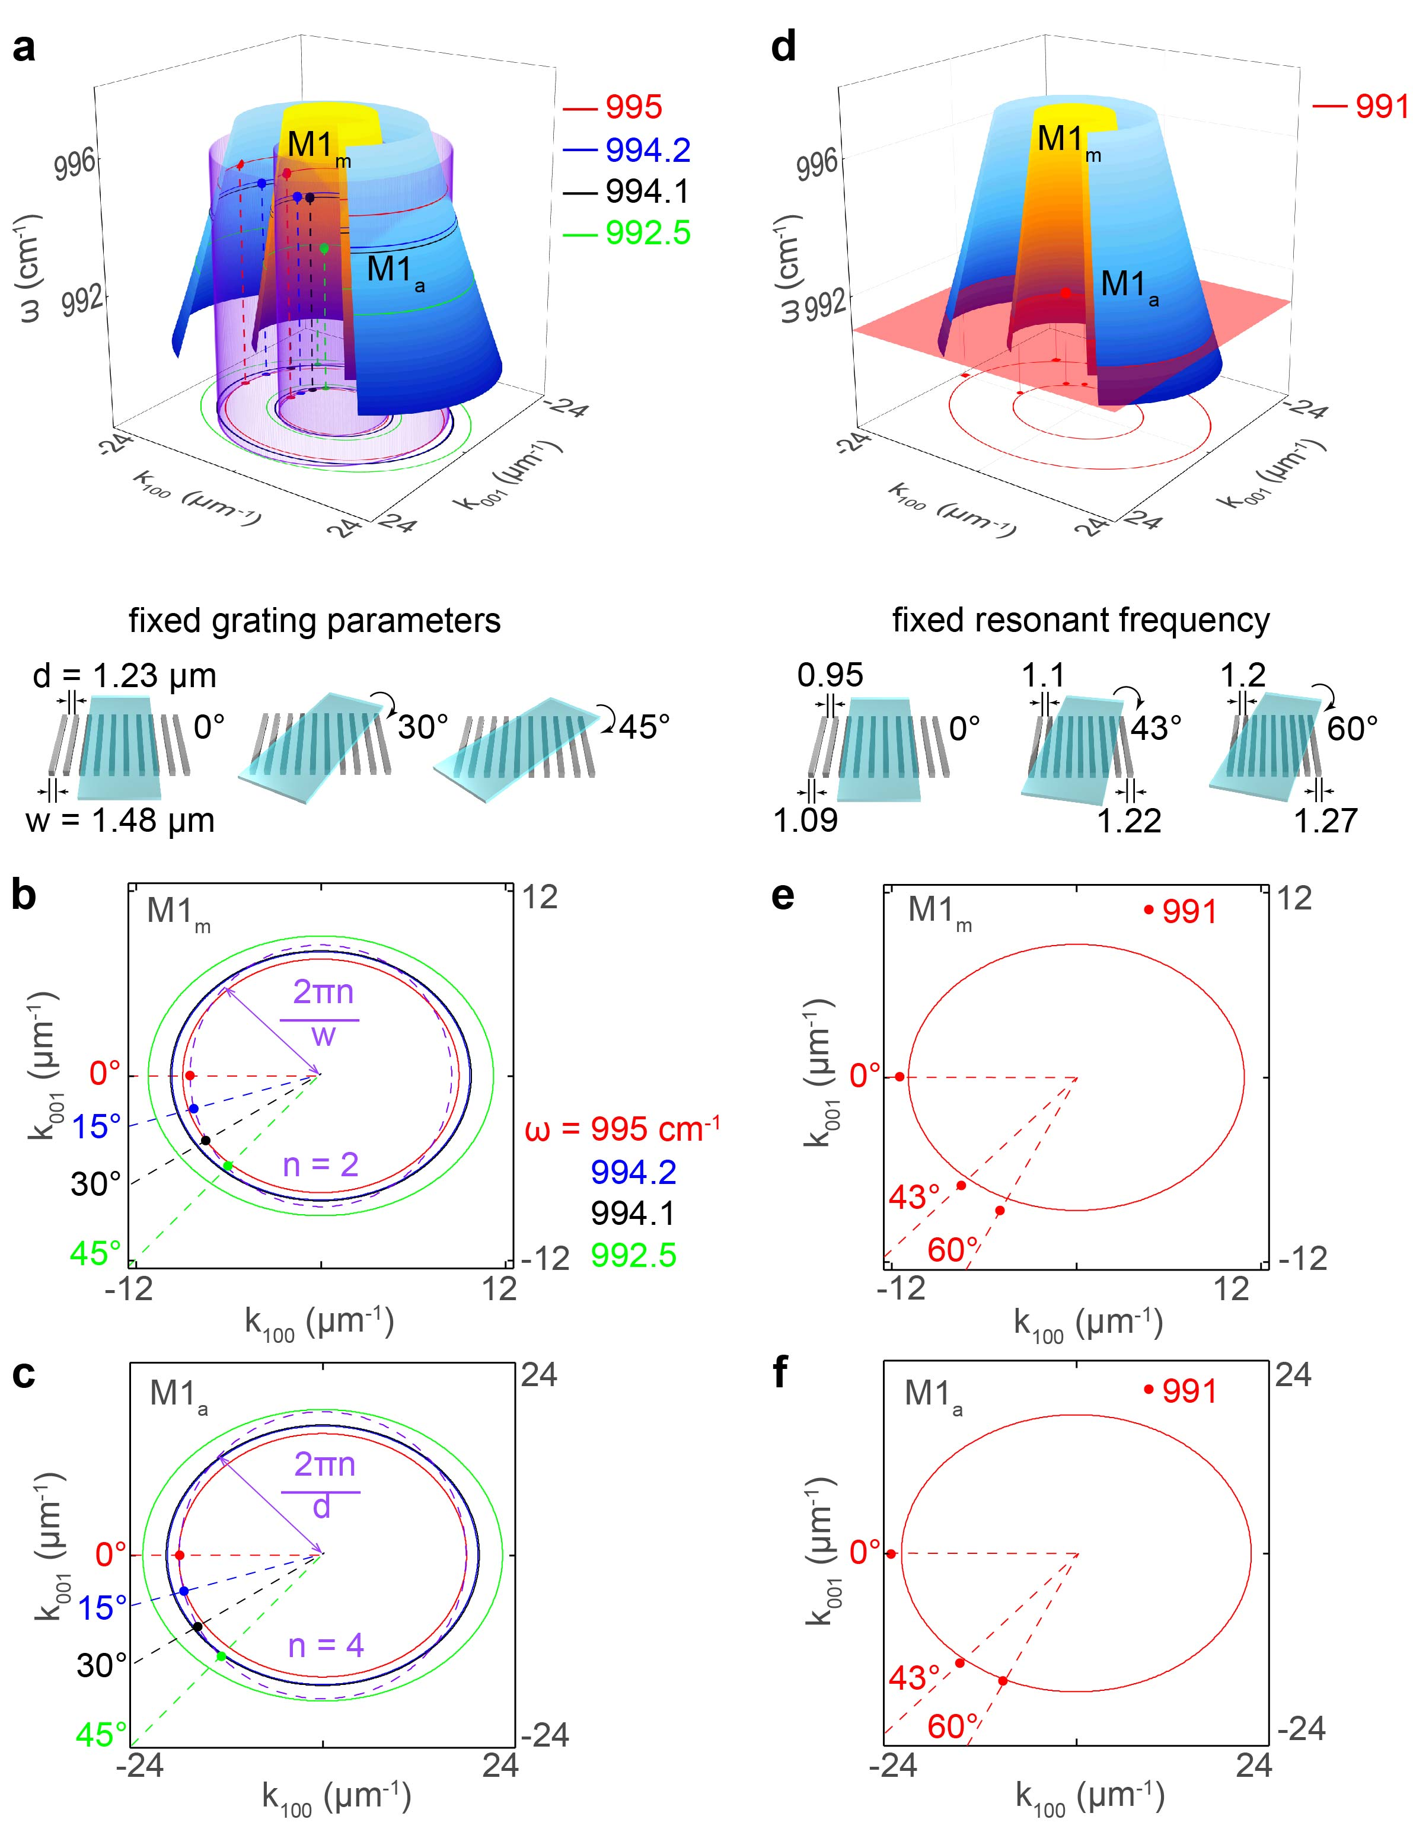
Fig.S5 | Probing the dispersion surfaces of the M1_{a} and M1_{m} PhP modes in the elliptic range. a, Analytical dispersion surfaces of the M1_{a} and M1_{m} PhP modes crossed by two cylinders representing constant momenta. The color dots mark the positions of the measured FPR peaks, 2m (near the yellow surface of the M1_{m} PhP mode) and 4a (near the blue surface of the M1_{a} PhP mode) in cylindrical coordinates (resonant frequency from Fig.S3d; either the inverse ribbon width, $2πn/w, n = 2$, or the inverse air gap width, $2πn/d, n = 4$, for 2m and 4a resonances, respectively; and the twisting angle, $φ$) for the same Au grating twisted at different angles, $φ$. b,e, Isofrequency curves for the M1_{m} mode at different frequencies, $ω$. c,f, Isofrequency curves for the M1_{a} mode at different frequencies, $ω$. d, Analogous dispersion surface as in (a), but crossed by a plane of a fixed frequency,$ω = 991$cm⁻¹. The points mark the 2m and 4a FBR peak positions for Al gratings (resonant frequencies from Fig.S2c, the inverse ribbon width of the grating, $2πn/w, n = 2$, and the inverse air gap width of the grating, $2πn/d, n = 4$, for 2m and 4a resonances, respectively, and the twisting angle, $φ$). The thicknesses of the flakes in (a,b,c) and (d,e,f) are 110 and 127.5 nm, respectively.

In analogy to the results shown in Fig.4 of the main text for probing the dispersion surface of M0_{a} PhP mode in the hyperbolic range (performed for the 1a FBR emerging in the flake area above the air gaps), we represent in Fig.S5 the results of the probing of the dispersion surfaces of the M1_{a} and M1_{m} PhP modes in the elliptic range for the 4a and 2m FPRs in the flake area above the air gaps and above the metal ribbons, respectively. The experimental data for Fig.S5a-c was taken from Fig.S3d, while the one for Fig.S5d-f was taken from Fig.S2c.

V. Experimental quality factors of the nanoresonators
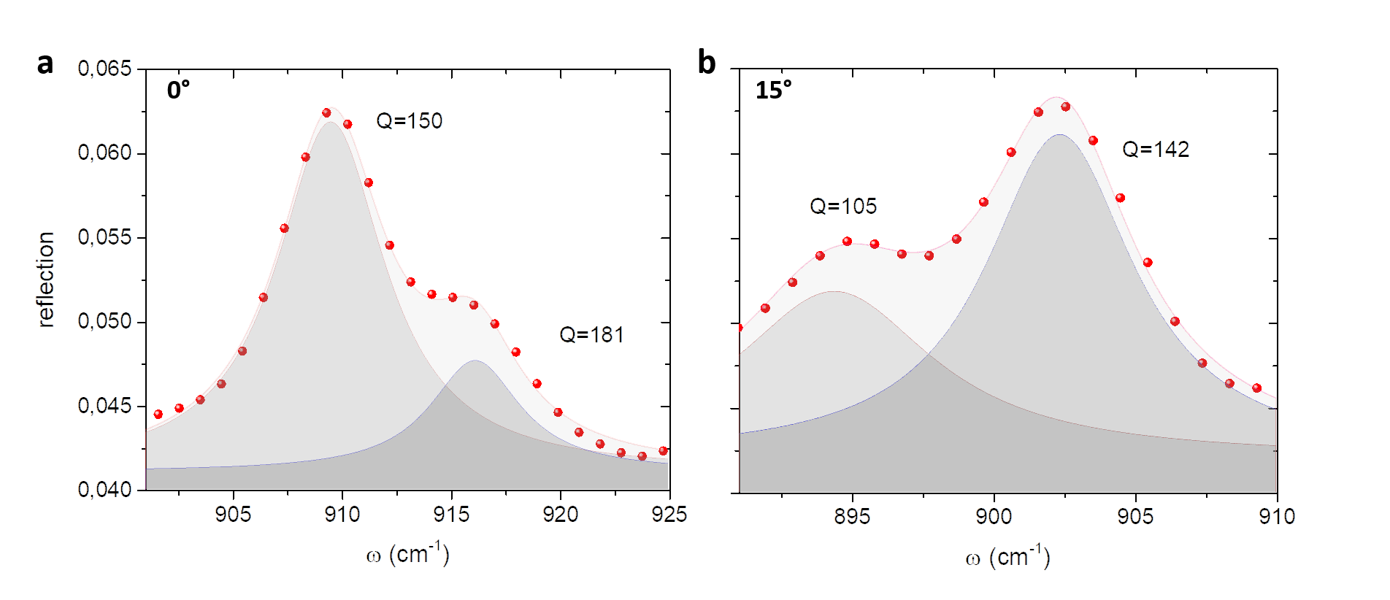Fig.S6 | Experimental reflection spectra in the hyperbolic range for an $α$-MoO₃ flake placed on top of a metal grating with $w = 1.48 μ$m, $d = 1.23 μ$m. a, Rotation angle $φ = 0°$. b, Rotation angle $φ = 15°$.
To evaluate the quality factors ($Q$) of the nanoresonators, we choose resonant peaks corresponding to the 1a and 6m resonances in the $α$-MoO₃ hyperbolic range and the 4a and 2m resonances in the elliptic range. In order to extract $Q$, we fit the reflection spectra by two Lorentzian curves. The red symbols represent the experimental data measured, while the gray areas represent the fitted Lorentzian line shape to the experimental spectra (Fig.S7). The quality factor can be defined as:
$Q= \frac{ω_{res}}{∆ω}$ (4)
where $Q$ is the relation between the resonance frequency $ω_{res}$ and the full width at half maximum $Δω$. We used the formula:
$y=y_{0}+ \frac{2A}{π}\frac{∆ω}{4{(ω-ω_{res})}^{2}+{∆ω}^{2}},$ (5)
obtaining the following results for the hyperbolic range:
Rotation angle $φ$ (°) | $ω_{res}$ (cm⁻¹) | $∆ω$ (cm⁻¹) | Quality factor ($Q$)
0 | Peak 1 909.50 Peak 2 916.14 | Peak 1 6.05 Peak 2 5.07 | Peak 1 150 Peak 2 181
15 | Peak 1 894.38 Peak 2 902.35 | Peak 1 8.56 Peak 2 6.37 | Peak 1 105 Peak 2 142
30 | 896.97 | 8.86 | 101
45 | 876.25 | 6.56 | 134

Analogously, we fitted (in this case by one Lorentzian curve) the resonances measured in the elliptic range obtaining the following values:
Rotation angle $φ$ (°) |  | $ω_{res}$ ( cm⁻¹) | $∆ω$ (cm⁻¹) | Quality factor ($Q$)
0 |  | 995.16 | 7.07 | 141
15 |  | 994.76 | 12.66 | 79
30 |  | 994.56 | 14.56 | 68
45 |  | 992.76 | 4.99 | 199

References
1. Nikitin, A.Y., Low, T. & Martín-Moreno, L. Anomalous reflection phase of graphene plasmons and its influence on resonators. Physical Review B 90, 5 (2014).
2. Álvarez-Pérez, G., Voronin, K.V., Volkov, V.S., Alonso-González, P. & Nikitin, A.Y. Analytical approximations for the dispersion of electromagnetic modes in slabs of biaxial crystals. Physical Review B 100, 11 (2019).

