Supplementary Material

A Highly Sensitive and Selective Fluorescent Probe for the Detection of Cerium(III) using Tridentate Based-Oxazolidine: Experimental and DFT Investigations

Malinee Promkatkaew¹, Laksamee Chaicharoenwimolkul Chuaitammakit², Kitiya Naree¹, Jinnapus Sillapa¹ and Sopanat Kongsriprapan¹*

¹ Faculty of Science at Si Racha, Kasetsart University, Si Racha Campus, Chonburi, 20230, Thailand
² Chemistry, Faculty of Science and Technology, Suratthani Rajabhat University, 272 Moo 9, Surat-Nasan Road., Khuntale, Muang, Surat Thani 84100, Thailand.
(*Corresponding author: e-mail: sfscispk@ku.ac.th)

Spectroscopic data

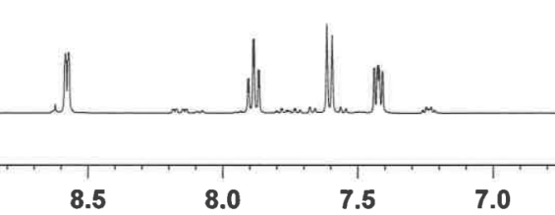
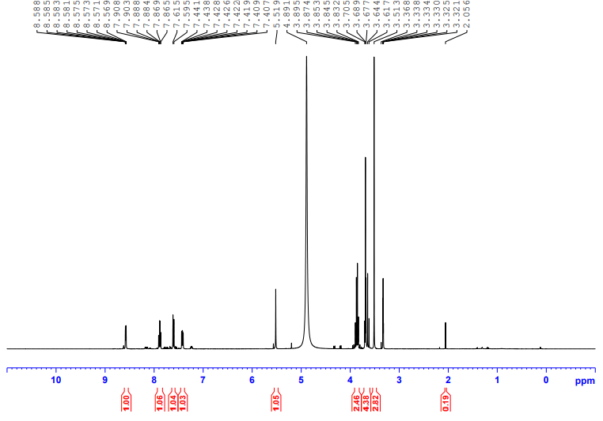
HOD
CD₃OD

Fig. S1 ¹H NMR spectrum of 2-(pyridin-2-yl)oxazolidine-4,4-diyl)dimethanol (TN), (CD₃OD, 400 MHz).
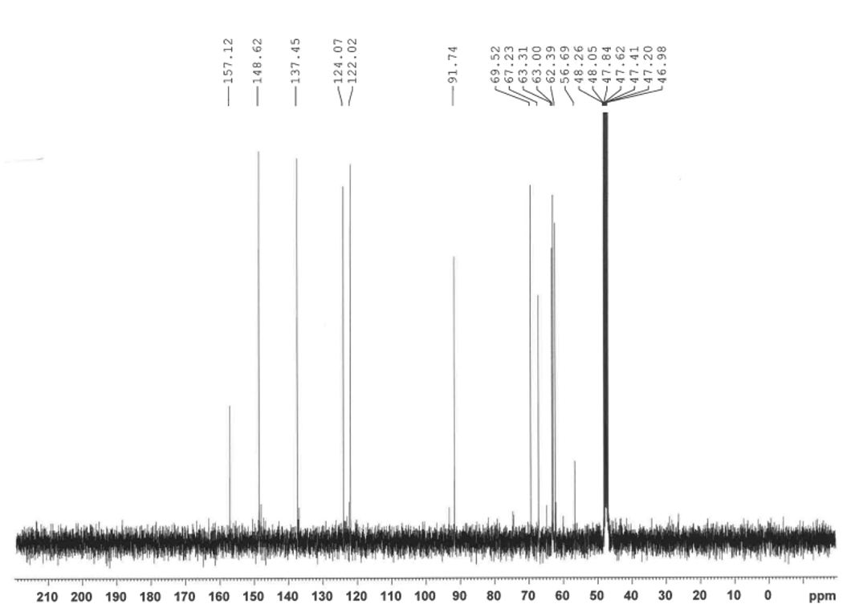

CD₃OD

Fig. S2 ¹³C NMR spectrum of 2-(pyridin-2-yl)oxazolidine-4,4-diyl)dimethanol (TN), (CD₃OD, 100 MHz).

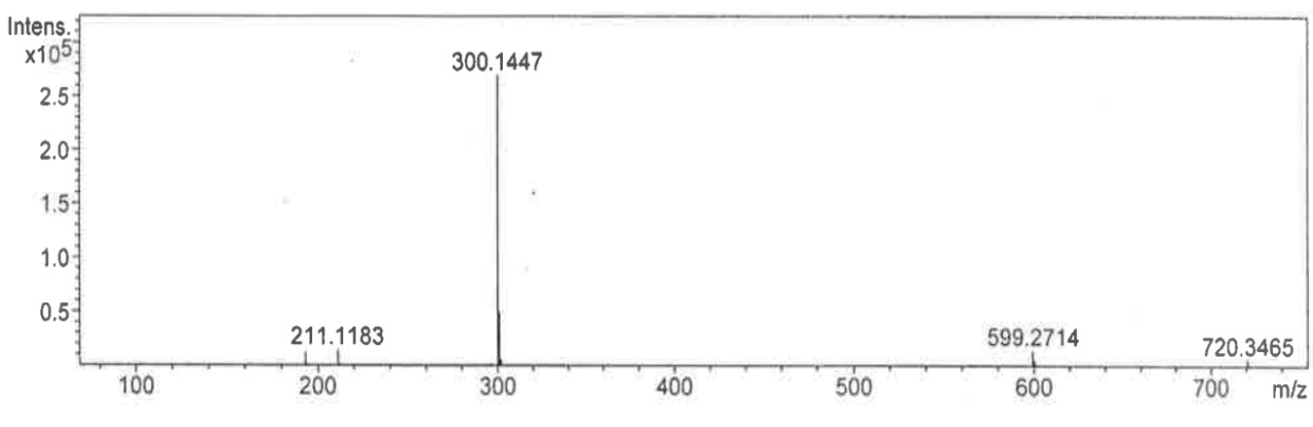
Fig. S3 Mass spectrum of 2-(pyridin-2-yl)oxazolidine-4,4-diyl)dimethanol (TN) (HRMS-ESI-TOF).

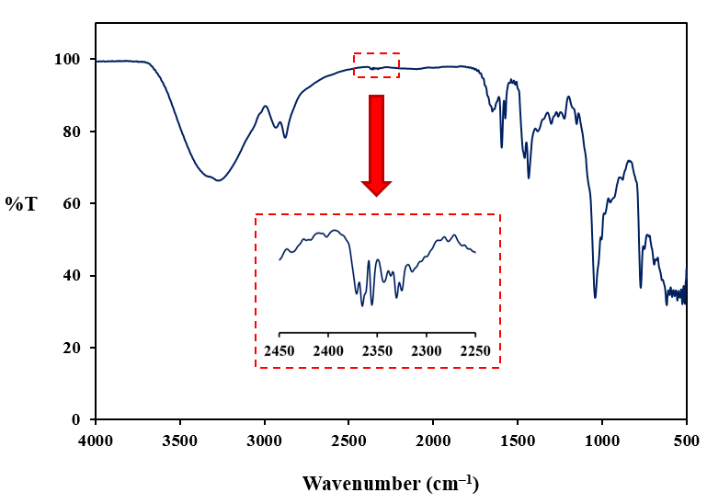
Fig. S4 Infrared spectrum of 2-(pyridin-2-yl)oxazolidine-4,4-diyl)dimethanol (TN).

