Clinical and bacteriological comparison of mouthwashes used in self-care during perioperative oral management: a randomized clinical trial

Hiroki Otagiri¹, Hiroshi Kurita^{1*}, Shin-ichi Yamada^{1,2}, Hironori Sakai¹, Haruko Tobata³, Kota Yanai³, Kaya Matsubara³, and Toru Eguchi³

*Corresponding author: Hiroshi Kurita, DDS, PhD
Department of Dentistry and Oral Surgery, Shinshu University School of Medicine, 3-1-1 Asahi, Matsumoto 390-8621, Japan
Tel.: +81 (0)263-37-2675; Fax: +81 (0)263-37-2676; E-mail: hkurita@shinshu-u.ac.jp

Supplementary Materials

Supplementary Figure Legends
Supplementary Figure 5 Changes in the oral flora in the buccal mucosa, tongue coat, and saliva from Bef_POC to 1W_surgery in each group (species level).
Only bacterial species with an average component ratio ≥ 1% among the subjects are labeled, and those with an average component ratio < 1% are grouped together as “other.” The top of each chart shows the time point at which antibiotic therapy was used and the duration of each antibacterial therapy.

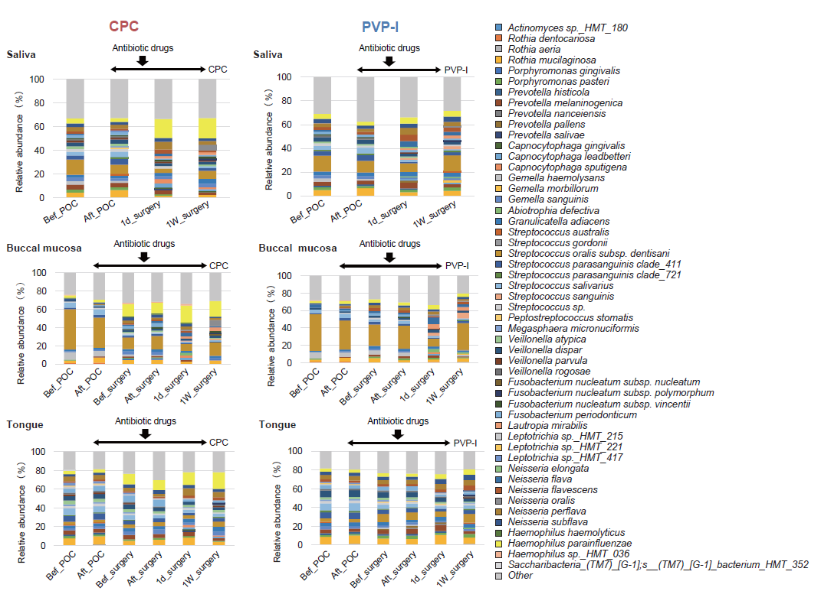
Supplementary Figure 5

