Clinical and bacteriological comparison of mouthwashes used in self-care during perioperative oral management: a randomized clinical trial

Hiroki Otagiri¹, Hiroshi Kurita^{1*}, Shin-ichi Yamada^{1,2}, Hironori Sakai¹, Haruko Tobata³, Kota Yanai³, Kaya Matsubara³, and Toru Eguchi³

*Corresponding author: Hiroshi Kurita, DDS, PhD
Department of Dentistry and Oral Surgery, Shinshu University School of Medicine, 3-1-1 Asahi, Matsumoto 390-8621, Japan
Tel.: +81 (0)263-37-2675; Fax: +81 (0)263-37-2676; E-mail: hkurita@shinshu-u.ac.jp

Supplementary Materials

Supplementary Figure Legends
Supplementary Figure 1 Differentially abundant taxa at (a) Bef_POC and (b) Aft_POC.
The distribution bar chart of LDA values shows the genera with LDA scores greater than the set value, and the species with significantly different abundances in different groups. The length of the histogram represents the magnitude of the impact of significantly different genera (LDA > 2, P < 0.05). Red and green is CPC and PVP-I groups, respectively.
Supplementary Figure 2 Differentially abundant taxa at Bef_surgery.
The distribution bar chart of LDA values shows the genera with LDA scores greater than the set value, and the species with significantly different abundances in different groups. The length of the histogram represents the magnitude of the impact of significantly different genera (LDA > 2, P < 0.05). Red and green is CPC and PVP-I groups, respectively.
Supplementary Figure 3 Differentially abundant taxa at Aft_surgery.
The distribution bar chart of LDA values shows the genera with LDA scores greater than the set value, and the species with significantly different abundances in different groups. The length of the histogram represents the magnitude of the impact of significantly different genera (LDA > 2, P < 0.05). Red and green is CPC and PVP-I groups, respectively.
Supplementary Figure 4 Differentially abundant taxa at 1d_surgery.
The distribution bar chart of LDA values shows the genera with LDA scores greater than the set value, and the species with significantly different abundances in different groups. The length of the histogram represents the magnitude of the impact of significantly different genera (LDA > 2, P < 0.05). Red and green is CPC and PVP-I groups, respectively.

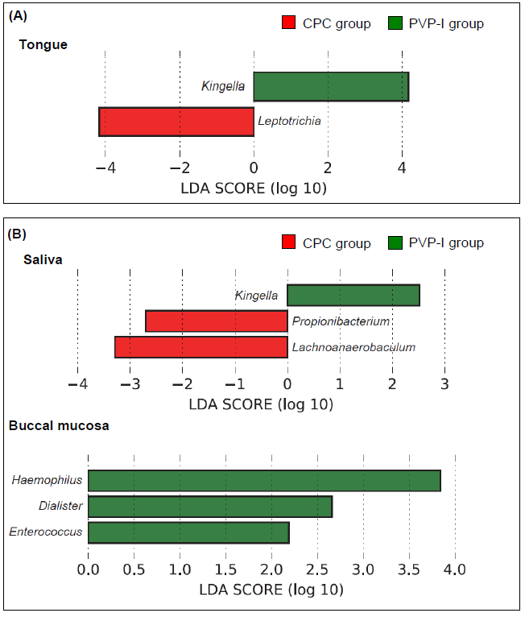
Supplementary Figure 1
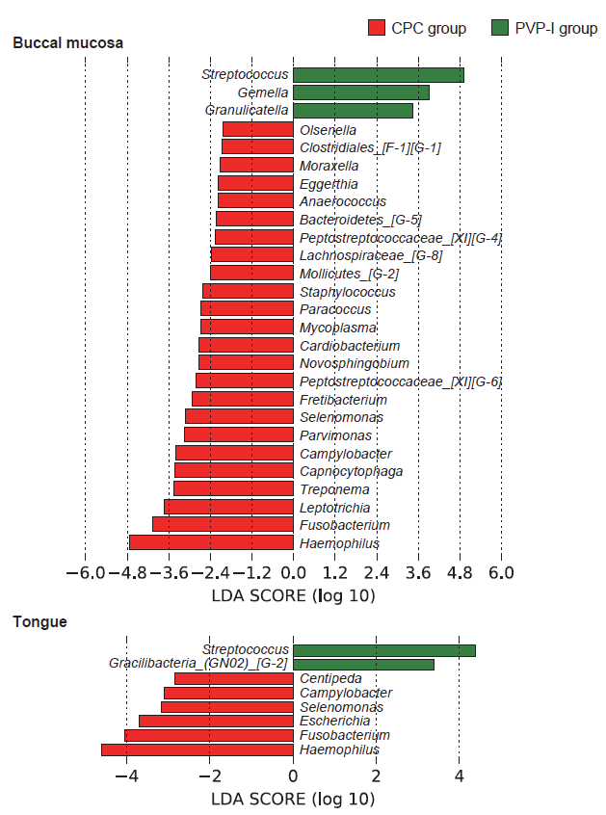
Supplementary Figure 2
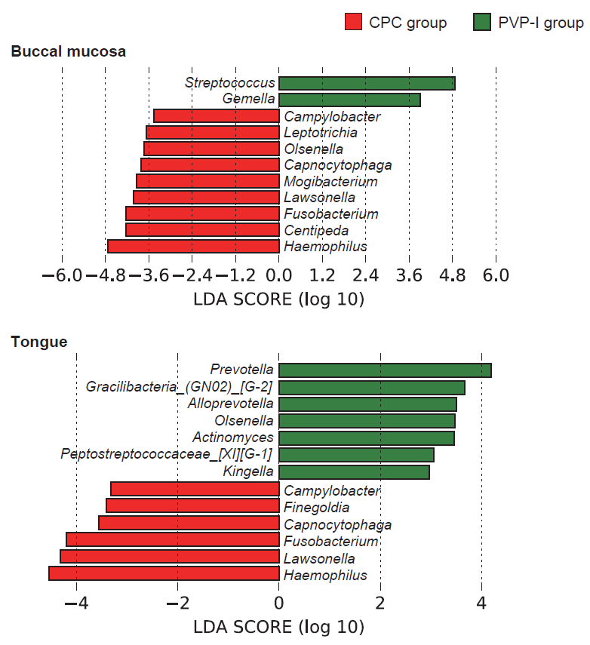
Supplementary Figure 3
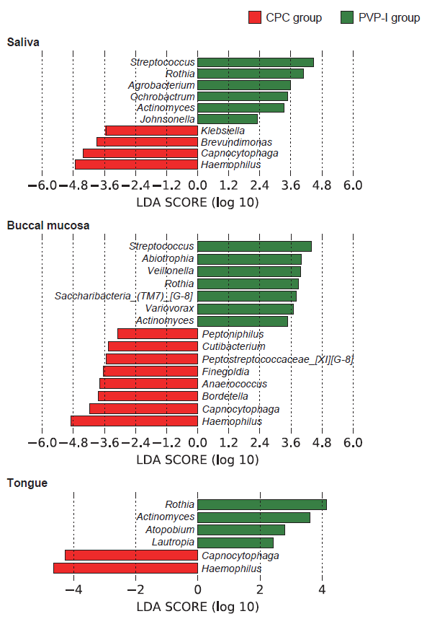
Supplementary Figure 4

