Table 1. Optimization of the reaction conditions in the synthesis of 4a
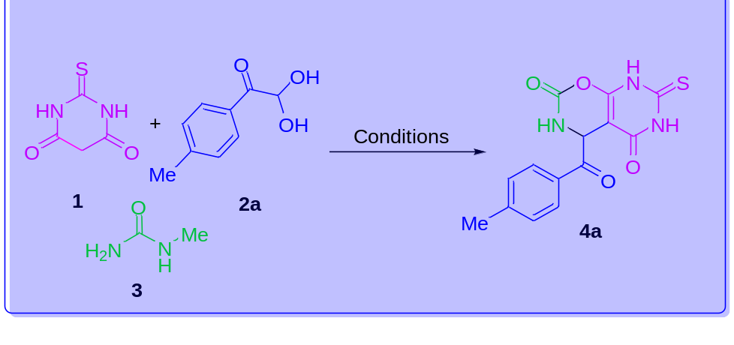
Entry | Solventª | mmol of 1:2a:3 | Temperature | Yield (%)^{b}
1 | THF | 1:1:1 | r.t | -
2 | Toluene | 1:1:1 | r.t | -
3 | 1,4-Dioxane | 1:1:1 | r.t | -
4 | CH₂Cl₂ | 1:1:1 | r.t | -
5 | EtOH | 1:1:1 | r.t | 20
6 | CH₃CN | 1:1:1 | r.t | 5
7 | EtOH | 1:1:1 | Reflux | 42
8 | EtOH | 1:2:1 | Reflux | 39
9 | EtOH | 1.5:1:1 | Reflux | 42
10 | EtOH | 1:1.5:1 | Reflux | 75
11 | EtOH | 1:1.5:1 | Reflux^{c} | 75
ª Reaction conditions: solvent was 5.0 mL and reaction time was 1 h.
^{b} Isolated yields
^{c} Reaction time was 12 h.

Table 2. Synthesis of 4-benzoyl-7-thioxo-4,6,7,8-tetrahydro-2H-pyrimido[5,4-e][1,3]oxazine-2,5(3H)-dione 4a-j
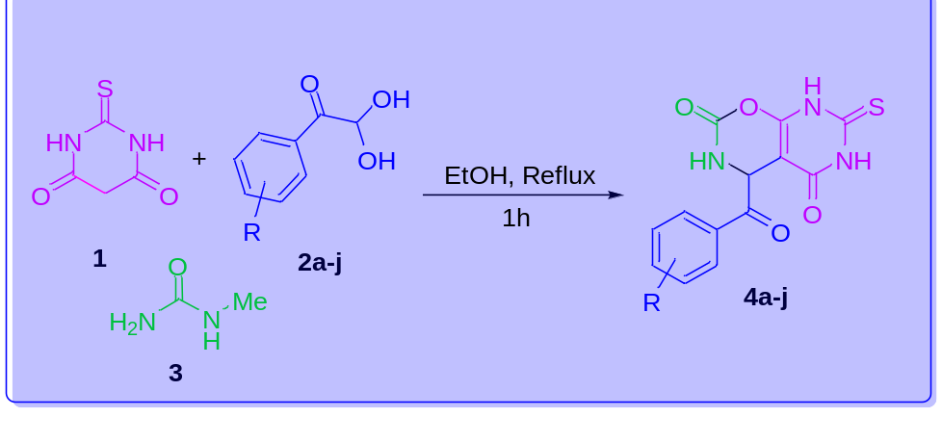

Entry | R | Product | Yield (%)ª | Yield (%)^{b}
1 | 4-Me | 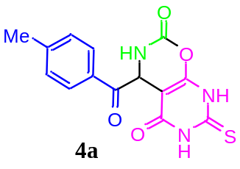 | 75 | 90
2 | 3,4-(OMe)₂ | 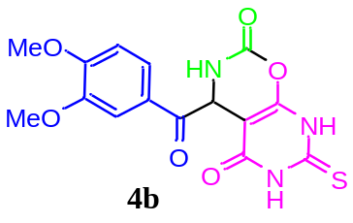 | 70 | 87
3 | C₄H₄ | 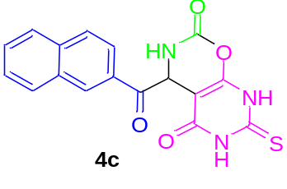 | 60 | 80
4 | 4-Cl | 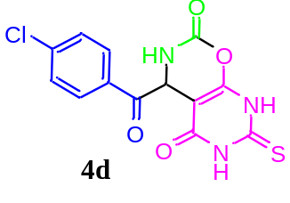 | 75 | 95
5 | 4-F | 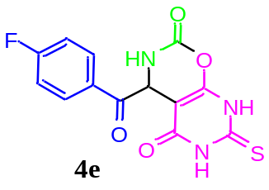 | 75 | 95
6 | 4-NO₂ | 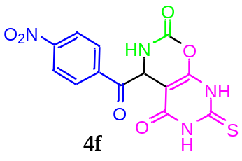 | 72 | 96
7 | 4-OMe | 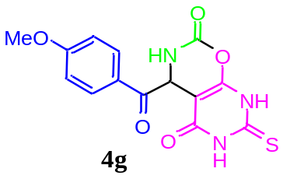 | 60 | 85
8 | 4-Br | 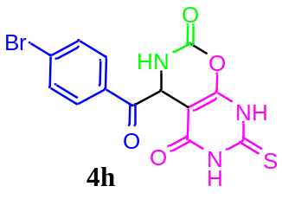 | 78 | 96
9 | 2-OMe | 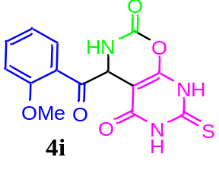 | 63 | 86
10 | 3-NO₂ | 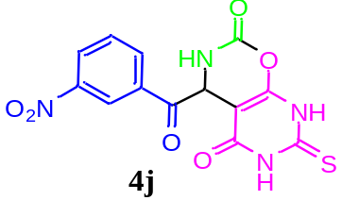 | 79 | 93
ª Isolated yield with thermal conditions; solvent was 5.0 mL, thiobarbituric acid (1, 1.0 mmol), aryl glyoxal (2a-j, 1.5 mmol), N-methyl urea (3, 1.0 mmol), reaction time was 1 h.
^{b} Isolated yields with microwave conditions at 700 W in 110 ºC for 5 min.

