Supporting Information
Melt-blown Fabric/SWCNTs Composites via the Dry and Binder-free Coating Process for Thermal Regulation and Electromagnetic Interference Shielding
Jun Cao†, Zhao Zhang†, Haohao Dong, Yuanlong Ding, Ruihao Chen, Yongping Liao*
School of Textile and Material Engineering, Dalian Polytechnic University, Dalian 116034, China
*Corresponding author:
E-mail: liaoyp@dlpu.edu.cn
† These two authors contributed equally to this work

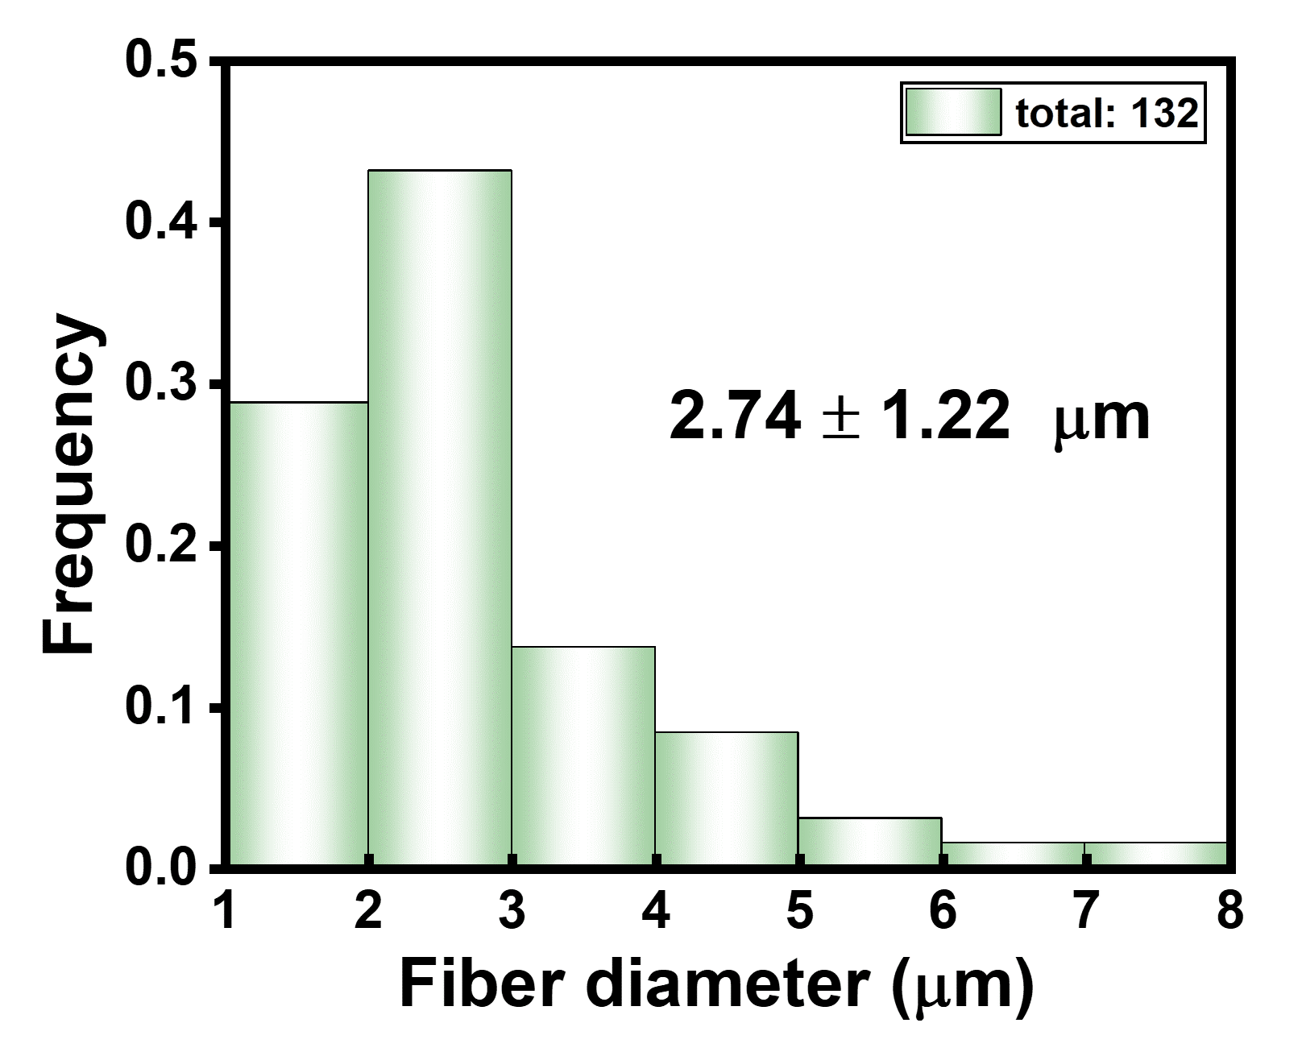
Figure S1. The diameter distribution of polypropylene fiber based on the statistics of 132 fibers.

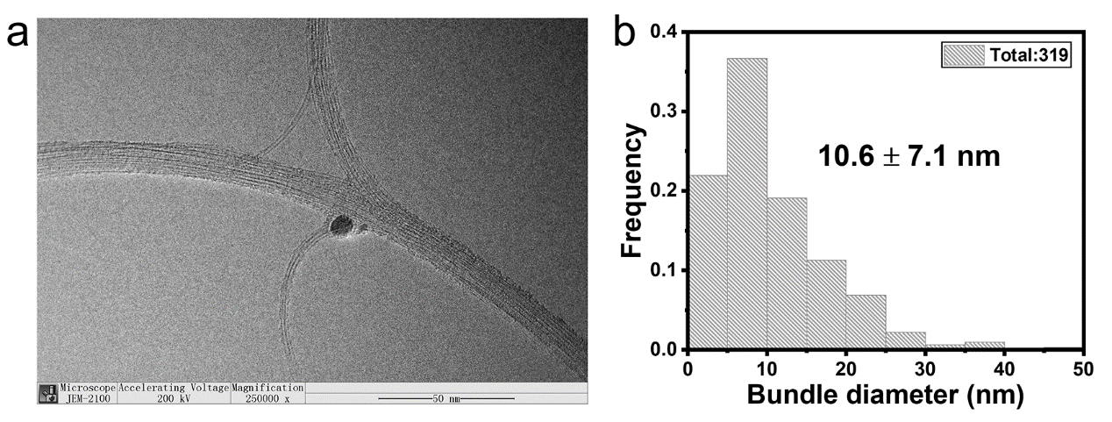
Figure S2. (a) The high-resolution TEM image of synthesized SWCNTs and (b) the corresponding bundle diameter distribution.
Figure S3. (a) The absorption spectrum of SWCNT thin film deposited for 3h (MBF/SWCNTs-3h) and (b) the radial breathing mode (RBM) of Raman spectrum.

Figure S4. The C 1s peaks detected from X-ray photoelectron spectroscopy (XPS) analysis of SWCNT film.
Figure S5. The representative infrared camera image for the pristine MBF/SWCNTs-8 at an applied voltage of 7V.

Figure S6. The doped MBF/SWCNTs acting as a fast water evaporator. (a) The optical images of a water droplet on MBF/SWCNTs with and without applied voltage, (b) the typical infrared camera image with an applied voltage of 3V, and (c) the mass change comparison.

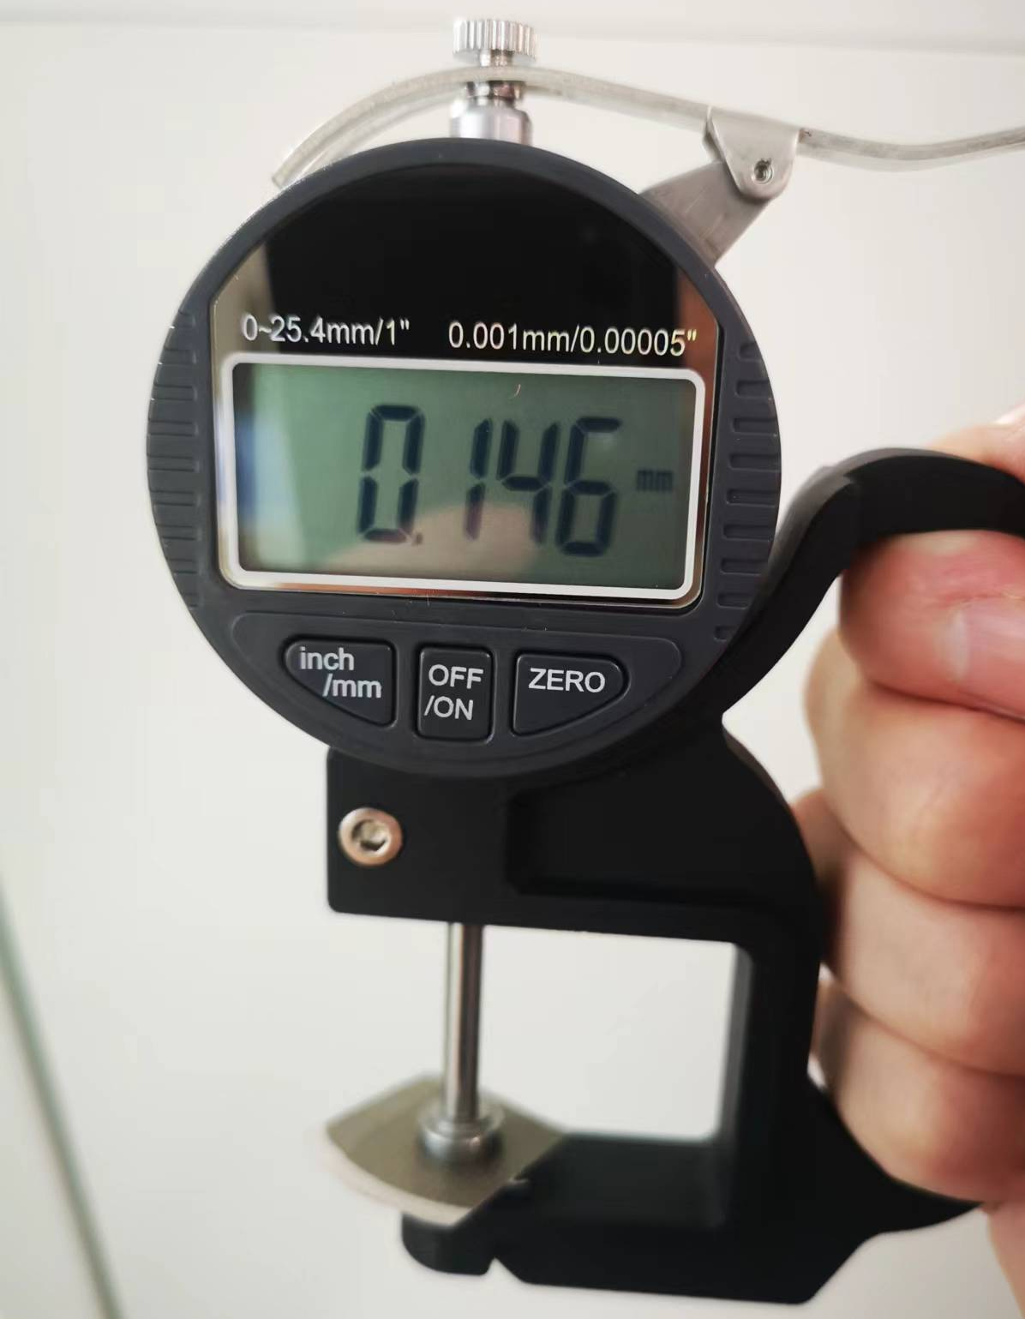
Figure S7. The thickness measurement of MBF/SWCNTs-8h using a thickness gauge, where it reads a thickness of 0.146 mm.

