Supporting information
Insight into the evolution characteristics on molecular weight of compost dissolved organic matters using high-performance size exclusion chromatography combined with a two-dimensional correlation analysis
Xufang Yuª, Ao Chengª, Dan Chenª, Ting Liª, Xingjun Fan^{a,b,}*, Xiang Wang^{a,b}, Wenchao Ji^{a,b}, Jianfei Wang^{a,b}, Lantian Ren^{c}

ªCollege of Resource and Environment, Anhui Science and Technology University, Fengyang 233100, P. R. China
^{b}Anhui Province Key Laboratory of Biochar and Cropland Pollution Prevention, Bengbu 233400, P. R. China
^{c}College of Agronomy, Anhui Science and Technology University, Fengyang 233100, China

* Corresponding author
E-mail address: fanxj@ahstu.edu.cn (Xingjun Fan);

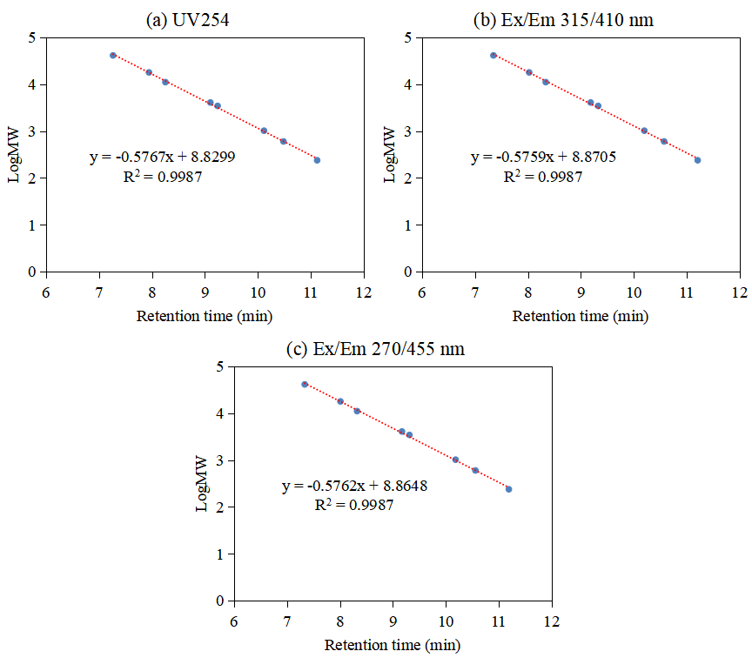
Fig. S1. Retention time-Log10 molecular weight (Da) calibration curve for the size exclusion chromatography analysis detected at UV254 (a), and fluorescence Ex/Em wavelength pairs of 315/410 nm (b) and 270/455 nm (c), used in this work.

Fig. S2. Variations of the DOC content of DOM during composting.
Fig. S3. Variations of the normalized UV-vis spectra by DOC content for compost DOM during composting.
Fig. S4. Variations of the EEM spectra of compost DOM during composting.

