Table S1 Sensitivity analysis for the rate of postoperative rescue analgesia.
Study omitted | Estimate | 95% CI |  | P | Heterogeneity | P
Study omitted | SMD | Lower | Upper | P | I2 (%) | P
Aditianingsih 2019 | 0.68 | 0.18 | 2.6 | 0.58 | 86% | 0.007
Hashim 2022 | 0.62 | 0.14 | 2.65 | 0.52 | 91% | 0.001
Kotb 2021 | 1.07 | 0.90 | 1.25 | 0.45 | 0% | 0.32
İPEK 2019 | 0.11 | 0.03 | 0.39 | 0.001 | 0% | 0.87
Öksüz 2019 | 0.58 | 0.13 | 0.26 | 0.48 | 28% | 0.24
Sato 2019 | 0.32 | 0.04 | 2.61 | 0.29 | 84% | 0.01
Pangthipampai 2021 | 0.50 | 0.10 | 2.40 | 0.30 | / | /
Yoshida 2020 | 1.01 | 0.81 | 1.25 | 0.96 | / | /
Table S2 Sensitivity analysis for postoperative pain scores.
Study omitted | Estimate | 95% CI |  | P | Heterogeneity | P
Study omitted | SMD | Lower | Upper | P | I2 (%) | P
Postoperative pain scores(caudal VS QLB) 2h
İPEK 2019 | / | / | / | / | / | /
Öksüz 2019 | / | / | / | / | / | /
Postoperative pain scores(caudal VS QLB) 4h
İPEK 2019 | / | / | / | / | / | /
Öksüz 2019 | -0.26 | -0.85 | 0.33 | 0.39 | / | /
Sato 2019 | -0.59 | -1.15 | -0.04 | 0.04 | / | /
Postoperative pain scores(caudal VS QLB) 12h
İPEK 2019 | / | / | / | / | / | /
Öksüz 2019 | / | / | / | / | / | /
Postoperative pain scores(caudal VS QLB) 24h
İPEK 2019 | / | / | / | / | / | /
Öksüz 2019 | 0.26 | -0.33 | 0.85 | 0.39 | / | /
Sato 2019 | -0.59 | -1.15 | -0.04 | 0.04 | / | /
Postoperative pain scores(epidural VS QLB2) 6h
Hashim 2022 | 3.75 | 2.74 | 4.77 | 0.000 | / | /
Kang 2019 | 0.31 | -0.20 | 0.82 | 0.23 | / | /
Postoperative pain scores(epidural VS QLB2) 12h
Hashim 2022 | 4.08 | 3.01 | 9.03 | 0.000 | / | /
Kang 2019 | 0.00 | -0.51 | 0.51 | 1 | / | /
Postoperative pain scores(epidural VS QLB2) 24h
Hashim 2022 | 6.20 | 0.83 | 4.74 | 0.000 | / | /
Kang 2019 | 0.20 | -0.30 | 0.71 | 0.43 | / | /
Postoperative pain scores(spinal VS QLB2) 2h
Okur2020 | 0.31 | -0.86 | 1.49 | 0.60 | 92% | 0.000
Salama2020 | 0.44 | -0.73 | 1.60 | 0.46 | 91% | 0.000
Tamura20219 | -0.05 | -0.53 | 0.44 | 0.85 | 51% | 0.13
Yoshida2020 | 0.61 | -0.29 | 1.52 | 0.18 | 88% | 0.000
Postoperative pain scores(spinal VS QLB2) 6h
Okur2020 | -0.03 | -0.89 | 0.84 | 0.95 | 89% | 0.000
Salama2020 | -0.19 | -1.18 | 0.80 | 0.71 | 91% | 0.000
Tamura 2019 | -0.43 | -0.98 | 0.12 | 0.12 | 69% | 0.02
Pangthipampai2021 | -0.18 | -1.12 | 0.76 | 0.70 | 91% | 0.000
Yoshida2020 | 0.12 | -0.57 | 0.81 | 0.73 | 84% | 0.000
Postoperative pain scores(spinal VS QLB2) 12h
Salama2020 | 0.03 | -0.42 | 0.48 | 0.90 | 0% | 0.89
Pangthipampai2021 | -1.46 | -4.45 | 1.53 | 0.34 | 97% | 0.000
Yoshida2020 | -1.49 | -4.42 | 1.44 | 0.32 | 97% | 0.000
Postoperative pain scores(spinal VS QLB2) 24h
Okur2020 | -0.44 | -1.48 | 0.59 | 0.40 | 92% | 0.000
Salama2020 | -0.33 | -1.16 | 0.51 | 0.44 | 87% | 0.000
Tamura 2019 | -0.92 | -1.78 | -0.05 | 0.04 | 86% | 0.000
Pangthipampai2021 | -0.82 | -1.92 | 0.28 | 0.14 | 92% | 0.000
Yoshida2020 | -0.62 | -1.76 | 0.52 | 0.29 | 93% | 0.000
Postoperative pain scores(epidural VS QLB3) 2h
Aditianingsih2019 | / | / | / | / | / | /
Rahendra2019 | / | / | / | / | / | /
Postoperative pain scores(epidural VS QLB3) 6h
Aditianingsih2019 | 0.44 | -0.75 | 1.63 | 0.47 | 93% | 0.000
Kang2019 | -0.63 | -1.45 | 0.18 | 0.13 | 88% | 0.000
Kotb2021 | 0.24 | -1.18 | 1.66 | 0.74 | 96% | 0.000
Rahendra2019 | 0.02 | -1.60 | 1.64 | 0.98 | 96% | 0.000
SHE 2021 | 0.02 | -1.63 | 1.68 | 0.98 | 96% | 0.000
Postoperative pain scores(epidural VS QLB3) 12h
Aditianingsih2019 | 0.18 | -1.11 | 1.47 | 0.78 | 94% | 0.000
Kang2019 | -0.33 | -1.00 | 0.34 | 0.33 | 83% | 0.0005
Kotb2021 | 0.59 | -0.27 | 1.46 | 0.18 | 90% | 0.000
Rahendra2019 | 0.13 | -1.17 | 1.43 | 0.84 | 94% | 0.000
SHE 2021 | 0.18 | -1.14 | 1.50 | 0.79 | 94% | 0.000
Postoperative pain scores(epidural VS QLB3) 24h
Aditianingsih2019 | 0.06 | -0.65 | 0.78 | 0.86 | 84% | 0.0001
Kang2019 | -0.16 | -0.47 | 0.15 | 0.31 | 27% | 0.25
Kotb2021 | 0.23 | -0.29 | 0.76 | 0.38 | 76% | 0.006
Rahendra2019 | 0.09 | -0.62 | 0.79 | 0.81 | 84% | 0.0004
SHE 2021 | 0.07 | -0.65 | 0.80 | 0.84 | 84% | 0.0004
Fig. S1A. Egger’s test for the pain scores between QLB3 and epidural at 6h.
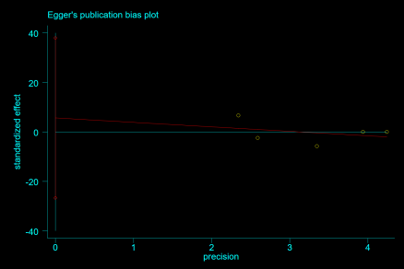
Fig. S1B. Egger’s test for the pain scores between QLB3 and epidural at 12h.
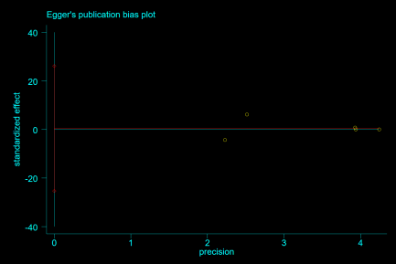
Fig. S2A. Egger’s test for the pain scores between QLB2 and spinal at 6h.
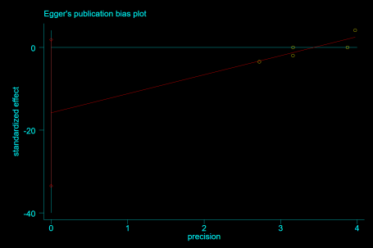
Fig. S2B. Egger’s test for the pain scores between QLB2 and spinal at 12h.
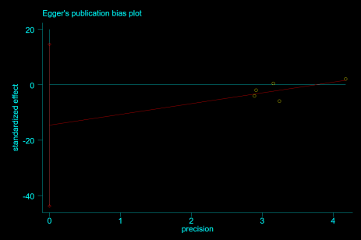

Appendix 1
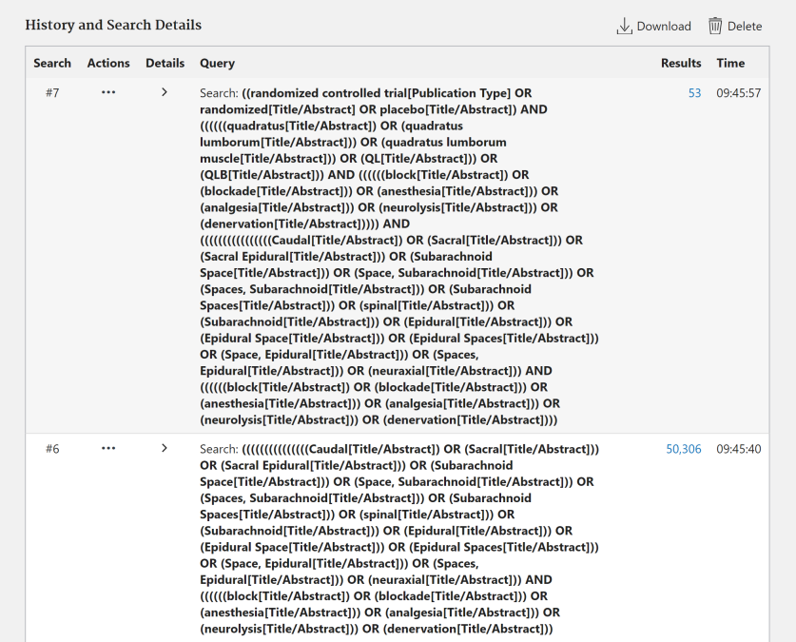
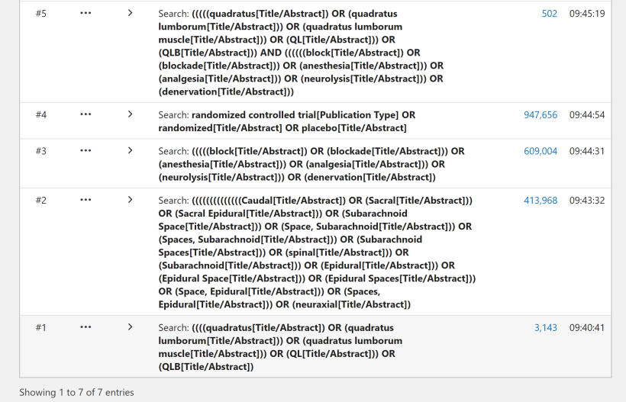
History and Search Details to Pubmed
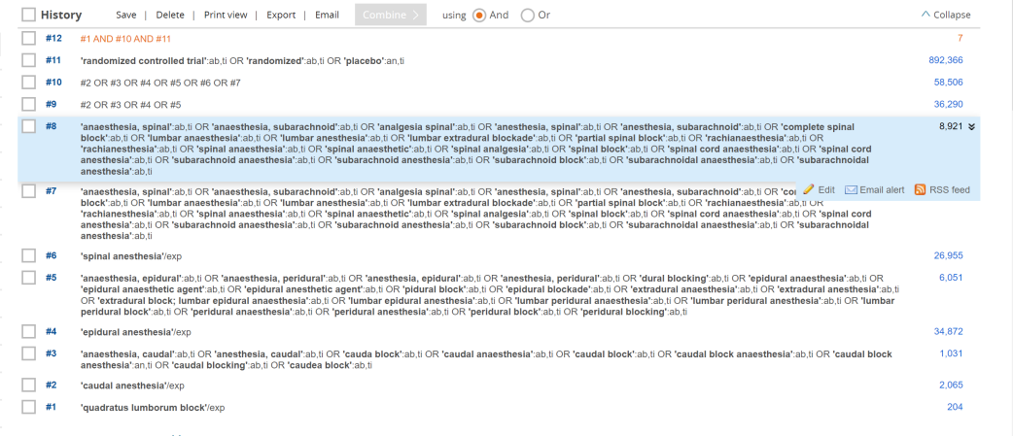
History and Search Details to Embase
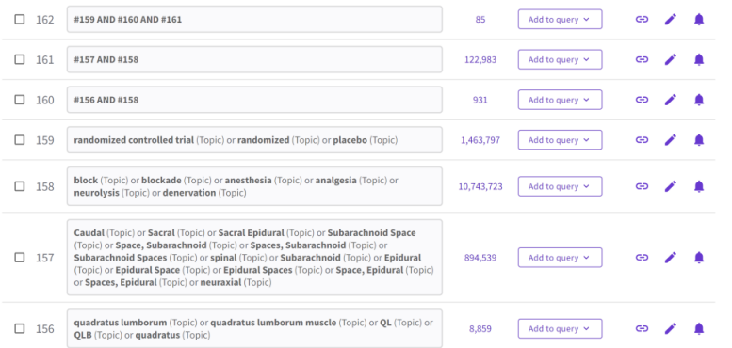
History and Search Details to Web of Science
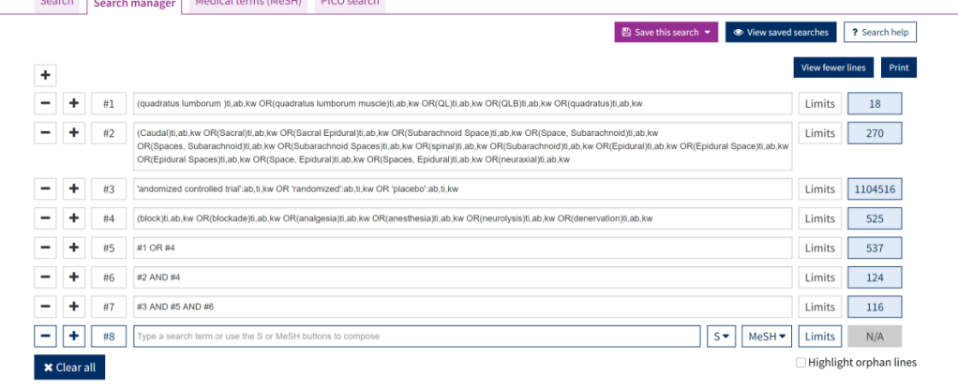
History and Search Details to Cochrane Library
Appendix 2
Outcomes | Design | Number  of studies | Risk of bias | Inconsistency | Indirectness | Imprecision | Other  considerations | Quality of evidence (GRADE)
Rate of postoperative rescue analgesia
QLB VS epidural | RCT | 3 | Not serious | Serious | Not serious | serious | None | Low
QLB VS caudal | RCT | 3 | Not serious | Serious | Not serious | serious | None | Low
QLB VS spinal | RCT | 2 | Not serious | Not serious | Not serious | serious | None | Moderate
Postoperative pain scores(caudal VS QLB)
Pain scores – 2h | RCT | 2 | Not serious | Not serious | Not serious | serious | None | Moderate
Pain scores – 4h | RCT | 3 | Not serious | Not serious | Not serious | serious | None | Moderate
Pain scores – 12h | RCT | 2 | Not serious | Not serious | Not serious | serious | None | Moderate
Pain scores – 24h | RCT | 3 | Not serious | Serious | Not serious | serious | None | Low
Postoperative pain scores(epidural VS QLB2)
Pain scores –6h | RCT | 2 | Not serious | Serious | Not serious | serious | None | Low
Pain scores – 12h | RCT | 2 | Not serious | Serious | Not serious | serious | None | Low
Pain scores – 24h | RCT | 2 | Not serious | Serious | Not serious | serious | None | Low
Postoperative pain scores(spinal VS QLB2)
Pain scores – 2h | RCT | 4 | Not serious | Serious | Not serious | serious | None | Low
Pain scores – 6h | RCT | 5 | Not serious | Serious | Not serious | serious | None | Low
Pain scores – 12h | RCT | 3 | Not serious | Serious | Not serious | serious | None | Low
Pain scores – 24h | RCT | 5 | Not serious | Serious | Not serious | serious | None | Low
Postoperative pain scores(epidural VS QLB3)
Pain scores – 2h | RCT | 2 | Not serious | Not serious | Not serious | serious | None | Moderate
Pain scores – 6h | RCT | 5 | Not serious | Serious | Not serious | serious | None | Low
Pain scores – 12h | RCT | 5 | Not serious | Serious | Not serious | serious | None | Low
Pain scores – 24h | RCT | 5 | Not serious | Serious | Not serious | serious | None | Low
Patient satisfaction | RCT | 3 | Not serious | Serious | Not serious | serious | None | Low
complications | RCT | 8 | Not serious | Not serious | Not serious | serious | None | Moderate

