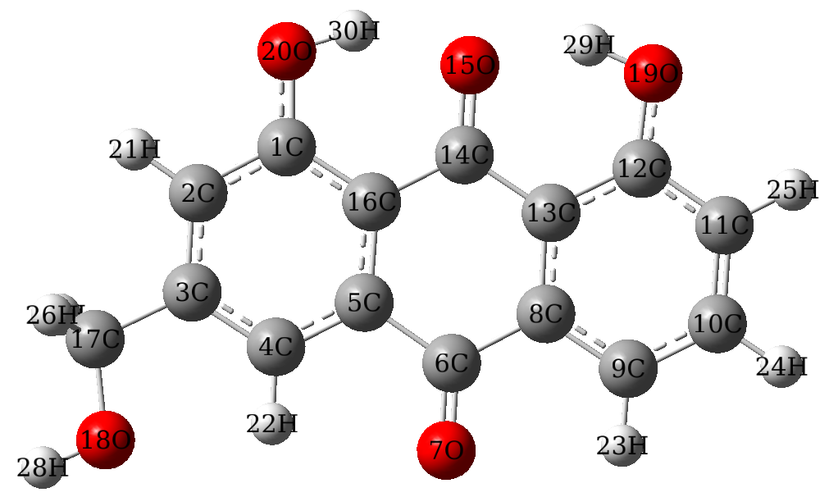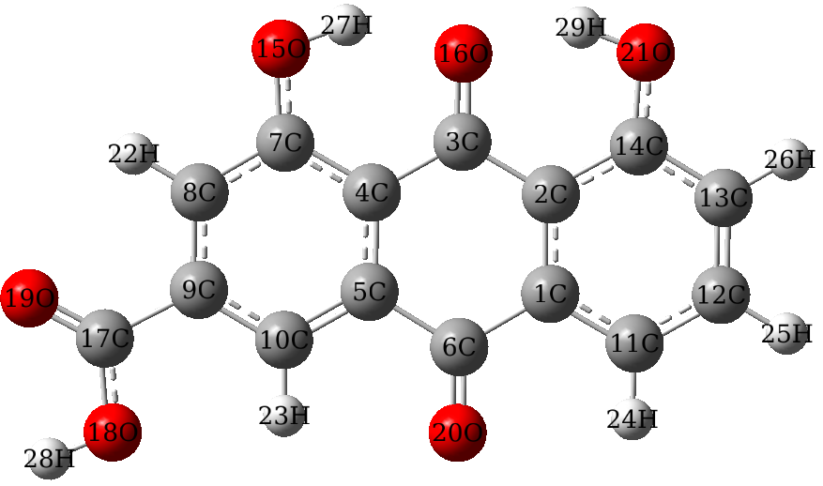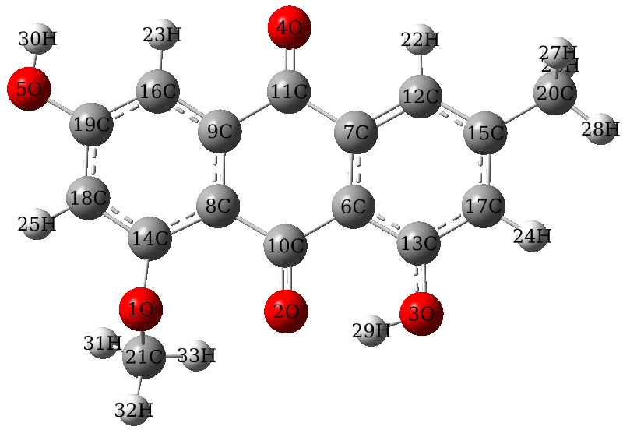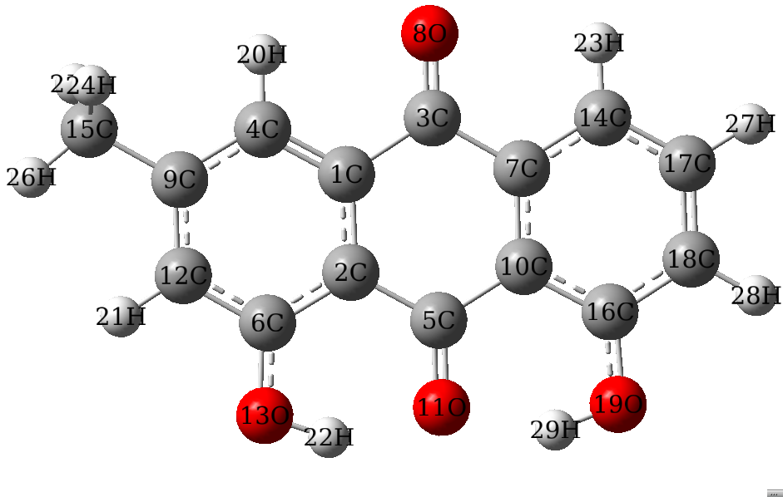
(a) (b) (c) (d)
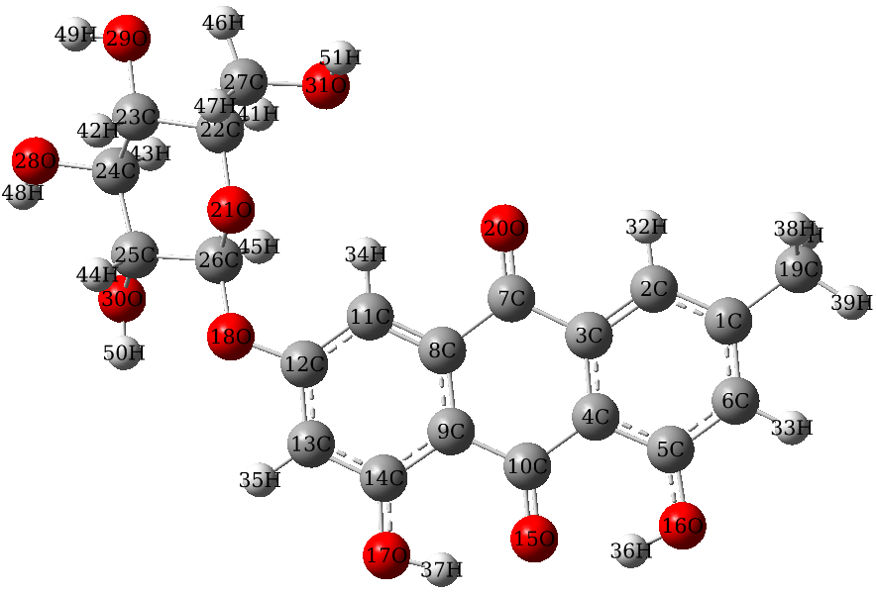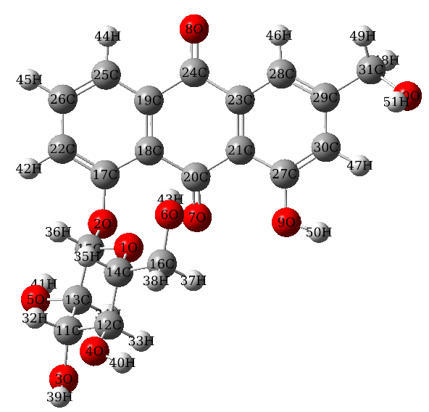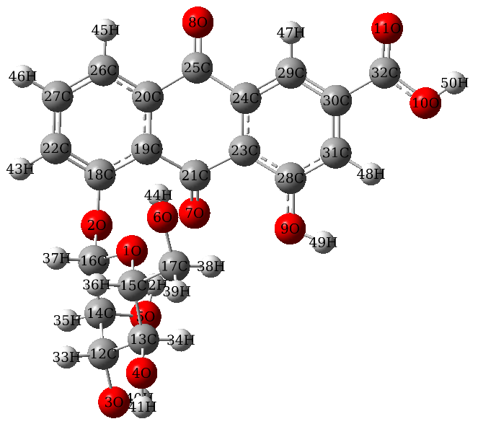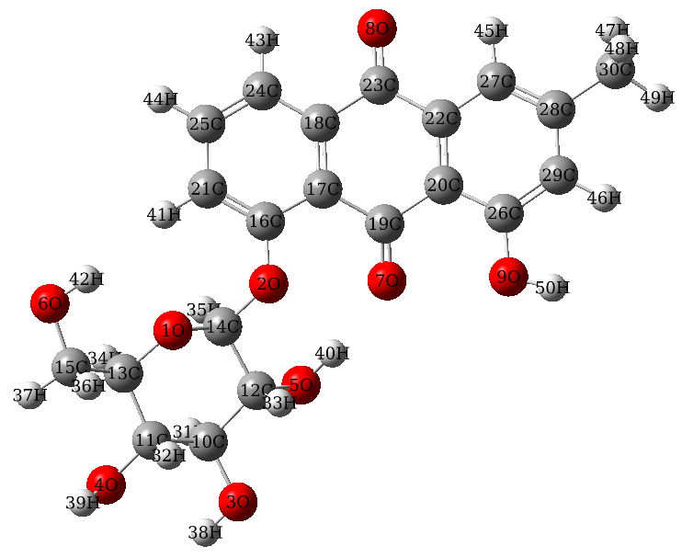
(e) (f) (g) (h)
Fig.S1 Schematic diagram of two-dimensional plane structure of (a) Aloe_emodin, (b) rhein, (c) emodin 8-methyl ether, (d) Crysophanol, (e) Emodin-6-O-beta-D-glucopyranoside, (f) Aloe-emodin-8-O-beta-D-glucopyranoside, (g) Rhein 8-O-beta-D-Glucopyranoside and (h) Chrysophanol-8-O- glucoside. The number and type of the atoms have been indicated.

Table S1 Pivotal structural parameters of the compounds M1-M10.
Parameters Optimized Active site Parameters Optimized Active site
M1 |  |  | M2
C6-O7 | 1.2221 | 1.2220 | C3-C17 | 1.5103 | 1.5105
C12-O17 | 1.3413 | 1.3414 | C17-O18 | 0.4195 | 0.4196
O17-H25 | 0.9871 | 0.9873 | O18-H28 | 0.9626 | 0.9631
O19-H27 | 0.9875 | 0.9875 | C1-O20-H30 | 107.05 | 107.05
O18-H26 | 0.966 | 0.9660 | C12-O19-H29 | 107.1 | 107.08
C11-C12-O17-H25 | 180.0 | 0.4009 | C3-C17-O18-H28 | 180.0 | 43.19
C2-C1-O19-H27 | 180.0 | 128.31
C2-C3-O18-H26 | 0.0 | -157.34
M3 |  |  | M4
C17-O19 | 1.2099 | 1.2103 | C14-O1 | 1.365 | 1.3652
C17-O18 | 1.3437 | 1.3441 | O1-C21 | 1.4393 | 1.4399
O18-H28 | 0.9706 | 0.9699 | O5-H30 | 0.9662 | 0.966
C7-O15-H27 | 107.19 | 107.19 | O3-H29 | 0.9919 | 0.9923
C14-O21-H29 | 107.38 | 107.36 | C19-O5-H30 | 110.20 | 110.26
C9-C17-O18-H28 | 180.0 | -109.84 | C13-O3-H29 | 105.91 | 105.88
 |  |  | O8-C14-O1-C21 | -84.43 | 177.53
M5 |  |  | M6
C6-O13 | 1.3408 | 1.3411 | C17-O2 | 1.3702 | 1.3701
O13-H22 | 0.9852 | 0.9863 | O2-C15 | 1.4249 | 1.425
C16-O19 | 1.3409 | 1.3412 | O8-H50 | 0.9662 | 0.9654
O19-H29 | 0.9855 | 0.985 | O10-H51 | 0.9921 | 0.9925
C2-C6-O13-H22 | 0 | -52.46 | C18-C17-O2-C15 | 63 | 56.17
C10-C16-O19-H29 | 0 | -48.52 | C25-C26-O8-H50 | -179.98 | -168.85
 |  |  | C22-C27-O10-H51 | 0.5401 | 23.83
M7 |  |  | M8
C12-O18 | 1.364 | 1.3639 | O2-C17 | 1.3772 | 1.3779
O18-C26 | 1.4129 | 1.4126 | C20-O7 | 1.2128 | 1.2118
O17-H37 | 0.9857 | 0.9858 | C27-O9 | 1.3529 | 1.3521
O16-H36 | 0.9857 | 0.9859 | O9-H50 | 0.9639 | 0.9635
C11-C12-O18-C26 | 16.23 | -116.95 | C31-O10 | 1.4208 | 1.4213
C9-C14-O17-H37 | -0.084 | -36.02 | O10-H51 | 0.9632 | 0.9626
C4-C5-O16-H36 | -0.139 | 0.2294 | C18-C17-O2-C15 | 109.41 | 137.82
 |  |  | C21-C27-O9-H50 | -178.4 | -10.29
 |  |  | C29-C31-O10-H51 | -66.81 | 112.95
M9 |  |  | M10
C18-O2 | 1.3567 | 1.3584 | C16-O2 | 1.3619 | 1.3625
C16-O2 | 1.391 | 1.3905 | C14-O2 | 1.4053 | 1.4057
C21-O7 | 1.1862 | 1.186 | O5-H40 | 0.9719 | 0.9729
C28-O9 | 1.3379 | 1.3381 | O3-H38 | 0.9641 | 0.9636
O9-H49 | 0.9408 | 0.9407 | O9-H50 | 0.9637 | 0.9641
C32-O11 | 1.1806 | 1.1805 | C26-O9 | 1.3518 | 1.3518
C32-O10 | 1.3266 | 1.3266 | C17-C16-O2-C14 | -141.44 | 111.44
O10-H50 | 0.9459 | 0.9465 | C20-C26-O9-H50 | -176.91 | 35.54
C19-C18-O2-C16 | 101.97 | 87.28
C23-C28-09-H49 | -177.57 | -177.32
C30-C32-O10-H50 | 179.99 | -75.41

Table S2 Electron densities and Laplacian values of electron densities for M1 at both status
化学键 M1 ρ_{bcp} e/A⁻³ DockM1ρ_{bcp} e/A⁻³ M1 ∇²ρ_{bcp}e/A⁻⁵ DockM1∇²ρ_{bcp}e/A⁻⁵
C1-C2 | 2.123 | 1.997 | -21.194 | -20.926
C1-O19 | 2.085 | 1.895 | -9.610 | -8.473
O19-H27 | 2.273 | 2.084 | -47.384 | -31.848
C2-H21 | 1.905 | 1.719 | -24.158 | -17.534
C2-C3 | 2.146 | 2.019 | -21.371 | -20.898
C3-O18 | 1.994 | 1.819 | -7.283 | -7.208
O18-H26 | 2.462 | 2.234 | -50.385 | -37.323
C3-C4 | 2.097 | 1.976 | -20.959 | -20.479
C4-H22 | 1.947 | 1.717 | -25.849 | -17.443
C4-C5 | 2.159 | 2.048 | -21.251 | -21.709
C5-C16 | 2.022 | 1.914 | -18.819 | -19.430
C16-C14 | 1.941 | 1.814 | -18.068 | -18.145
C14-O15 | 2.471 | 2.315 | -2.364 | -10.725
C13-C14 | 1.919 | 1.791 | -17.751 | -17.832
C8-C13 | 2.024 | 1.913 | -18.862 | -19.457
C5-C6 | 1.813 | 1.679 | -16.174 | -15.721
C6-O7 | 2.703 | 2.513 | 4.952 | -6.037
C6-C8 | 1.823 | 1.690 | -16.301 | -15.936
C12-C13 | 2.061 | 1.929 | -19.746 | -19.383
C11-C12 | 2.117 | 1.985 | -21.285 | -20.522
C12-O17 | 2.072 | 1.869 | -9.445 | -7.617
O17-H25 | 2.278 | 2.118 | -47.451 | -29.614
C8-C9 | 2.149 | 2.039 | -21.165 | -21.636
C9-H23 | 1.948 | 1.736 | -25.637 | -17.882
C9-C10 | 2.074 | 1.956 | -19.981 | -20.348
C10-C11 | 2.139 | 2.020 | -20.933 | -21.312
C11-H24 | 1.925 | 1.703 | -24.824 | -17.182
C10-C20 | 1.728 | 1.607 | -14.798 | -14.858
C20-H28 | 1.891 | 1.667 | -23.516 | -16.626
C20-H29 | 1.867 | 1.669 | -22.913 | -16.653
C20-H30 | 1.867 | 1.670 | -22.911 | -16.711

Table S3 Electron densities and Laplacian values of electron densities for M6 at both status
化学键 M6 ρ_{bcp} e/A⁻³ DockM6ρ_{bcp} e/A⁻³ M6 ∇²ρ_{bcp}e/A⁻⁵ DockM6∇²ρ_{bcp}e/A⁻⁵
C17-C21 | 1.984 | 2.012 | -20.620 | -21.120
C17-O2 | 1.691 | 1.740 | -6.437 | -6.727
O2-C15 | 1.399 | 1.519 | -3.771 | -4.775
C21-H42 | 1.785 | 1.709 | -18.562 | -17.276
C21-C26 | 2.009 | 2.015 | -20.888 | -20.984
C26-O8 | 1.739 | 1.823 | -6.834 | -7.188
O8-H50 | 2.065 | 2.240 | -28.475 | -37.430
C25-C26 | 2.004 | 2.006 | -20.906 | -20.929
C25-H44 | 1.823 | 1.735 | -19.453 | -17.869
C25-C19 | 2.039 | 2.035 | -21.581 | -21.483
C18-C19 | 1.900 | 1.899 | -19.246 | -19.188
C18-C20 | 1.756 | 1.731 | -17.130 | -16.589
C20-O7 | 2.224 | 2.392 | -9.986 | -8.380
C20-C22 | 1.796 | 1.760 | -17.561 | -16.989
C22-C23 | 1.928 | 1.927 | -19.783 | -19.751
C19-C24 | 1.672 | 1.666 | -15.635 | -15.494
C24-O9 | 2.401 | 2.509 | -8.998 | -6.274
C23-C24 | 1.737 | 1.714 | -16.790 | -16.349
C22-C27 | 1.922 | 1.928 | -19.513 | -19.534
C27-C30 | 1.967 | 1.987 | -20.442 | -20.791
C27-O10 | 1.857 | 1.895 | -8.096 | -8.297
O10-H51 | 1.794 | 2.045 | -22.393 | -33.317
C23-C28 | 2.037 | 2.031 | -21.500 | -21.388
C28-H45 | 1.810 | 1.734 | -19.187 | -17.857
C28-C29 | 1.945 | 1.956 | -20.307 | -20.419
C29-C30 | 2.030 | 2.030 | -21.514 | -21.576
C30-H46 | 1.804 | 1.725 | -19.006 | -17.662
C29-C31 | 1.583 | 1.609 | -14.326 | -14.866
C31-H49 | 1.756 | 1.670 | -18.139 | -16.713
C31-H47 | 1.734 | 1.670 | -17.757 | -16.669
C31-H48 | 1.733 | 1.668 | -17.747 | -16.649

