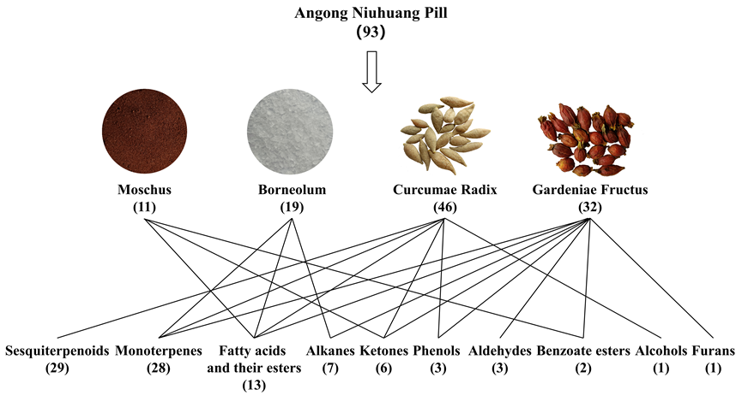
Figure S1 The sources of volatile constituents in ANP samples.
Figure S2 The concentration heat map of 21 volatile analytes in ANP samples from eight batches.

