9. Supplementary Data
An in-house protocol of S. frugiperda semi-solid artificial diet was used for S. frugiperda caterpillar rearing (adapted from (Bowling 1967; Greene et al. 1976). Mixture A was prepared by combining 100g of navy bean flour, 25g of soy flour, and 600ml of filtered water and mixing with a stick blender. Mixture A was heated using a microwave to a boil (4 mins). In a separate measuring cup, mixture B was prepared by combining 18g of agar (GELITA, A-181017), 1.5g of sorbic acid (Sigma-Aldrich, S1626), and 500ml of filtered water and mixed with a spatula. Mixture B was heated using a microwave until boiling (8 mins). Mixture A and B were combined with a stick blender and allowed to cool down to 60℃ at room temperature. The remaining dry ingredients including 60g of wheat germ, 30g of brewers’ dry yeast, 3.3g of L-ascorbic acid (Sigma-Aldrich, A4403), 10g of Vanderzant vitamin mixture for insect (Sigma-Aldrich, V1007), 15g of casein (Sigma-Aldrich, C7078), and 3g of Methyl parahydroxybenzoate (Sigma-Aldrich, 79721) were added. Finally, 5ml of vegetable oil was added. All the ingredients were thoroughly combined with a stick blender. The diet was poured into 45-wells plates or 32-well plates while still warm, then allowed to set at room temperature for at least an hour. The diet was either used immediately or was stored at 4°C for a maximum of one week.
10. Supplementary Figures
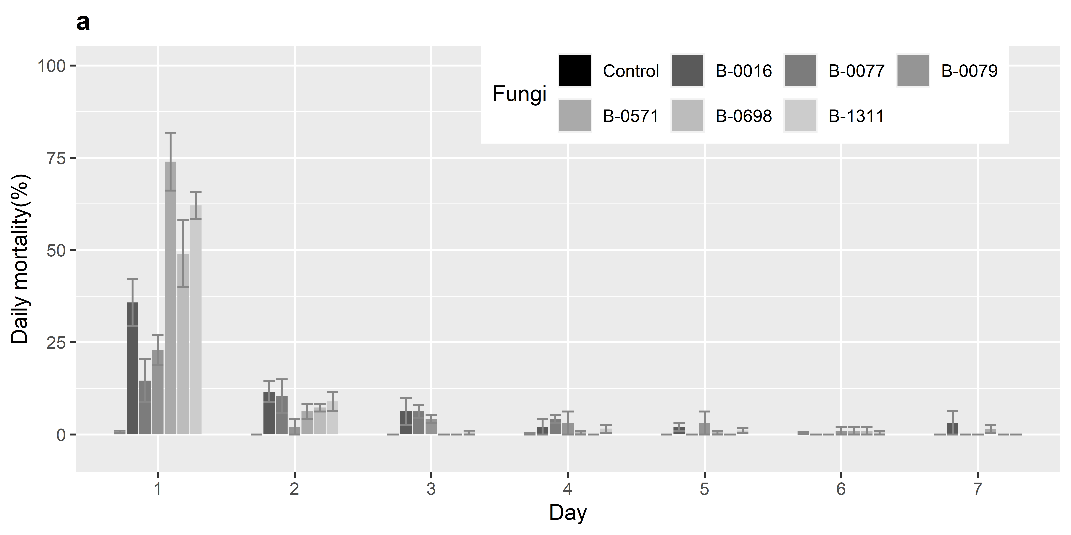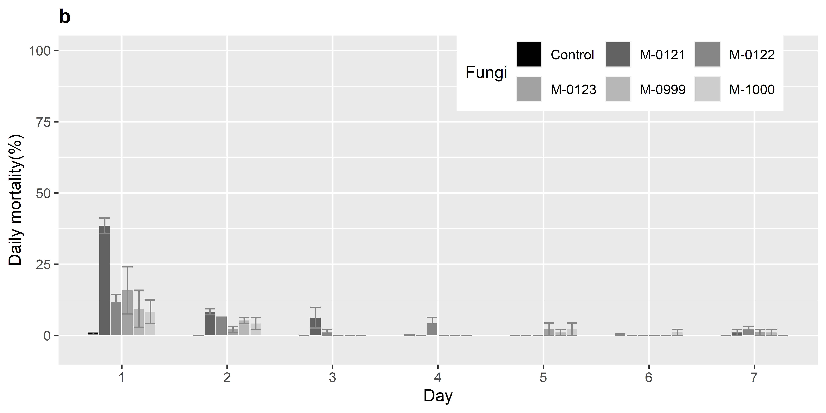
Figure S1. Daily mortality (%) of 3rd instar Spodoptera frugiperda infected with a). Beauveria sp. and b). Metarhizium sp. for seven days after infection. The error bars indicate the standard deviation of the results and the various shades of grey correspond to the treatment (labelled in the right conner).
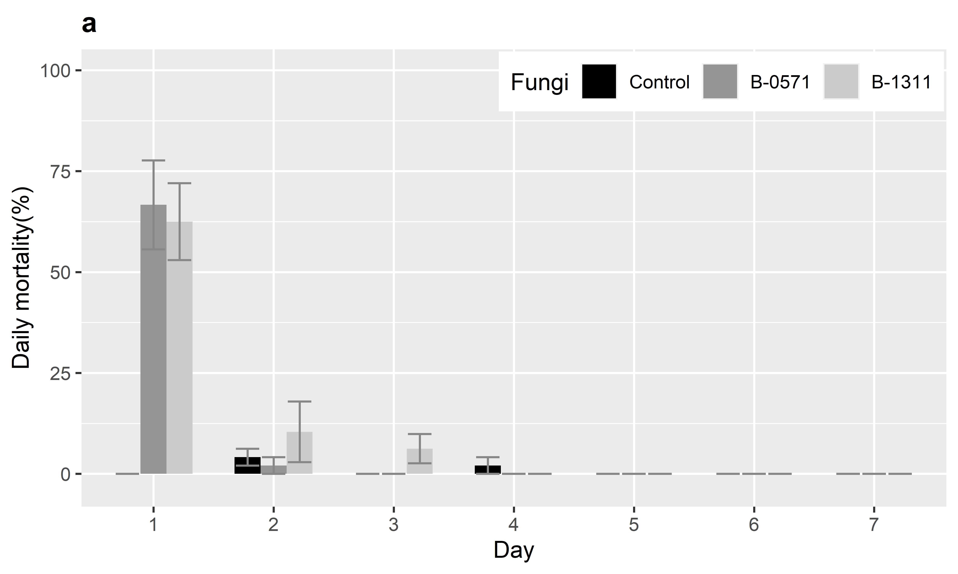
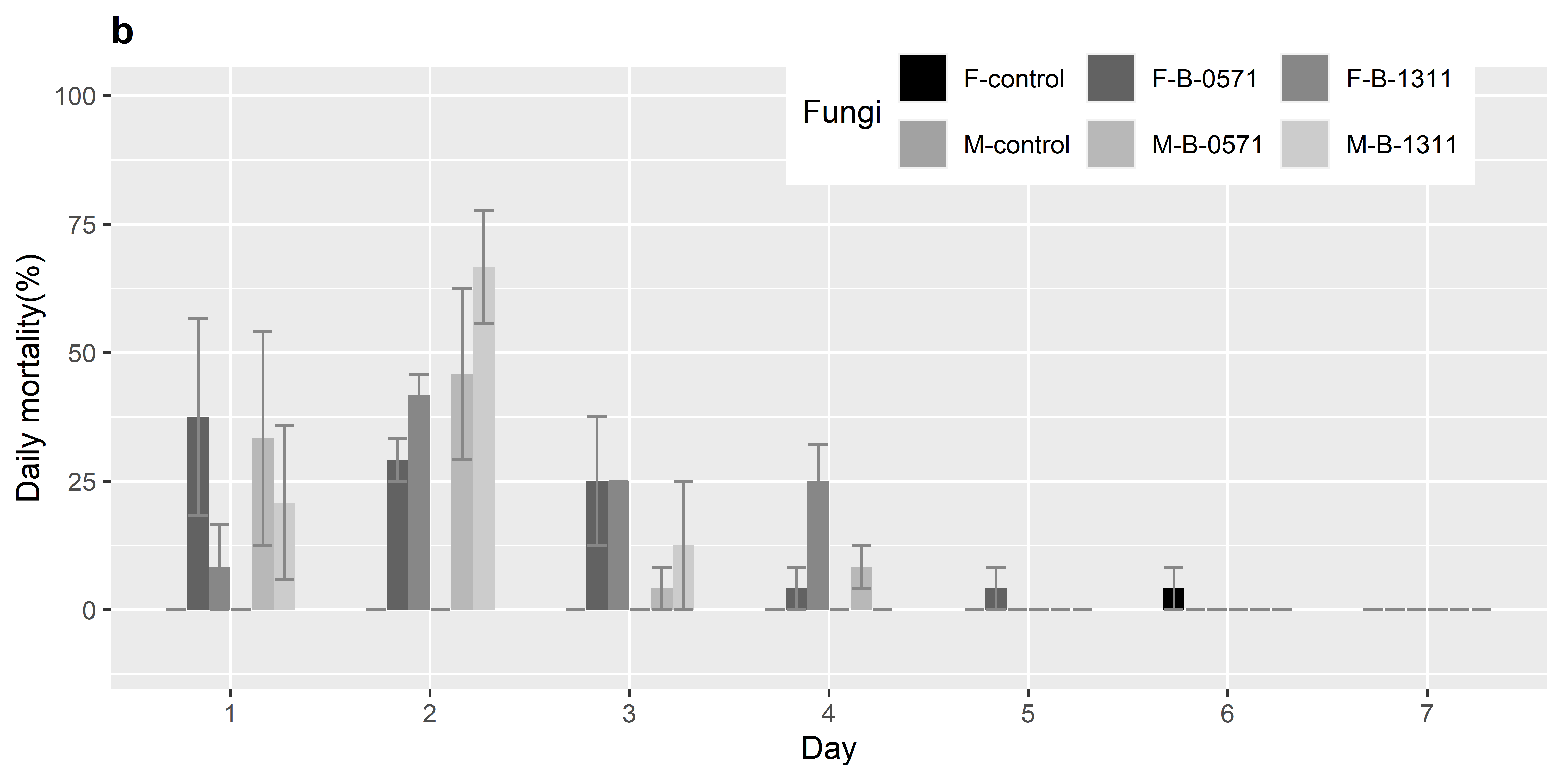
Figure S2. Daily mortality (%) of S. frugiperda at (a) 6th instar caterpillars and (b) moth life stages for seven days following infection with Beauveria sp. (B-0571 or B-1311). The standard deviation is indicated as the error bars and the treatment and sex of study samples are specified by the shade of the bars (F = female and M = male).

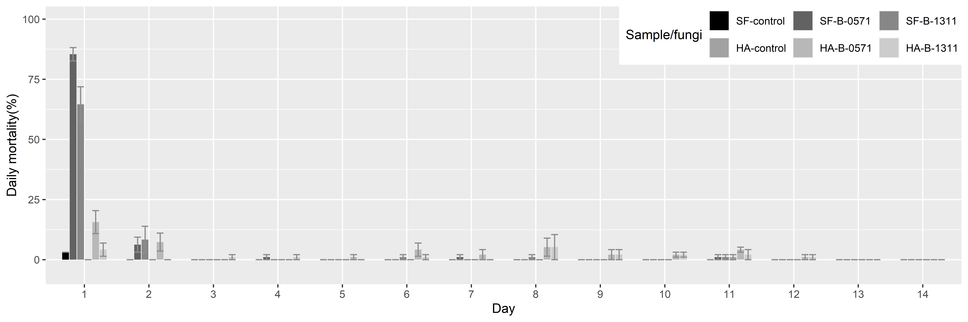
Figure S3. Daily mortality (%) of 3rd instar S. frugiperda and Helicoverpa armigera. The error bars show the standard deviation and the shades of grey indicate the treatment including control or treated as well as species of the test samples (SF = S. frugiperda and HA = H. armigera).

References
Bowling CC (1967) Rearing of Two Lepidopterous Pests of Rice on a Common Artificial Diet. Ann Entomol Soc Am ANN ENTOMOL SOC AM 60:1215–1216. https://doi.org/10.1093/aesa/60.6.1215
Greene GL, Leppla NC, Dickerson WA (1976) Velvetbean Caterpillar: A Rearing Procedure and Artificial Medium123. J Econ Entomol 69:487–488. https://doi.org/10.1093/jee/69.4.487

