Structural and functional landscape of α-synuclein fibril conformations amplified from cerebrospinal fluid

Arpine Sokratian^{#,1}, Ye Zhou^{#,2}, Enquan Xu¹, Elizabeth Viverette³, Lucas Dillard³, Yuan Yuan¹, Joshua Y. Li¹, Ariana Matarangas¹, Jonathan Bouvette³, Mario Borgnia³, Alberto Bartesaghi^{2,4,5}*, Andrew West^{1,6}*

¹ Duke Center for Neurodegeneration Research, Department of Pharmacology and Cancer Biology, Duke University, Durham, NC, USA
² Department of Computer Science, Duke University, Durham, North Carolina, USA
³Department of Health and Human Services, Genome Integrity and Structural Biology Laboratory, National Institute of Environmental Health Sciences, National Institutes of Health, Durham, NC 27709
⁴ Department of Biochemistry, Duke University School of Medicine, Durham, NC, 27708,USA
⁵ Department of Electrical and Computer Engineering, Duke University, Durham, NC, 27708, USA
⁶Aligning Science Across Parkinson’s (ASAP) Collaborative Research Network, Chevy Chase, MD, 20815.

#These authors contributed equally to this study.

*Corresponding authors. Tel: +1 919 684 1656; E-mail: Andrew.West@Duke.edu and Alberto.Bartesaghi@Duke.edu

Supplemental Figures

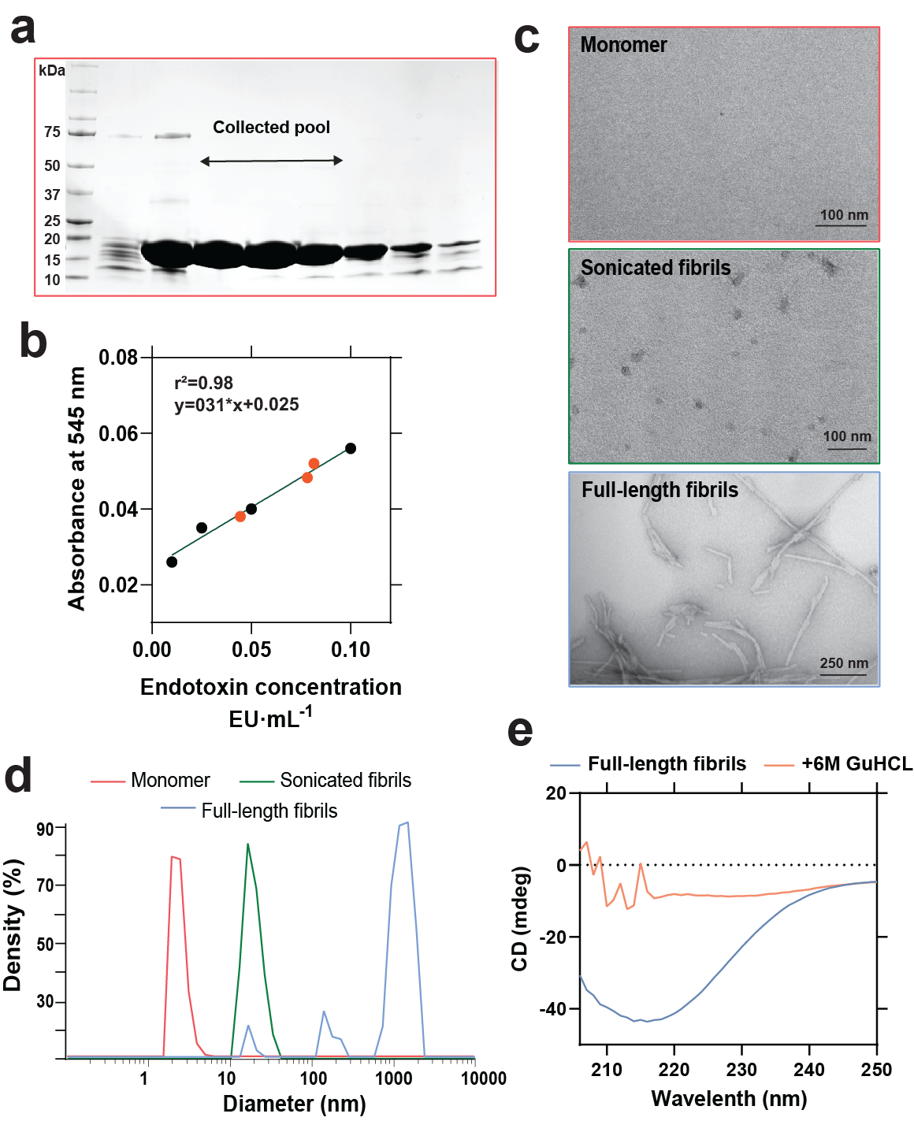
Supplemental Figure 1. Validation and quality analysis of α-synuclein monomeric protein used for fibril amplifications. a. Representative Coomassie blue staining of an SDS-PAGE gel highlighting the collected pools of pure (estimated >98%) α-synuclein monomer fractions eluted with anion-exchange chromatography on HiPrep Q HP 16/10 columns. b. Representative standard curves of endotoxin quantification of α-synuclein preparations after endotoxin depletion. Black data-points show known endotoxin standards against high-concentration (70 µM in the assay) α-synuclein monomer protein, with results from the three batches of protein used in this study shown. Levels of remaining endotoxin were measured at 0.05-0.1 endotoxin units (EU) per milligram of protein using the LAL method. c. Representative negative electron scan micrographs of monomer, sonicated, and full-length fibrils, along with d. representative histograms of molecular diameter relative to percent of density acquired by dynamic light scattering measurements. e. Circular dichroism spectra of full-length fibrils and after 5 min incubation in 6M guanidine chloride (GuHCL). 6M GuHCL treatment was always used prior to estimation of protein concentrations via A₂₈₀.
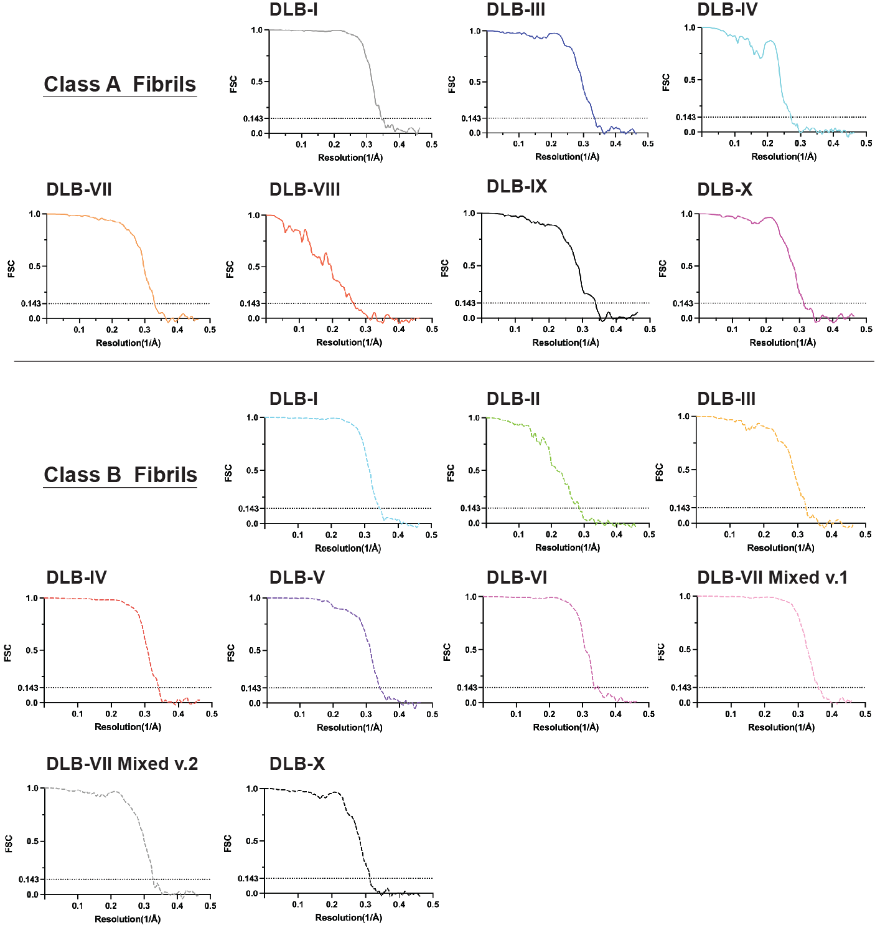

Supplemental Figure 2. Resolution estimation and validation of Cryo-EM collected images of procured α-synuclein fibril strains. Fourier shell correlation (FSC) for the 3D reconstruction of the cryo-EM maps. Class A and B fibril strains were identified through 2D reconstruction and the majority of the DLB-derived fibril preparations contain two populations with distinct structural arrangement. DLB-III is referred to class A accordingly and a lower resolution estimation for both cases is associated with flexibility of the structure. DLB-VII Class B (v.1 and v.2) are associated with two different assemblies with the same 3D map (Fig 2). Detailed collection data for the cryo-EM analysis with final resolution is described in Table 2.

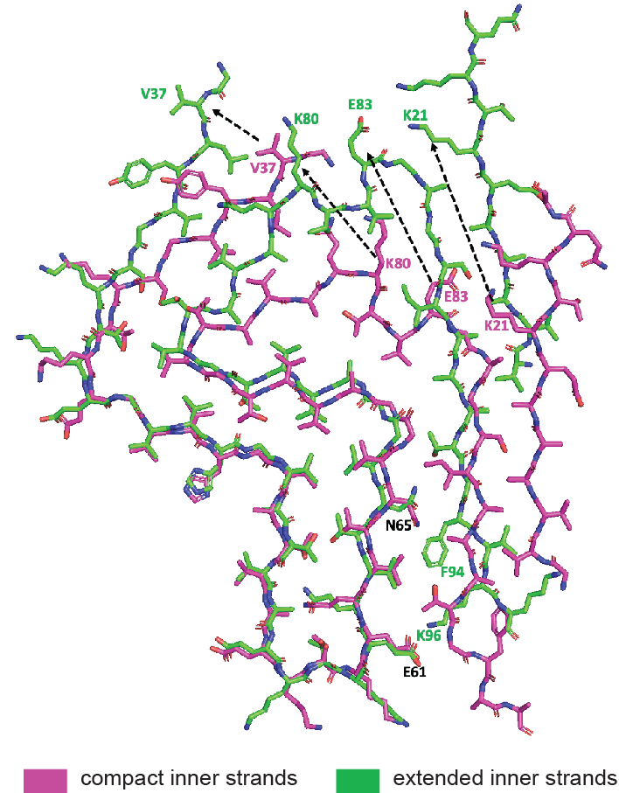
Supplemental Figure 3. Fitted atomic model of compact and extended in both Type I and Type II β-sheet stacked filaments with variations in bonding caused by different arrangements.
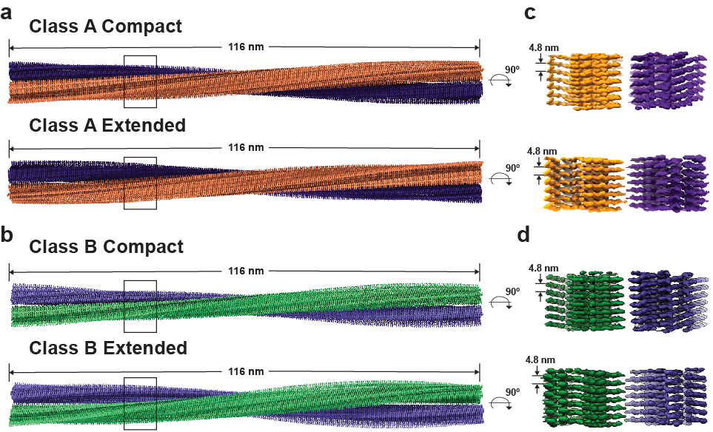
Supplemental Figure 4. Overview of cryo-EM structures of α-synuclein fibril classes. a.b., Side views of cryo-EM reconstructions for Class A and B fibrils, with extended and compact fibril arrangements. Cryo-EM density maps for both classes indicate left-handed helices with a pitch of 116 nm. Above, two protofibrils are colored dark-purple and orange for class A and light-purple and green for class B. Also shown, c., d., close-up side views of the density maps of extended and compact arrangements for class A and class B fibrils with intervals indicated between each protofibril stack (common 4.8 nm).

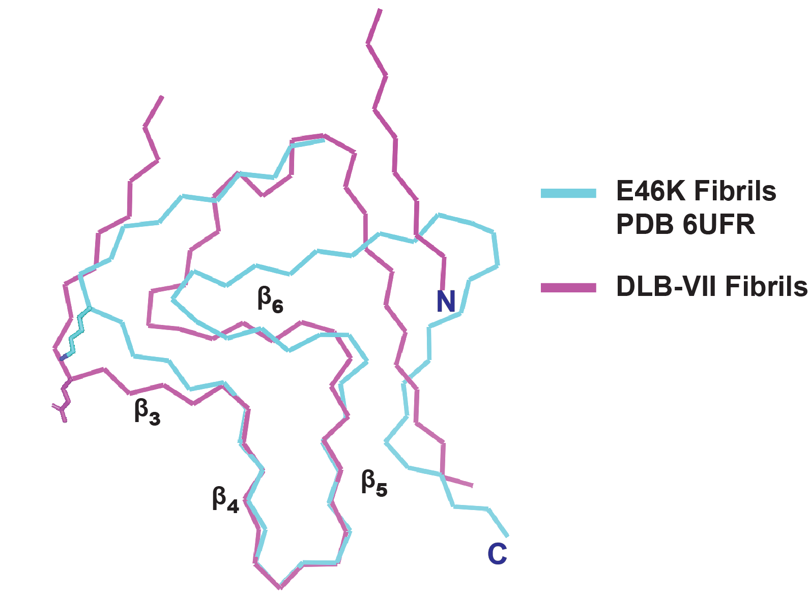
Supplemental Figure 5. Close alignment of DLB-VII fibrils with E46K-mutated fibrils (PDB 6UFR). The mutated E46K residue is highlighted above (cyan), together with similarity in alignment from β-strands 3 to 6, centered on positive alignment between β-strands 4 and 5, with extended pocket Class B filaments from DLB-VII (purple).

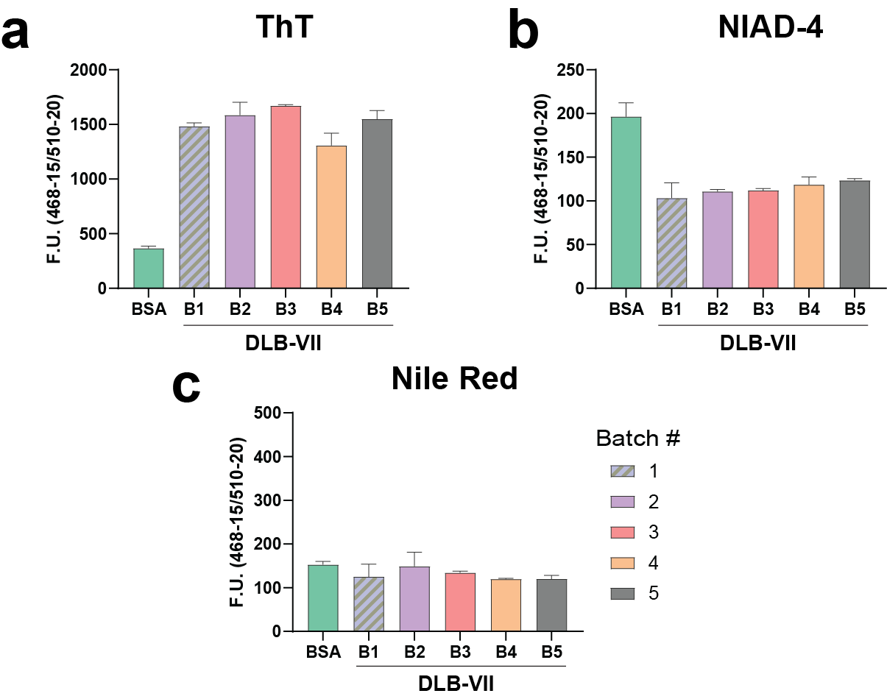
Supplemental Figure 6. Reproducibility of dye-binding characteristics of amplified α-synuclein fibril products. a. Fluorescence intensity (F.U.) of five different batches (b1-5) of DLB-VII CSF (10% w/v) grown at different times and standard BSA preparation in presence of ThT, b. NIAD-4 , or c. Nile Red. Columns show N=3 technical replicates from the same fibril preparation, means shown with error bars as S.E.M., One way ANOVA tests did not reveal batch differences within the spontaneous fibril group or within the DLB-VIII fibril amplification group.
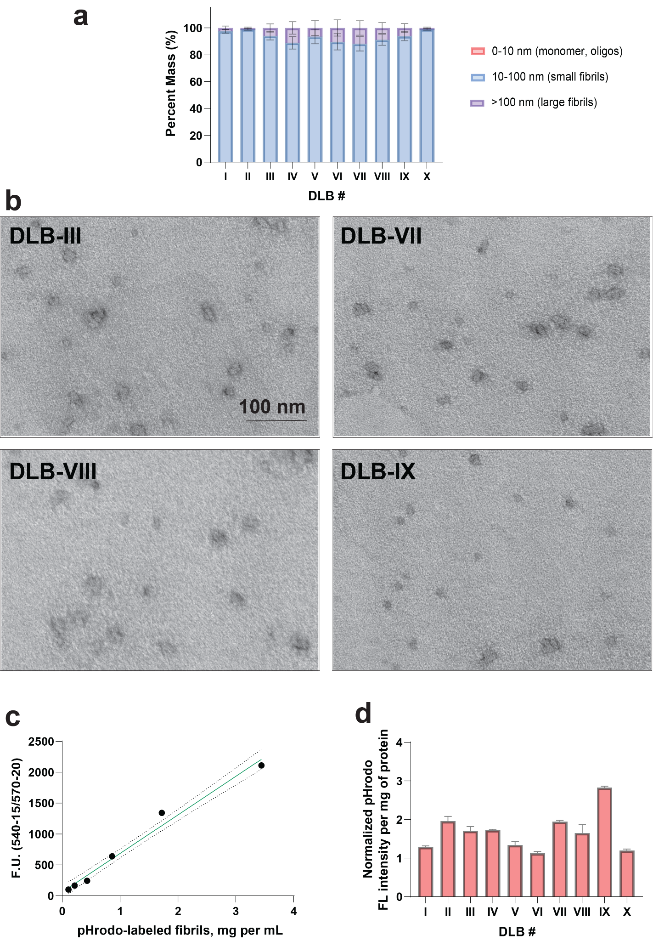
Supplemental Figure 7. Size distributions among shredded DLB-CSF amplified α-synuclein fibrils and fluorescence intensity of pHrodo-labeled strains. a. Group analysis of sized populations after water-cooled sonication, with bins corresponding to 0-10 nm (e.g., monomer or small oligomeric α-synuclein) , 10-100 nm (e.g., small α-synuclein fibrils), or particles larger than >100 nm (e.g., longer or aggregated fibrils). One-way ANOVA analysis did not reveal any differences across the group in triplicate measures. b. Selected representative negative stain electron micrographs of the processed small fibril samples prepared prior to addition to cells. Scale bar is 100 nm. c. Fluorescence intensity at 565 nm of pHrodo-labeled fibril samples incubated at pH 4.0 to maximize pHrodo fluorescence emission. Intensities are normalized against concentration estimated by A-280 absorbance after guanidine denaturation (see Methods- “Preparation of α-synuclein fibrils amplified from CSF”). d. Preceding all cellular assays, pHrodo fibril preparations were standardized between preparations to achieve similar fluorescence for each mg of fibril product. Results from three preparations are indicated as mean fluorescent values with S.E.M. as error bars.

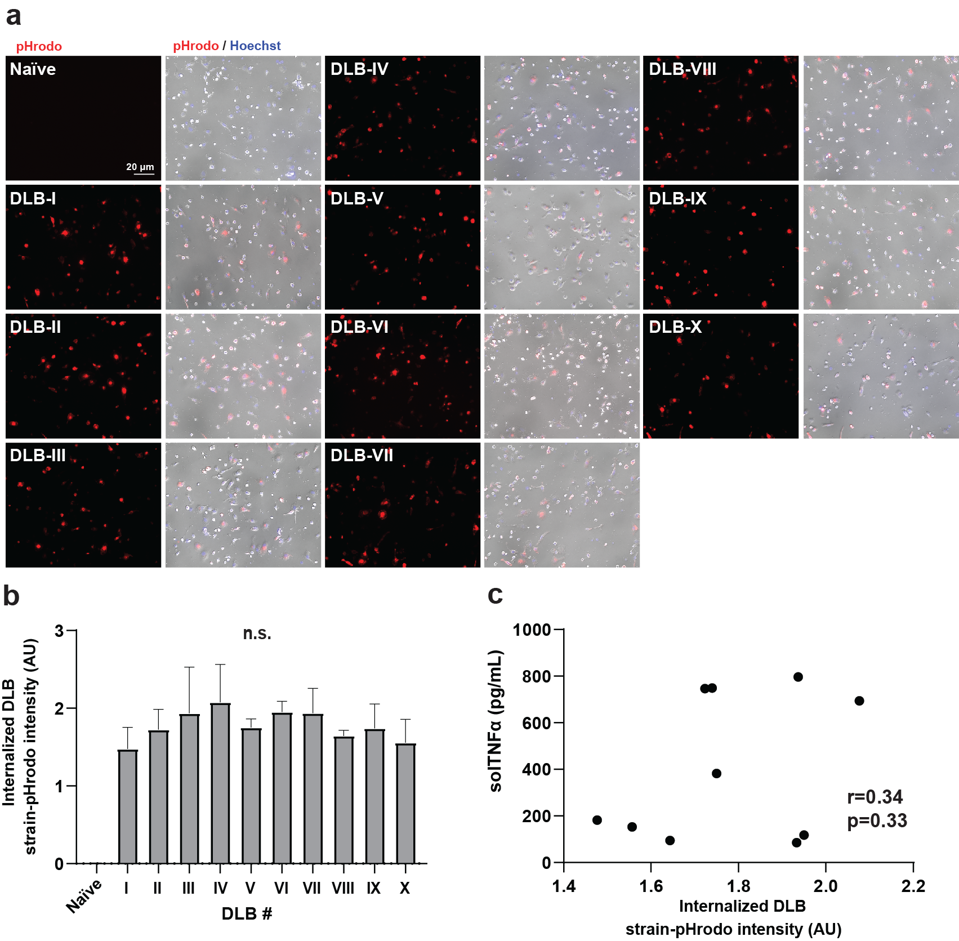
Supplemental Figure 8. Internalization of different α-synuclein DLB-CSF amplified fibril products in primary microglia. Amplified fibril products were labeled with the pH-sensitive dye pHrodo and applied to microglia (cultured for ten days) for a period of six hours prior to widefield immunofluorescence in the living cells to resolve the amount of fibrils internalized into the endolysosomal system of the cells. a. Representative immunofluorescence images (red, scale bar is 20 um) with phase-contrast overlays (grey) and b. group analysis of fibril products. One-way ANOVA of differences between experimental conditions (N=3 independent wells per fibril treatment) did not reveal differences between DLB-I through DLB-X groups. c. Correlation analysis where each dot represents the mean value for fibril uptake (panel b) and stimulated TNF (Fig. 6).
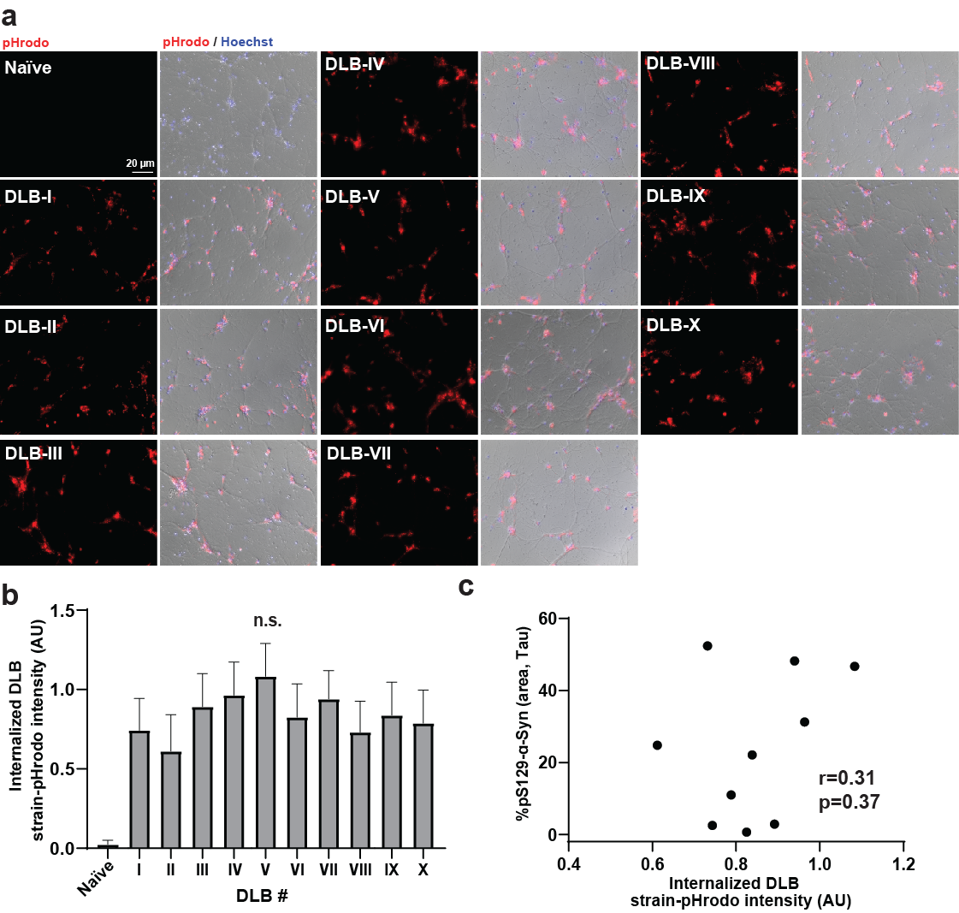

Supplemental Figure 9. Internalization of different α-synuclein DLB-CSF amplified fibril products in primary cultured neurons. Amplified fibril products were labeled with the pH-sensitive dye pHrodo and applied to neurons (cultured for seven days) for a period of six hours prior to widefield immunofluorescence in the living cells to resolve the amount of fibrils internalized into the endolysosomal system of the neurons. a. Representative immunofluorescence images (red, scale bar is 20 um) with phase-contrast overlays (grey) and b. group analysis of fibril products. One-way ANOVA of differences between experimental conditions (N=3 independent wells per fibril treatment) did not reveal differences between DLB-I through DLB-X groups. c. Correlation analysis where each dot represents the mean value for fibril uptake (panel b) and potency in pS129-α-synuclein inclusion seeding (see Fig. 7).

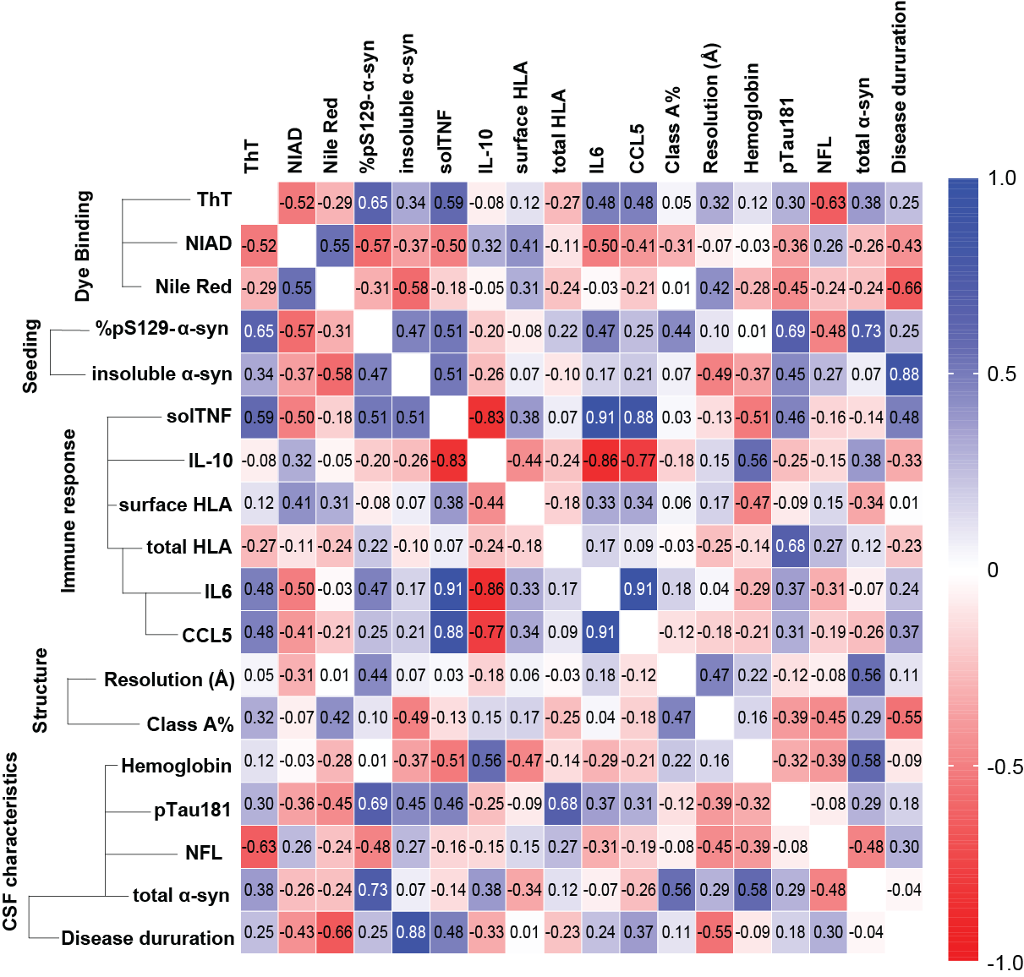

Supplemental Figure 10. Overall correlation matrix variables associated with DLB-I through DLB-X amplified α-synuclein fibrils. Pearson's correlation coefficients are given with darker colors showing stronger correlations, with dark red showing negative correlation and dark blue showing positive correlations.

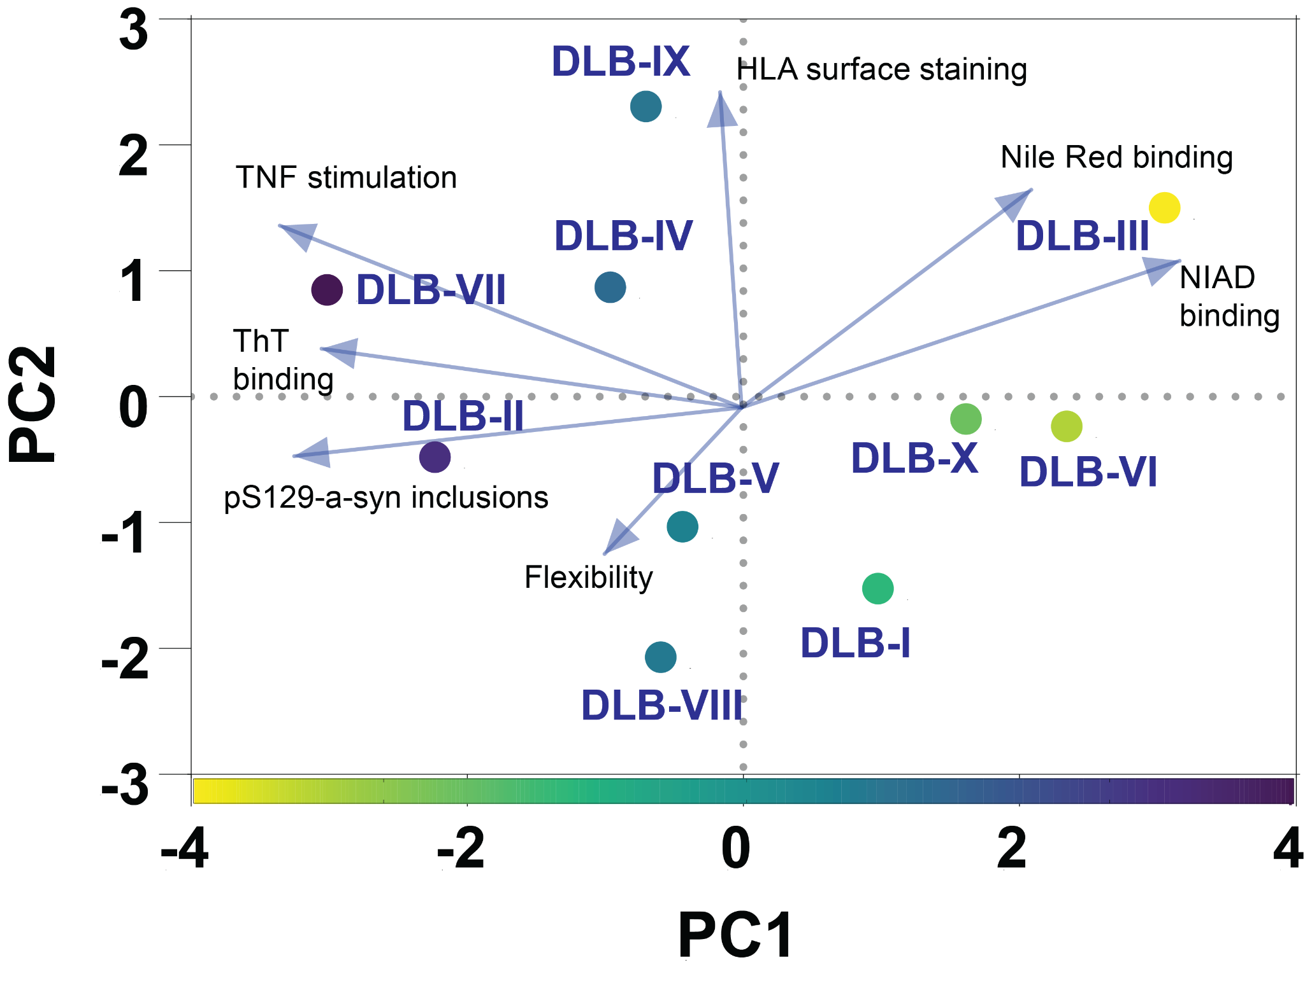

Supplemental Figure 11. Principal component analysis (PCA) of structural and functional variabilities observed with amplified α-synuclein fibrils. PC1 and 2 show 42% and 21% proportion of variance, respectively. PC1 variances are color coded above, with variables that include dye binding profiles, seeding capacity in neurons, and immunogenic potential in microglia.

