Supplementary Materials

Direct Investigation of the Reorientational Dynamics of A-site Cations in 2D Organic-Inorganic Hybrid Perovskite by Solid-State NMR

Cheng-Chieh Lin^{1,2}, Shing-Jong Huang³, Pei-Hao Wu⁴, Tzu-Pei Chen⁵, Chih-Ying Huang^{1,2}, Ying-Chiao Wang⁵, Po-Tuan Chen⁶, Vladimir M Gelev⁷, Raman Sankar⁸, Chun-Wei Chen^{1,5,9}*, Tsyr-Yan Yu^{1,4}*

¹International Graduate Program of Molecular Science and Technology (NTU-MST), National Taiwan University, Taipei 10617, Taiwan
²Molecular Science and Technology Program, Taiwan International Graduate Program (TIGP), Academia Sinica, Taipei 11529, Taiwan
³Instrumentation Center, National Taiwan University, Taipei 10617, Taiwan
⁴Institute of Atomic and Molecular Sciences, Academia Sinica, Taipei 10617, Taiwan
⁵Department of Materials Science and Engineering, National Taiwan University, Taipei 10617, Taiwan
⁶Department of Vehicle Engineering, National Taipei University of Technology, Taipei 10608, Taiwan
⁷Department of Chemistry and Pharmacy, Sofia University, 1 James Bourchier Boulevard, 1164 Sofia, Bulgaria
⁸Institute of Physics, Academia Sinica, Taipei, 115201, Taiwan
⁹Center of Atomic Initiative for New Materials (AI-MAT), National Taiwan University, Taipei 10617, Taiwan

Corresponding Authors
E-mail: chunwei@ntu.edu.tw (CWC) and tyyu@pub.iams.sinica.edu.tw (TYY)

- Supplementary Methods (SM)
SM1. Samples preparation
Synthesis of [U-¹³C, 99%;U-¹⁵N, 98%] methylammonium iodide. 4.00 g ¹⁵N-potassium phthalimide (21.5 mmol, 98% ¹⁵N, Cambridge Isotope Laboratories), 1.38 g K₂CO₃ (10.0 mmol) were suspended in 20 ml DMF (dried over 3Å molecular sieves). To this suspension was added dropwise 3.50 g ¹³CH₃I (24.5 mmol, 99% ¹³C, Cambridge Isotope Laboratories). The reaction mixture was stirred while protecting from light for 3 days. The salts were filtered off and the DMF solvent was removed under reduced pressure. The resulting solids were suspended in ethyl acetate and filtered. The filtrate was extracted with saturated NaCl solution, dried with Na₂SO₄ and the solvent was removed under reduced pressure to yield 3.0 g ¹³C-methyl-¹⁵N-phthalimide (19 mmol, 87%). This was suspended in 50 ml methanol and 1.13 ml (1.2 equivalents) of 80% hydrazine monohydrate was added. The solution was boiled under reflux for 2 hours. 12 ml 6M HCl and 5 ml H₂O were added, resulting in a thick white suspension, which was stirred overnight. The suspension was filtered, and the solid was washed twice with 25 ml of water. The combined filtrate and washes were reduced under vacuum to 50 ml and filtered again. 10 ml of 10M NaOH was added and the basic solution was purged with a gentle stream of argon while heating in a 100ºC oil bath. The evolving methylamine was recaptured by bubbling the gas stream through 50 ml of 5% HI. Purging was continued for 5 hours until the smell of amine disappeared from the NaOH solution. (The NaOH solution can be checked for residual methylamine by ¹³C-NMR.) The HI solution was evaporated under reduced pressure and the resulting orange solid was dissolved in methanol, precipitated with diethyl ether, and filtered. The methanol/ether precipitation was repeated two more times. Drying the product in vacuo over P₂O₅ yielded 2.1 g of fine white crystals of ¹³CH₃¹⁵NH₃I (13 mmol, 60% from the potassium phthalimide). The associated ¹H NMR (500 MHz) and ¹H-decoupled ¹³C NMR (125 MHz) spectra are shown in Fig S6 and S7, respectively.

SM2. Details of Materials Characterisations.
The photoluminescence (PL) spectra were recorded with a home-built laser scanning confocal microscope with 372 nm pulse laser (PicoQuant). Optical absorption spectra were measured by a microscopy system with an Ocean Optics spectrometer. The structure and phase purity of the 2D organic-inorganic hybrid perovskite crystals were characterised by X-ray diffraction (XRD) patterns using a Bruker D8 with Cu-Kα radiation (40 kV, λ = 1.5406 Å) a step size of 0.01°, and a scan speed of 0.5 s/step. The examination of possible phase transitions in 2D organic-inorganic hybrid perovskite crystals were investigated using Differential Scanning Calorimetry (DSC). DSC data were collected using a TA Q200 thermal analysis instrument at a scan rate of 5K min⁻¹ in sealed aluminium pans under ambient conditions.

- Supplementary Figures
Figure S1. The structural characterisations of 2D OIHP (n = 2) crystals using X-ray diﬀraction (XRD). The XRD spectra of (a) 2D (BA)₂(MA)Pb₂I₇ (n = 2) and (b) 2D (PEA)₂(MA)Pb₂I₇ (n = 2) crystals, synthesised with both natural-abundance MA (blue) and [U-¹³C,U-¹⁵N]MA (black), respectively.

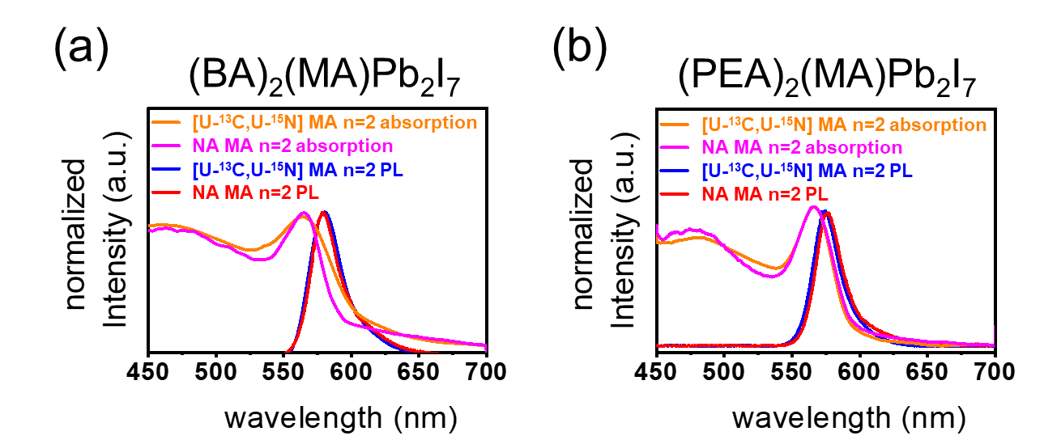
Figure S2. The characterisations of the optoelectronic properties of 2D OIHP (n = 2) crystals using both photoluminescence and absorption spectroscopy, respectively. The photoluminescence and absorption spectra of (a) 2D (BA)₂(MA)Pb₂I₇ (n = 2) and (b) 2D (PEA)₂(MA)Pb₂I₇ (n = 2) crystals. [U-¹³C,U-¹⁵N] MA with n = 2 absorption spectrum: orange; natural-abundance MA with n = 2 absorption spectrum: magenta; [U-¹³C,U-¹⁵N] MA with n = 2 PL spectrum: blue; natural-abundance MA with n = 2 PL spectrum: red)
Figure S3. ¹³C CPMAS NMR spectra of 2D OIHP crystals (n = 2). The full-scaled ¹³C CPMAS spectra of (a) 2D (BA)₂([U-¹³C,U-¹⁵N]MA)Pb₂I₇ (n = 2) and (b) 2D (PEA)₂([U-¹³C,U-¹⁵N]MA)Pb₂I₇ (n = 2) recorded at various temperatures, ranging from 308 to 243K. The dashed lines are guides to the eye.

Figure S4. The differential scanning calorimetry (DSC) measurement of 2D (BA)₂(MA)Pb₂I₇ (n = 2, black) and 2D (PEA)₂(MA)Pb₂I₇ (n = 2, blue) crystals.

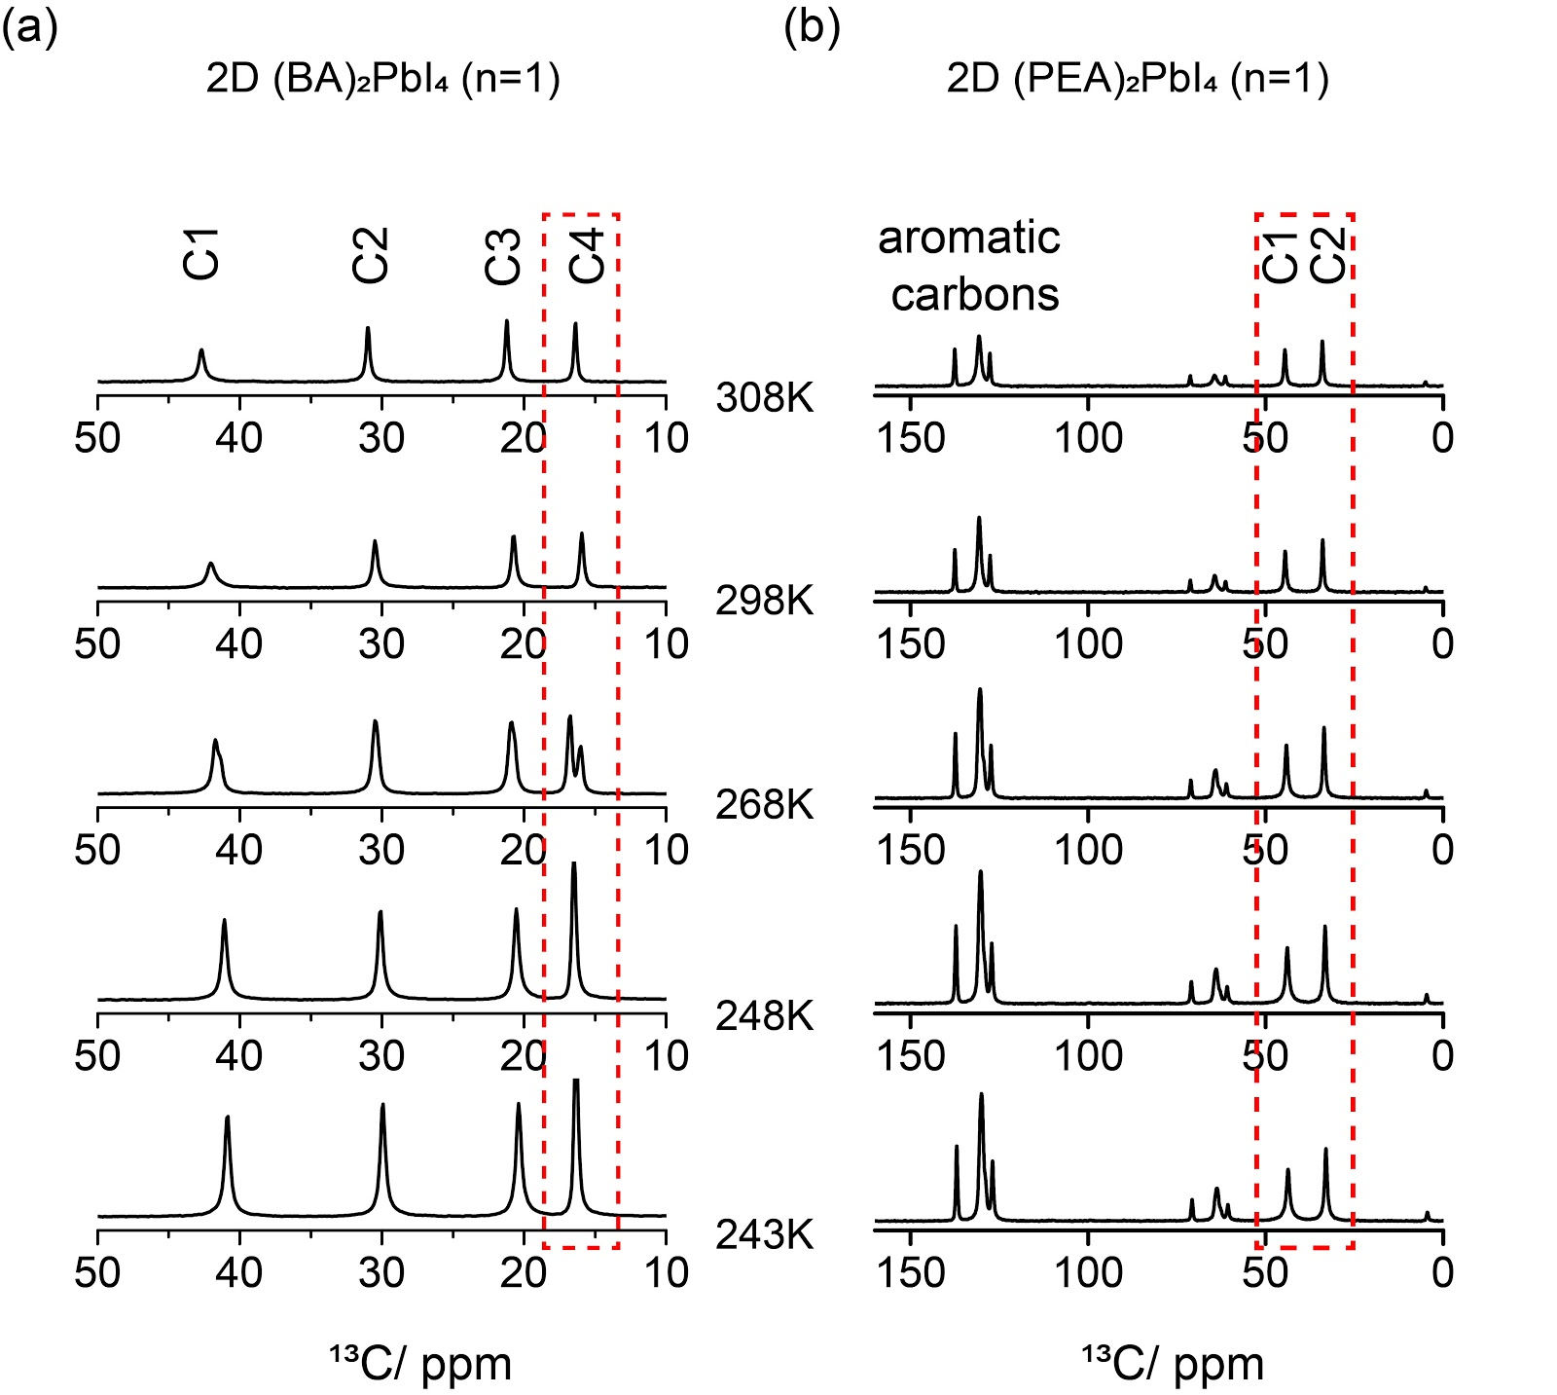
Figure S5. ¹³C CPMAS NMR spectra of 2D OIHP crystals (n = 1). The temperature dependent ¹³C spectra of (c) 2D (BA)₂PbI₄ (n = 1) and (d) 2D (PEA)₂PbI₄ (n = 1) recorded from 308K to 243K. The resonance peak of the C4 of BA in 2D (BA)₂PbI₄ (n = 1) was observed to split into two peaks as the temperature decreased from RT to 268 K. As the temperature further decreased to 248K and 243K, only one peak of C4 of BA was observed. By contrast, there is no change in the chemical environment either at peak splitting or at peak position shift during the cooling process for 2D (PEA)₂PbI₄ (n = 1), consistent with a previous study where no phase change of 2D (PEA)₂PbI₄ (n = 1) was observed at this temperature range.² The dashed boxes are guides to the eye.



Figure S6. ¹H NMR spectrum of ¹³C-methyl-¹⁵N-amine iodide in D₂O (500 MHz).

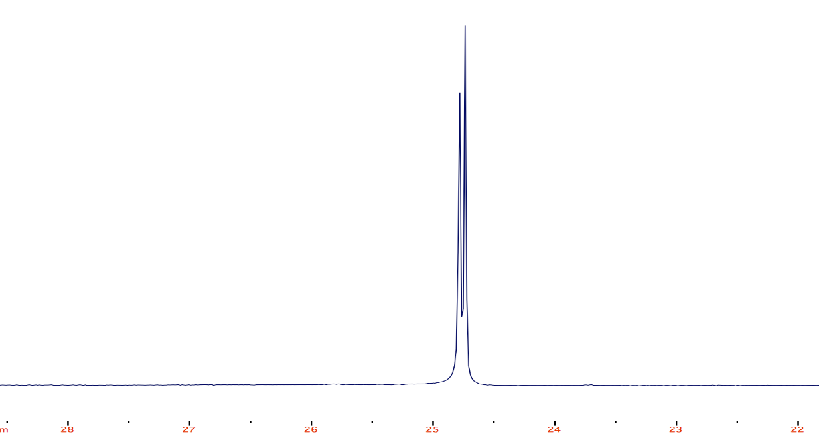

Figure S7. Proton decoupled ¹³C-NMR spectrum of ¹³C-methyl-¹⁵N-amine iodide in D₂O (125 MHz).

- Supplementary References
- Raghavan, C. M. et al. Low-Threshold Lasing from 2D Homologous Organic-Inorganic Hybrid Ruddlesden-Popper Perovskite Single Crystals. Nano Lett 18, 3221-3228 (2018).
- Chakraborty, R. & Nag, A. Correlation of Dielectric Conﬁnement and Excitonic Binding Energy in 2D Layered Hybrid Perovskites Using Temperature Dependent
Photoluminescence. J. Phys. Chem C 124, 16177–16185 (2020).

