Supplementary File.

Table of Contents
List of Investigators | Page 2-3
Definitions of the clinical events | Page 4
Supplementary Figure Legends | Page 5
Supplementary Tables | Page 6
Supplementary Figures | Page 7-20

List of Investigators
Principal Investigators
Takeshi Kimura, Department of Cardiovascular Medicine, Kyoto University Graduate School of Medicine, Kyoto, Japan
Ryuzo Sakata, Department of Cardiovascular Surgery, Kyoto University Graduate School of Medicine, Kyoto, Japan

List of participating centers and investigators for the CURRENT AS registry
Cardiology
Kyoto University Graduate School of Medicine: Takeshi Kimura, Tomohiko Taniguchi, Hiroki Shiomi, Naritatsu Saito, Masao Imai, Junichi Tazaki, Toshiaki Toyota, Hirooki Higami, Tetsuma Kawaji
Kokura Memorial Hospital: Kenji Ando, Shinichi Shirai, Kengo Kourai, Takeshi Arita, Shiro Miura, Kyohei Yamaji
Shimada Municipal Hospital: Takeshi Aoyama, Norio Kanamori
Shizuoka City Shizuoka Hospital: Tomoya Onodera, Koichiro Murata
Kobe City Medical Center General Hospital: Yutaka Furukawa, Takeshi Kitai, Kitae Kim
Kurashiki Central Hospital: Kazushige Kadota, Yuichi Kawase, Keiichiro Iwasaki, Hiroshi Miyawaki, Ayumi Misao, Akimune Kuwayama, Masanobu Ohya, Takenobu Shimada, Hidewo Amano
Tenri Hospital: Yoshihisa Nakagawa, Chisato Izumi, Makoto Miyake, Masashi Amano, Yusuke Takahashi, Yusuke Yoshikawa, Shunsuke Nishimura, Maiko Kuroda
Nara Hospital, Kinki University Faculty of Medicine: Manabu Shirotani, Hirokazu Mitsuoka
Mitsubishi Kyoto Hospital: Shinji Miki, Tetsu Mizoguchi, Masashi Kato, Takafumi Yokomatsu, Akihiro Kushiyama, Hidenori Yaku, Toshimitsu Watanabe
Kinki University Hospital: Shunichi Miyazaki, Yutaka Hirano
Kishiwada City Hospital: Mitsuo Matsuda, Shintaro Matsuda, Sachiko Sugioka
Osaka Red Cross Hospital: Tsukasa Inada, Kazuya Nagao, Naoki Takahashi, Kohei Fukuchi
Koto Memorial Hospital: Tomoyuki Murakami, Hiroshi Mabuchi, Teruki Takeda, Tomoko Sakaguchi, Keiko Maeda, Masayuki Yamaji, Motoyoshi Maenaka, Yutaka Tadano
Shizuoka General Hospital: Hiroki Sakamoto, Yasuyo Takeuchi, Makoto Motooka, Ryusuke Nishikawa
Nishikobe Medical Center: Hiroshi Eizawa, Keiichiro Yamane, Mitsunori Kawato, Minako Kinoshita, Kenji Aida
Japanese Red Cross Wakayama Medical Center: Takashi Tamura, Mamoru Toyofuku, Kousuke Takahashi, Euihong Ko
National Hospital Organization Kyoto Medical Center: Masaharu Akao, Mitsuru Ishii, Nobutoyo Masunaga, Hisashi Ogawa, Moritake Iguchi, Takashi Unoki, Kensuke Takabayashi, Yasuhiro Hamatani, Yugo Yamashita
The Tazuke Kofukai Medical Research Institute, Kitano Hospital: Moriaki Inoko, Eri Minamino-Muta, Takao Kato
Hikone Municipal Hospital: Yoshihiro Himura, Tomoyuki Ikeda
Kansai Electric Power Hospital: Katsuhisa Ishii, Akihiro Komasa
Hyogo Prefectural Amagasaki General Medical Center: Yukihito Sato, Kozo Hotta, Shuhei Tsuji
Rakuwakai Otowa Hospital: Yuji Hiraoka, Nobuya Higashitani
Saiseikai Noe Hospital: Ichiro Kouchi, Yoshihiro Kato
Shiga Medical Center for Adults: Shigeru Ikeguchi, Yasutaka Inuzuka, Soji Nishio, Jyunya Seki
Hamamatsu Rosai Hospital: Eiji Shinoda, Miho Yamada, Akira Kawamoto, Chiyo Maeda
Japanese Red Cross Otsu Hospital: Takashi Konishi, Toshikazu Jinnai, Kouji Sogabe, Michiya Tachiiri, Yukiko Matsumura, Chihiro Ota
Hirakata Kohsai Hospital: Shoji Kitaguchi, Yuko Morikami

Cardiovascular Surgery
Kyoto University Graduate School of Medicine: Ryuzo Sakata, Kenji Minatoya, Kenji Minakata
Kokura Memorial Hospital: Michiya Hanyu
Shizuoka City Shizuoka Hospital: Fumio Yamazaki
Kobe City Medical Center General Hospital: Tadaaki Koyama
Kurashiki Central Hospital: Tatsuhiko Komiya
Tenri Hospital: Kazuo Yamanaka
Nara Hospital, Kinki University Faculty of Medicine: Noboru Nishiwaki
Mitsubishi Kyoto Hospital: Hiroyuki Nakajima, Motoaki Ohnaka, Hiroaki Osada, Katsuaki Meshii
Kinki University Hospital: Toshihiko Saga
Kishiwada City Hospital: Masahiko Onoe
Osaka Red Cross Hospital: Shogo Nakayama
Shizuoka General Hospital: Genichi Sakaguchi
Japanese Red Cross Wakayama Medical Center: Atsushi Iwakura
National Hospital Organization Kyoto Medical Center: Kotaro Shiraga
The Tazuke Kofukai Medical Research Institute, Kitano Hospital: Koji Ueyama
Hyogo Prefectural Amagasaki General Medical Center: Keiichi Fujiwara
Rakuwakai Otowa Hospital: Atsushi Fukumoto
Shiga Medical Center for Adults: Masaki Park
Hamamatsu Rosai Hospital: Junichiro Nishizawa
Japanese Red Cross Otsu Hospital: Mitsuru Kitano

A clinical event committee
Hirotoshi Watanabe, MD (Kyoto University Graduate School of Medicine); Kenji Nakatsuma, MD (Kyoto University Graduate School of Medicine), Tomoki Sasa, MD (Kishiwada City Hospital)
Definitions of the baseline characteristics
Aortic/peripheral vascular disease was defined as having a history or a plan of treatment of peripheral arterial disease such as upper/lower extremity, aortic aneurysm, or aortic dissection. Immunosuppressive therapy was defined as being immunocompromised due to immunosuppressive medication therapy within 30 days preceding the index echocardiography. Moderate and severe chronic lung disease was regarded as FEV1 50% to 59% of predicted, or on chronic oral/systemic steroid therapy aimed at lung disease; FEV1 < 50% or Room Air pO2 < 60 or pCO2 > 50, respectively. Heart failure hospitalization at the index echocardiography was defined as hospitalization due to worsening heart failure requiring intravenous drug therapy.

Supplementary Figure Legend
Supplementary Figure 1. The cumulative incidence of all-cause death after SAVR in the entire cohort.
SAVR=surgical aortic valve replacement.

Supplementary Figure 2. The Kaplan-Meier curves for the observed mortality rate after SAVR in patients with severe AS and the expected mortality rate in an age- and sex-matched general population stratified by the age and sex categories: (A) Men, <65 years of age, (B) Women, <65 years of age, (C) Men, 65 to 74 years of age, (D) Women, 65 to 74 years of age, (E) Men, 75 to 80 years of age, (F) Women, 75 to 80 years of age, (G) Men, >80 years of age, and (H) Women, >80 years of age.
SAVR=surgical aortic valve replacement.

Supplementary Figure 3. The Kaplan-Meier curves for the observed mortality rate after SAVR compared between the mechanical and bioprosthetic valve groups in patients with severe AS stratified by the age categories: (A) Entire cohort, (B) <65 years of age, (C) 65-74 years of age, (D) 75-80 years of age, and (E) >80 years of age.
Eight patients with missing data on the valve types were excluded.
SAVR=surgical aortic valve replacement.
Supplementary Table 1. The 30-day mortality and symptomatic stroke after SAVR
 | Number of patients with event  (30-day cumulative incidence) | P value
30-day mortality (N=1163) | 21 (1.8%) | -
Age groups
<65 years of age (N=185) | 2 (1.1%) | 0.22
65-74 years of age (N=394) | 4 (1.0%) | 0.22
75-80 years of age (N=345) | 10 (2.9%) | 0.22
>80 years of age (N=239) | 5 (2.1%) | 0.22
Procedures
SAVR with concomitant procedure (N=545) | 16 (2.9%) | 0.007
Isolated SAVR (N=618) | 5 (0.8%) | 0.007
Subgroup analysis
Dialysis patients (N=131) | 10 (7.6%)
SAVR with concomitant procedure (N=77) | 9 (11.7%) | 0.04
Isolated SAVR (N=54) | 1 (1.9%) | 0.04
Non-dialysis patients (N=1032) | 11 (1.1%)
SAVR with concomitant procedure (N=468) | 7 (1.5%) | 0.22
Isolated SAVR (N=564) | 4 (0.7%) | 0.22
30-day symptomatic stroke (n=1163) | 32 (2.8%)
Age groups
<65 years of age (N=185) | 4 (2.2%) | 0.35
65-74 years of age (N=394) | 7 (1.8%) | 0.35
75-80 years of age (N=345) | 13 (3.8%) | 0.35
>80 years of age (N=239) | 8 (3.4%) | 0.35
Procedures
SAVR with concomitant procedure (N=545) | 16 (3.0%) | 0.70
Isolated SAVR (N=618) | 16 (2.6%) | 0.70
Subgroup analysis
Dialysis patients (N=131) | 6 (4.6%)
SAVR with concomitant procedure (N=77) | 3 (3.9%) | 0.68
Isolated SAVR (N=54) | 3 (5.6%) | 0.68
Non-dialysis patients (N=1032) | 26 (2.5%)
SAVR with concomitant procedure (N=468) | 13 (2.8%) | 0.63
Isolated SAVR (N=564) | 13 (2.3%) | 0.63

Supplementary Figure 1.
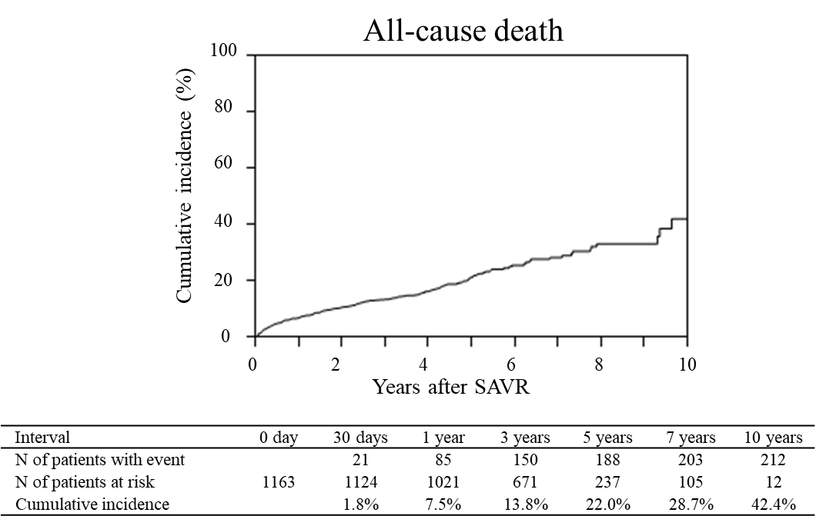

Supplementary Figure 2.
(A)
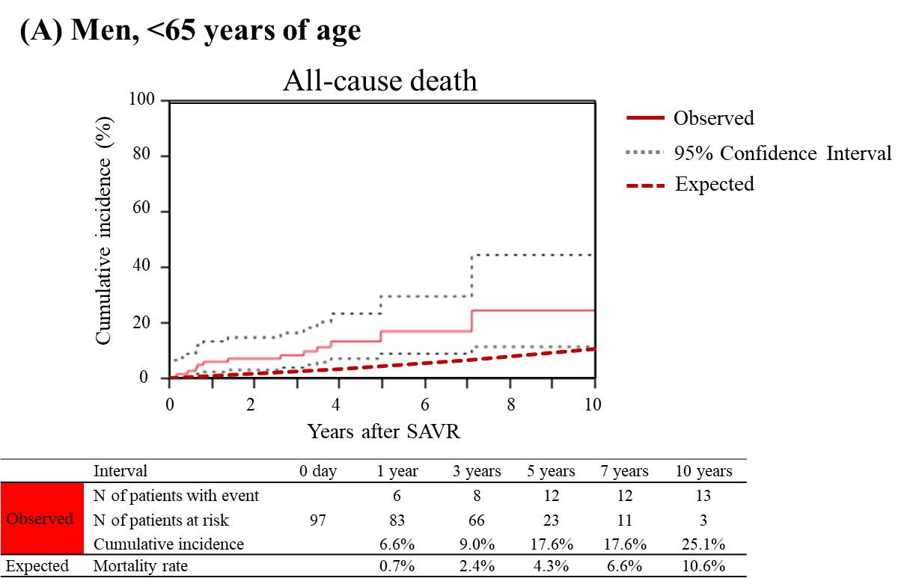

(B)
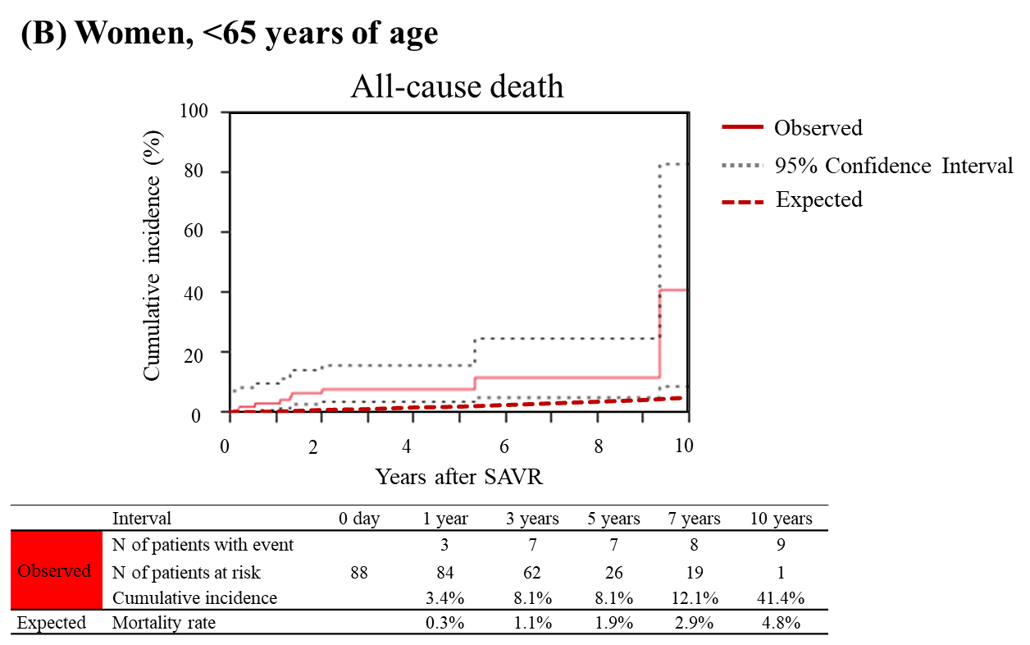

(C)
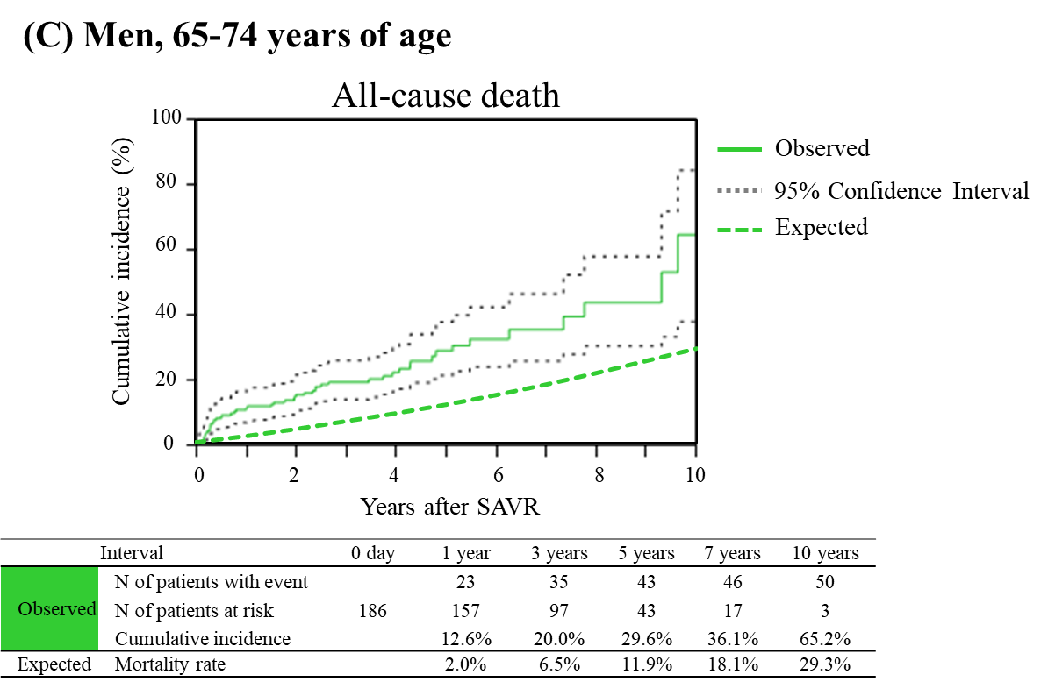
(D)
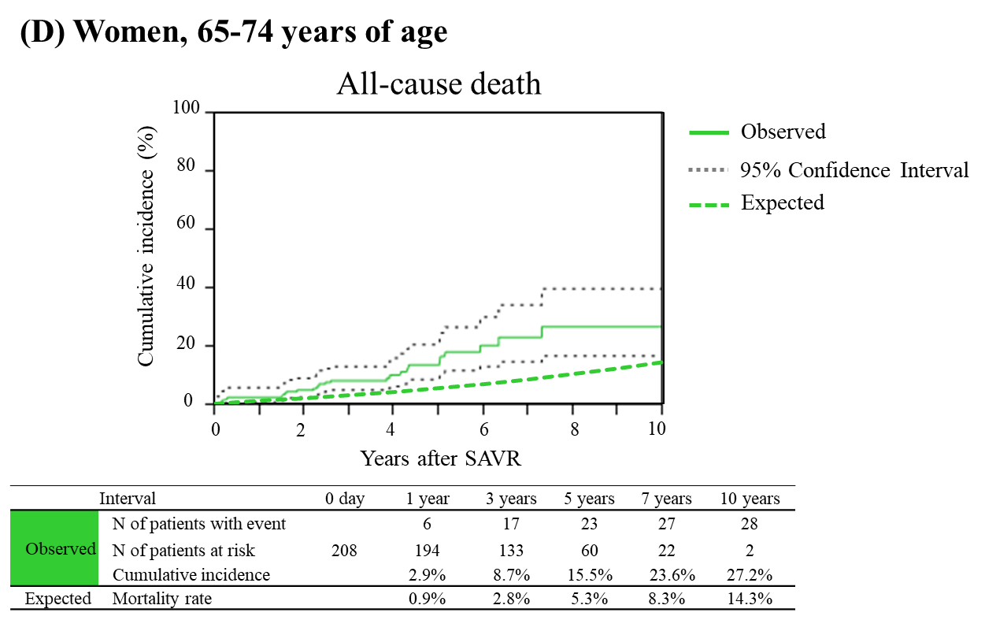

(E)
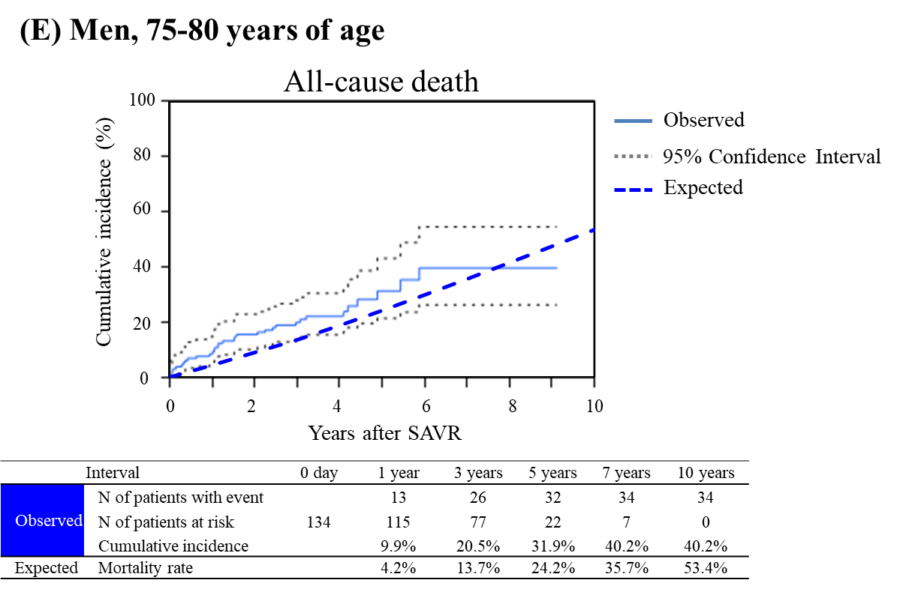

(F)
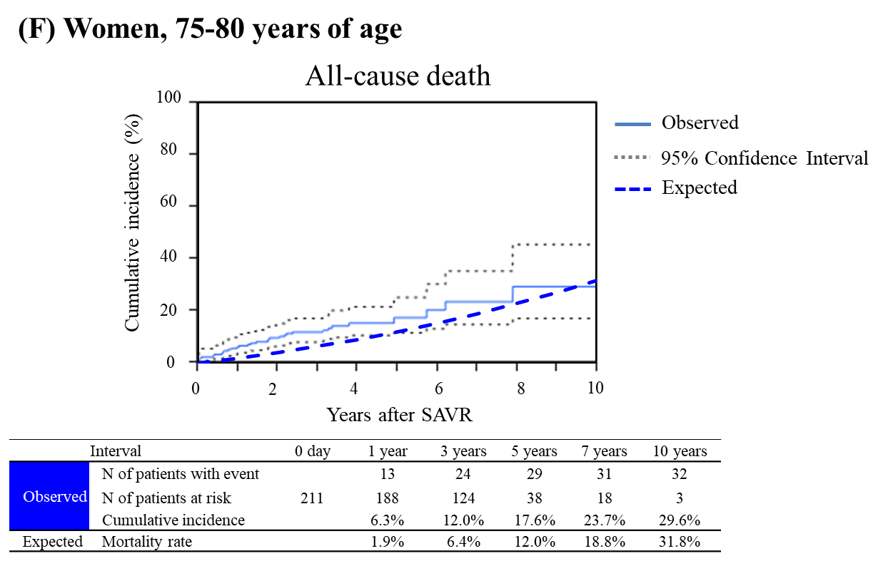
(G)
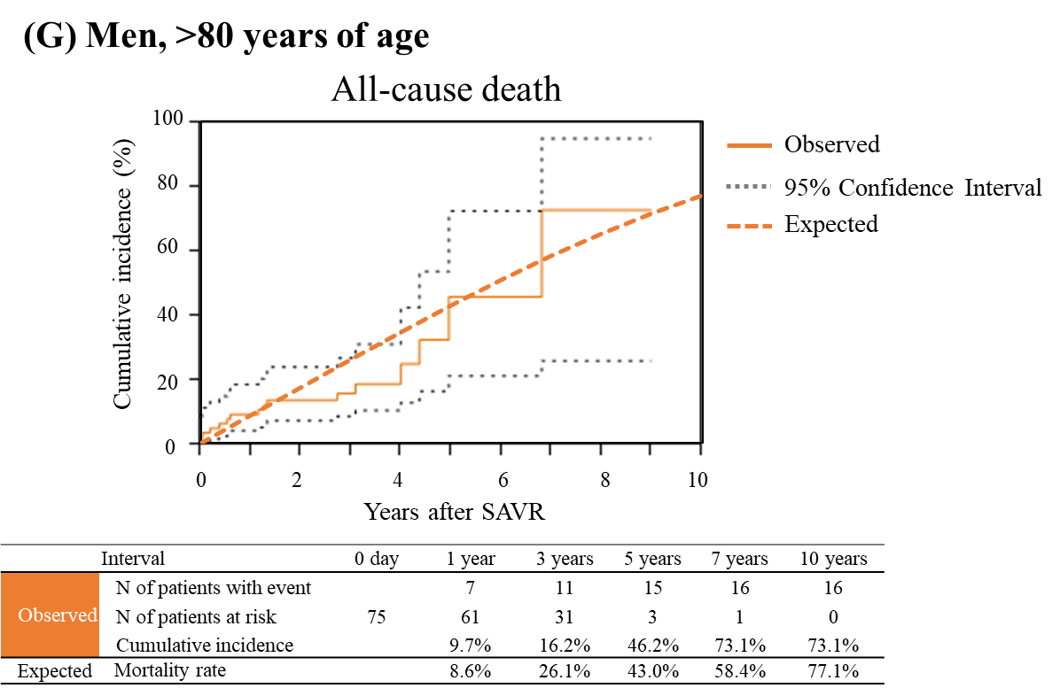

(H)

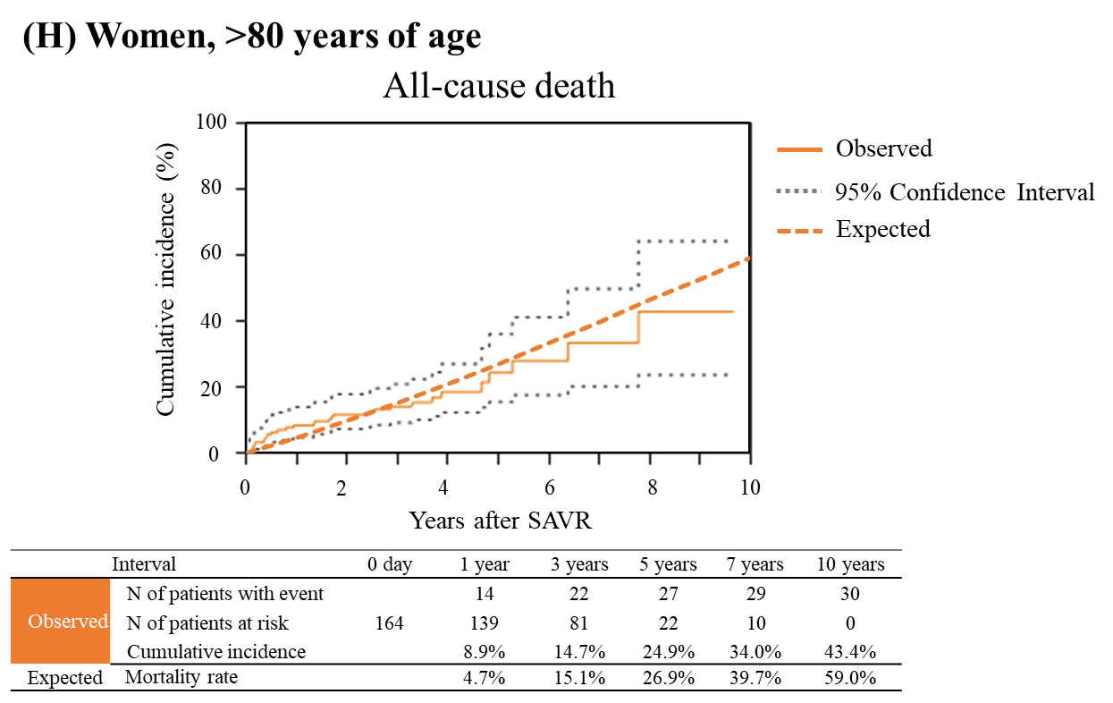
Supplementary Figure 3.
(A)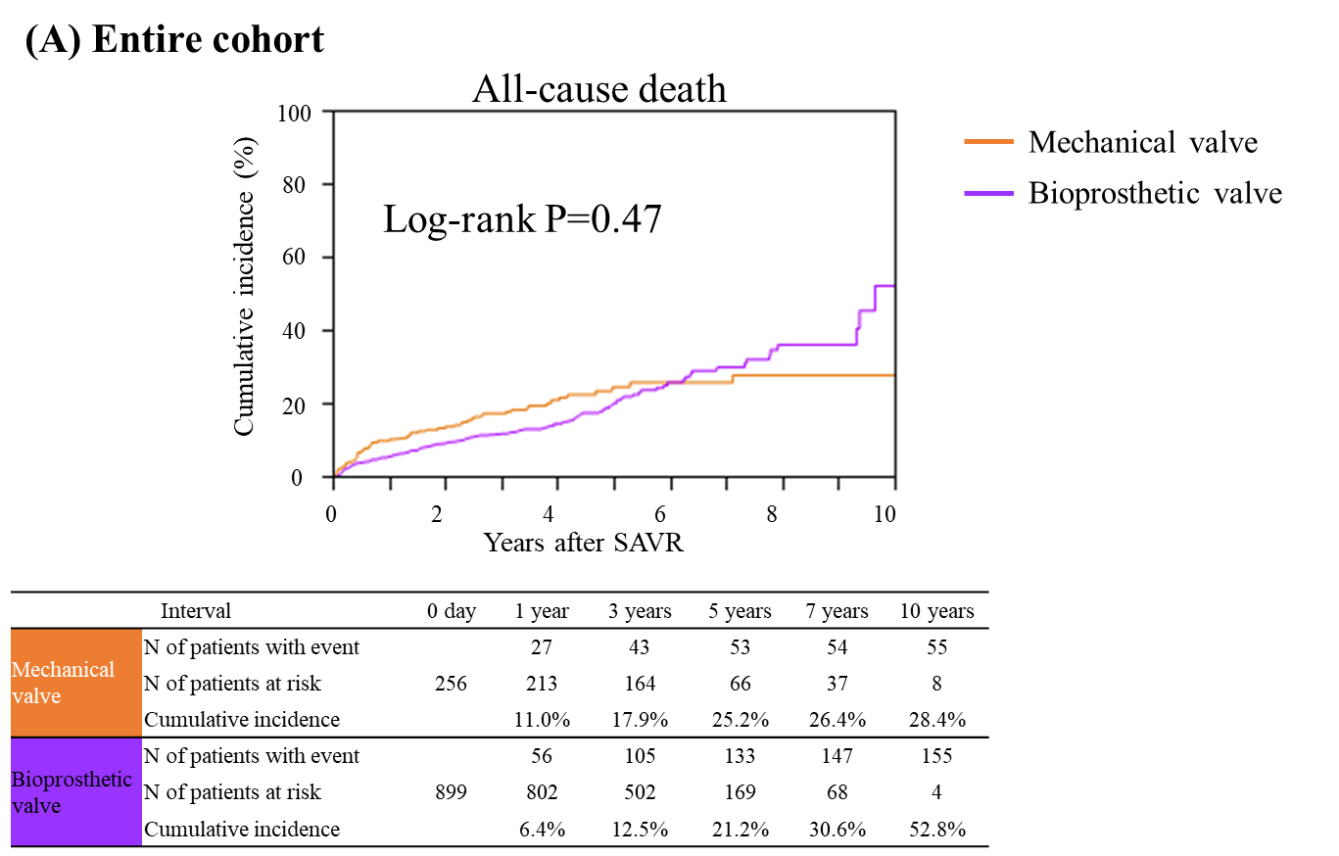

(B)
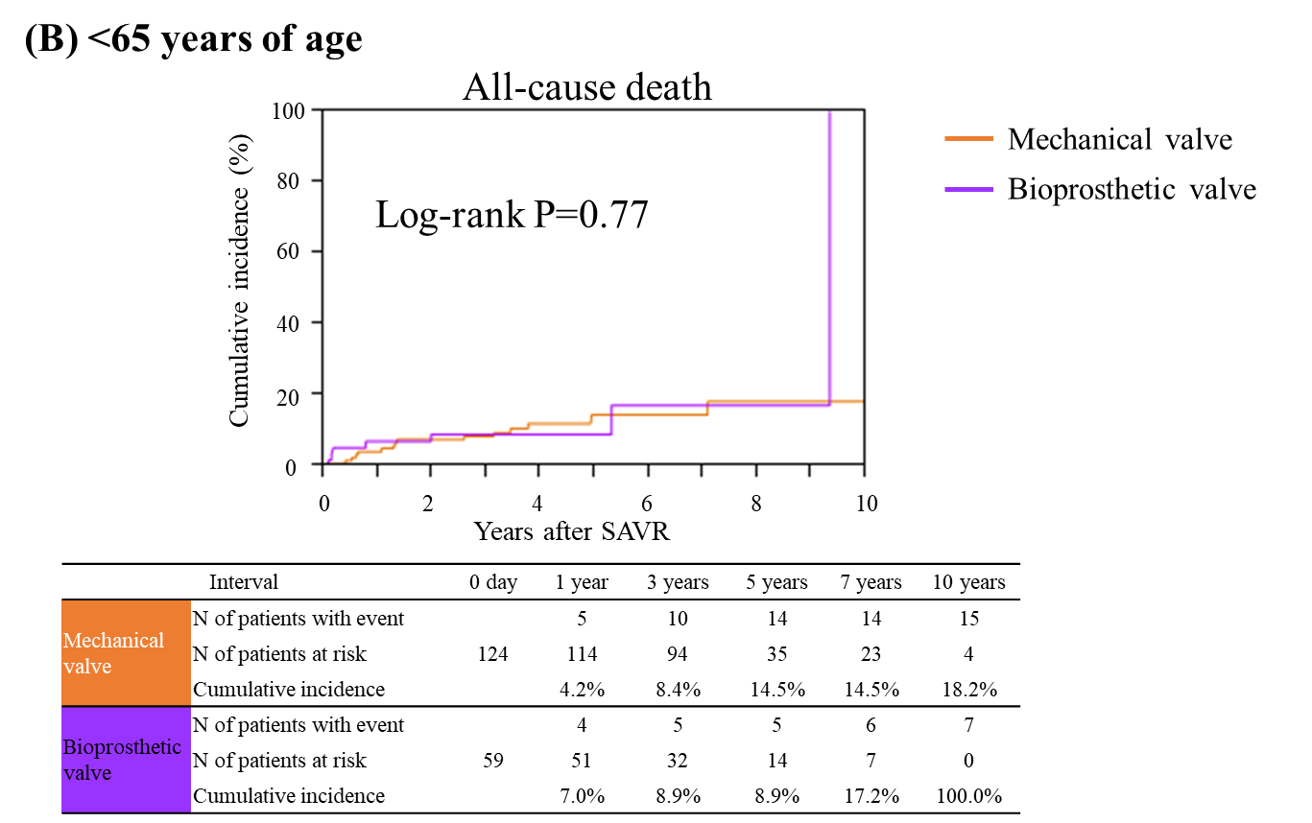

(C)
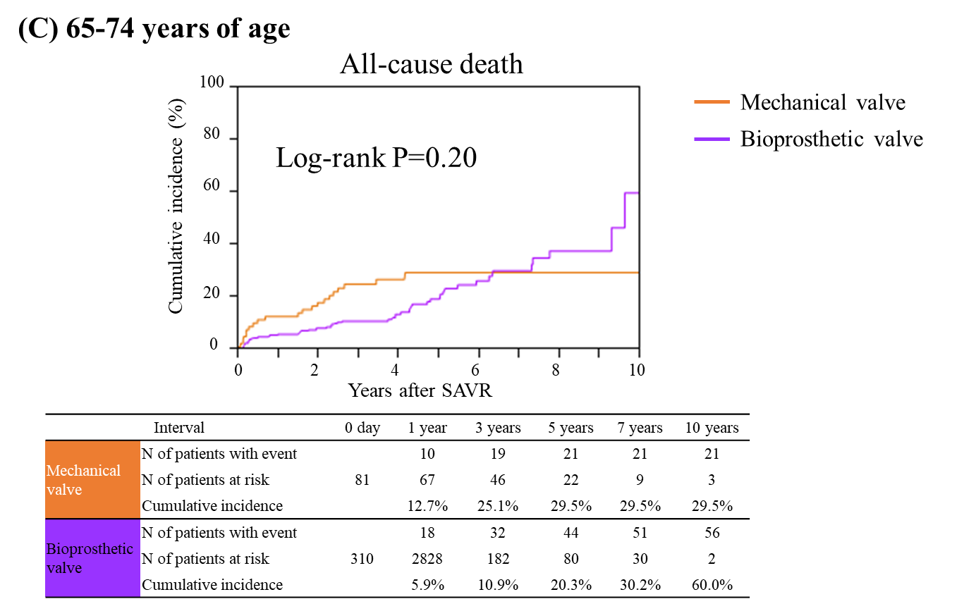

(D)
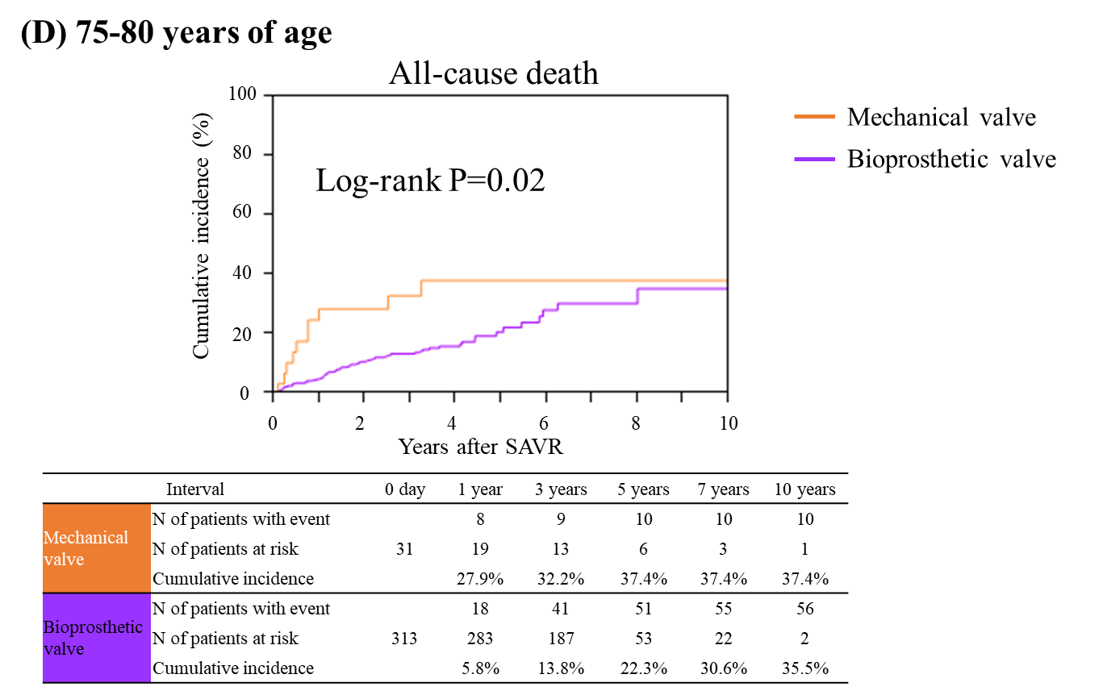

(E)
