Supporting information
Enzymatic polymerization of enantiomeric DOPA into films with enhanced rigidity and stability
Yuhe Shen,^{1,#} Rongxin Su, ^{1,5,#} Dongzhao Hao,¹ Yuefei Wang,^{1,}* Meital Reches,³ Heng Chang,¹ Xiaojian Xu,¹ Tao Yu, ¹ Qing Li,¹ Xiaoyu Zhang,² Yuefei Wang, ^{2,4,}* Wei Qi, ^{1,5,}* Zhimin He¹
¹ State Key Laboratory of Chemical Engineering, Tianjin Key Laboratory of Membrane Science and Desalination Technology, School of Chemical Engineering and Technology, Tianjin University, Tianjin 300072, P. R. China
² State Key Laboratory of Component-based Chinese Medicine, Tianjin University of Traditional Chinese Medicine, Tianjin 301617, China.
³ Institute of Chemistry, the Hebrew University, Jerusalem 91904, Israel
⁴ Haihe Laboratory of Modern Chinese Medicine, Tianjin 301617, China.
⁵ Collaborative Innovation Center of Chemical Science and Engineering (Tianjin), Tianjin 300072, P. R. China
# These authors contributed equally to this work.
* Corresponding authors: wangyuefei@tju.edu.cn (Yuefei Wang), wangyf0622@tjutcm.edu.cn (Yuefei Wang), and qiwei@tju.edu.cn (Wei Qi)

Table of contents
METHODS 3
Chemicals and Materials 3
Synthesis of Chiral DOPA Polymers 3
Preparation of Chiral DOPA Monolayers 3
Ultraviolet-visible Spectroscopy of Reaction Solution 4
Scanning electron microscopy (SEM) 4
Transmission electron microscopy (TEM) 4
Grazing-incidence wide-angle X-ray scattering (GIWAXS) 4
In situ synchrotron wide angle X-ray diffraction (WAXD) 5
Circular Dichroism spectroscopy (CD) 5
Atomic force microscopy (AFM) characterization 5
Powder X-Ray scattering measurements 6
XPS analysis 9
Supporting Figures 12
REFERENCES 26

METHODS

Chemicals and Materials
The _{L}- and _{D}-DOPA were purchased from Sigma-Aldrich (Beijing, China). Hydrochloric acid (HCl), sodium hydroxide (NaOH), sodium chloride (NaCl), phosphate, and potassium chloride were obtained from Tianjin Kemiou Chemical Reagent Co., Ltd. (Tianjin, China). Phosphate buffered saline (PBS, pH 7.4; 10 mM phosphate, 138 mM sodium chloride, and 2.7 mM potassium chloride) was used as flowing buffer. The water used in all experiments was prepared by a three-stage Millipore Milli-Q Plus 185 purification system (Millipore Corp., Bedford, MA) and had a resistivity of 18 MΩ cm. The pH values of all solutions were measured with a MP220 pH meter (Mettler Toledo, Switzerland). All solutions were filtered using a 0.22 µm syringe filter before use. Phosphate buffered saline (PBS, pH 7.4; 10 mM phosphate, 138 mM sodium chloride and 2.7 mM potassium chloride) was prepared in our laboratory. The buffers pH values were measured using a MP220 pH meter (Mettler Toledo, Switzerland). Ultrapure deionized water was produced by a Milli-Q water purification system (Millipore Corporation, Billerica, MA, USA).

Synthesis of Chiral DOPA Polymers
In a typical experiment, chiral _{L}-/_{D}-DOPA was dissolved in PBS buffer (50 mM, pH 7.4) to a final concentration of 2 mg/ mL. By mixing two solutions in a ratio of 1:1, racemic _{L+D}-DOPA solution is obtained. 5 mL of the above three solutions and 10 U mL⁻¹ tyrosinase were mixed evenly, and the reaction was stirred at 37 °C for 6 hours to obtain full oxidation. The final black solid products were obtained by centrifugation and washed three times with distilled water.

Preparation of Chiral DOPA Monolayers
_{L}-DOPA and _{D}-DOPA were dissolved in PBS to a final concentration of 2 mg/mL, and a solution with a ratio of 1:1 _{L+D}-DOPA was prepared. After ultrasonic cleaning, put the substrate into a container, add a mixed solution of DOPA and tyrosinase (enzyme concentration 10 U mL⁻¹), and react at 37 °C for 6 hours. After the reaction, the coating was washed and dried.

Ultraviolet-visible Spectroscopy of Reaction Solution
2 mg mL⁻¹ _{L/D/L+D}-DOPA solutions were prepared, and 10 U mL⁻¹ mushroom tyrosinase was added to make the reaction happen. Then the solution was stirred at 37°C for 6 hours. The UV-Vis time-correlated spectra were recorded and analyzed by drawing 1 mL solution from each sample at different time intervals. All UV–vis spectra were recorded on a UH5300 UV–vis spectrophotometer (Hitachi, Japan).

Scanning electron microscopy (SEM)
10 µL of prepared DOPA assemblies were deposited neatly on a microscope glass coverslip and dried in air. All samples were sputter-coated with platinum using an E1045 Pt-coater (Hitachi High-technologies CO., Japan), and then imaged with an S-8100 field emission scanning electron microscope (SEM, Hitachi High-technologies CO., Japan) at an acceleration voltage of 3 keV.

Transmission electron microscopy (TEM)
The morphology of the self-assemblies was further assessed using a JEOL JEM-F200 transmission electron microscope (TEM, JEOL Ltd., Japan) operated at 200 keV. To prepare samples, 10 µL aliquot of DOPA assemblies was placed onto a 200 meshes carbon-coated copper grid, air dried.

Grazing-incidence wide-angle X-ray scattering (GI-WAXS)
The GI-WAXS measurements were performed at beamline 1W1A of the Beijing Synchrotron Radiation Facility (BSRF, Beijing, China), with a Xenocs-SAXS/WAXS system. The X-ray wavelength was 1.5493 Å and the distance from the sample to the detector was set at 438 mm. The chiral DOPA films were obtained by dropping them on silicon substrates and drying at 37 ℃. The samples were irradiated at a fixed angle of 0.2°.

In situ synchrotron wide angle X-ray diffraction (WAXD)
In situ X-ray scattering measurements were carried out at beamline 1W2A of the Beijing Synchrotron Radiation Facility (Beijing, China). The wavelength of the radiation source was λ= 0.154 nm. Mar165-CCD was set at 160 mm sample-detector distance in the direction of the beam for WAXS data collections.

Circular Dichroism spectroscopy (CD)
The secondary structure of samples was characterized by circular dichroism (CD) with a Jasco-810 CD spectrophotometer (Japan). Freshly prepared sample (25 µL) was loaded carefully in a cell with a path length of 0.1 mm (Precision Cells, Inc., USA), which was scanned at room temperature by subtracting the buffer background. The presented spectra represent an average of three scans between 300 nm to 180 nm with a step size of 0.2 nm and a speed of 100 nm/ s.

Atomic force microscopy (AFM) characterization
The morphology of the chiral DOPA coating was imaged by AFM. The AFM samples were prepared by applying 15 µL of sample to freshly cleaned mica. After 30 min incubation, the excess sample solution was wicked off with filter paper and the mica surface was rinsed once with distilled water. Then, the mica was dried with N₂ and stored in a desiccator overnight before imaging. The AFM (MultiMode 8, Bruker Corporation) was operated in tapping mode with a silicon tip (ScanAsyst-Air, Bruker Corporation) and the scanning area was 1.6 × 1.6 µm². NanoScope Analysis software (version 1.90, Bruker Corporation) was used to compute an average Rq. The surface roughness values were an average result obtained from 3 samples.
Force Curve Measured by AFM.
The force measurements were conducted using a commercial AFM (MultiMode 8, Bruker Corporation) in tapping mode with a silicon tip (ScanAsyst-Air, Bruker Corporation. Two kinds of tips with different spring constant (9 N m⁻¹ and 45 N m⁻¹) were used in expermients. All AFM experiments were carried out at room temperature. In a typical experiment, the AFM tip is moved normally toward and eventually penetrates into the prepared DOPA coated mica substrate surface then the tip is retracted away from the surface. The adhesive interactions are manifested as negative force values. NanoScope Analysis software (1.90, Bruker Corporation) and AtomicJ software (version 1.7.3)¹ was used to analysis the force curves and adhesive forces.

Powder X-Ray scattering measurements
Freshly prepared samples were centrifuged and washed, followed by being frozen in liquid nitrogen and dried in a lyophilizer to yield a white powder for X-ray diffraction. The sample was placed in a fixed stage and the data was collected on Smartlab X-ray Diffractometer with a solid detector. The X-ray source is a Philips high intensity ceramic sealed tube (3 kW) and the X-ray of the wavelength of 1.5405 Å is generated by copper radiation and nickel filtration. The spectra were averaged with multiple scans.
Measurements of Chemical Modification by SPR
Gold-coated chips (BioNavis Ltd., Finland) were cleaned using an ultrasonic cleaner (KQ-250E, KunShan Ultrasonic Instruments Co., LTD, China). The chips were then immersed in alkali piranha solution (H₂O/NH₃/H₂O₂ = 5:1:1) at 75 °C for 10 min followed by extensive rinsing with ultrapure water and N2 blow dry. The gold chips were placed in an ultraviolet (UV)/ozone cleaning device (PSD-UV4-Novascan, USA) for 1 h. These chips were then rinsed with anhydrous ethanol and Milli-Q water, and subsequently dried with high-purity N₂ before use. To evaluate the effect of chirality on the chemical modification of DOPA molecules, we dissolved _{L}-DOPA and _{D}-DOPA in PBS to a final concentration of 2 mg/ mL, and prepared a ratio of 1:1 _{L+D}-DOPA solution. A SPR Navi 200A instrument (BioNavis Ltd., Finland) equipped with a 670 nm laser as the light source was used to measure the real-time modification of the chiral DOPA moleculars on the gold chips. For each experiment, the baseline signal was established by flowing PBS buffer solution over the chip surface at a flow rate of 50 µL/min for approximately 10–20 min, and record the initial SPR value and angle curve of the unmodified chip. Prepare 10 U/ ml tyrosinase solution, mix DOPA with enzyme solution and shake well, inject it into the flow cell at a flow rate of 10 µL/min for 10 minutes, and then rinse with PBS buffer solution at a flow rate of 50 µL/ min for 10 minutes minute. The injection of the above-mentioned DOPA-enzyme solution is repeated several times until the ΔSPR no longer increases to ensure that the gold chip reaches adsorption saturation. Record the saturated adsorption amount at the moment and the SPR angle of the modified chip. After the chemical modification is complete, we separately configure 1 M NaCl, 0.01 M HCl, 0.01 M NaOH solutions, and use the SPR sensor to test the acid, alkali and salt resistance of the chip after stable adsorption. Use PBS buffer solution as the mobile phase, and in the order of salt→acid→alkali, inject the solution into the flow cell at a flow rate of 10 µL/ min for 10 minutes to test the change in adsorption capacity to evaluatethe stability of chemically modified coatings. The values reported in the main text and SI are according to the means and standard deviations of the measurements.
Matrix-assisted Laser Desorption-tandem Time-of-flight Mass Spectrometry (MALDI-TOF)
500 µL of 1 mg·mL⁻¹ sample aqueous solution and 500 µL of saturated 2,5-Dihydroxybenzoic acid (DHB) solution were mixed uniformly to analyze the molecular weight of the synthesized products. Pipette 1 µl of the spot target and let it dry naturally at room temperature. Bruker MALDI-TOF MS technique (UltrafleXtreme) was used to determine molecular weight.
Solid-State NMR Experiments
¹³C cross-polarization magic-angle spinning (CPMAS) NMR measurements were performed at a typical 15 kHz (±20 Hz) spinning speed and with a recycle delay of 10 s between successive acquisitions to observe resonances from the various carbon moieties. Ramped-amplitude cross-polarization, ²in which the proton field strength was varied linearly by ∼20–50%, was implemented to compensate for inhomogeneous radiofrequency fields across the sample and improve spectral observation of DOPA polymers moieties with varying molecular mobilities. Typical 1–2 ms ¹H spin-lock times were used to transfer magnetization from ¹H to ¹³C nuclear spin baths, and high-power heteronuclear proton decoupling (90–185 kHz) was achieved using the TPPM or SPINAL composite pulse sequences.^{3, 4}High-fidelity ¹³C direct polarization (DPMAS) experiments were conducted at typical 15 kHz spinning speeds, with 100 s delays between successive acquisitions. Typically, 24 000–36 000 and 1500–2000 transients were collected for CPMAS and DPMAS experiments, respectively, on natural abundance DOPA oxidized polymers. ⁵⁻⁷
In previous studies, several groups have tentatively identified functional groups in synthetic and natural eumelanins from different sources by using high-resolution ¹³C and ¹⁵N solid-state NMR¹ in conjunction with established chemical shift trends, such as those containing complex nitrogen- containing aromatic ring structures. In all cases, the chemical shifts were consistent with molecular structures that include open chain methylene groups (30 ppm), oxygenated aliphatic carbons (CHnO, 60–80 ppm), aromatic and/or olefinic carbons (110−160 ppm), and carboxyls (COO, 170–173 ppm). There were no prominent spectral features that could be attributed to proteinaceous materials (C_{α}, ∼50 ppm) or phenolic moieties (58 and 150 ppm). Resonances corresponding to the two enriched protonated aromatic carbons in the ¹³C NMR results of synthetic melanoids in the presence of _{L+D}-DOPA substrates are dramatically enhanced compared with the chain methylenes, and prominent aromatic resonances could be observed.⁶
Contact angle (CA) Measurement
An OCA15EC optical contact angle measurements (DataPhysics Instruments, Germany) was used to measure the contact angles and evaluate the surface wettability of samples at atmospheric pressure and 50 % relative humidity. The chips (_{L}-modified, _{D}-modified, _{L+D}-modified and bare substrate) were mounted on the platform. Next, 1µL water droplet was injected on the. The contact angle values were measured using the instrument, which can capture and analyze the curve profile of water droplet in the three-phase interface. In order to obtain a reliable value for the contact angle, the measurements were performed by placing water droplets at five different locations on the sample surface and averaging the obtained values. The values reported in the main text and SI are according to the means and standard deviations of the measurements.

XPS analysis
The XPS spectra of poly(DOPA) modified surfaces were acquired using a PHI5000VersaProbe spectrometer (ULVAC-PHI, Japan). Survey spectra were recorded from 0 eV to 1350 eV at 1.0 eV steps and 150 ms dwell times, and the C 1s, N1s, O 1s and Si 2p spectra were collected.
Raman Spectroscopy and Data Analysis
Raman spectroscopy was performed by using DXR Smart Raman Spectrometer (Thermo Scientific, USA). A spectrum of buffer was subtracted from that of each time point to remove the broad contribution of water near 1650 cm^{–1}, followed by the removal of the spectrum of a blank quartz tube.
Fourier Transform Infrared Spectroscopy (FTIR).
The secondary structure of _{L+D}-DOPA assembly was characterized by FTIR. The FTIR spectra were collected with an average of 16 scans on a Bruker Vertex-70 Spectrometer (USA) with 4 cm⁻¹ resolution in the range of 4000-400 cm⁻¹. For sample preparation, the sample was frozen in liquid nitrogen and lyophilized to give a dry powder. The dried powder was mixed with KBr (at a ratio of 1:10 (w/w)) and grounded into a fine powder, followed by pressing into the transparent disk. The blank KBr disk was scanned as background, which was subtracted from the sample spectra.
Density Functional Theory (DFT) Calculations
Discovery studio2019 was used to construct molecular models of three DOPA multimers. After forming the input files using GaussView6.0, we used Gaussian16 to perform configuration optimization and frequency calculations for the three molecules under the b3lyp/6-311G* method. The final molecular structure is generated after the frequency calculation results are free of imaginary frequencies. The distance between the two interacting molecules after optimization was measured using PyMol software.
Calculation of Intermolecular Binding Energy (△E)
Molecular interaction models are constructed in GaussView 6.0. First, the pm6 method plus dispersion correction (D3) is used to optimize the structure of the models, and then the density functional theory is used to apply dispersion correction (DFT-D3). Under the b3lyp/6-311G* method, the single-point energy (E_{A}) of the optimized models are calculated; then the single-point energy (E_{B}, E_{C}) of the two single molecules were calculated under the same method respectively, and the binding energy was calculated according to the following formula:
△E=E_{A}-E_{B}-E_{C}
Molecular dynamics simulations (MDSs)
The classical MD simulation was performed using the Gromacs 2019.6 software package.⁸ All constructed molecules and models are structurally optimized using Gaussian16, and usable structural topology files were generated using acpype. Use Gromacs tools and VMD to view and analyze MD simulation results. The Gromacs utils gmx rms, gmx sasa were used to analyze the root mean square deviation (RMSD) and solvent accessible surface area (SASA) of the simulated structures. The models of (_{D}-DOPA_{ox})₂, (_{L}-DOPA_{ox})₃ and (_{L+D}-DOPA_{ox})₉ were generated using Gromacs 2019.6 to generate square boxes with side lengths of 8 nm, into which 150 molecules and water solvent were added. This procedure uses the SPC water molecule model and uses the conjugate gradient (CG) algorithm for energy minimization.⁹ The effect of charge is taken into account in the simulation, and the total charge of the monomers is all zero (electrical neutrality). The 60ns all-atom molecular dynamics simulation was performed using Gromacs 2019.6 under the GAFF force field at a constant temperature of 298.15K and a pressure of 1.013 bar. After the end, the system was proved to be in equilibrium by calculating the RMSD.

Supporting Figures
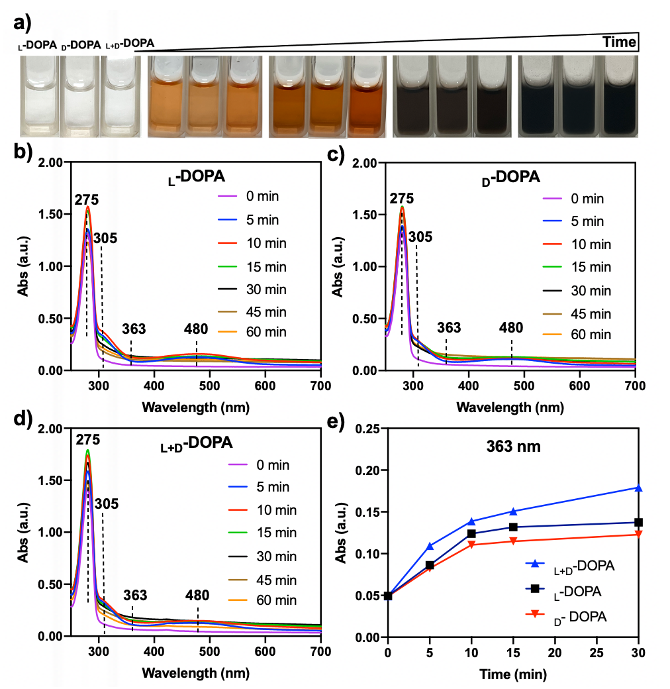
Fig. S1. a) Macrophotograph and b-d) UV–vis spectra of the supernatant of DOPA molecules during enzymatic oxidation at 37 °C. e) The kinetic curve of _{L}-DOPA, _{D}-DOPA and _{L+D}-DOPA enzyme catalysis at 363 nm, which is reported as a characteristic peak of melanin intermediates.¹⁰

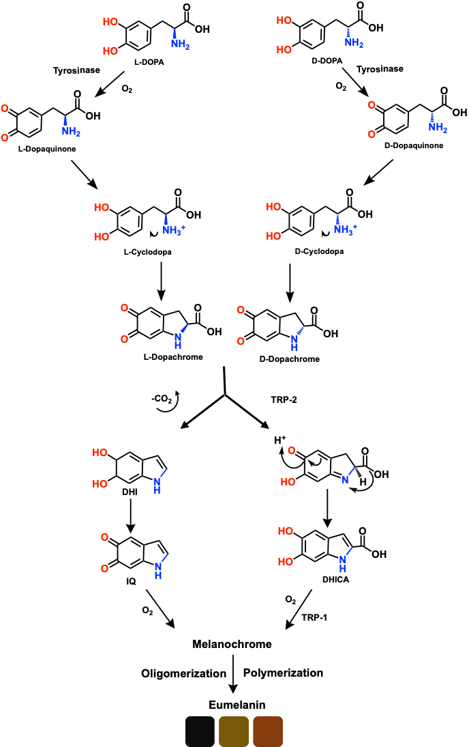
Fig. S2. Raper–Mason scheme of eumelanin production pathway using DOPA as precursor. Both _{L}-DOPA and _{D}-DOPA get oxidized in the presence of the enzyme tyrosinase (TYR) to form dopaquinone (DQ), which readily undergoes cyclization and forms dopachrome (DC) through the intermediate cyclodopa, which has a chiral configuration. Afterwards, 5,6-Dihydroxyindole (DHI) or 5,6-dihrdoxyindole-2-carboxylic acid (DHICA) is produced from DC via decarboxylation or spontaneous rearrangement, respectively. The production of DHICA only happens in the presence of an enzyme called dopachrome tautomerase (DCT, also known as TYRP2). The thus-formed DHI and DHICA get oxidized to form the pigment precursor melanochrome (MC) and subsequently melanin.
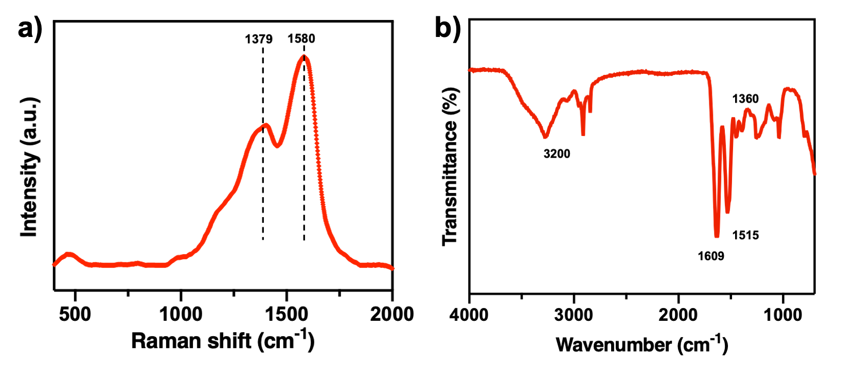
Fig. S3. a) Resonance Raman spectra of the DOPA oxidation products, it shows that the peaks at 1379 and 1580 cm-1 were ascribed to the in-plane stretching of the aromatic ring (∼1580 cm–1), the linear stretching vibration of the C–C bond in the ring, and some C–H stretching vibrations from methyl and methylene groups (∼1375 cm–1), which are defined as the melanin signals and b) FT-IR spectroscopy of products formed after oxidative polymerization of DOPA. The large, broad peak spanning 3100–3300 cm⁻¹ originates from the OH and NH stretching vibrations. The 1610 cm⁻¹ may be caused by the combination of the C=O stretching of the carbonate group and/or the C=C aromatic ring vibration, and the 1360 cm⁻¹ peak comes from indole ring vibration and/or CN stretching.
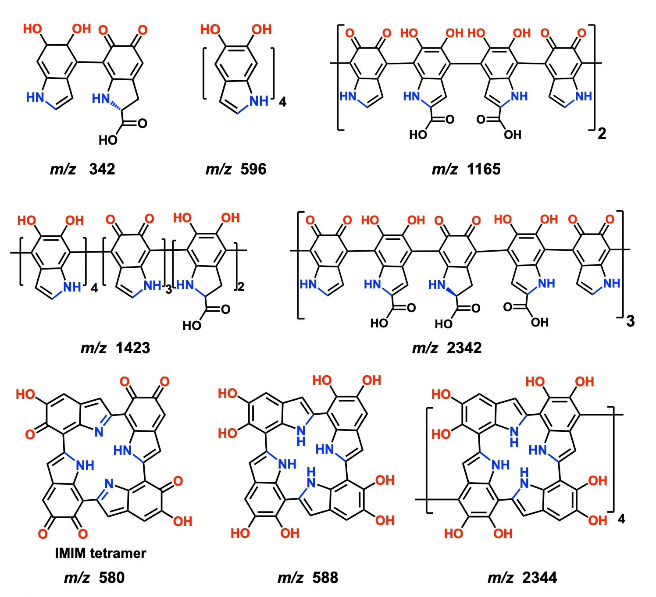
Fig. S4. Possible structures assigned to the other peaks marked in orange in Fig. 4e, which are detected by MALDI-TOF-MS. The derivation of each molecular formula is mainly based on the oxidation process and main building blocks of natural melanin reported in literatures, among which the core motif of (_{L+D}-DOPA_{ox})₉ is inspired by the IMIM tetramer, which is derived from the recently proposed structural model for eumelanin protomolecules.^{11, 12} It was confirmed by the combination of simulation and experimental results as an important reason for the lamellar structure in eumelanin.¹³
Fig. S5. CD spectra of self-assembled nanostructures of chiral DOPA molecules after different reaction times. Among them, the CD peak at 218 nm of _{L}-DOPA (positive) and _{D}-DOPA (negative) solutions may be attributed to the n-π* transition of amido bond. As the reaction progresses, the CD signals of the enantiomers are gradually weakened, but still appear as mirror images, and the racemic solution has no corresponding CD signal in this region.
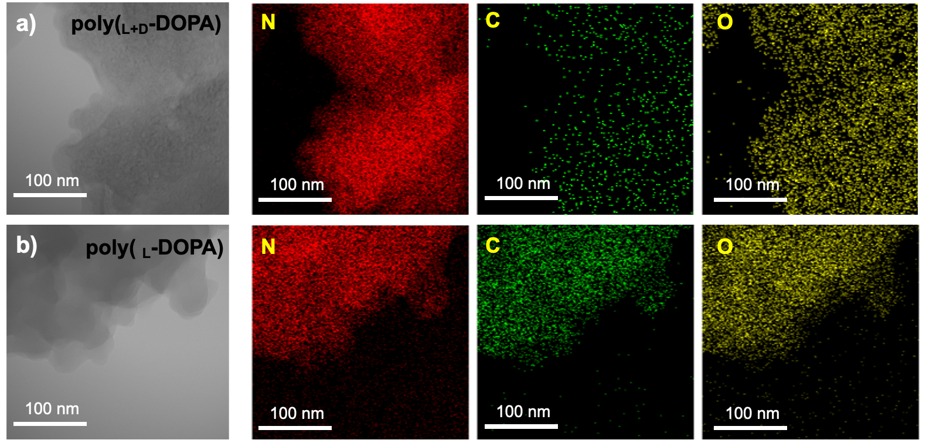
Fig. S6. Representative TEM images and EDS analysis of DOPA aggregates in solution.

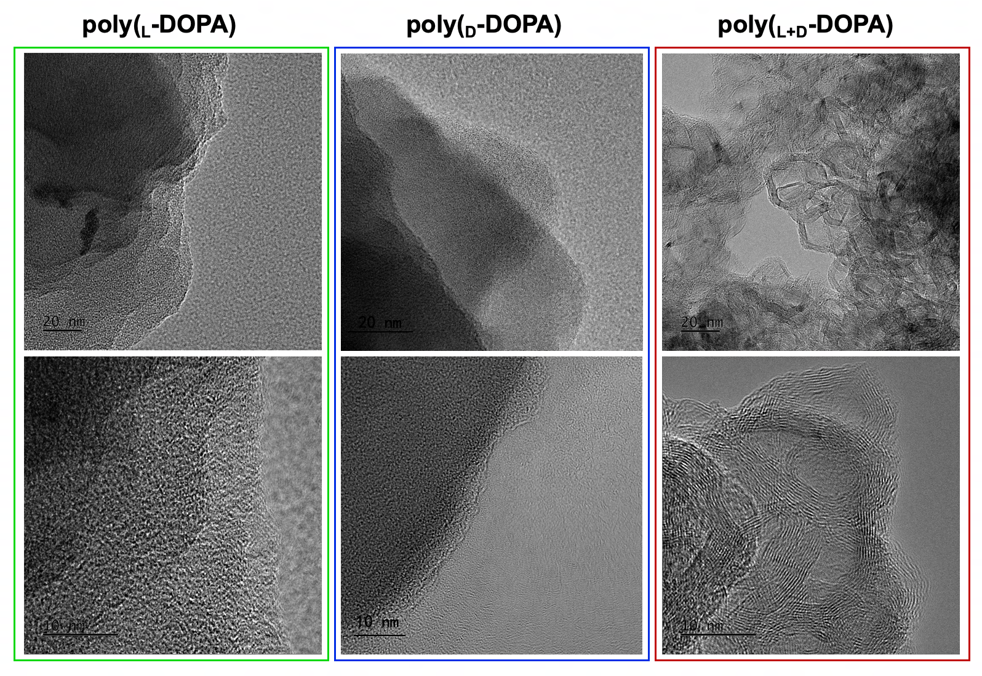
Fig. S7. Supplementary high-resolution transmission electron microscopy (TEM) images of the poly(_{L}-DOPA), poly(_{D}-DOPA), and poly(_{L+D}-DOPA) solutions. It can be clearly seen that all three molecules assemble into layer-by-layer structures, but only poly(_{L+D}-DOPA) molecule has the highly ordered fingerprint-like structure.
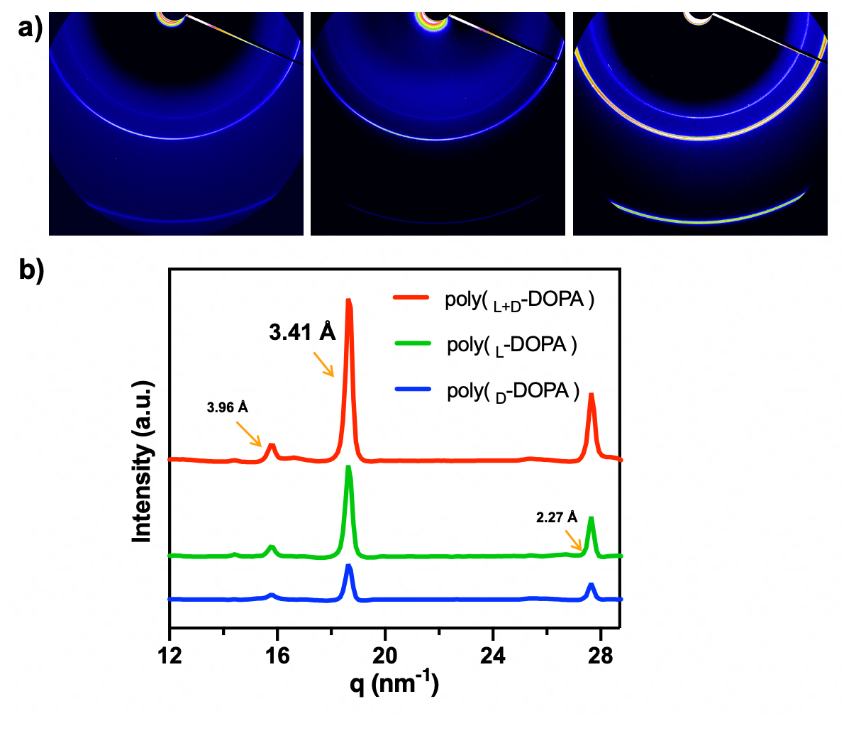
Fig. S8. The wide-angle X-ray scattering 2D patterns (a) and corresponding azimuthally integrated spectra (b) of poly(_{L}-DOPA), poly(_{D}-DOPA), and poly(_{L+D}-DOPA) solutions. The oxidized DOPA solutions showed strong diffraction peaks corresponding to the spacing of 3.41 Å, similar to that of the melanin “local structure” produced by previous WAXS experiments, in which the 5,6-indolequinone units are arranged in planes by π-stacking. ^{13, 14} Among them, the heterochiral poly(_{L+D}-DOPA) showed the strongest diffraction signal.
The WAXS of poly(DOPA) shows weaker diffraction peaks than XRD due to the low crystallinity in the solution, and the solids are more neatly arranged with the disappearance of the solvent.
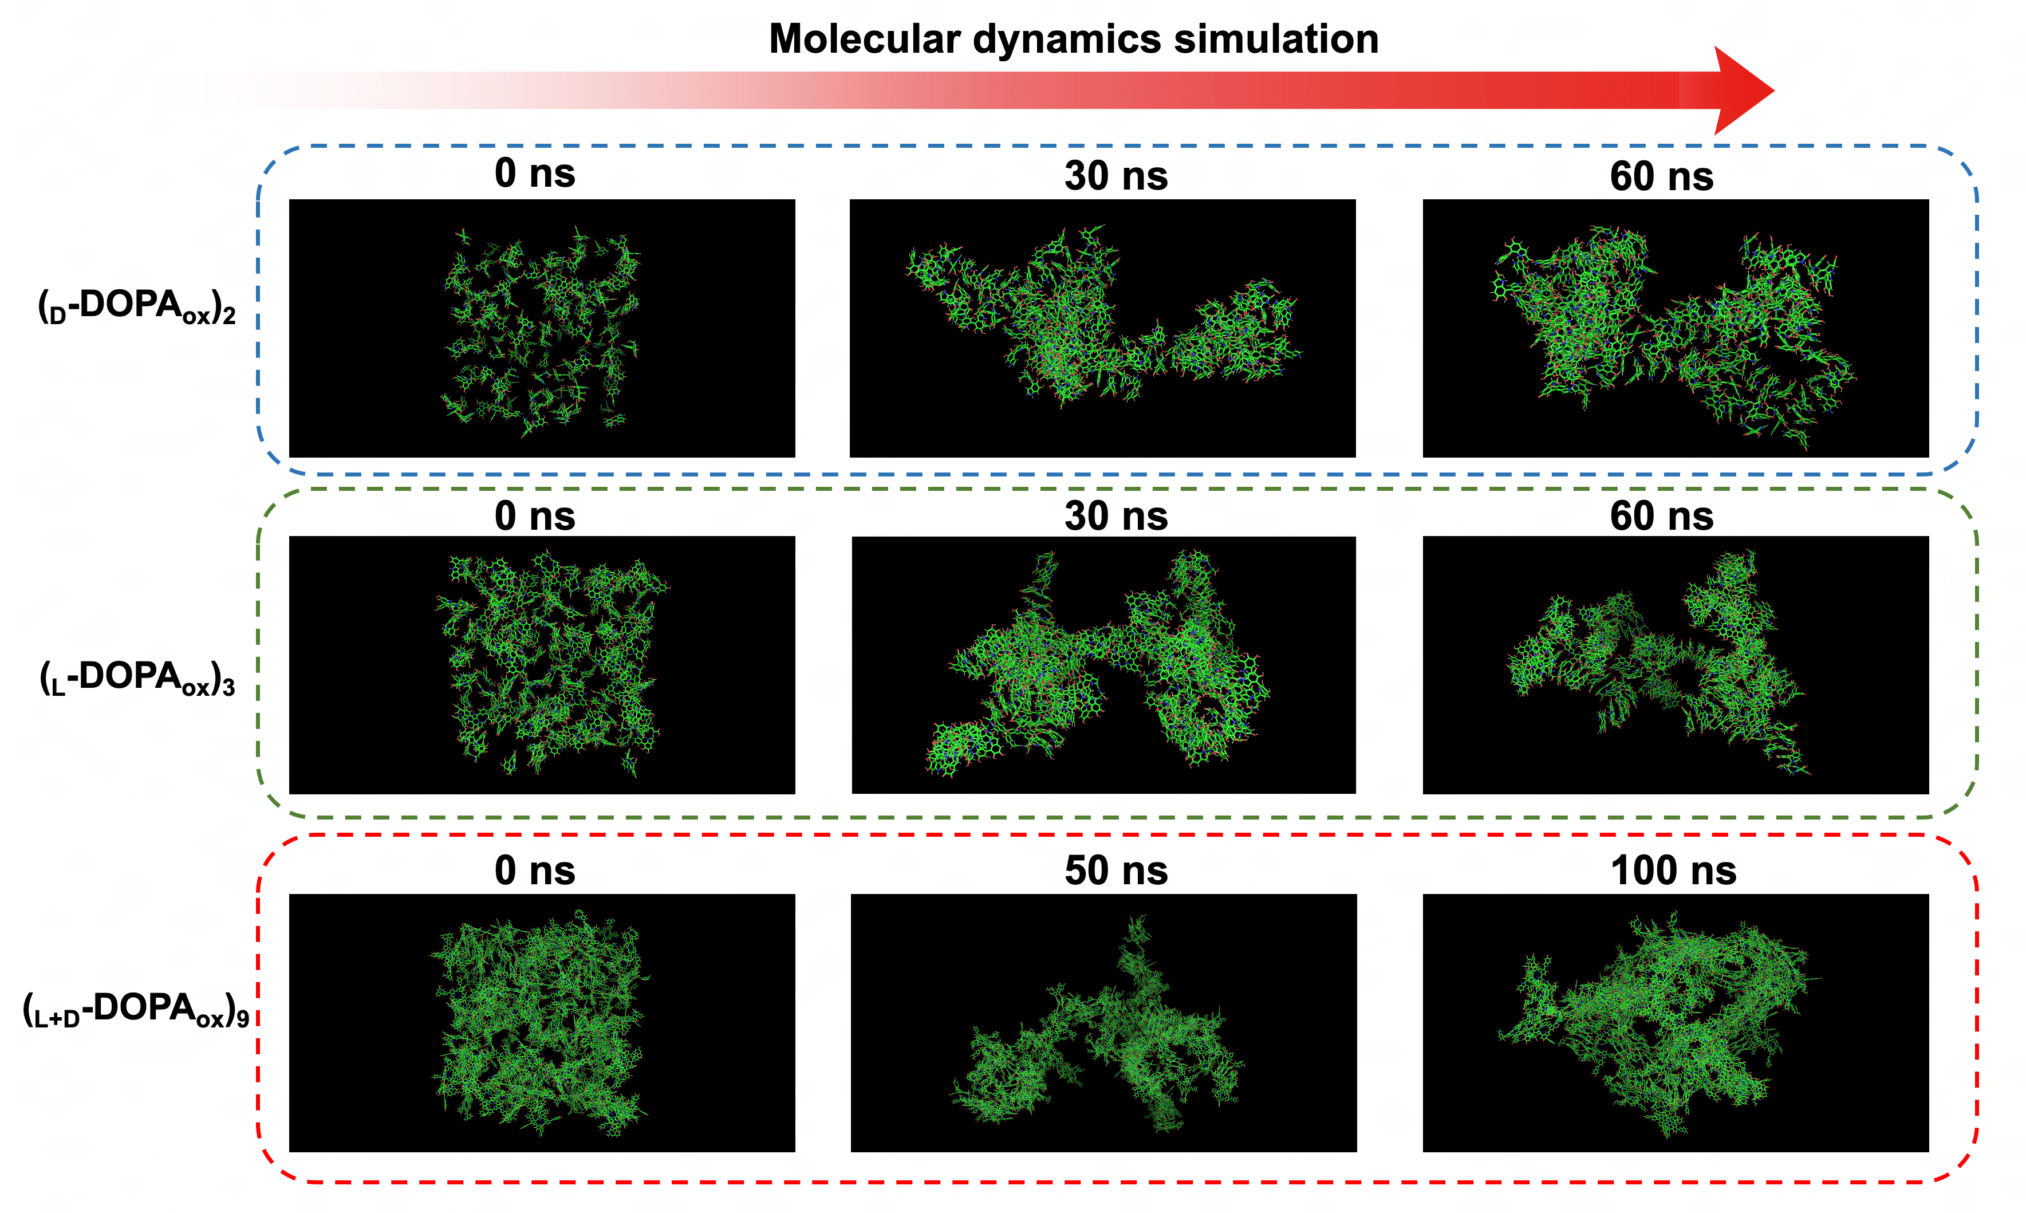
Fig. S9. Snapshots of the self-assembly process of 150 poly(DOPA) molecules in square box systems.
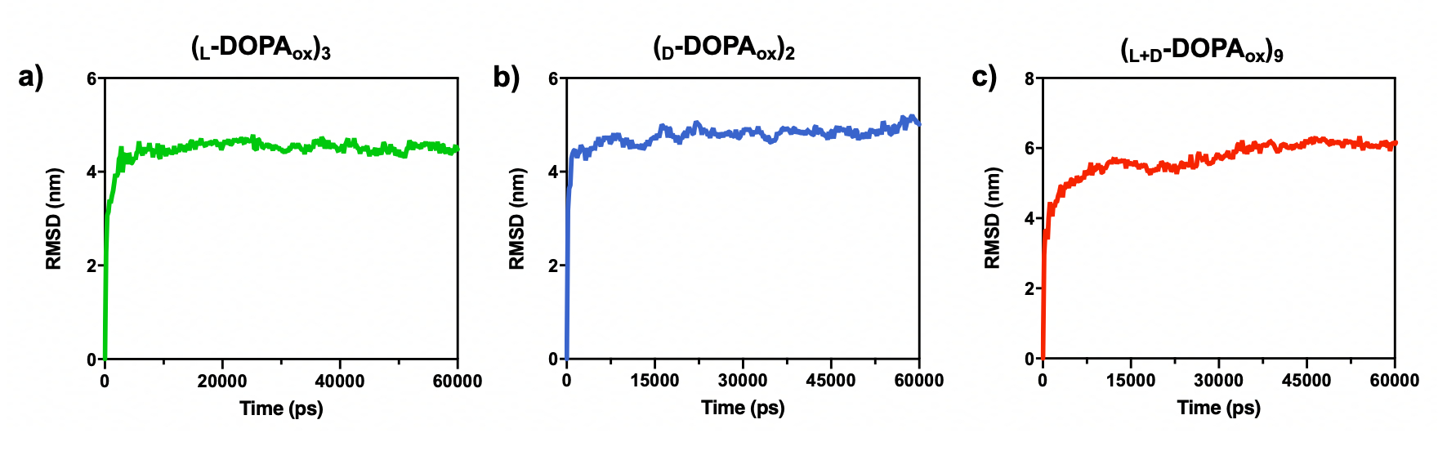
Fig. S10. a-c) The root mean square deviation (RMSD) curves of (_{D}-DOPA_{ox})₂, (_{L}-DOPA_{ox})₃ and (_{L+D}-DOPA_{ox})₉, proving the simulated systems have reached equilibrium at 60 ns and 100 ns, respectively.
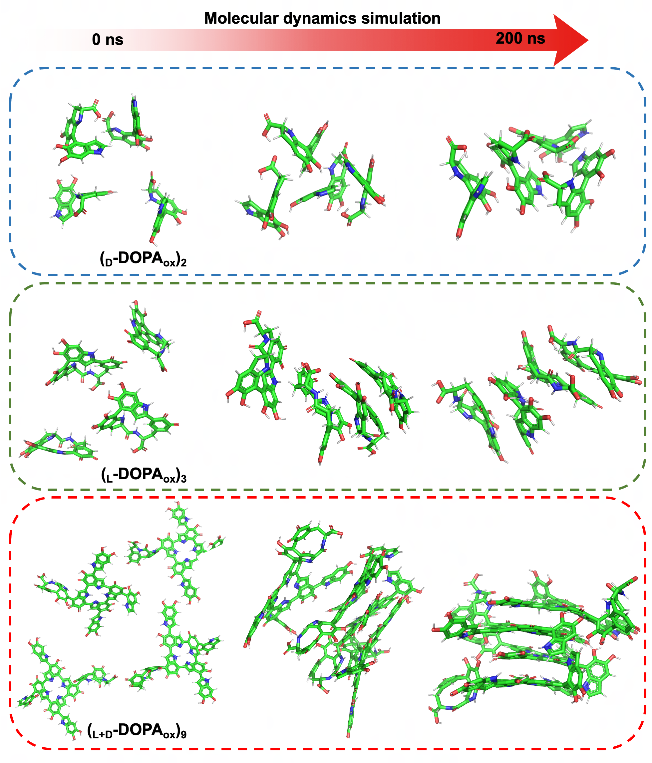
Fig. S11. Local snapshots of the self-assembly process of DOPA-oxidized polymers. The poly(DOPA) molecules are separated from each other in the initial configuration but quickly stack together to form a secondary structure.

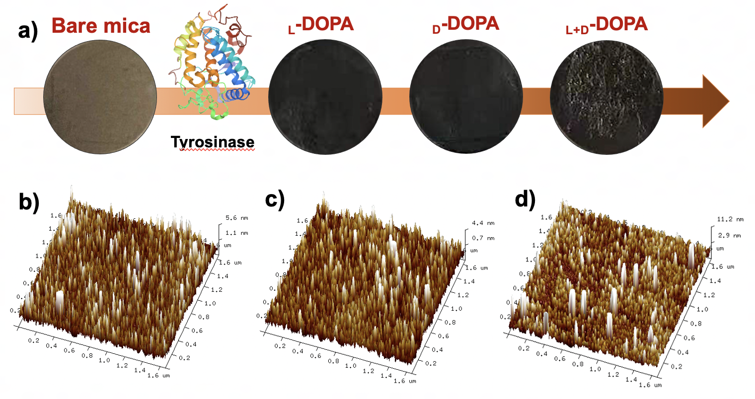
Fig. S12. a) Schematic illustration of the process of oxidative loading of chiral DOPA molecules on bare mica substrates. b-d) Three-dimensional topographic AFM images of the surface modified by (b) _{L}-DOPA, (c) _{D}-DOPA, and (d) _{L+D}-DOPA. (Scanning area size = 1.6 × 1.6 µm).

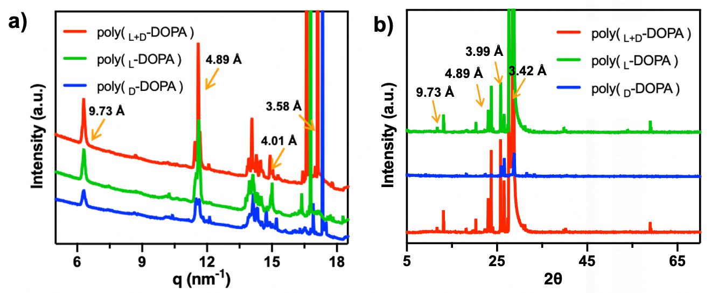
Fig. S13. a) 2D-GIWAXS data of enzymatic oxidative polymerization of DOPA in PBS (50 mM) and dried on a silicon substrate, corresponding azimuthally integrated spectra of poly(_{L}-DOPA), poly(_{D}-DOPA), and (d) poly(_{L+D}-DOPA) shown in green, blue, and red, respectively. b) Powder X-ray diffraction XRD spectrum analysis of poly(DOPA). The X-ray diffraction of the dried assembled samples showed similar crystal structures and was consistent with the WAXS and 2D-GIWAXS data. All X-ray scattering results show that poly(_{L+D}-DOPA) has a stronger alignment signal and diffraction peak, confirming that the alignment of the molecules in the mixture has changed.
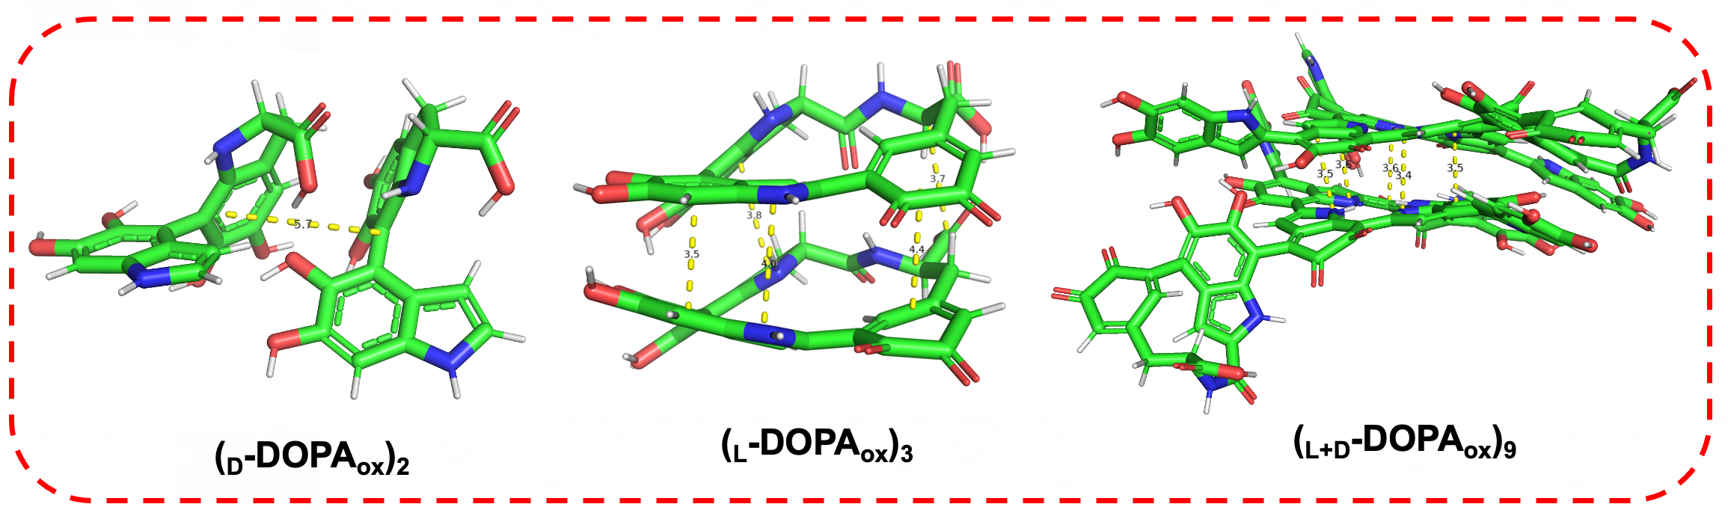
Fig. S14. The distance between the two interacting molecules after optimization, which was measured by PyMol.
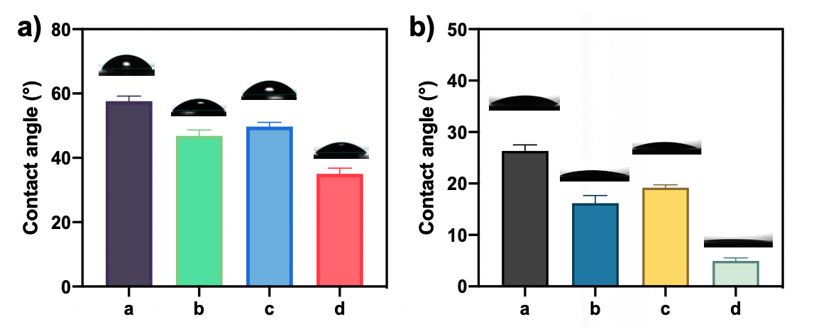
Fig. S15. Contact angles of different surface. water droplets on (a) bare substrate, (b) _{L}-DOPA-coated, (c) _{D}-DOPA-coated, and (d) _{L+D}-DOPA hybrid coated at 25 ℃. The substrate in the left picture is a glass slide, and the right is silica. We prepared DOPA solutions (2 mg/ ml) with different chirality and added tyrosinase (10 U/ ml) for oxidation. The reaction solution was adhered and assembled on the surface of the glass substrate by spin coating at room temperature, and the change in the hydrophilicity and hydrophobicity of the surface was measured after 5 repetitions. The figure shows the contact angles of water on the four surfaces before and after modification (bare slide, _{L}-DOPA-coated, _{D}-DOPA-coated, and _{L+D}-DOPA hybrid coated). The untreated bare glass slide exhibits weak hydrophilicity due to hydrogen bonding, and its contact angle value is 57.64°. After modification, the contact angle of the surface is significantly reduced, indicating that DOPA molecules have excellent hydrophilic properties. Compared with the single chiral DOPA coating with contact angle values of 46.29° and 49.28°, the water contact angle of _{L+D}-DOPA decreased to 35.09°, confirming that the surface is more hydrophilic, that is, it has more adsorption quality on the substrate surface. After replacing the substrate with silica (contact angle=26.8°) and re-coating, we also found that the water contact angle of _{L+D}-DOPA decreased to 5.27°, compared to the single chiral DOPA coating with contact angles of 17.40° and 19.83°, confirming that it formed a more hydrophilic surface, which further proved that _{L+D}-DOPA showed higher adsorption capacity on different substrate surfaces.

Fig. S16. Wide scan XPS spectrogram of the three chiral DOPA modification on silica surfaces. C, O, N, and Si elements were detected by XPS. The high content of C suggested that polymers were successfully adsorbed on the surface, as well as the existence of N. The high intensities of Si and O are attributed to the silica substrate.
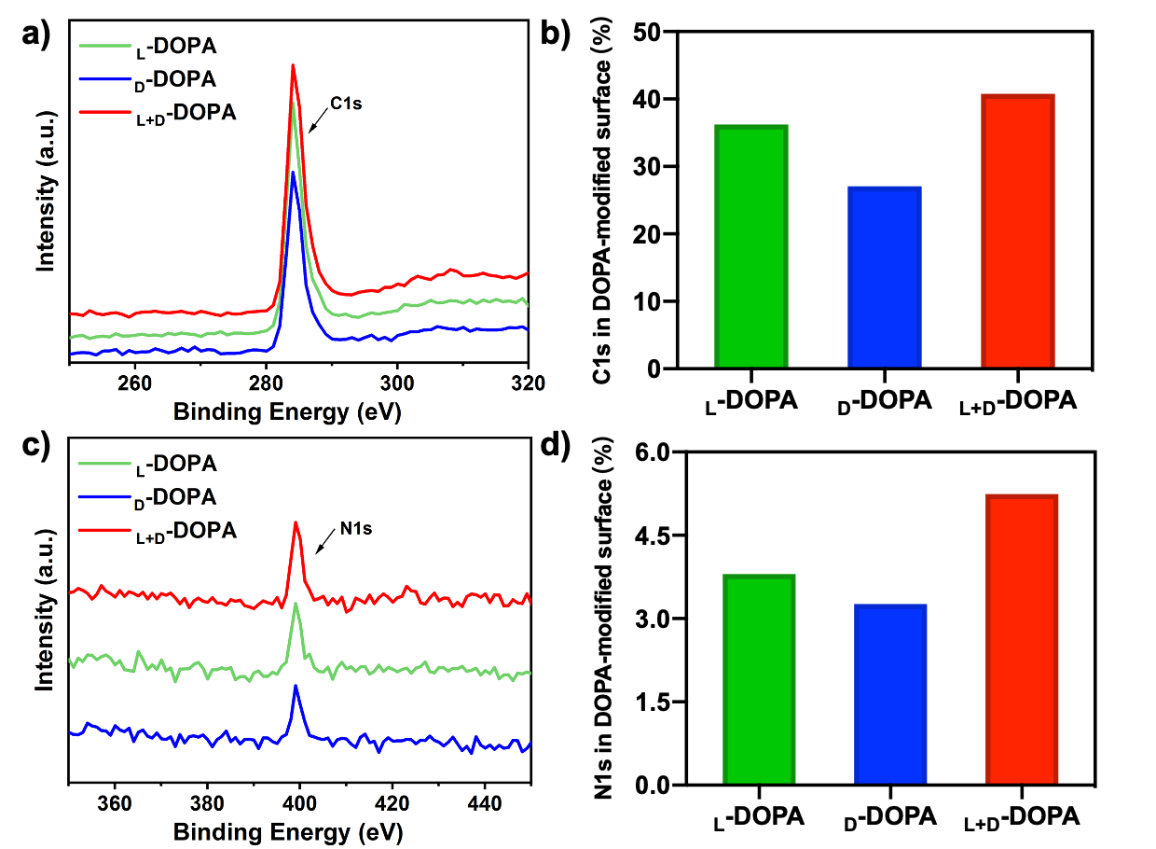
Fig. S17. XPS spectrogram monitoring the C/N element for chiral DOPA at same adsorption concentrations for saturation adsorption, the amounts of C/N were collected and shown in the panel B for the C1S and D for the N1S. After the adsorption reached saturation, the C content in _{L}-DOPA was 36.23%, and the N content was 3.8%, both of which were greater than the element content of the surface modified by _{D}-DOPA with C of 27.05% and N of 3.26%. However, the chiral mixed _{L+D}-DOPA obviously has a higher loading effect. The C element loading of 40.76% and the N element loading of 5.24% both confirmed its larger adsorption capacity, which is consistent with other experimental results.

REFERENCES

1. Hermanowicz P, Sarna M, Burda K, Gabryś H. AtomicJ: an open source software for analysis of force curves. Rev. Sci. Instrum. 85, 063703 (2014).
2. Metz G, Wu XL, Smith SO. Ramped-Amplitude Cross Polarization in Magic-Angle-Spinning NMR. J. Magn. Reson., Ser A 110, 219-227 (1994).
3. Fung BM, Khitrin AK, Ermolaev K. An improved broadband decoupling sequence for liquid crystals and solids. J. Magn. Reson. 142, 97-101 (2000).
4. Riedel K, Herbst C, Leppert J, Ohlenschlager O, Gorlach M, Ramachandran R. Heteronuclear decoupling in rotating solids: Improving the efficacy of CNnv symmetry-based tanh/tan adiabatic RF pulse schemes. Chem. Phys. Lett. 429, 590-594 (2006).
5. Tian S, Garcia-Rivera J, Yan B, Casadevall A, Stark RE. Unlocking the molecular structure of fungal melanin using 13C biosynthetic labeling and solid-state NMR. Biochemistry 42, 8105-8109 (2003).
6. Thureau P, et al. Probing the motional behavior of eumelanin and pheomelanin with solid-state NMR spectroscopy: new insights into the pigment properties. Chemistry (Easton) 18, 10689-10700 (2012).
7. Grieco C, Kohl FR, Hanes AT, Kohler B. Probing the heterogeneous structure of eumelanin using ultrafast vibrational fingerprinting. Nat. Commun. 11, 4569 (2020).
8. Abraham MJ, et al. GROMACS: High performance molecular simulations through multi-level parallelism from laptops to supercomputers. SoftwareX 1-2, 19-25 (2015).
9. Jorgensen WL, Chandrasekhar J, Madura JD, Impey RW, Klein ML. Comparison of simple potential functions for simulating liquid water. J. Chem. Phys. 79, 926-935 (1983).
10. Mondal S, Thampi A, Puranik M. Kinetics of Melanin Polymerization during Enzymatic and Nonenzymatic Oxidation. J. Phys. Chem. B 122, 2047-2063 (2018).
11. Kaxiras E, Tsolakidis A, Zonios G, Meng S. Structural model of eumelanin. Phys. Rev. Lett. 97, (2006).
12. Meng S, Kaxiras E. Theoretical models of eumelanin protomolecules and their optical properties. Biophys. J. 94, 2095-2105 (2008).
13. Chen CT, et al. Self-assembly of tetramers of 5,6-dihydroxyindole explains the primary physical properties of eumelanin: experiment, simulation, and design. ACS Nano 7, 1524-1532 (2013).
14. Cheng J, Moss SC, Eisner M. X-ray characterization of melanins--II. Pigment Cell Res. 7, 263-273 (1994).

