Supplementary Materials

Supplementary Materials
Fig 1S: Representative H&E images of a patient case with both well-differentiated and poorly differentiated tumor cells on same FFPE slide.
Fig 2S: Analysis of N-glycosylation changes between well differentiated and poorly differentiated glands within each patient
Fig 3S: Representative glycan image demonstrating upregulation of a biantennary glycan (2101.7551 m/z) in hormonally-treated tumors (specific tumor regions demarcated in black)
Fig 4S: Representative glycan image demonstrating downregulation of a tetraantennary glycan (1891.6924 m/z) in hormonally-treated tumors (specific tumor regions demarcated in black)
Fig 5S. Significant N-glycans with a high degree of quantitative change in hormonally treated tumors
Fig 6S: Flow cytometric analysis of cell lines for PHA-L activity to detect beta 1-6 branched glycans
Fig 7S: MGAT4 and MGAT5 mRNA levels in hormone resistant PCa patients
Fig 8S. Significant N-glycans with a high degree of quantitative change in hormone resistant tumors
Fig 9S: Representative H&E images of a patient case with both adenocarcinoma and neuroendocrine tumor cells on same FFPE slide.
Fig 10S: Scatter plots depicting high mannose (Man 5-9) structure abundance between all adenocarcinoma (n = 17) and NE regions (n = 38)

Fig 11S: Analysis of N-glycosylation changes between adenocarcinoma and NE regions within each patient that can be statistically analyzed

Fig 12S: Scatter plots depicting non-fucosylated and fucosylated Gal3Man3GlcNAc6 levels in hormone-sensitive (n = 120), hormonally treated (n = 37), and hormone resistant (n = 75) tumor regions
Fig 13S: Significant N-glycans with a high degree of quantitative change in NE tumor regions

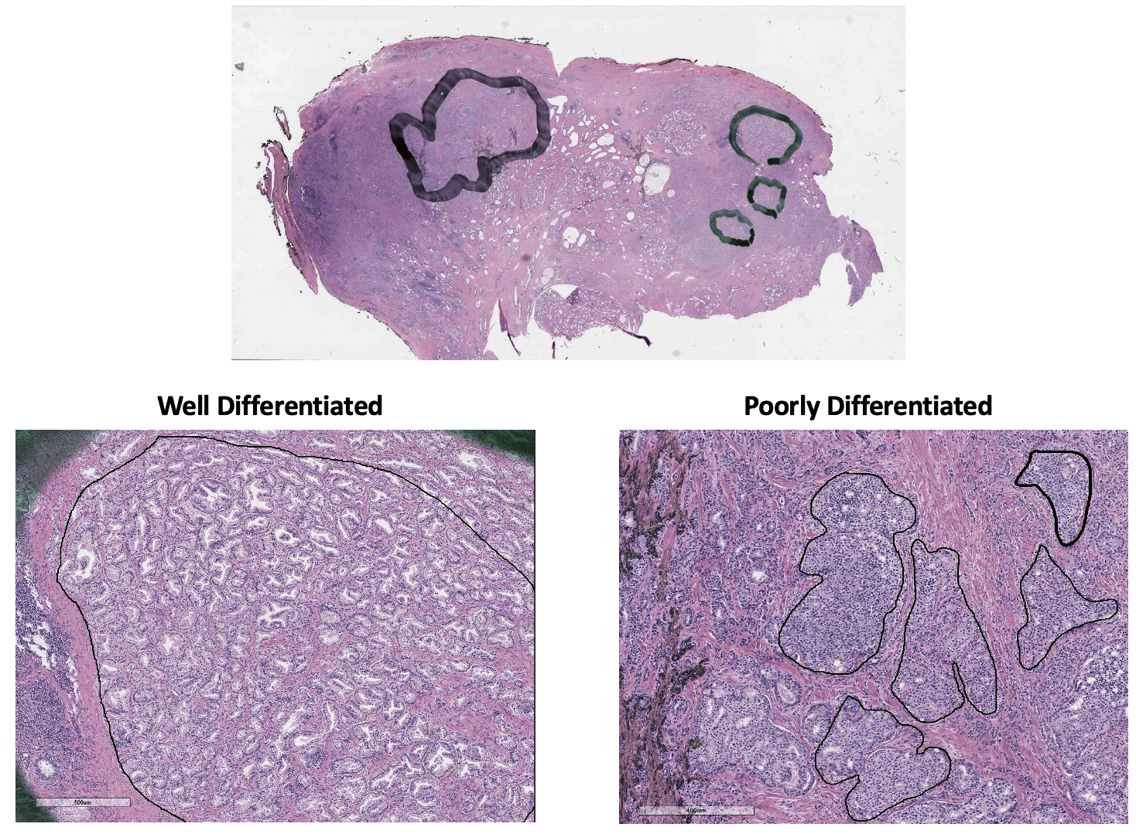
Fig 1S: Representative H&E images of a patient case with both well-differentiated and poorly differentiated tumor cells on same FFPE slide. Upper panel demonstrates pathological annotation of targeted tumor regions (green = abundance of low grade tumor cells, black = abundance of high grade tumor cells). Lower panel demonstrates representative demarcated pure tumor cell regions within targeted areas.

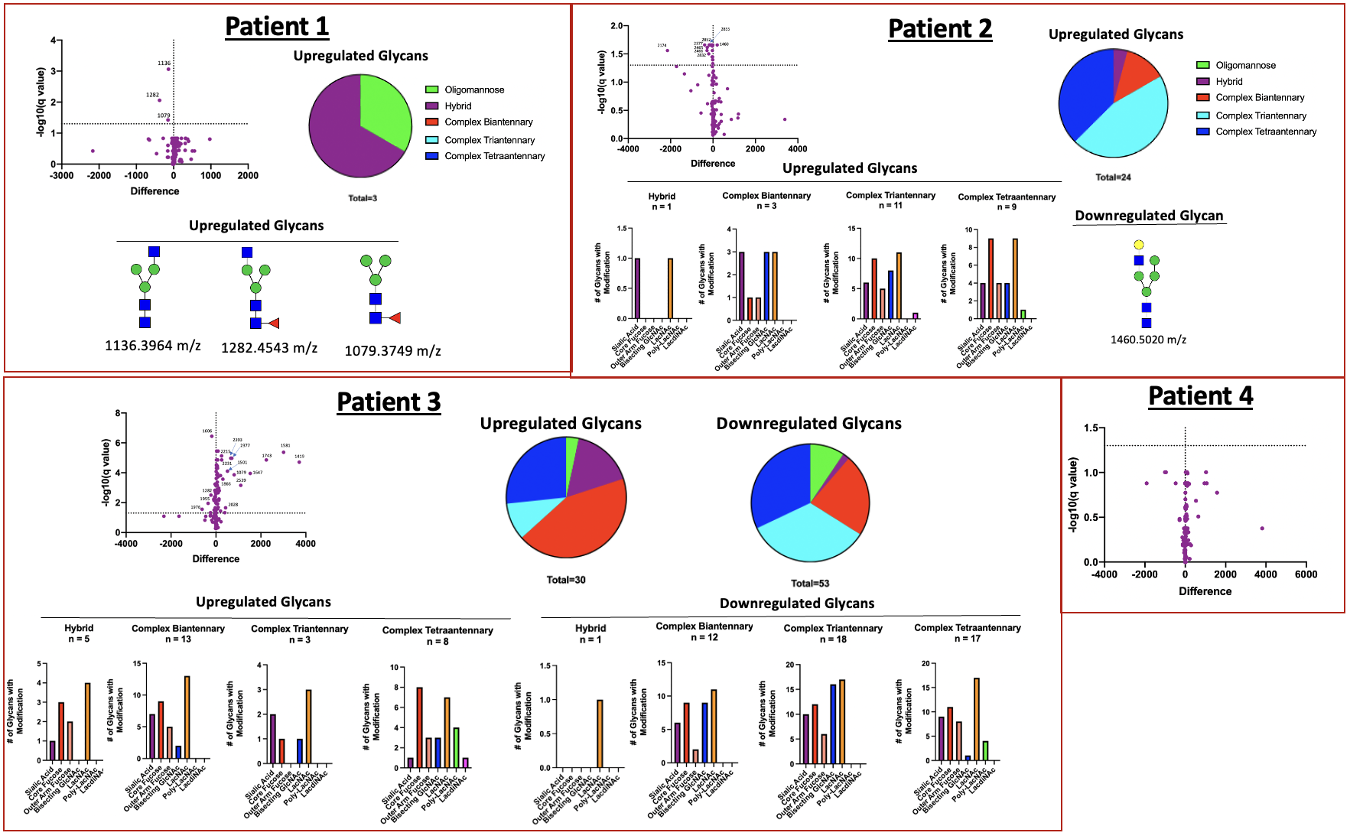
Fig 2S: Analysis of N-glycosylation changes between well differentiated and poorly differentiated glands within each patient

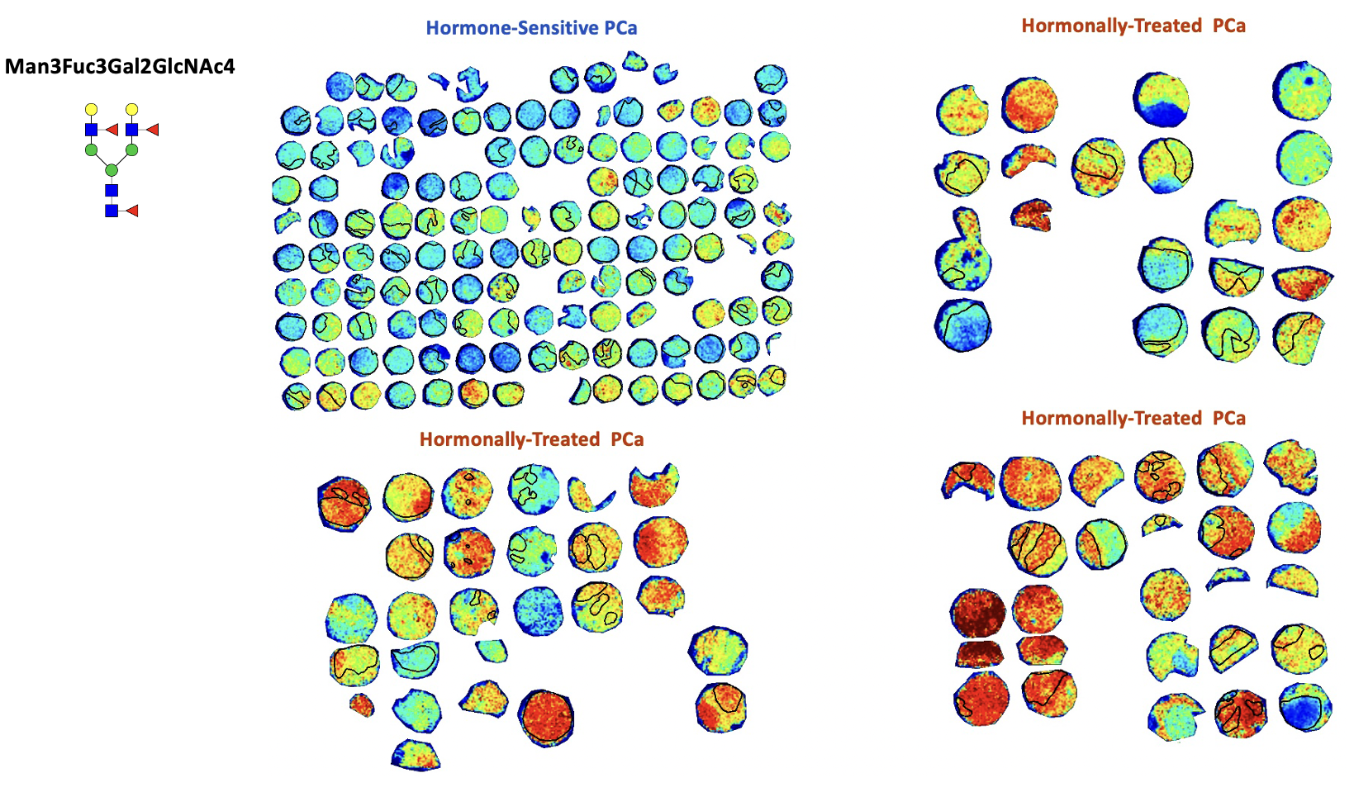
Fig 3S: Representative glycan image demonstrating upregulation of a biantennary glycan (2101.7551 m/z) in hormonally-treated tumors (specific tumor regions demarcated in black)

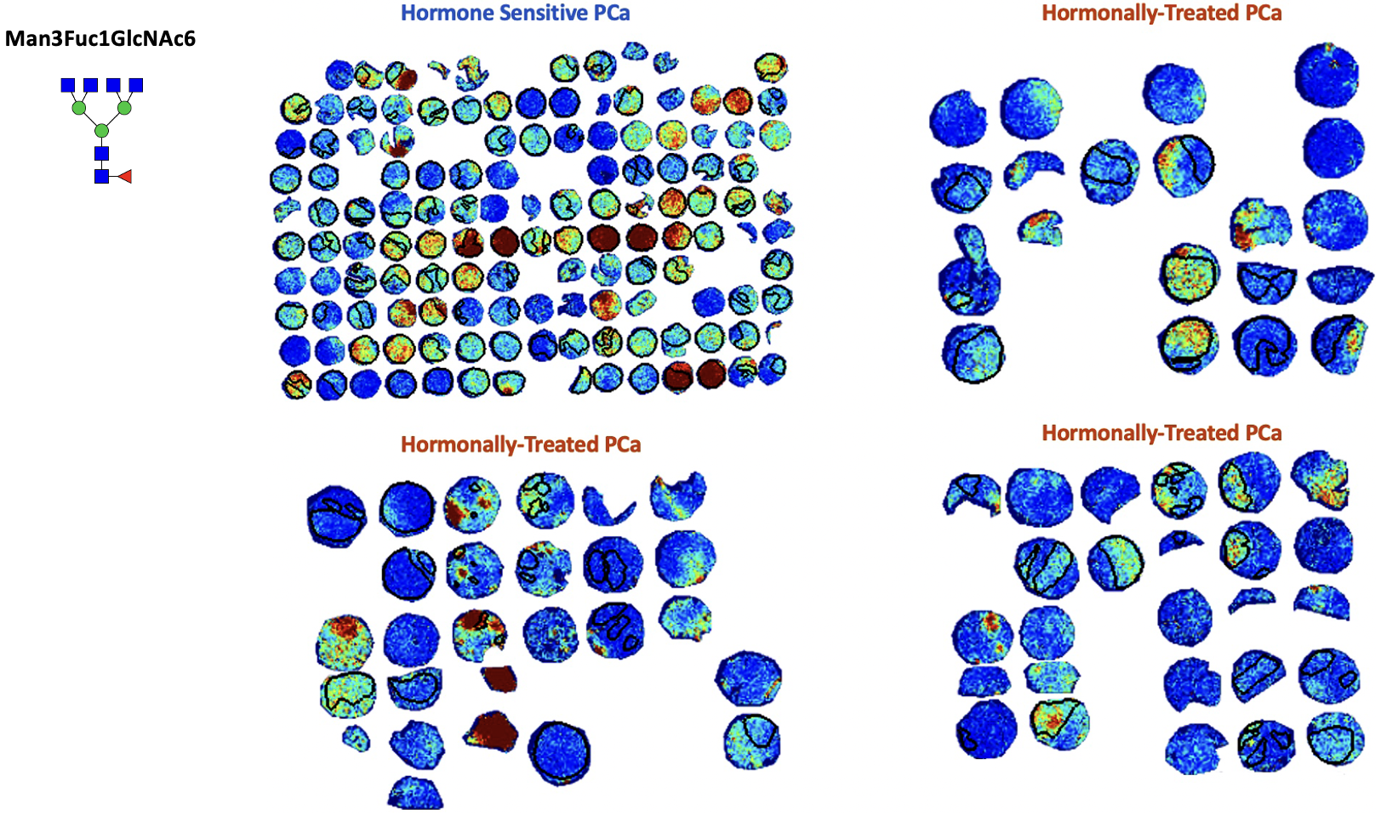

Fig 4S: Representative glycan image demonstrating downregulation of a tetraantennary glycan (1891.6924 m/z) in hormonally-treated tumors (specific tumor regions demarcated in black)

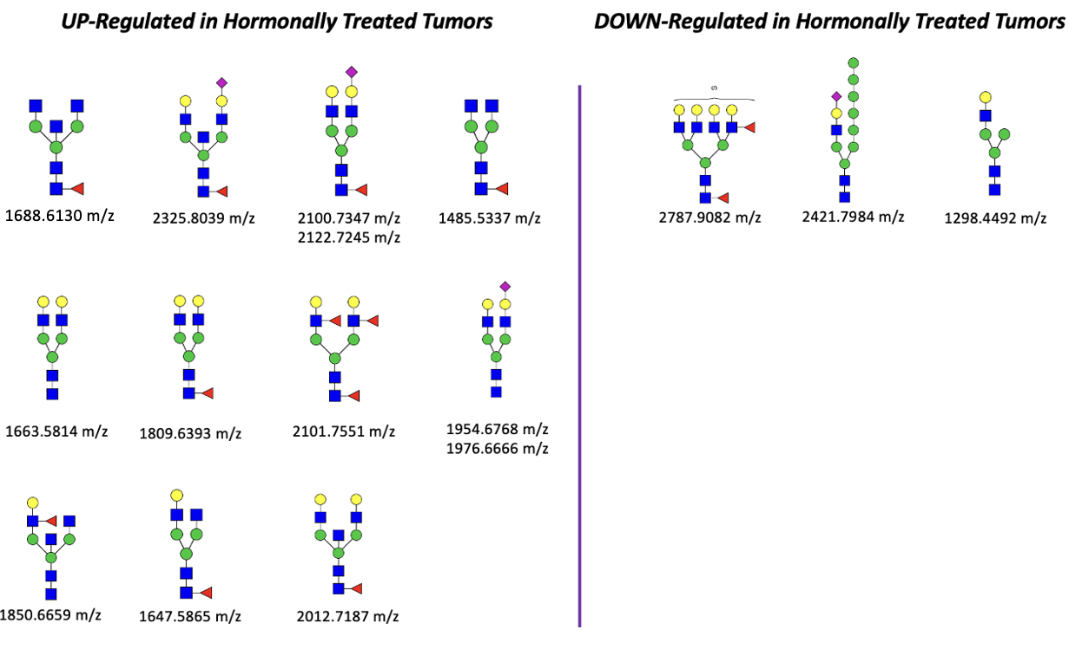
Fig 5S. Significant N-glycans with a high degree of quantitative change in hormonally treated tumors

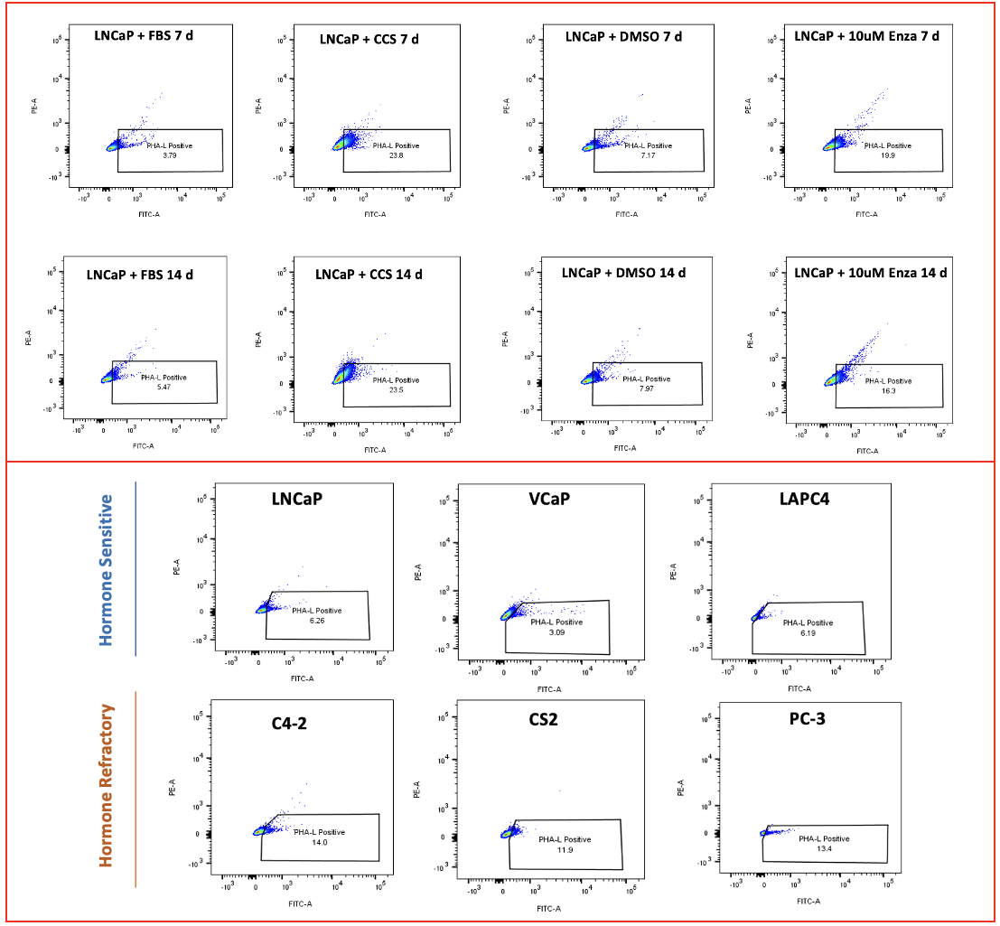
Fig 6S: Flow cytometric analysis of cell lines for PHA-L activity to detect beta 1-6 branched glycans

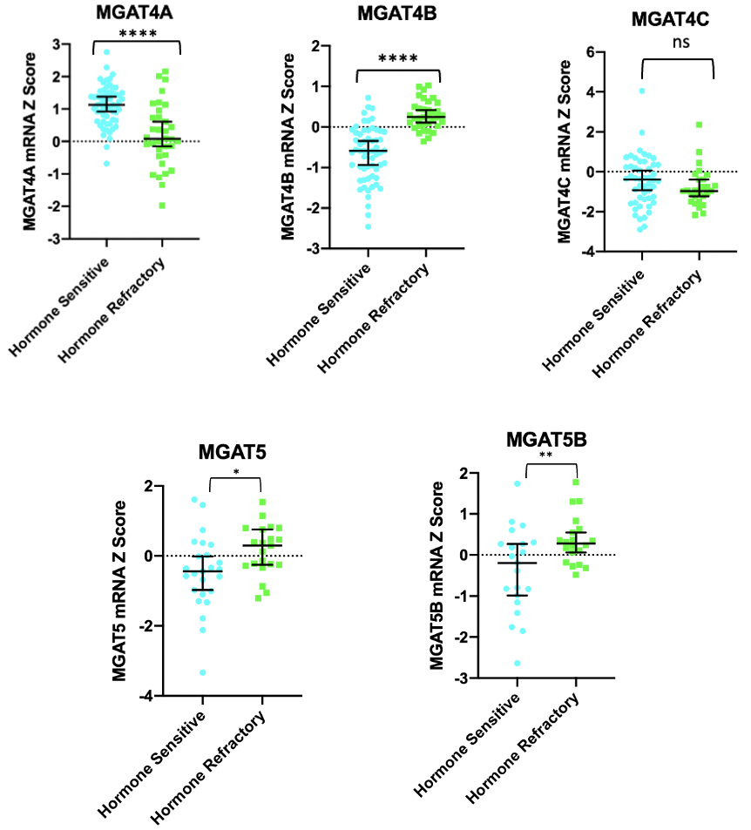
Fig 7S: MGAT4 and MGAT5 mRNA levels in hormone refractory PCa patients

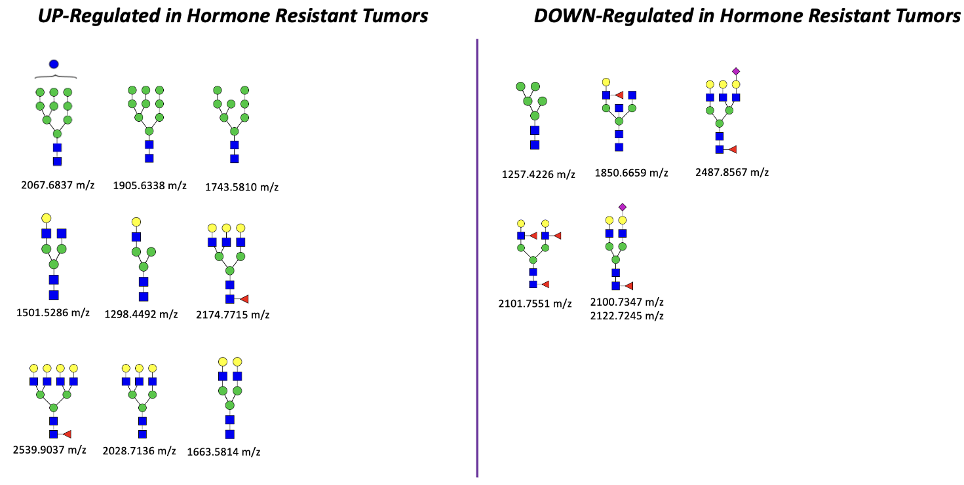
Fig 8S. Significant N-glycans with a high degree of quantitative change in hormone resistant tumors

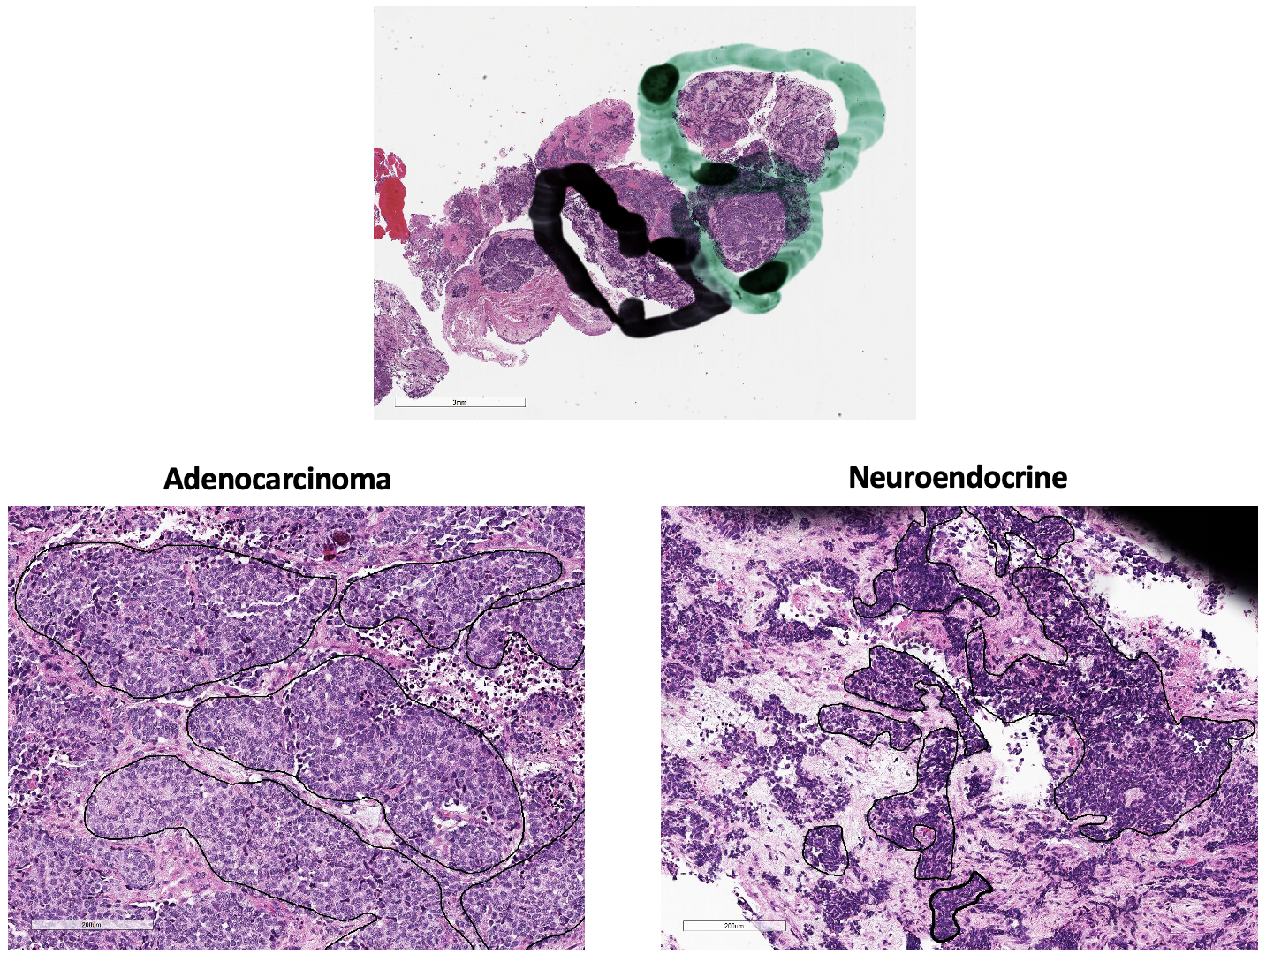
Fig 9S: Representative H&E images of a patient case with both adenocarcinoma and neuroendocrine tumor cells on same FFPE slide. Upper panel demonstrates pathological annotation of targeted tumor regions (green = abundance of adenocarcinoma tumor cells, black = abundance of neuroendocrine tumor cells). Lower panel demonstrates representative demarcated (black circles) pure tumor cell regions within targeted areas.

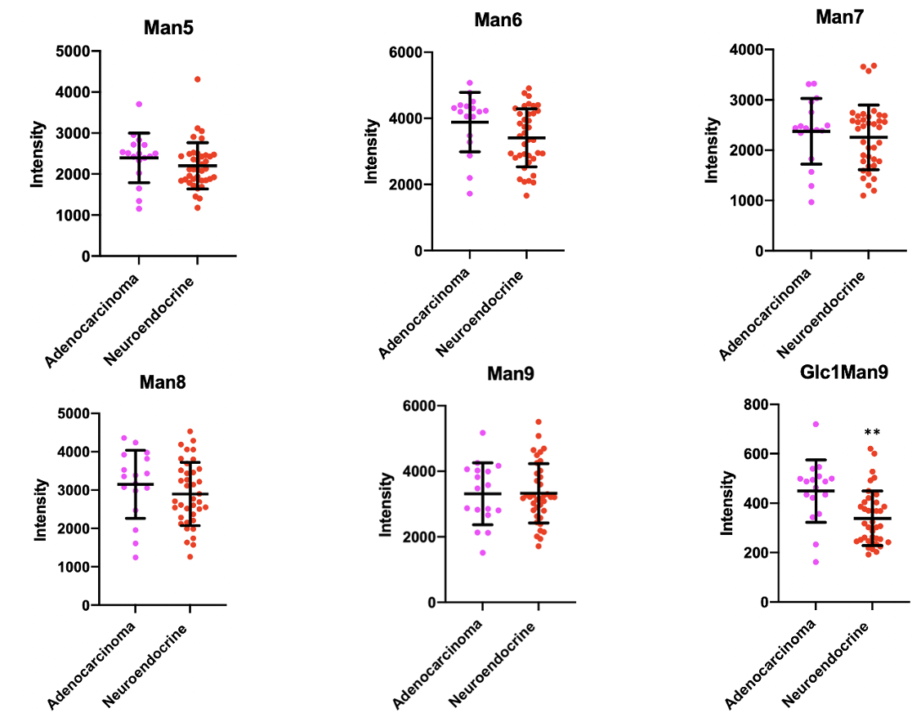
Fig 10S: Scatter plots depicting high mannose (Man 5-9) structure abundance between all adenocarcinoma (n = 17) and NE regions (n = 38)

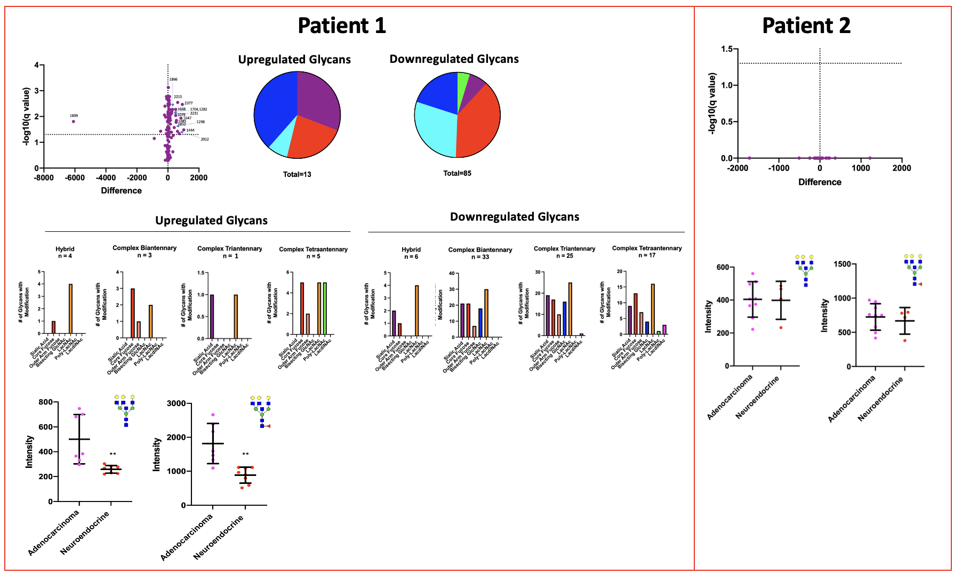
Fig 11S: Analysis of N-glycosylation changes between adenocarcinoma and NE regions within each patient that can be statistically analyzed

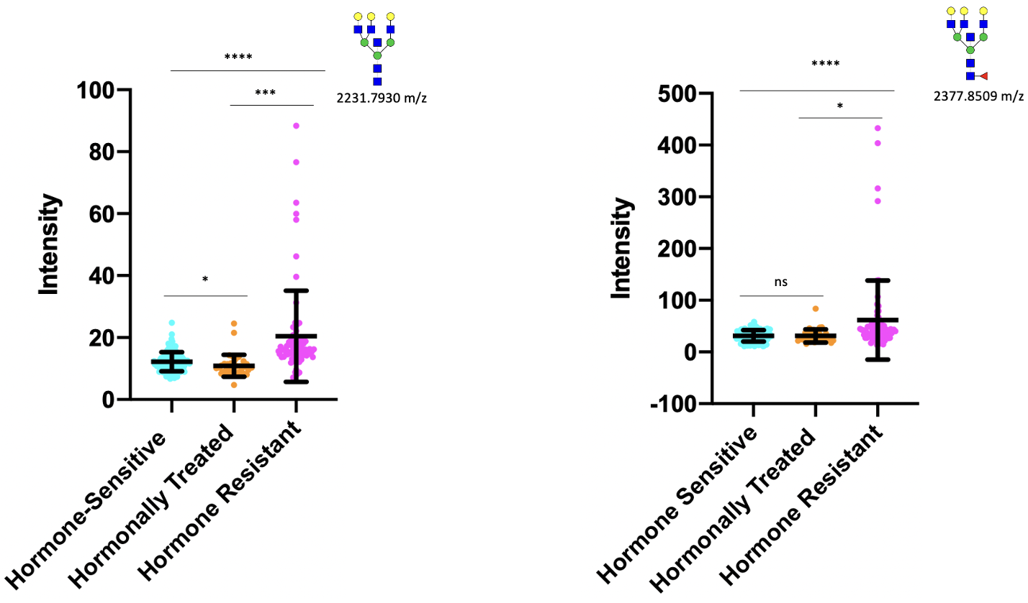
Fig 12S: Scatter plots depicting non-fucosylated and fucosylated Gal3Man3GlcNAc6 levels in hormone-sensitive (n = 120), hormonally treated (n = 37), and hormone resistant (n = 75) tumor regions

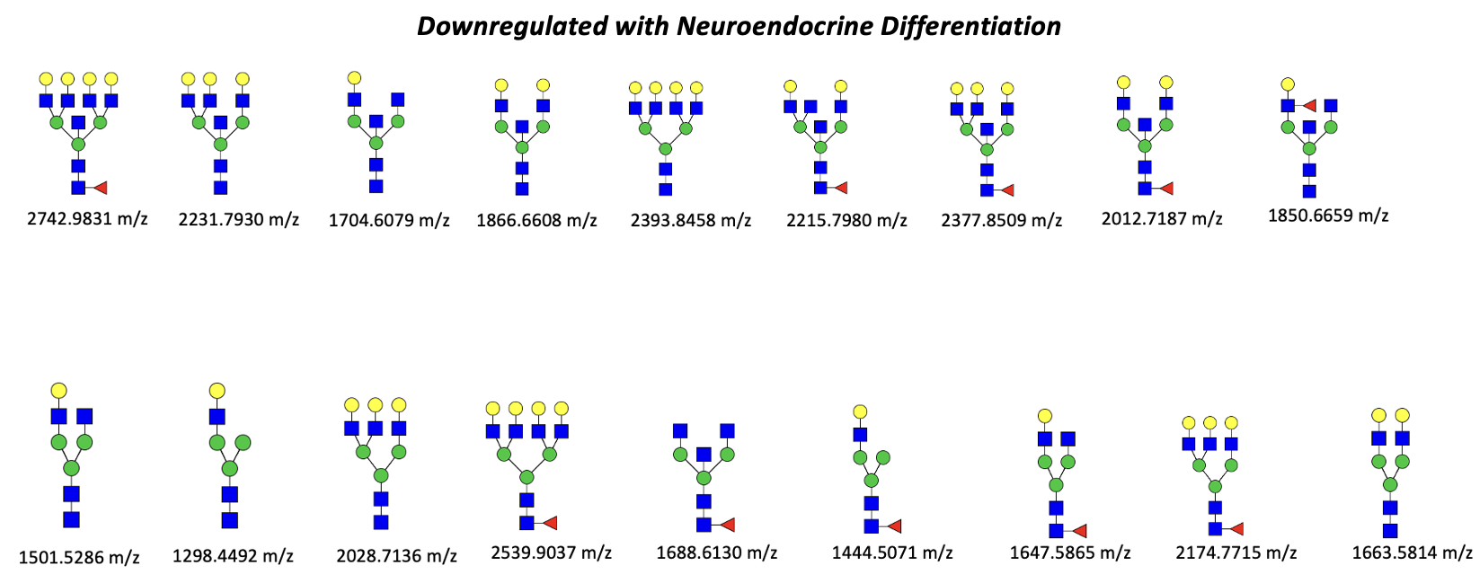

Fig 13S: Significant N-glycans with a high degree of quantitative change in NE tumor regions

