Reusable titania-SBA-15 photocatalyst synthesized by different silica/titania ratios for enhancing methylene blue photodegradation

Sevgi Can Göl, Elif AKBAYª
Eskişehir Technical University, Dept. of Chemical Engineering, Eskişehir, 26470, Turkey
ªCorresponding Authors: eodes@eskisehir.edu.tr

Supplementary data

Table S1. The naming of TiO₂/SBA-15 (R=Si/Ti) catalysts synthesized containing of TiO₂
Name of catalyst | Containing TiO₂ amount (g)
TiO₂/SBA-15 (64) | 0.05
TiO₂/SBA-15 (32) | 0.1
TiO₂/SBA-15 (16) | 0.2
TiO₂/SBA-15 (11) | 0.3
TiO₂/SBA-15 (8) | 0.4
TiO₂/SBA-15 (6) | 0.5

Tablo S2. Amounts of catalyst used in the photocatalytic reaction for each catalyst
Catalyst | TiO₂ Content  (mg) | Amount of Catalyst (mg)
TiO₂ | 6 | 6
TiO₂/SBA15 (R=64) | 6 | 311
TiO₂/SBA15 (R=32) | 6 | 162
TiO₂/SBA15 (R=16) | 6 | 75
TiO₂/SBA15 (R=11) | 6 | 65
TiO₂/SBA15 (R=8) | 6 | 50
TiO₂/SBA15 (R=6) | 6 | 39

Table S3. Textural properties of reused TiO₂/SBA-15 (16) catalysts
TiO₂/SBA-15 (R=16) | Surface Area BET  (m²/g) | Pore Volume  (cm³/g) | Pore Diameter (nm)
Fresh catalyst | 609 | 0,76 | 5,45
Reused Catalyst without calcination | 503 | 0,47 | 4,26
Reused Catalyst with calcination | 670 | 0,67 | 4,75

Figures

b)

a)

d)

c)

f)

e)

Figure S1. The bandgap energy (E_{g}) by using the modified plot of the Kubelka–Munk function, a) TiO₂/SBA-15(R=64), b) TiO₂/SBA-15(R=32), c) TiO₂/SBA-15(R=16), d) TiO₂/SBA-15(R=11), e) TiO₂/SBA-15(R=8), f) TiO₂/SBA-15(R=6)

Figure S2. Wide-angle (a) and small-angle (b) XRD patterns of reused TiO₂/SBA-15 (16) catalysts

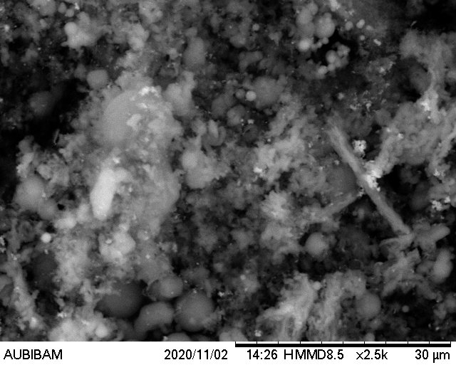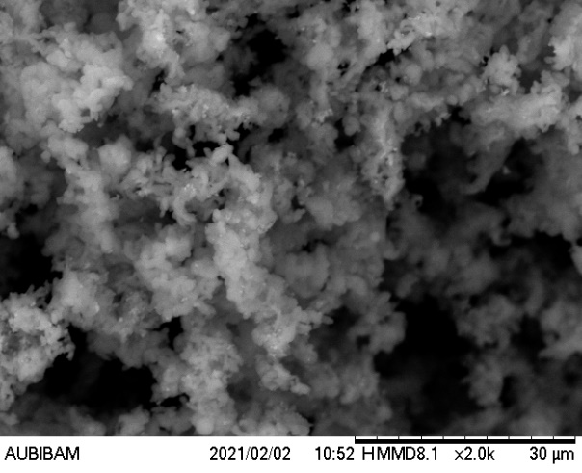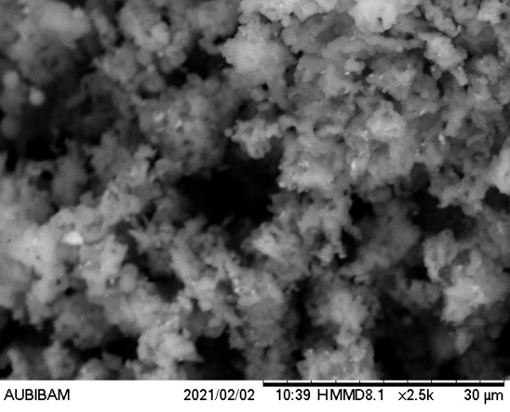
c)
b)
a)

Figure S3. SEM of reused TiO₂/SBA-15 (16) catalysts; a) fresh B) reused, c) reused with calcination

Figure S4. (a) N₂ adsorption-desorption isotherms and (b) pore distributions of reused TiO₂/SBA-15 (16) catalysts

