SUPPLEMENTARY INFORMATION

“Comparing the evolutionary dynamics of predominant SARS-CoV-2 virus lineages co-circulating in Mexico”

Hugo G. Castelán-Sánchez ^{1,2,†}, Luis Delaye ^{1,3,†}, Rhys P. D. Inward ^{4,†}, Simon Dellicour ^{5,6,†}, Bernardo Gutierrez ^{1,4,†}, Natalia Martinez de la Vina ⁸, Oliver G Pybus ^{4,7}, Guillermo de Anda Jáuregui ^{1,2,8} , Plinio Guzmán⁹, Marisol Flores Garrido¹⁰, Óscar Fontanelli^{1,3}, Maribel Hernández Rosales^{1,3}, Amilcar Meneses¹¹, Gabriela Olmedo-Alvarez^{1,3}, Alfredo Herrera-Estrella^{1,12,}, Celia Boukadida^{1,13}, Alejandro Sanchez-Flores^{1,14}, José Esteban Muñoz-Medina ^{1,15}, Andreu Comas-García ^{1,16}, Bruno Gómez-Gil ^{1,17}, Selene Zárate ^{1,18}, Blanca Taboada ^{1,19}, Susana López ^{1,19}, Carlos F. Arias ^{1,19}, Moritz U.G. Kraemer ^{1,4}, Antonio Lazcano ^{1,20}, Marina Escalera-Zamudio ^{1,4,} *

CONTENTS

Supplementary Figure 1. Cumulative number of cases per state compared to the number of viral genome sequences generated in Mexico up to March 2022

Supplementary Figure 2. Root-to-tip regression plots for assessing temporal signal

Supplementary Figure 3. Distribution of genome sequences for the B.1.1.519 and B.1.617.2 datasets before and after subsampling under a migration and phylogenetically-informed approach

Supplementary Figure 4. Main ‘Mexico’ clades within the B.1.1.7 phylogenetic tree

Supplementary Figure 5. Main ‘Mexico’ clades within the P.1+ tree

Supplementary Figure 6. Mean interstate connectivity recorded between 2021 and 2022 derived from anonymized mobile device locations

Supplementary Table 1. Bayes Factor Rate (BRF) and Posterior Probability (PP) well-supported transitions (BFR>100 and a PP>.90) observed between locations
Supplementary Figure 1. Cumulative number of cases per state compared to the number of viral genome sequences generated in Mexico up to March 2022

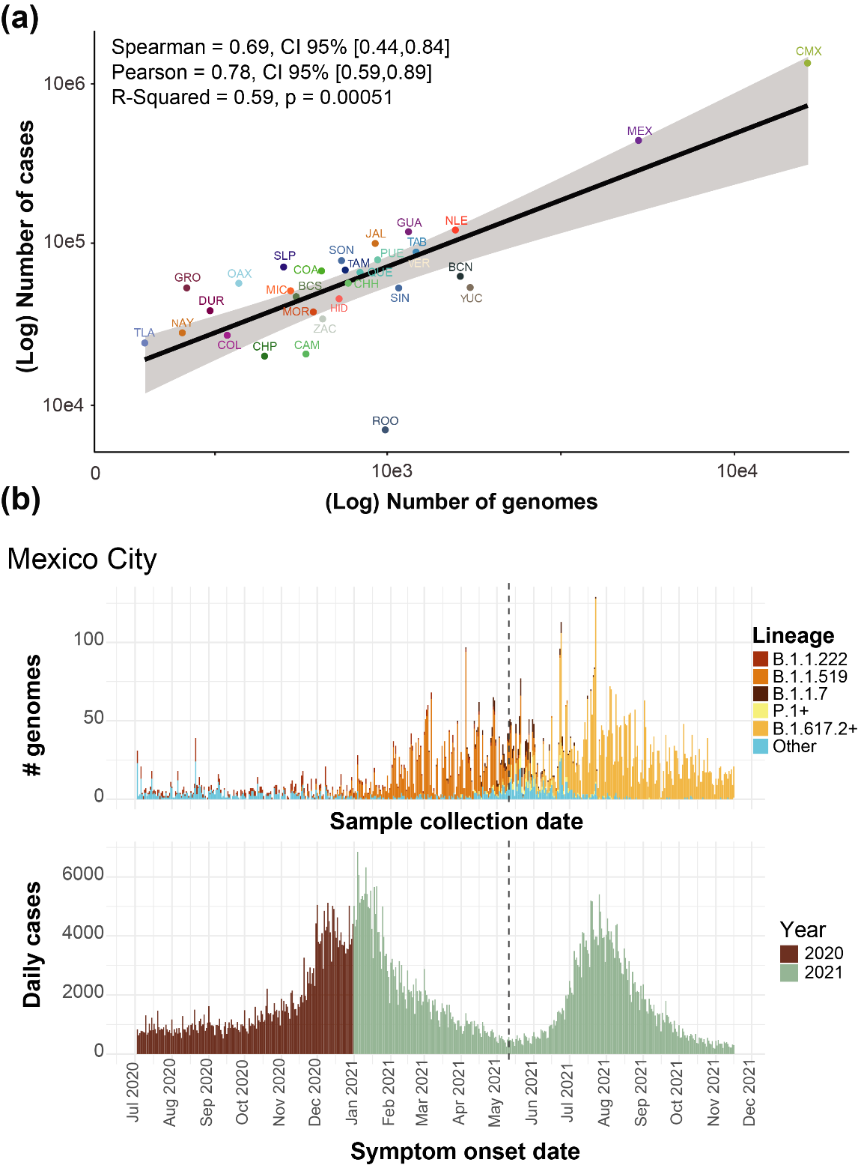

(a) A significant correlation between the cumulative number of cases per state versus the number of viral genome sequences available per state is observed, indicating the corresponding estimated Spearman/Pearson coefficients and associated 95% confidence intervals (CI). The 32 states of the country are highlighted with different colours. Mexico City (CMX) displays the highest number of genomes sequenced relative to the reported number of cases. (b) A comparison between the total number of genomes sequenced from Mexico City (CMX) assigned to the lineages of interest plotted against collection date, and the number of daily cases reported for Mexico City (CMX) with symptom onset dates ranging from July 2020 up to November 2021 (coloured according to the year of collection).
Supplementary Figure 2. Root-to-tip regression plots for assessing temporal signal

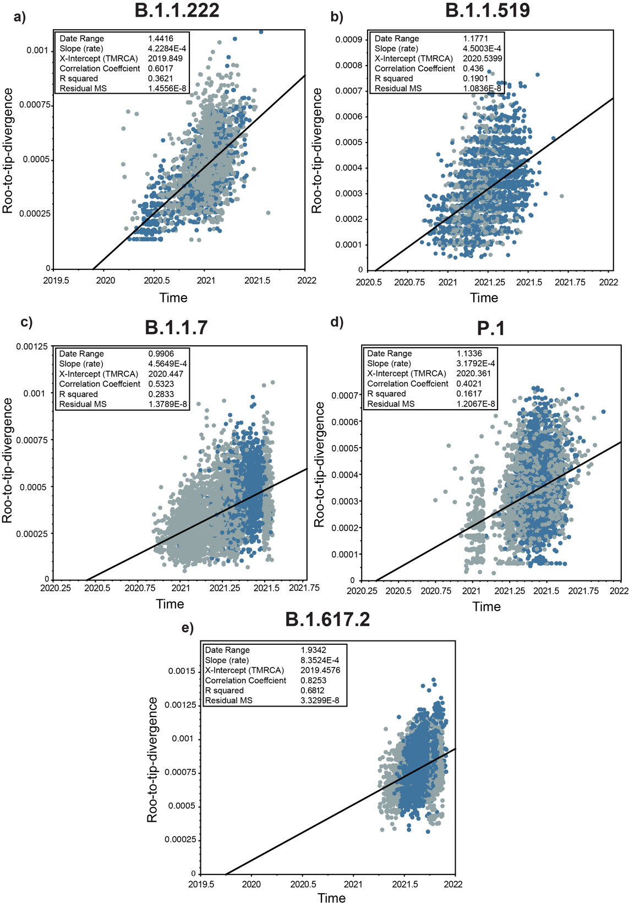

Root-to-tip regression analyses based on the ML trees obtained for each SARS-CoV-2 genome datasets used for this study: (a) B.1.1.222, (b) B.1.1.519, (c) B.1.1.7, (d) B.1.617.2 and (e) P.1. Viral genomes sampled from Mexico are shown with blue dots, whilst genomes sampled elsewhere are shown with grey dots. Plots show a weak temporal signal, and support the use of a fixed molecular clock rate (8×10⁻⁴) for the temporal calibration of phylogenetic trees.
Supplementary Figure 3. Distribution of genome sequences for the B.1.1.519 and B.1.617.2 datasets before and after subsampling under a migration and phylogenetically-informed approach

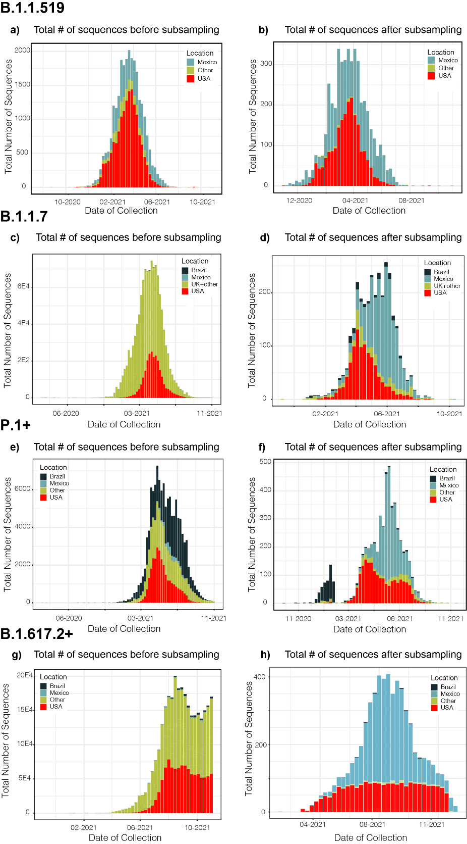
Distribution plots for the number of genomes in the datasets before and after subsampling under our migration and phylogenetically-informed subsampling pipeline. Plots for the B.1.1.519 (a and b), B.1.1.7 (c and d), P.1+ (e and f), and B.1.617.2+ (g and h) show the total number of sampled genomes coloured according to location, ranked according to the countries representing the most intense human mobility flow into Mexico derived from the Google COVID-19 Aggregated Mobility Research Data.
Supplementary Figure 4. Main ‘Mexico’ clades within the B.1.1.7 phylogenetic tree
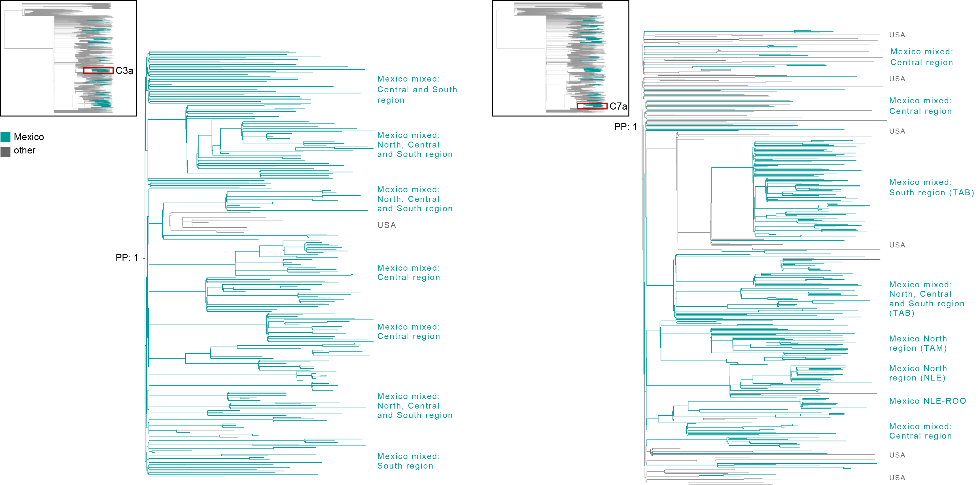

Zoom-in on the C3a and C7a clades identified as the largest clusters within the B.1.1.7 phylogenetic tree. Branch sampling locations are indicated for large sub-clusters composed of >5 sequences. The C3a clade is composed of 254 genome sequences sampled from 22/32 states in the country, mostly from Mexico City (CMX) and State of Mexico (MEX). The C7a clade is composed of 364 genome sequences, sampled mostly from the southern state of Tabasco (TAB). A full list of names for all genome sequences within each clade can be found in Supplementary Data 2.
Supplementary Figure 5. Main ‘Mexico’ clades within the P.1+ tree

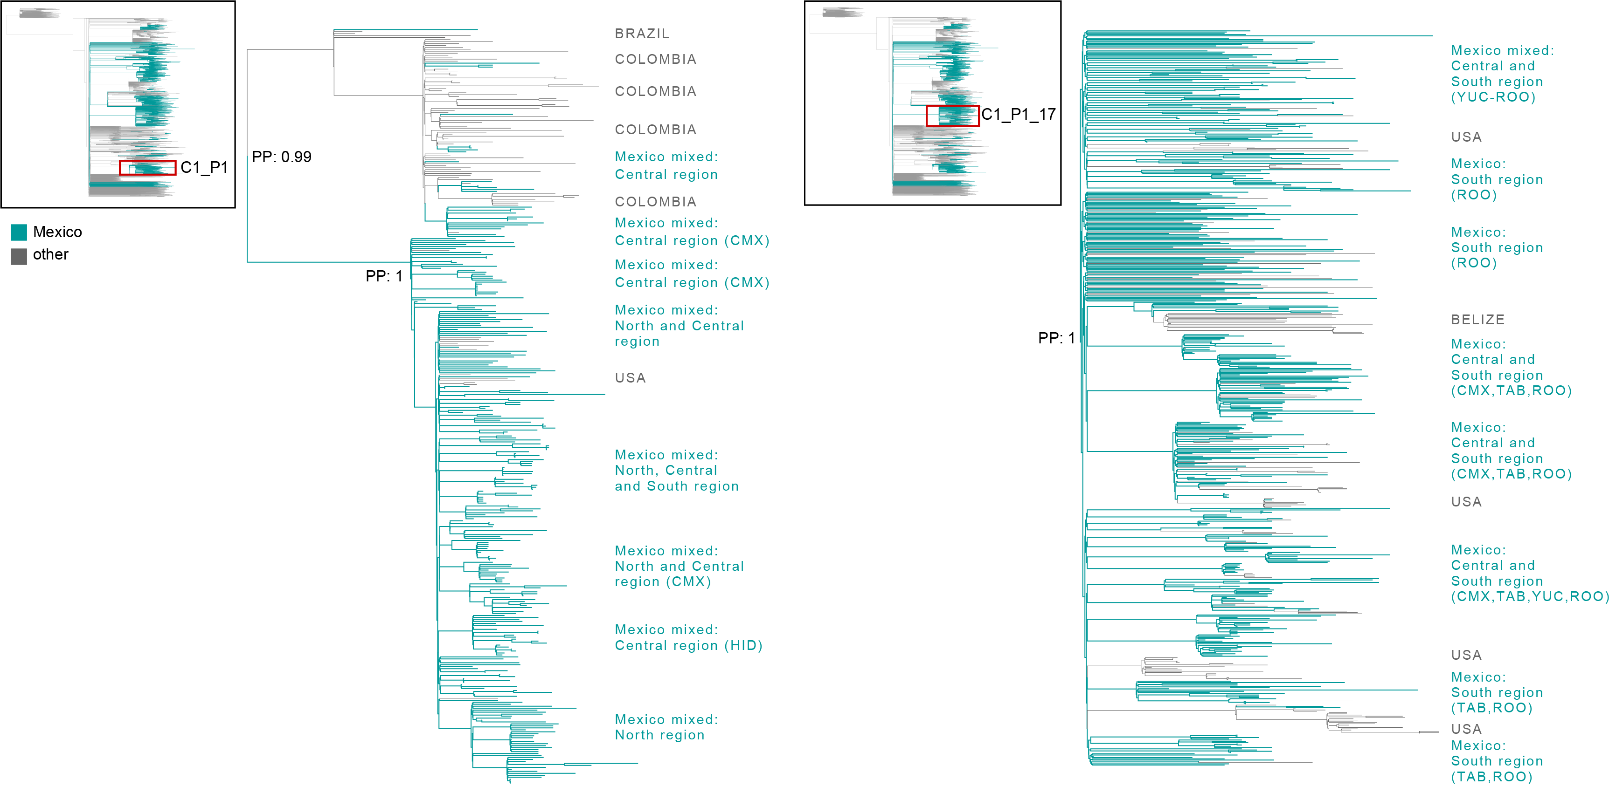

Zoom-in on the C1_P1 and C1_P1_17 clades, identified as the largest clusters within the P.1+ tree. Branch sampling locations are indicated for large sub-clusters composed of >5 sequences. The C1_P1 clade is composed of 277 genome sequences, mostly sampled from the central region of Mexico City (CMX). The C1_P1_17 clade is composed of 588 genome sequences, mostly sampled from the southern states of Quintana Roo (ROO) and Yucatán (YUC). A full list of names for all genome sequences within each clade can be found in Supplementary Data 2.
Supplementary Figure 6. Mean interstate connectivity recorded between 2021 and 2022 derived from anonymized mobile device locations

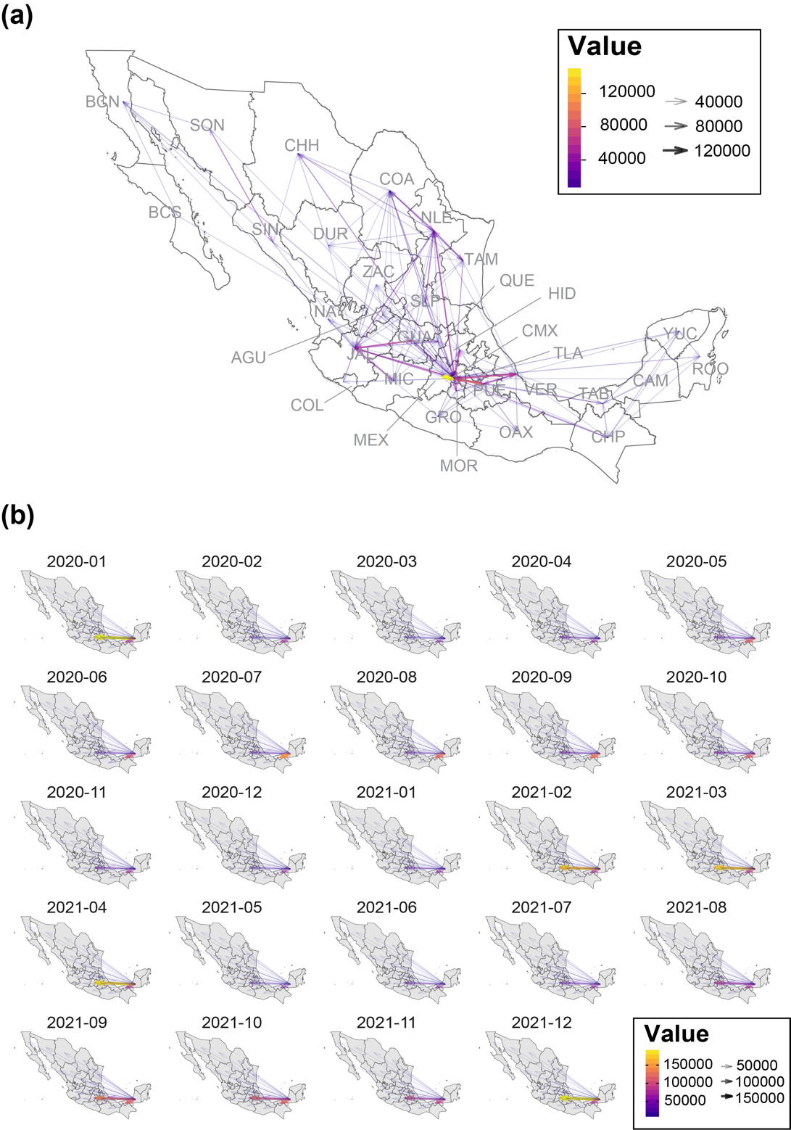

(a) Map graph showing the mean intra-state connectivity recorded within national territory, derived from anonymized mobile device locations collected between 01/01/2020 and 31/12/2021. Values above 4E4 are indicated using a colour gradient, whilst arrow thickness within the map represents the total number of bidirectional movements between states. (b) Maps graphs showing the mean inter-state connectivity between the southern region of the country (represented by the states of Yucatán, Quintana Roo, Chiapas and Campeche) and the remaining 28 states (recorded between 01/01/2020 and 31/12/2021). Again, values above 10⁻⁴ are indicated using a colour gradient, whilst arrow thickness within the map represents the total number of bidirectional movements between states.
Supplementary Table 1. Supplementary Table 1. Bayes Factor Rate (BFR) and Posterior Probability (PP) for well-supported transitions (BFR>100 and a PP>.90) observed between locations*

C5d |  |  |  |  | C6d
Location |  |  |  |  | Location
From | To | BFR | PP |  | From | To | BFR | PP
BCN | CHH | 14535.32494 | 1 |  | AGU | CHP | 13635.15617 | 1
CAM | CHP | 14535.32494 | 1 |  | BCN | CHP | 13635.15617 | 1
CAM | CMX | 14535.32494 | 1 |  | CHP | CMX | 13635.15617 | 1
CAM | MEX | 14535.32494 | 1 |  | CHP | COA | 13635.15617 | 1
CAM | MIC | 14535.32494 | 1 |  | CHP | DUR | 13635.15617 | 1
CAM | other | 14535.32494 | 1 |  | CHP | GRO | 13635.15617 | 1
CAM | QUE | 14535.32494 | 1 |  | CHP | GUA | 13635.15617 | 1
CAM | ROO | 14535.32494 | 1 |  | CHP | HID | 13635.15617 | 1
CAM | SLP | 14535.32494 | 1 |  | CHP | JAL | 13635.15617 | 1
CAM | SON | 14535.32494 | 1 |  | CHP | MEX | 13635.15617 | 1
CAM | TAB | 14535.32494 | 1 |  | CHP | MIC | 13635.15617 | 1
CAM | TAM | 14535.32494 | 1 |  | CHP | NLE | 13635.15617 | 1
CAM | TLA | 14535.32494 | 1 |  | CHP | OAX | 13635.15617 | 1
CAM | VER | 14535.32494 | 1 |  | CHP | other | 13635.15617 | 1
CAM | ZAC | 14535.32494 | 1 |  | CHP | PUE | 13635.15617 | 1
CMX | CHH | 14535.32494 | 1 |  | CHP | QUE | 13635.15617 | 1
CHH | CHP | 14535.32494 | 1 |  | CHP | SIN | 13635.15617 | 1
CHH | CMX | 14535.32494 | 1 |  | CHP | SLP | 13635.15617 | 1
CHH | DUR | 14535.32494 | 1 |  | CHP | SON | 13635.15617 | 1
CHH | GUA | 14535.32494 | 1 |  | CHP | TAB | 13635.15617 | 1
CHH | MIC | 14535.32494 | 1 |  | CHP | TLA | 13635.15617 | 1
CHH | NLE | 14535.32494 | 1 |  | CHP | VER | 13635.15617 | 1
CHH | QUE | 14535.32494 | 1 |  | CAM | CHP | 13635.15617 | 0.998890122
CHH | TAB | 14535.32494 | 1 |  | NLE | TAB | 13635.15617 | 0.998890122
CHH | TAM | 14535.32494 | 1 |  | CHP | TAM | 6810.002999 | 0.997780244
CHH | VER | 14535.32494 | 1 |  | CHP | YUC | 2714.911095 | 0.99445061
CHH | ZAC | 14535.32494 | 1 |  | MEX | PUE | 164.4591205 | 0.915649279
CAM | CMX | 14535.32494 | 0.998890122
CHH | TLA | 14535.32494 | 0.998890122
CAM | SIN | 3621.718465 | 0.995560488
BCS | CHH | 1023.240732 | 0.984461709
MIC | YUC | 468.8988157 | 0.966703663
CHH | other | 399.6060762 | 0.961154273
CAM | COA | 188.7999953 | 0.921198668
MEX | YUC | 126.5111615 | 0.886792453

*derived from the phylogeographic analyses for C5d and C6d (B.1.617.2+)

