Supplementary data

Enzymatic dynamic reductive kinetic resolution towards 12% w/v (S)-2-phenylpropanol

Christian Rappª, Simone Pival^{a,c}, Erika Tassano^{b}, Bernd Nidetzky^{a,c}, Regina Kratzerª*

ªInstitute of Biotechnology and Biochemical Engineering, Graz University of Technology, NAWI Graz, 8010 Graz, Austria. ^{b}Department of Chemistry, University of Graz, Heinrichstrasse 28, NAWI Graz, 8010 Graz, Austria. ^{c}Austrian Centre of Industrial Biotechnology (acib), 8010 Graz, Austria.
*Corresponding author phone +43 316 873 8412, e-mail: regina.kratzer@tugraz.at

Content

1 Reduction of racemic 2-phenylpropanal by isolated D51A CtXR
Figure S1. Time course of the reduction of 0.5mM substrate with 240 U/mL isolated D51A CtXR. Blue dots (S)-2-phenylpropanal, orange dots (R)-2-phenylpropanol.

2 Biotransformation of 100mM racemic 2-phenylpropanal
Table S1. Data for Figure 1.

3 Reversed phase, chiral HPLC
Figure S2. Overlay of HPLC traces for rac-2-phenylpropanal (1), acetophenone (2), 1-phenylethanol (3), (R,S)-2-phenylpropanol (4), reaction buffer with NAD⁺ (5), reaction buffer (6), bioreduction sample 1M 2-phenylpropanal reacted with 40g_{CDW}/L and 6mM NAD⁺ (7).

Table S2 (data to Figure S1). Retention times for main products and by-products obtained from reversed phase, chiral HPLC.

4 Chiral GC-FID
Figure S3. Selected GC traces for bioreduction replicates (N=6) of 1M 2-phenylpropanal reacted with 40g_{CDW}/L and 6mM NAD⁺.

Table S3 (data corresponding to Figure S2). Retention times for main products and by-products obtained from chiral GC.

5 ¹H-NMR
Figure S4. ¹H-spectra in MeOD. Graph shows a spectrum of isolated product of a reaction with 78 % analytical yield (HPLC). Spectra were recorded immediately after work-up. Ethyl acetate related signals at 1.75, and 3.9ppm; acetophenone related signal at 2.45ppm.

1 Reduction of racemic 2-phenylpropanal by isolated D51A CtXR Time course

Figure S1. Time course of the reduction of 0.5mM substrate with 240 U/mL isolated D51A CtXR. Blue dots (S)-2-phenylpropanal, orange dots (R)-2-phenylpropanol.

2 Biotransformation of 100mM racemic 2-phenylpropanal

Table S1 (data for Figure 1). Conversions and product e.e.-values of 100mM racemic 2-phenylpropanal reduction by lyophilized whole-cell catalyst and cell-free catalyst. Effects of catalyst form and loadingª.

Whole-cell catalyst  (g_{CDW}/L) | Cell-free catalyst  (g_{CDW}/L) | Conversion  (%) | e.e.  (%) | Ratio  (g_{substrate}/g_{CDW})
4 | 0 | 41.3 | 95.3 | 3.4
10 | 0 | 66.5 | 61.3 | 1.4
20 | 0 | 69.4 | 49.0 | 0.7
40 | 0 | 72.4 | 45.8 | 0.3
0 | 4 | 29.1 | 95.7 | 3.4
0 | 10 | 72.7 | 58.1 | 1.4
0 | 20 | 69.6 | 41.7 | 0.7
0 | 40 | 76.9 | 27.5 | 0.3
ªNAD⁺ concentration 6mM, reaction time 24h. Data are based on HPLC analysis.

3 Reversed phase, chiral HPLC

Separation of main products and by-products on HPLC (stationary phase Chiralpak® AD-RH column from Daicel, mobile phase 25 % acetonitrile in ddH₂O, 40°C).

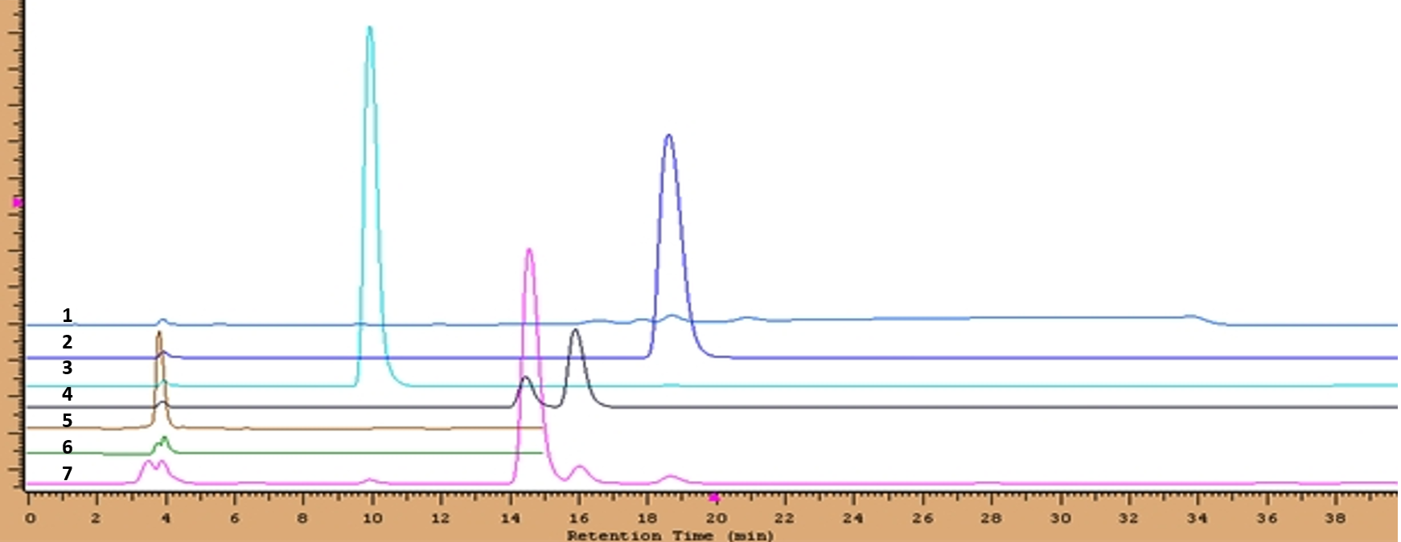

Figure S2. Overlay of HPLC traces for rac-2-phenylpropanal (1), acetophenone (2), rac. 1-phenylethanol (3), (R,S)-2-phenylpropanol (4), reaction buffer with NAD⁺ (5), reaction buffer (6), bioreduction sample 1M 2-phenylpropanal reacted with 40g_{CDW}/L and 6mM NAD⁺ (7).

Table S2 (data corresponding to Figure S1). Retention times for main products and by-products on reversed phase, chiral HPLC.

Analyte | Retention time (min)
rac-2-Phenylpropanal | broad peak, not applicable
(R)-2-Phenylpropanol | 15.8
(S)-2-Phenylpropanol | 14.5
Acetophenone | 18.6
rac.- 1-Phenylethanol | 9.9 (no separation)

4Chiral GC-FID
(S)-2-phenylpropanol

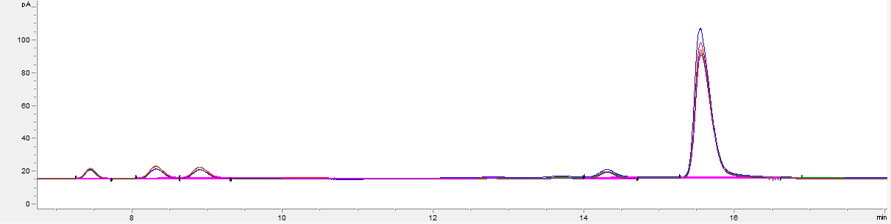
(R)-2-phenylpropanol

rac-2-phenylpropanal
Acetophenone
Figure S3. GC traces for bioreduction replicates (N=6) of 1M 2-phenylpropanal reacted with 40g_{CDW}/L and 6mM NAD⁺.

Table S3 (data corresponding to Figure S2). Retention times for main products and by-products on chiral GC.

Analyte | Retention time (min)
(R)-2-Phenylpropanal | 8.2
(S)-2-Phenylpropanal | 8.8
(R)-2-Phenylpropanol | 14.8
(S)-2-Phenylpropanol | 15.4
Acetophenone | 6.9

5 ¹H-NMR

Bioreduction analysis
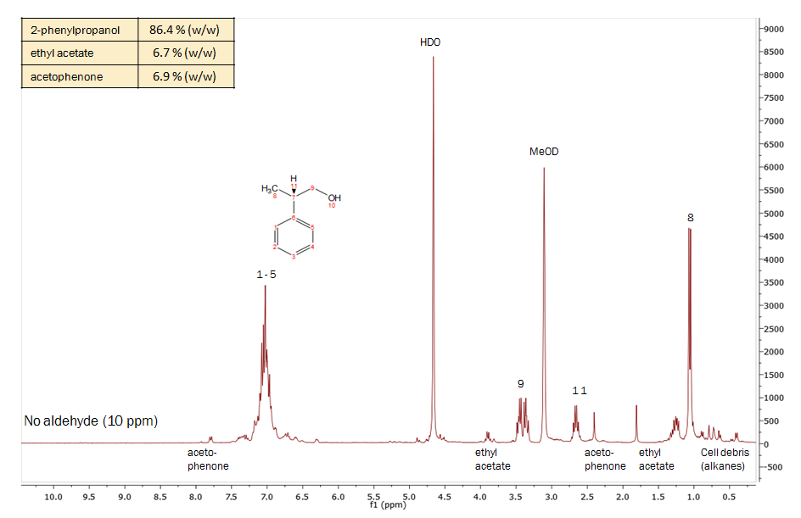
The isolate (extraction with ethylacetate) of a bioreduction mixture from 1M 2-phenylpropanal reacted with 40g_{CDW}/L and 6mM NAD⁺ was analyzed by ¹H-NMR.

Figure S4. ¹H-spectra in MeOD. Graph shows a spectrum of isolated product of a reaction with 78 % analytical yield (HPLC). Spectra were recorded immediately after work-up. Ethyl acetate related signals at 1.75, and 3.9ppm; acetophenone related signal at 2.45ppm.

