Supplemental Figure 2: Risk of bias assessment results.
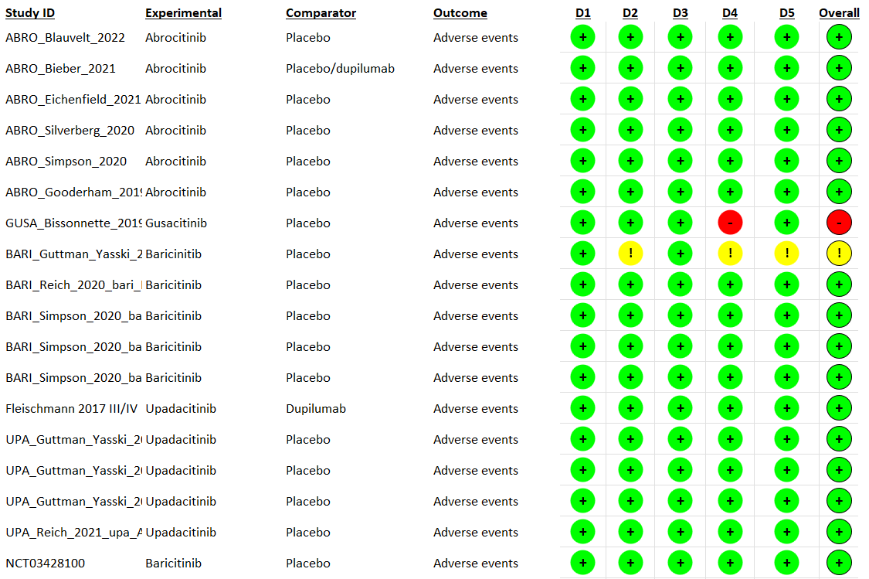
Legend
 | Low risk
 | Some concerns
 | High risk
D1 | Randomisation process
D2 | Deviations from the intended interventions
D3 | Missing outcome data
D4 | Measurement of the outcome
D5 | Selection of the reported result

