Figure S4 - Risk of any adverse event between treatments

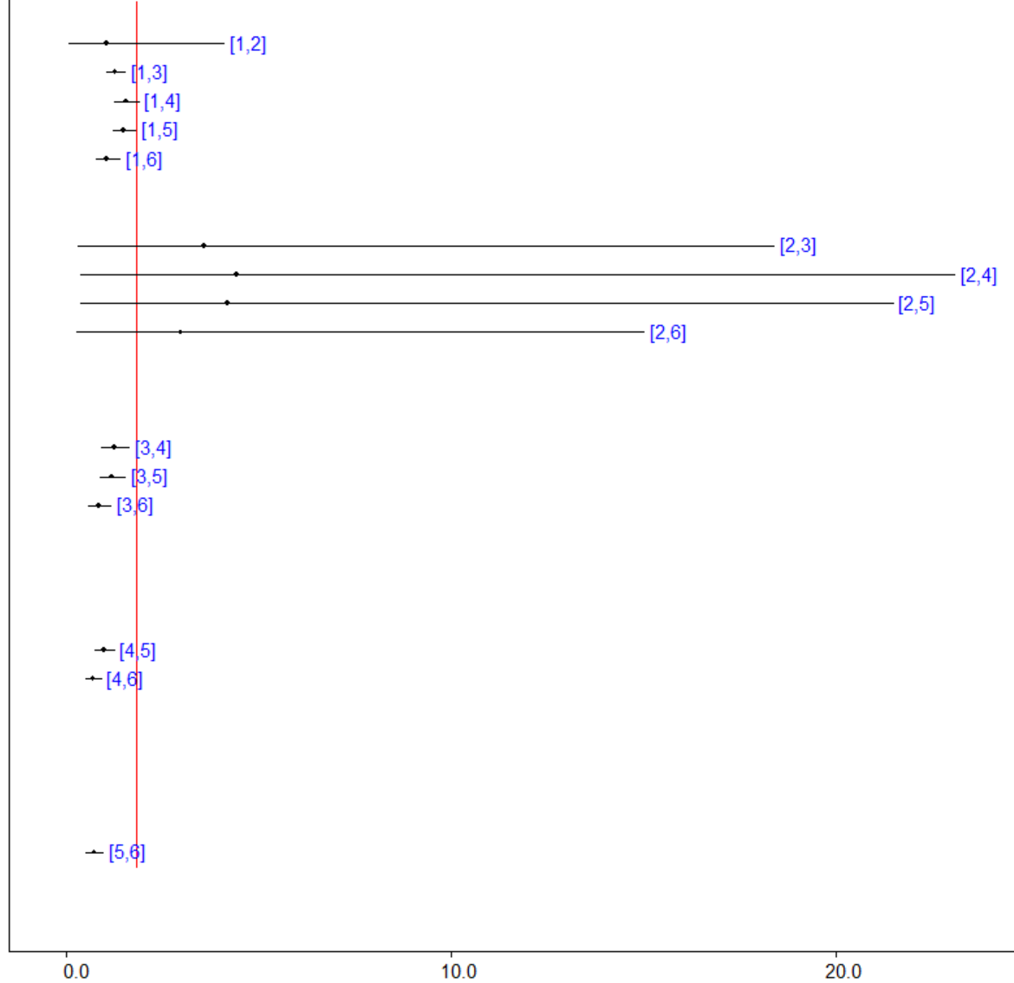

Legend: 1, Placebo; 2, Ruxolitinib; 3, Tofacitinib; 4, Delgocitinib; 5, Gusacitinib; 6, Baricitinib; 7, Abrocitinib; 8, Upadacitinib; 9, Triamcinolone acetonide; 10, Dupilumab

