Supplemental Figure 3 (a): Map of the any adverse event network.
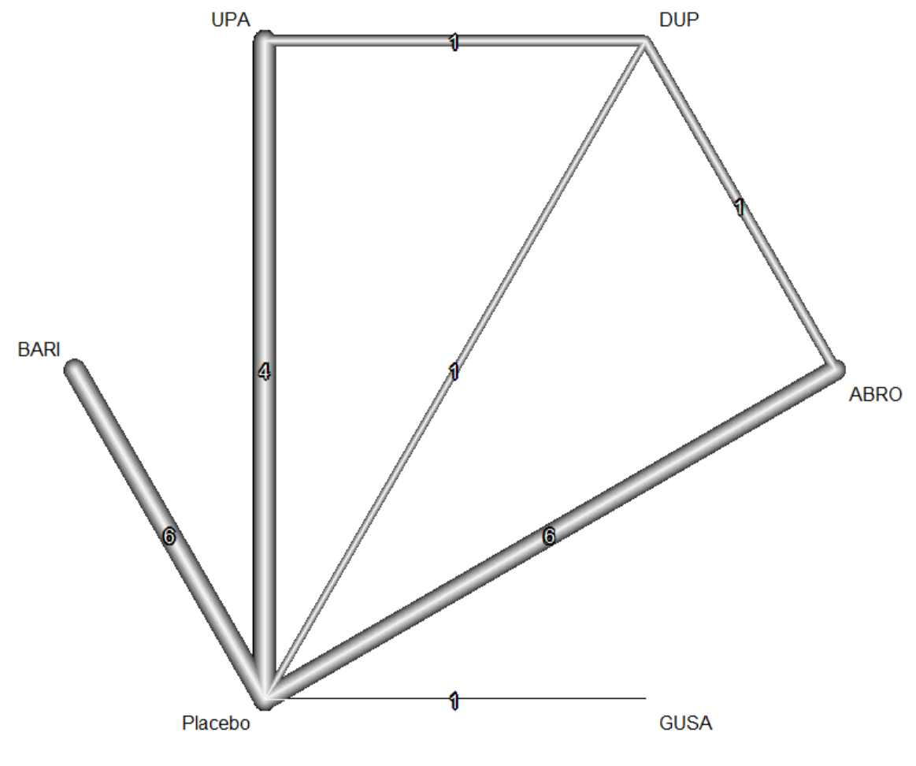

ABRO, abrocitinib; BARI, baricitinib; DUP, Dupilumab; GUSA, gusacitinib; UPA, upadacitinib;
Supplemental Figure 3 (b): Map of the serious adverse event network.

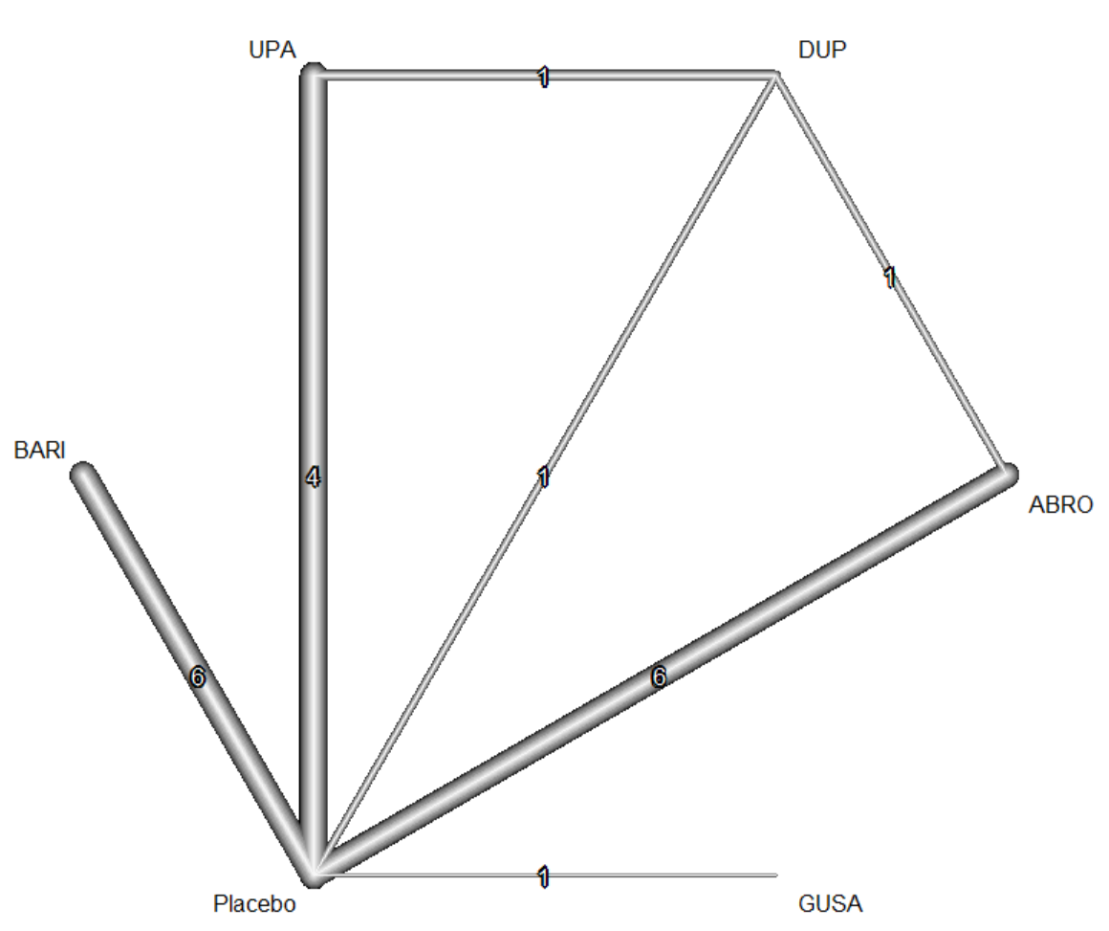
ABRO, abrocitinib; BARI, baricitinib; DUP, Dupilumab; GUSA, gusacitinib; UPA, upadacitinib;

Supplemental Figure 3 (c): Map of the adverse events leading to discontinuation network.

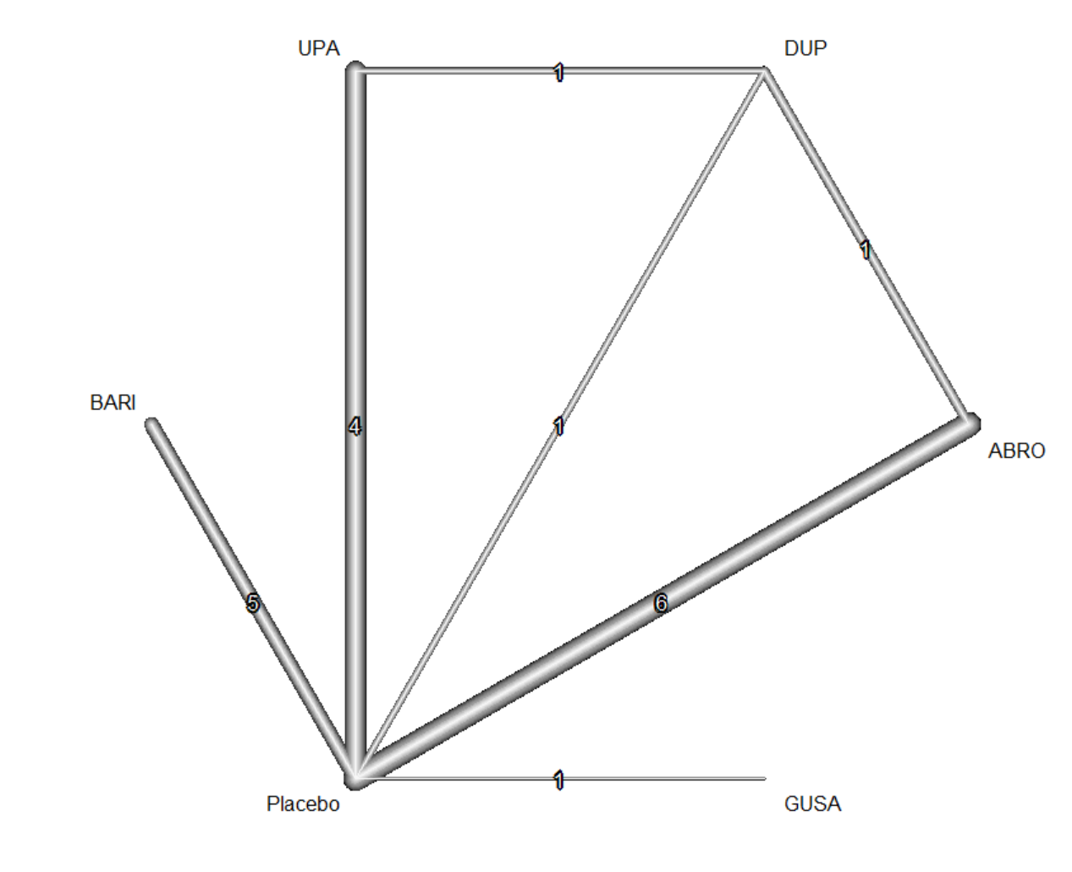
ABRO, abrocitinib; BARI, baricitinib; DUP, Dupilumab; GUSA, gusacitinib; UPA, upadacitinib;

Supplemental Figure 3 (d): Map of the any infection network.

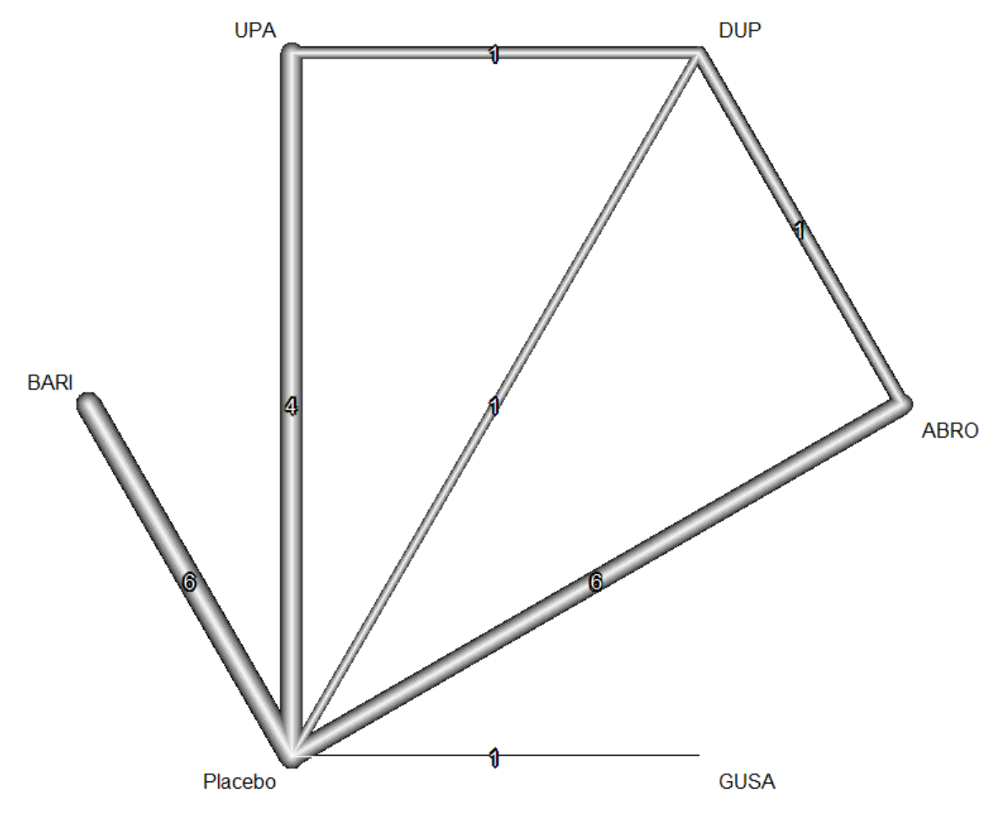
ABRO, abrocitinib; BARI, baricitinib; DUP, Dupilumab; GUSA, gusacitinib; UPA, upadacitinib;

Supplemental Figure 3 (e): Map of the serious infections network.
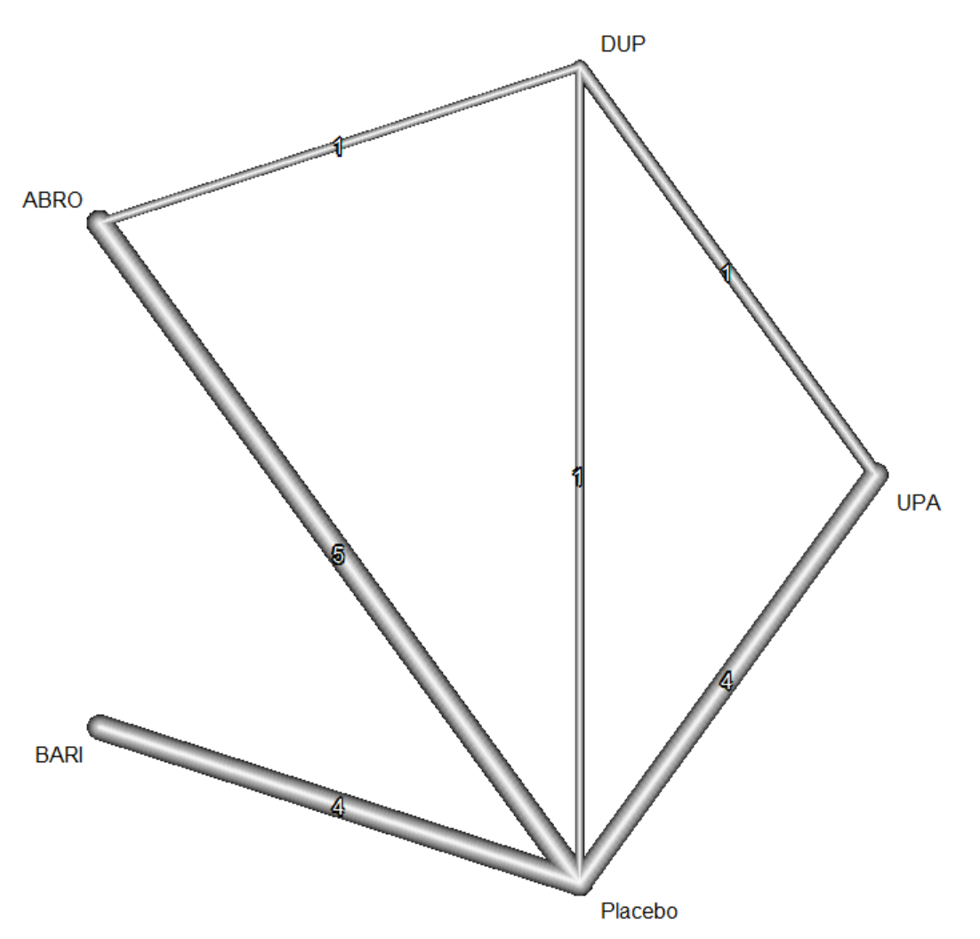

ABRO, abrocitinib; BARI, baricitinib; DUP, Dupilumab; UPA, upadacitinib;

Supplemental Figure 3 (f): Map of the herpes viral infections network.

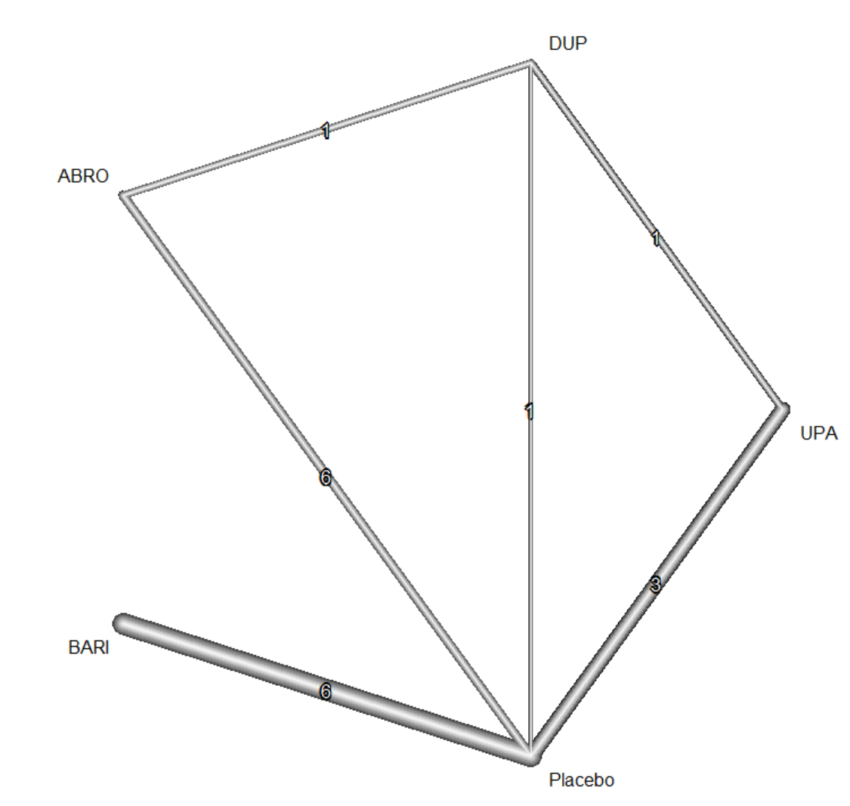
ABRO, abrocitinib; BARI, baricitinib; DUP, Dupilumab; UPA, upadacitinib;

