Supporting information
Pheromone mediated sexual reproduction of pennate diatom Cylindrotheca closterium
Franziska Klapper¹, Sien Audoor², Wim Vyverman², Georg Pohnert^{1,3*}
* Georg Pohnert
Georg.Pohnert@uni–jena.de
1 Institute for Inorganic and Analytical Chemistry, Bioorganic Analytics, Friedrich Schiller University Jena, Lessingstrasse 8, D-07743 Jena, Germany
2 Laboratory of Protistology and Aquatic Ecology, Department of Biology, University Gent, Krijgslaan 281 S8, 9000 Gent, Belgium
3 Max Planck Institute for Chemical Ecology, Hans-Knöll-Straße 8, D-07745 Jena, Germany

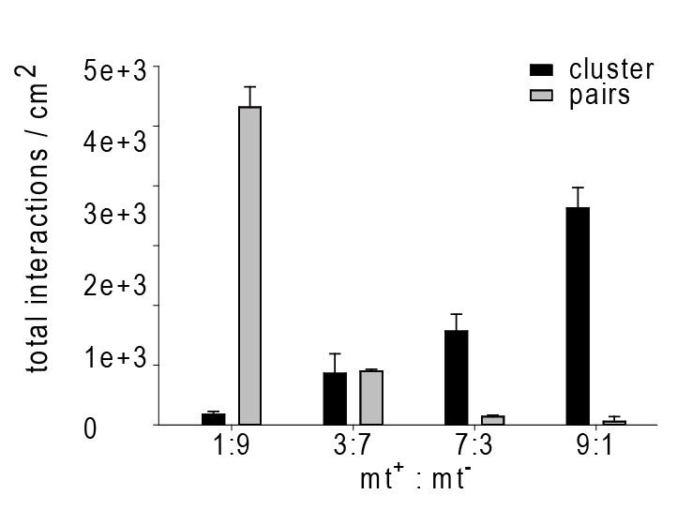
Fig. S1 Crosses of mt⁺ (~21 µm) and mt¯ (~48 µm) in Cylindrotheca closterium in different mating type ratios 5 h after mating. Clusters (black bars), and pairs (grey bars) depending on different mating type ratios. If mt¯ is in majority mostly pairs are formed whereas clusters dominate the culture when mt⁺ is in majority.

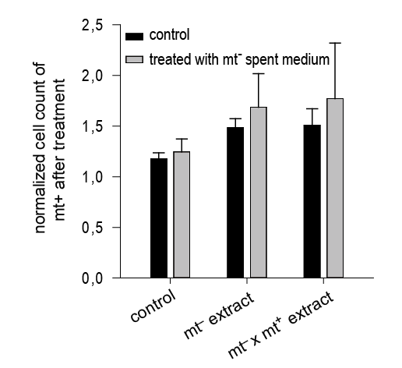
Fig. S2 Attraction of mt⁺ cells towards different extract in C. closterium. In a chemoattraction assay glass capillaries were filled with different extracts to monitor mt⁺ cell accumulation around it (n = 3). The accumulation of mt⁺ cells (black bars) and of mt⁺ cells conditioned with mt¯ medium (grey bars) around capillaries filled with medium extract of mt⁺ (control), extracts of mt¯ or extracts of a mating culture was evaluated. Significance was calculated with one-way ANOVA (α = 0.05, Tukey test).
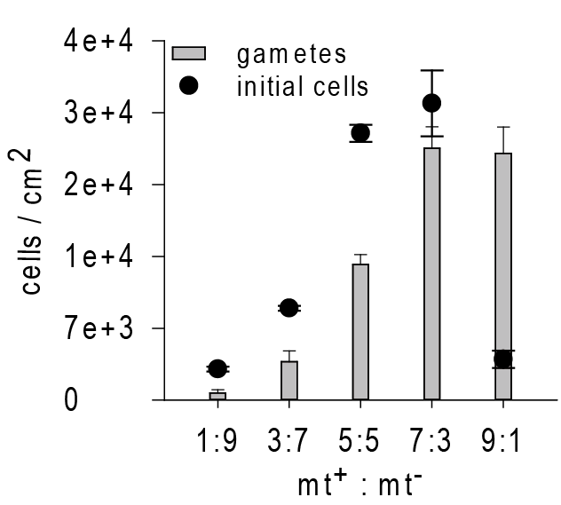
Fig. S3 Gamete and initial cell formation 5 days after crossing cultures of C. closterium. Crossing mt⁺ and mt¯ of C. closterium (n = 3) resulted in gamete (bars) and initial cell (dots) formation which showed unusually high numbers of gametes in crosses of high mt⁺: mt¯ cell ratio along with peak of initial cells when the mating type ratio gets close to 1.

