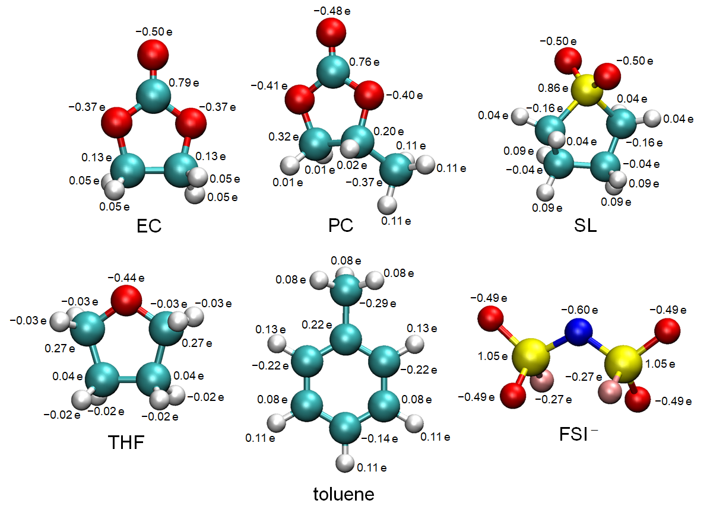
Extended Data Figure S1. Partial atomic charges of ethylene carbonate (EC), propylene carbonate (PC), sulfolane (SL), tetrahydrofuran (THF), toluene, and bis(fluorosulfonyl)imide anion (FSI–) for MD simulations (cyan, carbon; red, oxygen; white, hydrogen; yellow, sulphur; blue, nitrogen; pink, fluorine).

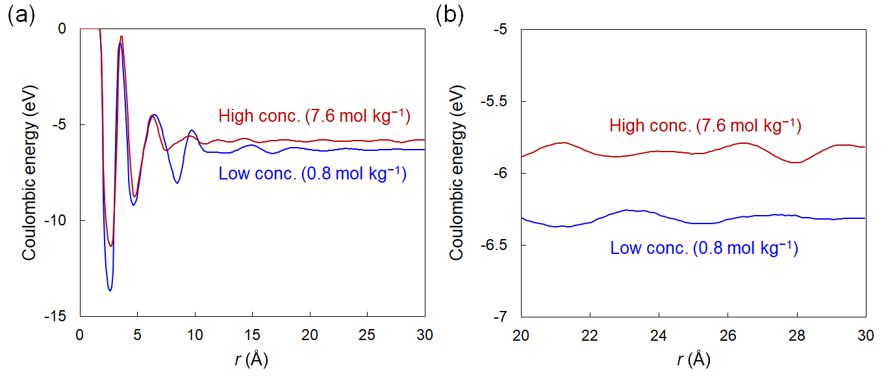
Extended Data Figure S2. (a) Coulombic energy as a function of r (distance from Li⁺) in 0.8 mol kg^{–1} LiFSI/EC and 7.6 mol kg^{–1} LiFSI/EC electrolytes, and (b) enlarged plots for r > 20 Å.

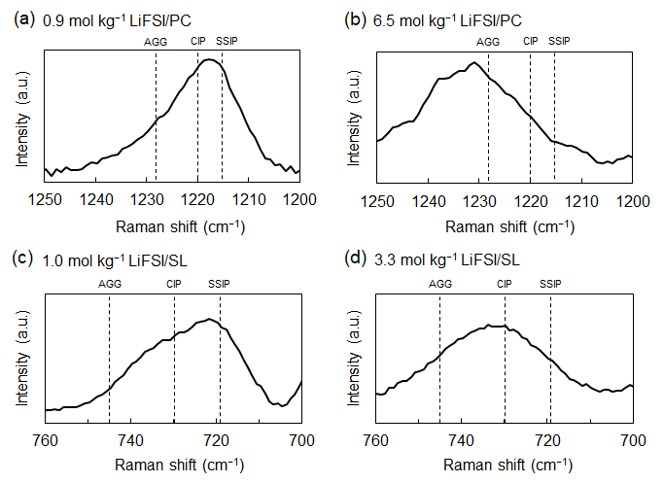
Extended Data Figure S3 | Raman spectra of (a) 0.9 mol kg^{–1} LiFSI/PC, (b) 6.5 mol kg^{–1} LiFSI/PC, (c) 1.0 mol kg^{–1} LiFSI/SL, and (d) 3.3 mol kg^{–1} LiFSI/SL electrolytes. Black dashed lines show the representative position for the coordination state of Li⁺ and FSI– ion pairs.

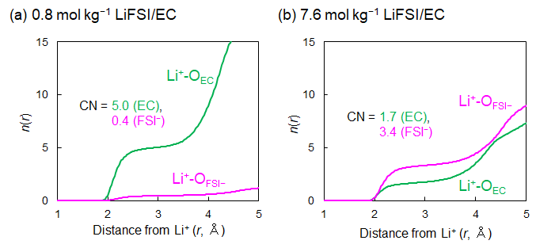
Extended Data Figure S4 | Number distribution functions n(r) with the coordination numbers (CN) in the first coordination sphere (r < 2.9 Å (green) or 3.1 Å (magenta)) in (a) 0.8 mol kg^{–1} and (b) 7.6 mol kg^{–1} LiFSI/EC electrolytes.

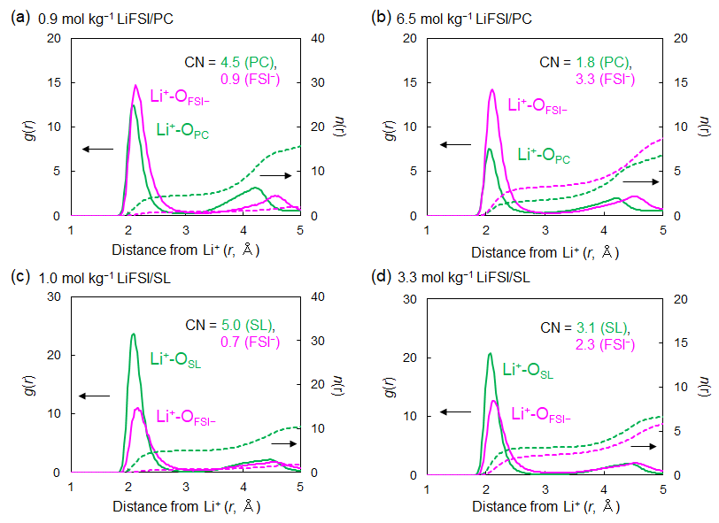
Extended Data Figure S5 | Radial distribution functions g(r) (solid lines) and number distribution functions n(r) (dashed lines) in (a) 0.9 mol kg^{–1} LiFSI/PC, (b) 6.5 mol kg^{–1} LiFSI/PC, (c) 1.0 mol kg^{–1} LiFSI/SL, and (d) 3.3 mol kg^{–1} LiFSI/SL electrolytes. The CNs in the first coordination sphere (r < 2.9 Å (green) or 3.1 Å (magenta)) are also shown.

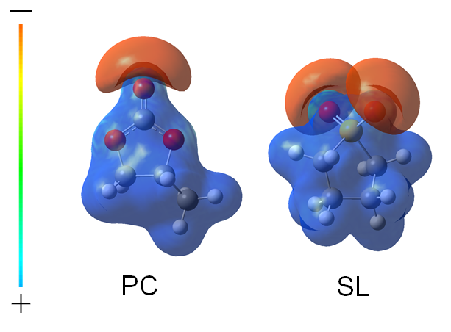
Extended Data Figure S6 | Electron density isosurface mapped with molecular electrostatic potential of PC and SL solvents.

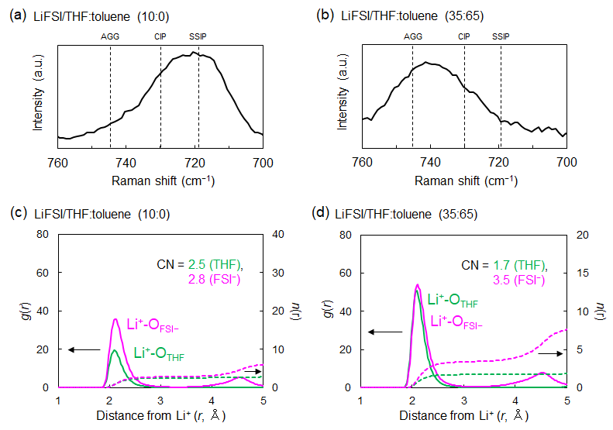

Extended Data Figure S7 | Raman spectra of (a) 1.5 mol dm^{–3} LiFSI/THF:toluene (10:0) and (b) 1.5 mol dm^{–3} LiFSI/THF:toluene (35:65) electrolytes. Black dashed lines show the representative position for the coordination state of Li⁺ and FSI– ion pairs. Radial distribution functions g(r) (solid lines) and number distribution functions n(r) (dashed lines) in (c) 1.5 mol dm^{–3} LiFSI/THF:toluene (10:0) and (d) 1.5 mol dm^{–3} LiFSI/THF:toluene (35:65) electrolytes. The CNs in the first coordination sphere (r < 3.1 Å (green) or 3.3 Å (magenta)) are also shown.

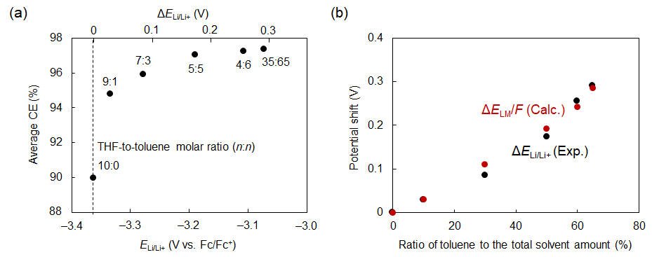
Extended Data Figure S8 | (a) Average Coulombic efficiencies (CEs) of Li plating/stripping reaction measured in Li|Cu cells with 1.5 mol dm^{–3} LiFSI/THF:toluene electrolytes depending on the electrode potential of Li/Li+ (E_{Li/Li+}: bottom axis) or the potential shift (ΔE_{Li/Li+}: top axis). The average CE was calculated from 2 to 20 cycles. The THF-to-toluene molar ratio (n:n) are specified close to each data point. (b) Experimental data of ΔE_{Li/Li+} and the calculated potential shifts of liquid Madelung potential (ΔE_{LM}/F) were designated as the shift from the data for 1.5 mol dm^{–3} LiFSI/THF electrolyte without toluene and plotted as a function of the ratio of toluene to the total solvent amount (%).

Extended Data Table S1 | Molarities, simulation cell lengths, and numbers of molecules/ions for MD simulations in LiFSI/EC, LiFSI/PC, and LiFSI/SL electrolytes at various concentrations.
Electrolyte  (Salt-to-solvent molar ratio, n:n) | Molarity  (mol kg^{–1}) | Cell length  (Å) | N  (Li⁺) | N  (FSI–) | N  (Solvent)
LiFSI/EC (1:13.8) | 0.8 | 69.2 | 200 | 200 | 2760
LiFSI/EC (1:10) | 1.1 | 70.3 | 280 | 280 | 2800
LiFSI/EC (1:8) | 1.4 | 68.8 | 320 | 320 | 2560
LiFSI/EC (1:6) | 1.9 | 70.6 | 440 | 440 | 2640
LiFSI/EC (1:4) | 2.8 | 70.3 | 600 | 600 | 2400
LiFSI/EC (1:3) | 3.8 | 69.7 | 720 | 720 | 2160
LiFSI/EC (1:2) | 5.7 | 71.3 | 1000 | 1000 | 2000
LiFSI/EC (1:1.5) | 7.6 | 71.8 | 1200 | 1200 | 1800
LiFSI/PC (1:10.6) | 0.9 | 67.9 | 200 | 200 | 2120
LiFSI/PC (1:8) | 1.2 | 67.0 | 240 | 240 | 1920
LiFSI/PC (1:6) | 1.6 | 67.8 | 320 | 320 | 1920
LiFSI/PC (1:4) | 2.5 | 69.4 | 480 | 480 | 1920
LiFSI/PC (1:3) | 3.3 | 69.4 | 600 | 600 | 1800
LiFSI/PC (1:2) | 4.9 | 70.7 | 840 | 840 | 1680
LiFSI/PC (1:1.5) | 6.5 | 71.5 | 1040 | 1040 | 1560
LiFSI/SL (1:9.5) | 0.9 | 69.8 | 208 | 208 | 1976
LiFSI/SL (1:8) | 1.0 | 69.5 | 240 | 240 | 1920
LiFSI/SL (1:6) | 1.4 | 70.2 | 320 | 320 | 1920
LiFSI/SL (1:4) | 2.1 | 71.8 | 480 | 480 | 1920
LiFSI/SL (1:3) | 2.8 | 71.8 | 600 | 600 | 1800
LiFSI/SL (1:2.5) | 3.3 | 72.9 | 720 | 720 | 1800

Extended Data Table S2 | Simulation cell lengths and numbers of molecules/ions for MD simulations in 1.5 mol dm^{–3} LiFSI/THF:toluene electrolytes with various THF-to-toluene molar ratios (n:n).
Electrolyte  (THF-to-toluene molar ratio, n:n) | Cell length  (Å) | N  (Li⁺) | N  (FSI–) | N  (THF) | N  (toluene)
1.5 M LiFSI/THF (10:0) | 70.2 | 320 | 320 | 2272 | 0
1.5 M LiFSI/THF:toluene (9:1) | 70.8 | 320 | 320 | 2016 | 224
1.5 M LiFSI/THF:toluene (7:3) | 72.3 | 320 | 320 | 1587 | 680
1.5 M LiFSI/THF:toluene (5:5) | 73.7 | 320 | 320 | 1136 | 1136
1.5 M LiFSI/THF:toluene (4:6) | 74.4 | 320 | 320 | 912 | 1368
1.5 M LiFSI/THF:toluene (35:65) | 74.7 | 320 | 320 | 792 | 1470

