Supplementary Information

Atomic imaging and thermally induced dynamic structural evolution of two-dimensional non-layered Cr₂S₃

Chia-Ling Liu ^{1†}, Yi-Tang Tseng ¹, Chun-Wei Huang ², Hung-Yang-Lo¹, An-Yuan-Hou¹, Che-Hung-Wang ¹, AkiraYasuhara³, Wen-Wei Wu ^{1,4*}
¹ Department of Materials Science and Engineering, National Yang Ming Chiao Tung University, Hsinchu 300, Taiwan
² Department of Materials Science and Engineering, Feng Chia University, Taichung 407, Taiwan
³ EM Application Department of EM Business Unit, JEOL Ltd, 3-1-2 Musashino, Akishima, Tokyo 196-8558, Japan
⁴ Center for the Intelligent Semiconductor Nano-system Technology Research, National Yang Ming Chiao Tung University, Hsinchu 300, Taiwan

*Correspondence and requests for materials should be addressed to W.W.W (email:
: wwwu@mail.nctu.edu.tw
List of contents

Figure S1｜Schematic diagram of the experimental setup.Figure S2｜XPS result of CVD-grown Cr₂S₃.
Figure S3｜EDS elemental mapping showing the distribution of Cr and S.
Figure S4｜Multislice simulated ADF-STEM image and atomic models of Cr-S compounds.Figure S5｜Simulated diffraction pattern of cross-sectional Cr-S compounds.
Figure S6｜Simulated diffraction pattern of plane-view Cr-S compounds.
Figure S7｜TEM images showing the phase transformation of Cr₂S₃ along [001].
Figure S8｜STEM images and EELS showing the morphologic information of FIB-fabricated Cr₂S₃ specimen.
Figure S9｜Line graph of theoretical distance between Cr atoms.
Figure S10｜Free energy curves at 600 °C.
Figure S11｜EDS result showing the variation of atomic ratio of Cr and S element.
Figure S12｜The schematic diagram of 2D and quasi-1D specimens shows the morphologic information and plane surface ratio.

Figure S1. The Schematic diagram of e experimental setup.
Figure S2. The XPS result of CVD-grown Cr₂S₃. (a) Survey scan spectrum for obtained Cr₂S₃ nanosheets and the corresponding atomic percentage of Cr and S elements are shown in the (b).

Figure S3. EDS elemental mapping showing the distribution of Cr and S. (a) Low-magnification STEM image (b,c) EDX spectrum of the Cr₂S₃ nanoflake. (d) Cr and S elemental atomic percentage of the plots shown in (a).

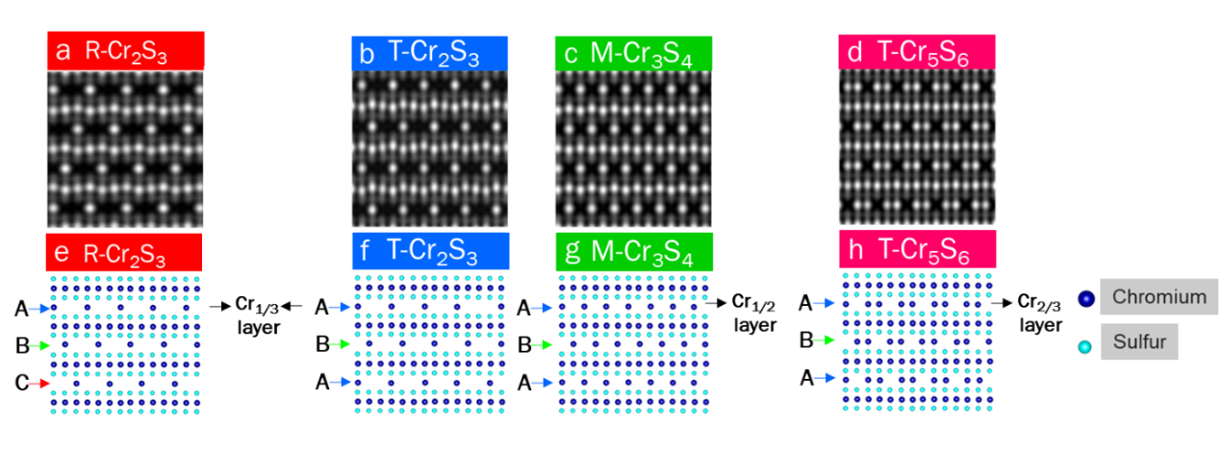 Figure S4. Multislice simulated ADF-STEM image and atomic models of Cr-S compounds. (a) STEM image of R-Cr₂S₃. (b) STEM image of T-Cr₂S₃. (c) STEM image of M-Cr₃S₄. (d) STEM image of T-Cr₅S₆. (f) Atomic model of R-Cr₂S₃. (g) Atomic model of T-Cr₂S₃. (h) Atomic model of M-Cr₃S₄. (i) Atomic model of T-Cr₅S₆.

Figure S5. Simulated diffraction pattern of cross-sectional Cr-S compounds. (a) Simulated diffraction pattern of R-Cr₂S₃. (b) Simulated diffraction pattern of T-Cr₂S₃. (c) Simulated diffraction pattern M-Cr₃S₄. (d) Simulated diffraction pattern T-Cr₅S₆. (e) The d-spacing corresponds to Cr-S crystals.

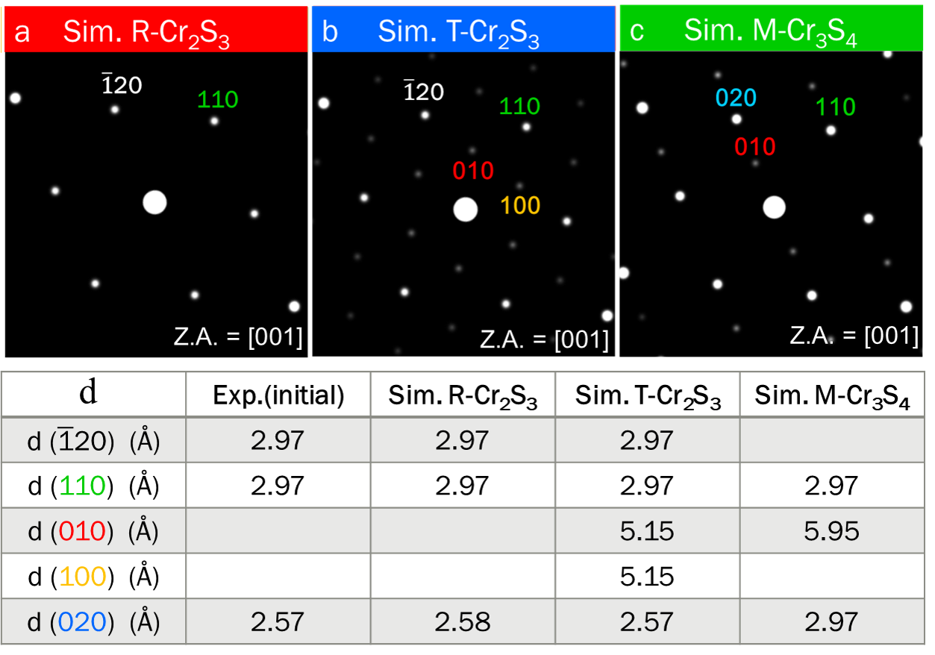 Figure S6. Simulated diffraction pattern of plan-view Cr-S compounds. (a) Simulated diffraction pattern of R-Cr₂S₃. (b) Simulated diffraction pattern of T-Cr₂S₃. (c) Simulated diffraction pattern of M-Cr₃S₄. (d) The d-spacing corresponds to Cr-S crystals.

Figure S7. TEM images showing the phase transformation of Cr₂S₃ along [001].
(a) HRTEM image were held at 600 °C for three minutes. (b) Correspond FFT pattern under 600°C.

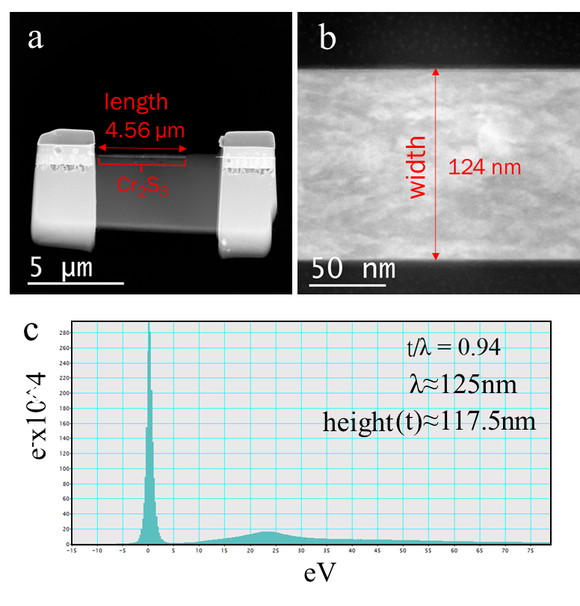
Figure S8. STEM images and EELS showing the morphologic information of FIB-fabricated Cr₂S₃ specimen. (a) Low-magnification ADF-STEM image shows the length of FIB-fabricated Cr₂S₃ is 4.56 µm. (b) High-magnification ADF-STEM image shows the width of FIB-fabricated Cr₂S₃ is 124 nm. (c) Electron energy loss spectroscopy determined the height of FIB-fabricated Cr₂S₃ is 117.5 nm.

Figure S9. Line graph of theoretical distance between Cr atoms. (a) Horizontal distance between Cr atoms for R-Cr₂S₃, Cr₂S₃(Trigonal), M-Cr₃S₄, and T-Cr₅S₆ crystals. (b) Vertical distance between Cr atoms for R-Cr₂S₃, T-Cr₂S₃, M-Cr₃S₄, and T-Cr₅S₆ crystals.

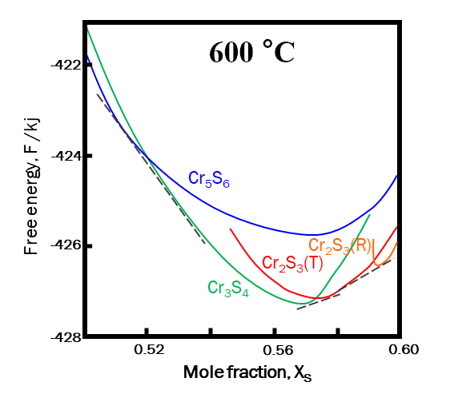
Figure S10. Free energy curves at 600 °C.³⁵

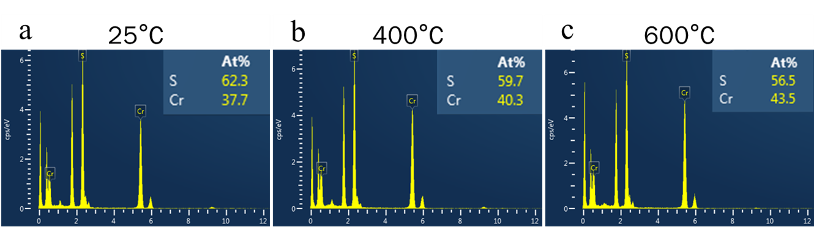
Figure S11. EDS result showing the variation of atomic ratio of Cr and S element. (a) Atomic ratio of Cr and S under 25°C. (b)Atomic ratio of Cr and S under 400°C. (c)Atomic ratio of Cr and S under 600°C.

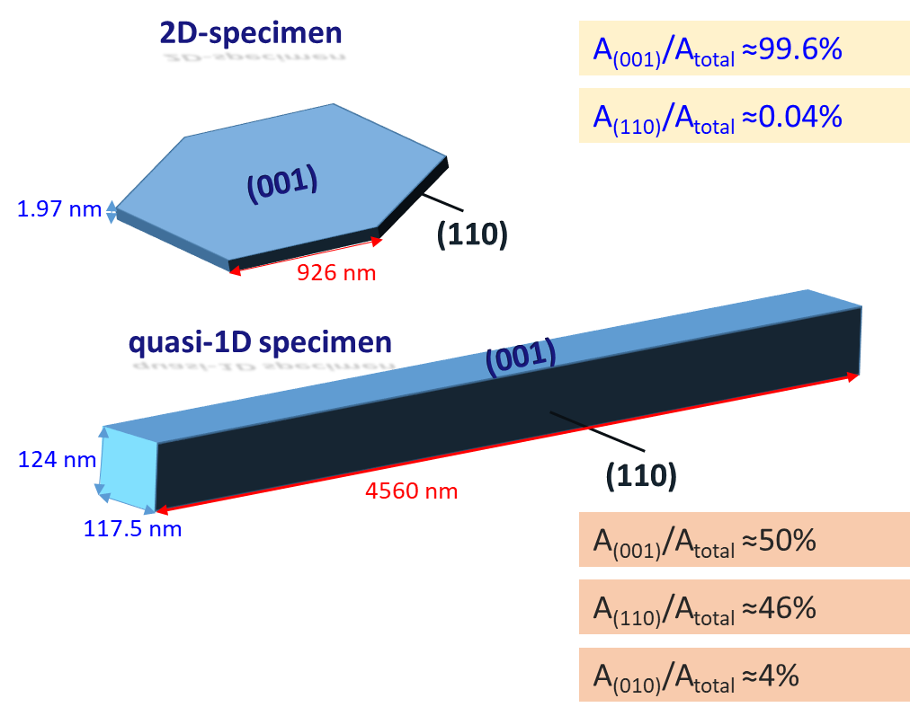
Figure S12. The schematic diagram of 2D and quasi-1D specimens shows the morphologic information and plane surface ratio.

