Arrays of TiO₂ nanosphere monolayer on GaN-based LED for the improvement of light extraction
Dohyun Kim¹, Uijin Jung¹, Bomseumin Jung¹, Kyoung-kook Kim², Jinsub Park^{1,*}
¹Department of Electronic Engineering, Hanyang University, Seoul 04763, Republic of Korea
²Department of Nano & Semiconductor Engineering, Tech University of Korea, Siheung, 429-793, Republic of Korea

*Corresponding Authors : E-mail: jinsubpark@hanyang.ac.kr, Tel: +82-2-2220-2318, Fax: +82-504-253-7081

Total number of pages (including cover page): 3
Total number of Figures: 2

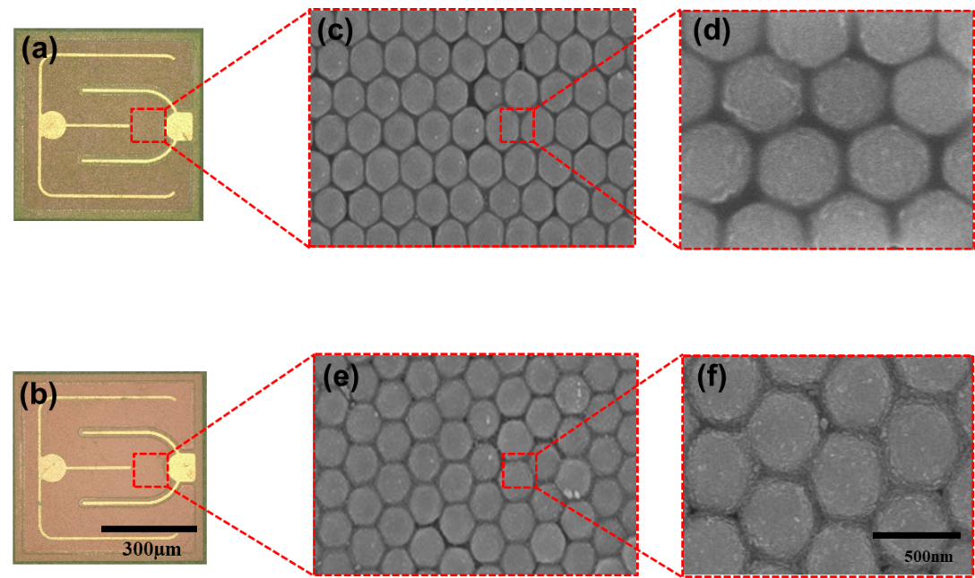

Fig. S1. (a) and (b) Optical microscope image of the TiO₂ nanosphere arrays on blue LED
chip with Am- and An-TiO₂ nanosphere. (c, d) and (e, f) show the SEM images of 500nm
size Am- and An-TiO₂ nanosphere arrays on p-GaN substrate, respectively.

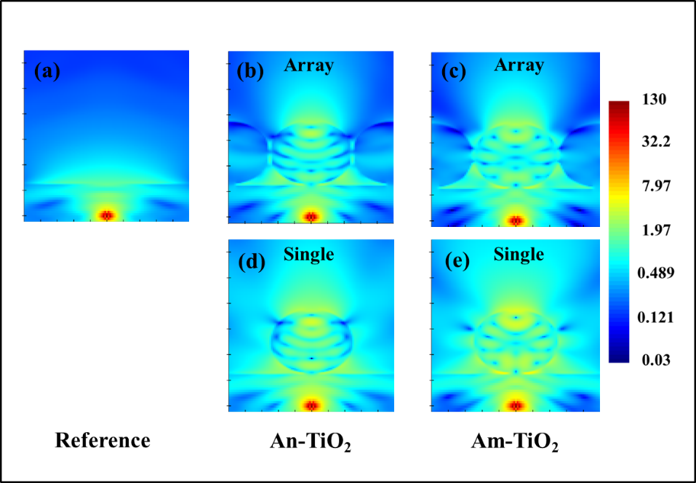

Fig. S2. (a-c) FDTD simulation results of compares cross sections of the power field for general planar LED and LEDs with Anatase-, Amorphous-TiO₂ sphere array (d, e) Anatase, Amorphous-TiO₂ single sphere cross section image.

