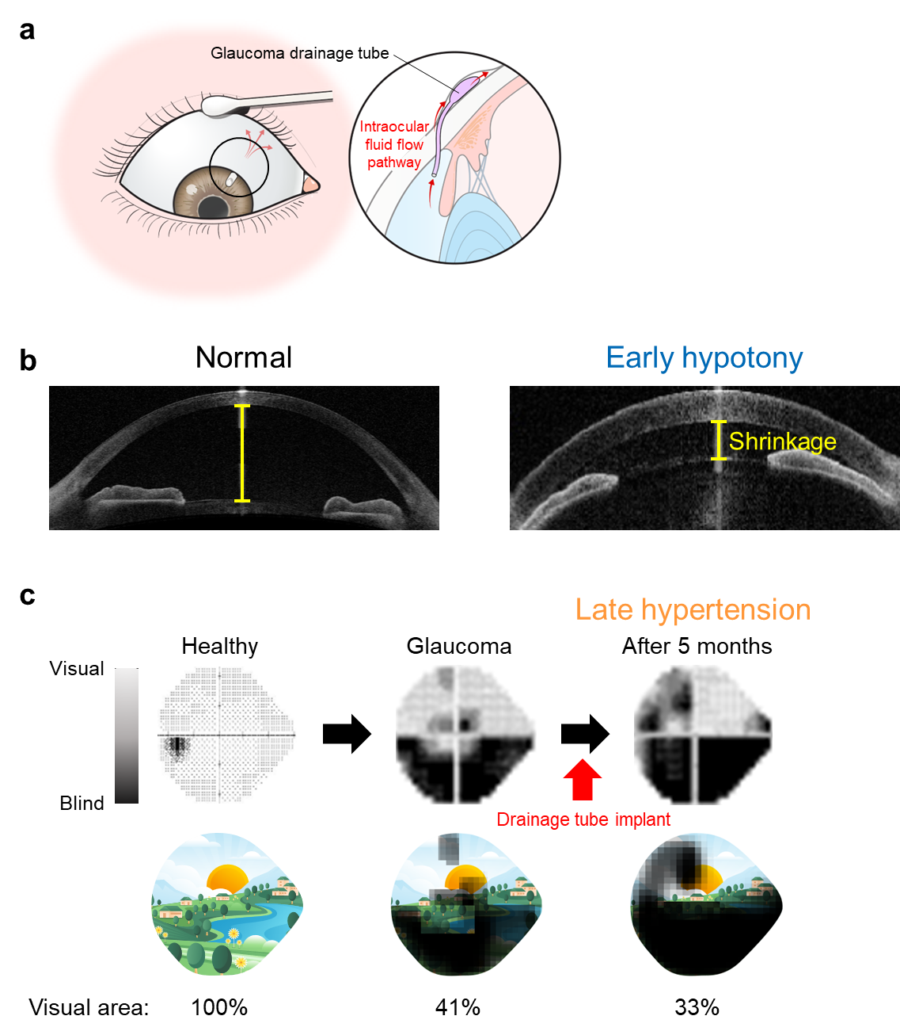
Supplementary Figure 1: Complications of glaucoma patients after implantation of the silicone drainage tube with the fixed diameter. a, When a drainage device is implanted into ae glaucomatous eye, intraocular fluid flows through the silicone tube owing to the in-out negative pressure, thereby reducing the intraocular pressure (IOP). b, The over-drainage by a silicone tube of large diameter (fixed) causes hypotonic IOP drop and consequent shrinkage of the anterior chamber compared to the normal case as visualized by optical coherence tomography (OCT). c, Glaucoma progression induces gradual loss of vision because the dominant area of the eye becomes blinded and the visual part of eye decreases to 41% compared to 100% of a normal eye. After 5-month implantation of drainage device, the vision loss worsened (approximately 33% of visual area) owing to the hypertensive increase of IOP primarily because of fibrotic tissue formation.
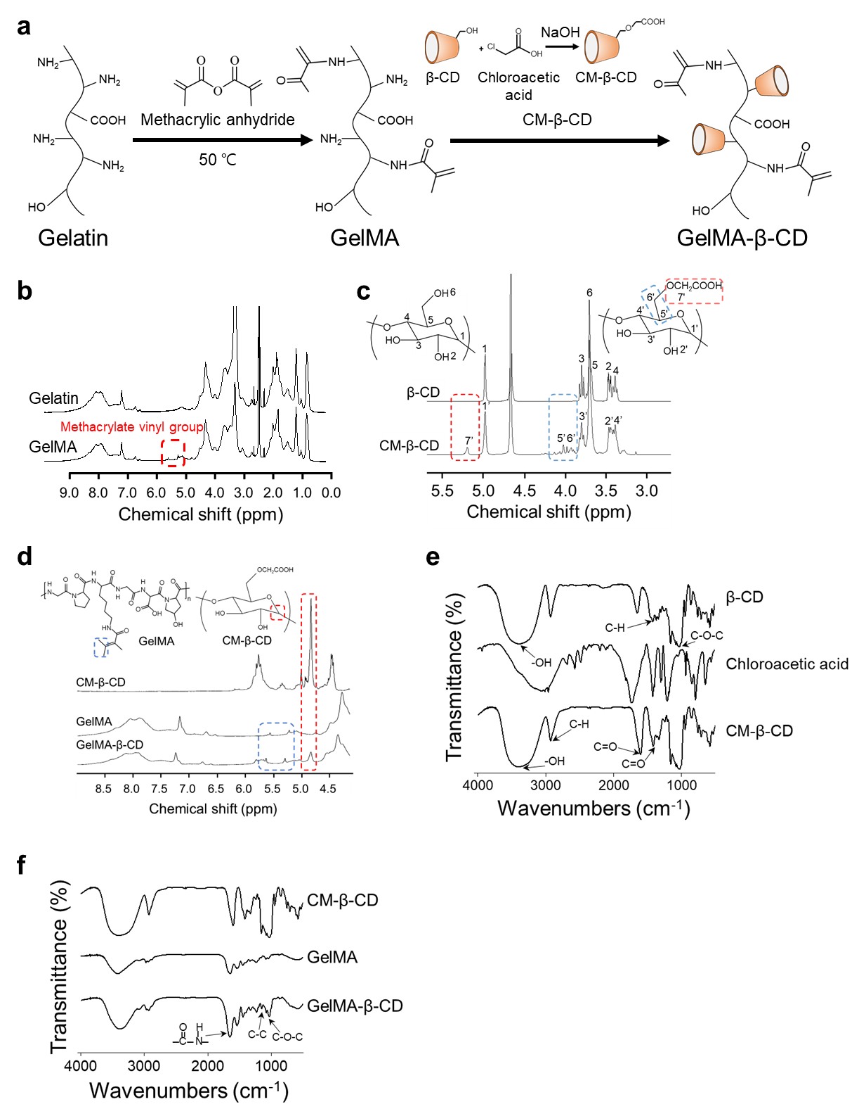
Supplementary Figure 2: Synthesis step of GelMA-β-CD with analysis of chemical structures. a, Gelatin was conjugated with methacrylic anhydride (GelMA) at 50 ºC, followed by conjugation with a complex of β-cyclodextrin (β-CD) and chloroacetic acid to produce GelMA-β-CD. ¹H-NMR was used to confirm the synthesis results of b, GelMA, c, carboxymethylated β-CD (CM-β-CD), and d, GelMA-β-CD in dimethyl sulfoxide-d₆ (DMSO-d₆) by analyzing the chemical structures. The successful synthesis was further evidenced by the Fourier transform infrared (FTIR) spectra of e, CM-β-CD and f, GelMA-β-CD.
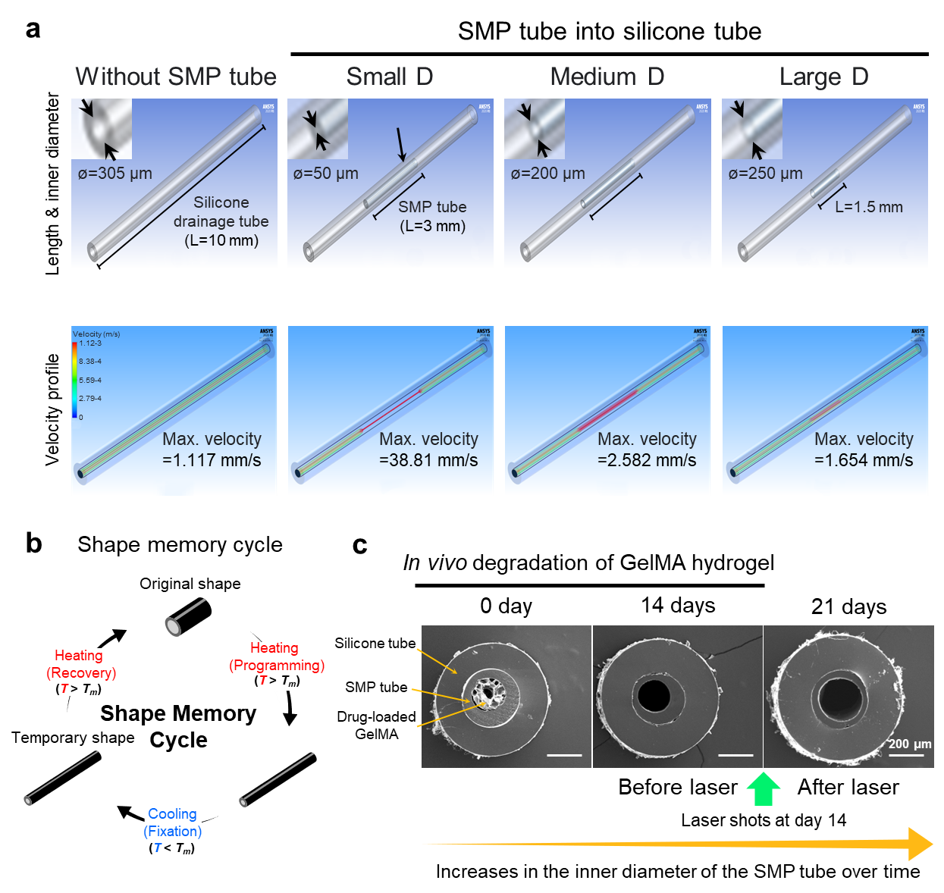
Supplementary Figure 3: Computational fluid dynamics (CFD) modeling and experimental validation of effects by tube diameter changes. a, CFD modeling was used to simulate the diameter (D) and velocity profiles and determine the length of the SMP tube for shape programing. The profiles were modeled when the SMP tube was inserted into a silicone tube (length: 10 mm / inner D: 305 µm) of a glaucoma drainage device. When an SMP tube of length 30 mm was inserted into the silicone tube, the post-recovery length became 15 mm. The D was changed from 50 µm (small D) to 200 µm (medium D) before and after GelMA degradation, respectively. This was further increased to 250 µm (large D) upon the shape recovery by argon laser shots. Accordingly, the CFD velocity increased markedly upon the insertion of SMP tube and decreased the level of the silicone tube only following the increased D, indicating stepwise control of the drainage flow rate and consequent IOP. b, The shape programing of SMP tube was performed following the shape memory cycle. i) The insertion shape of the SMP tube was programmed by pulling the SMP tube in hot water (T > T_{m}) to reduce the inner diameter. ii) The programmed shape was fixed by cooling in cold water (T < T_{m}). iii) The temporary shape of the SMP tube was recovered by energy transfer (i.e., argon laser). c, The progressive changes of D were validated in vivo from 21-day implantation into eyes by analyzing the cross-section of SMP tube in the SEM images. GelMA degradation until day 14 (before laser) and argon laser shots at day 14 increased D as programmed. D increased by argon laser shots was confirmed at day 21 (after laser).

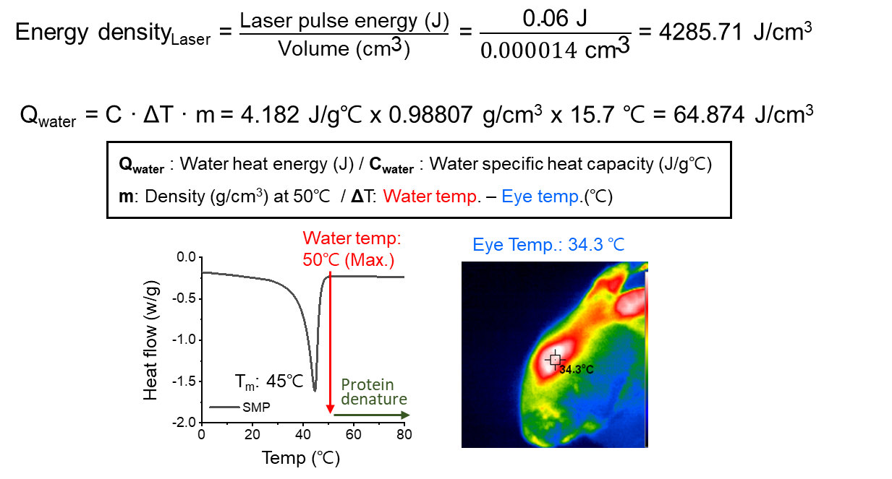
Supplementary Figure 4: Superior energy efficiency of argon laser compared to water heat energy. The use of warm water is another option to trigger shape recovery in the clinic although it spreads into the neighboring areas. Hence, the superior energy efficiency of argon laser (Energy density: approximately 4,286 J/cm³) was confirmed when compared to the heat energy of water (Q_{water}: approximately 65 J/cm³ at 50 °C) by calculation. In this case, the temperature of Q_{water} was set to 50° C which is above the shape recovery temperature (T_{m}: 45 °C) of SMP from DSC analysis. Further, the water temperature cannot be increased beyond 50 °C because proteins denature above it. ΔT was calculated by subtracting the corneal surface temperature of the rabbit eye (thermal imaging camera) from 50 °C.

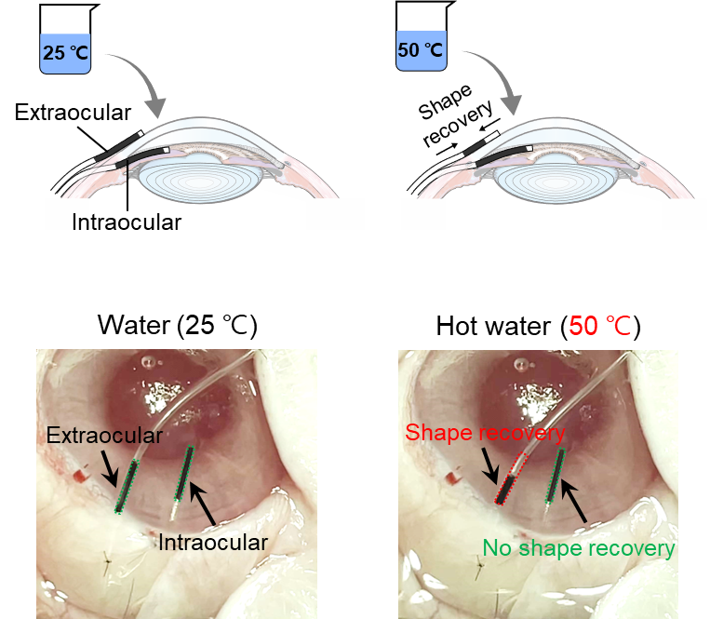
Supplementary Figure 5: Limitation of using water heat energy to trigger intraocular shape recovery of the SMP tube. a, As warm saline can be used in the clinic, saline groups at 25 ℃ and 50 ℃ were tested in triggering shape recovery of the SMP tube in intraocular and extraocular positions post implantation into rabbit eyes. The water at50 ℃ water induced shape recovery in the in the extraocular position but not in the intraocular position, evidenced by shortening the tube length, indicating the limitation of water heat owing to insufficient energy transfer to the intraocular position. Water at 25 ℃ could not induce shape recovery at any position owing to the low heat energy.
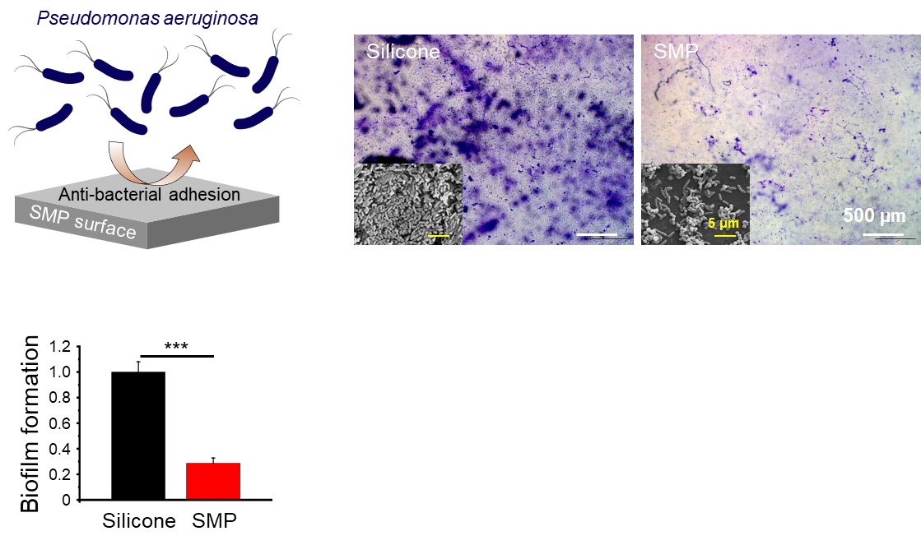
Supplementary Figure 6: Suppression of biofilm formation by SMP for addressing the post implantation issues of silicone. Since biofilm formation has been a critical issue during long-term implantation of the silicone device, suppression of bacterial adhesion by SMP was demonstrated on day 2 post-seeding of Pseudomonas aeruginosa. Compared to silicone, the superior anti-biofilm effect of SMP was evidenced by less crystal violet signals in the optical images and fewer bacteria in the SEM images (left bottom) with quantitative image analysis. Data = mean ± standard deviation (n = 3). *** p < 0.001 between lined groups from one-way ANOVA with Tukey’s post hoc test.

