Supplementary Fig. 1. In vivo tumour accumulation of FTn over time. a, Protein structure (left, PDB ID: 3AJO) and TEM image of FTn (right). Scale bar = 50 nm. b, In vivo imaging (left) and quantification analysis (right) of tumour accumulation of Cy5.5-labeled FTn at the specific time points of post-injection (0, 10, 30, 60, 180 minutes). Tumours are indicated by white circles.

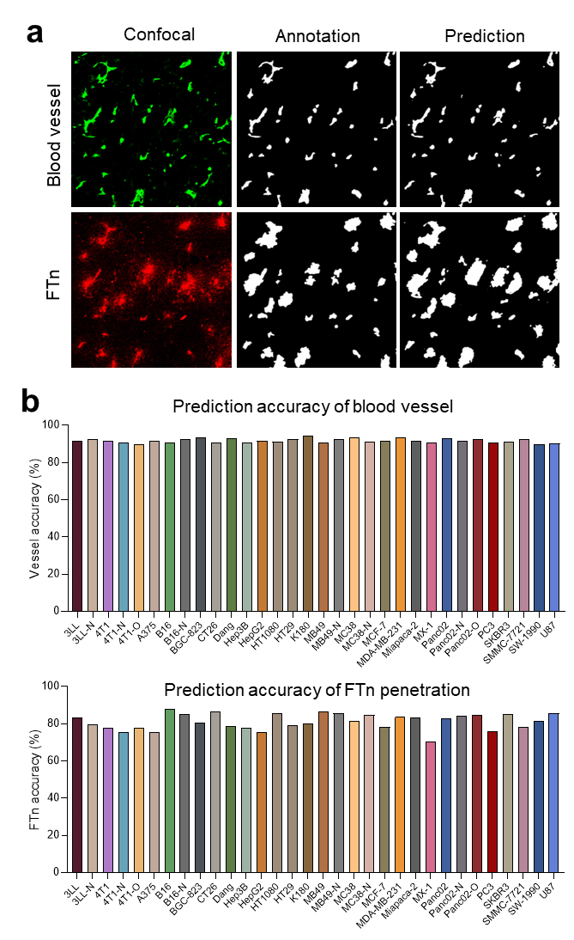
Supplementary Fig. 2. Prediction accuracies of ML-based segmentation model for vessel and FTn penetration. a, Representative images of confocal, manual annotation and ML-based prediction for vessel channel and FTn penetration channel. b, Prediction accuracies of vessel and FTn penetration in various tumour models using the established ML models by comparing manual annotation and the model prediction. The prediction accuracy was determined by Dice Similarity Coefficient (DSC).

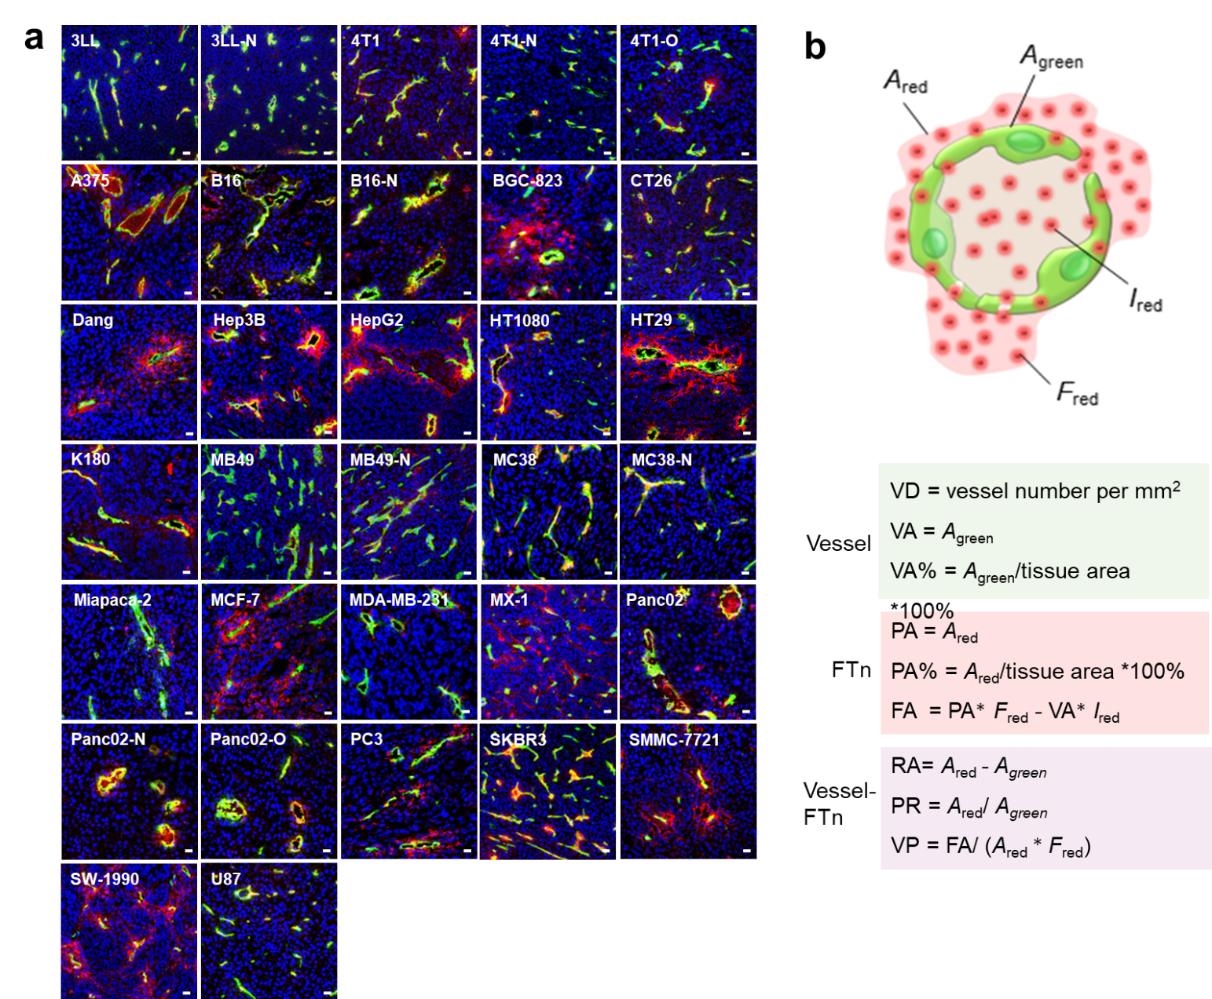
Supplementary Fig. 3. Confocal images and output indices. a, Representation confocal images of tissue sections from 32 tumour models. Blue, nucleus; green, vessel; red, FTn. Scale bar = 20 μm. b, Four basic parameters of automatic machine output and nine quantitative indices of single-vessel assessment.
Supplementary Fig. 4. Quantification analysis of total vessel numbers in various tumour models using the single-vessel analysis method.

Supplementary Fig. 5a. Quantification analysis the features from (a) vessel, (b) FTn penetration and (c) vascular penetration ability in 32 tumour models using the established ML models. For VD, total VA and total PA, one dot is a tumour tissue section. For others, one dot represents one single vessel.

Supplementary Fig. 6. Sequential cryosection analysis of different tumour tissues. a, Schematic illustration of different layers of tumour tissues by sequential cryosection. Representative confocal images of (b) 3LL, (c) K180 and (d) HT29. Quantification analysis of mean VP for each tumour type were determined using the established single-vessel analysis method. Scale bar = 50 μm.

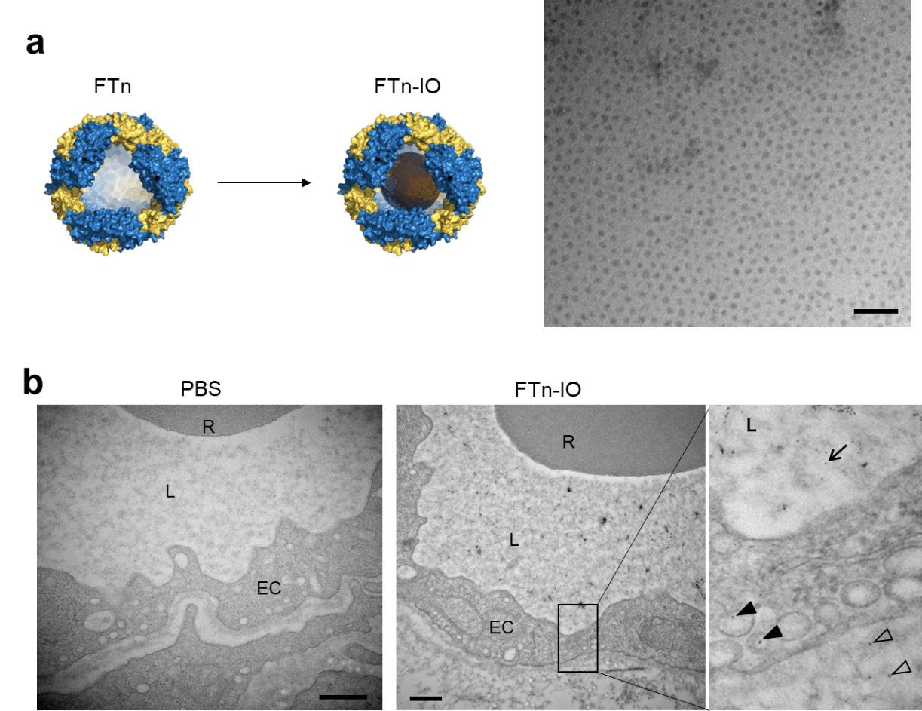
Supplementary Fig. 7. Preparation of FTn-IO for visualizing particle penetration using TEM. a, Schematic illustration, and TEM image of FTn-IO. IO nanoparticles were incorporated into FTn inner cavity through a biomimetically in situ synthesis approach. Scale bar = 50 nm. b, TEM images of tumour vessels following administration of PBS and FTn-IO. Compared to PBS treatment (control), FTn-IO were clearly visualized in the lumen (arrow), endothelial linings (solid triangle) and extravascular space (empty triangle). R, red blood cells; L, lumen; EC, endothelial cells. Scale bar = 500 nm.

Supplementary Fig. 8. Mechanisms of FTn penetration across tumour blood vessels. Three typical passive penetration mechanisms of vessels were observed including (a) inter-endothelial gap, (b) vesiculo-vacuolar organelles (VVO) and (c) tight junction. The typical feature of these pathways is that lumen directly connects with extravascular space. R, red blood cells; L, vessel lumen; Arrow, FTn-IO in the lumen; solid triangle, extravasating FTn-IO; empty triangle, extravasated FTn-IO. Enlarged images were indicated by dash lined boxes. Images with typical features, scale bar =1 μm; Enlarged images, scale bar =100 nm. The typical features of the formed vesicles for the (d) active vessels and (e) inactive vessels. Arrow, FTn-IO in the lumen; solid triangle, the formed vesicles with or without FTn-IO. Scale bars for left images and right images are 1 μm and 100 nm, respectively. (f and g) The active transport process of endothelial cells including capture (i), vesicle formation (ii) and transport and exocytosis (iii), is clearly observed under TEM. Arrows indicate the FTn-IO. Scale bars for left image and right image are 1 μm and 100 nm, respectively.

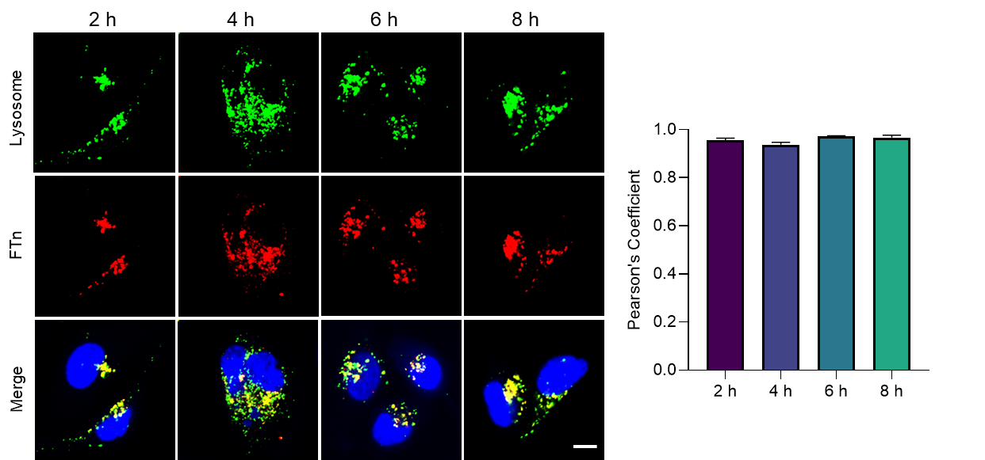
Supplementary Fig. 9. Co-localization of FTn and lysosome in HUVECs. After incubation HUVECs with Cy5-labeled FTn for 2 hours, the fresh medium was replaced and the cells were further cultured for 2, 4, 6 and 8 hours. The co-localization was quantified by determining Pearson’s Coefficients.

Supplementary Fig. 10. Representative confocal images of various tumours following administration of FTn and its variants with the equivalent Cy5. Scale bar = 100 μm.

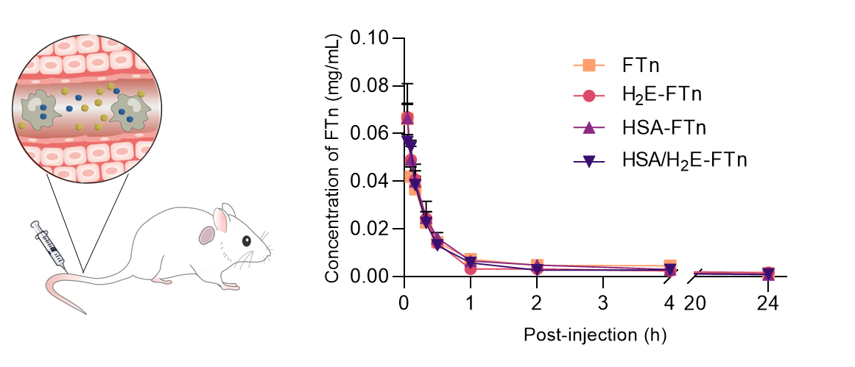
Supplementary Fig. 11. Plasma concentration profiles after intravenous administration of Cy5-labeled FTn and its variants. The FTn concentration was determined by measuring Cy5 fluorescence intensity in plasma.

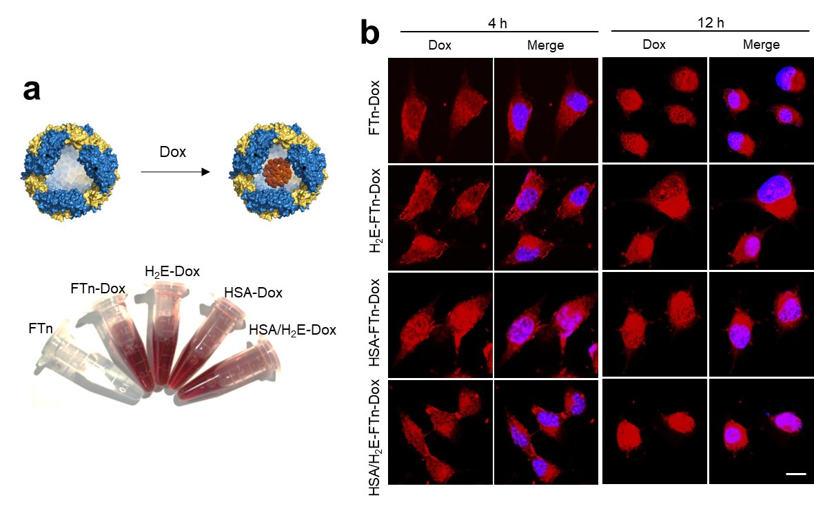
Supplementary Fig. 12. Dox loading and cell uptake. a, Dox was loaded into FTn and its variants. b, Co-localization of FTn-Dox and FTn variants-Dox with nucleus after tumour cell uptake for 4 hours and 12 hours, respectively. Scale bar = 5 μm.

Supplementary Table 1. Parameters for single-vessel analysis.
Name | Parameter | Channel | Formula
A_{red} | Total FTn coverage area for each vessel | / | Vessel + extravascular space
A_{green} | Coverage area of each vessel | / | Vessel
F_{red} | Total Cy5 fluorescence intensity for each vessel | / | Vessel + extravascular space
I_{red} | Cy5 fluorescence intensity in each vessel and its lumen | / | Vessel
VN | Vessel number | Vessel | Vessel counting number
VD | Vessel density | Vessel | VN per mm²
VA | Vessel area | Vessel | Vessel coverage area/each vessel
Mean VA | Mean vascular area | Vessel | Mean vessel coverage area/each image
Total VA% | The percentage of total VA in total tumour tissue area | Vessel | Total VA accounting for each image area (%)
PA | FTn penetration area | FTn | FTn penetration area/each vessel
Mean PA | Mean FTn penetration area | FTn | Mean PA/each image
Total PA% | The percentage of total PA in total tumour tissue area | FTn | Total PA accounting for each image area (%)
FA | FTn penetration amount | FTn | PA * F_{red} - VA * I_{red}
Mean FA | Mean FTn penetration amount | FTn | Mean FA/each image
RA | Relative FTn penetration area for each vessel | Vessel and FTn | PA - VA
PR | FTn penetration area ratio | Vessel and FTn | PA/VA
Mean RA | Mean relative penetration area | Vessel and FTn | Mean RA/each image
Mean PR | Mean FTn penetration area ratio | Vessel and FTn | Mean PR/each image
VP | Vascular permeability | Vessel and FTn | FA/(PA * F_{red})

Supplementary Table 2. Quantification analysis of vessel and FTn penetration.
 | VD  （mm⁻²） | VA  （µm⁻²） | Total VA% | PA  （µm⁻²•30 min⁻¹） | Total PA%  （30 min⁻¹） | FA  （30 min⁻¹） | RA  （µm⁻²•30 min⁻¹） | PR  （30 min⁻¹） | VP  （30 min⁻¹） | Permeable type
3LL | 157.33 | 389.72 | 5.30 | 1223.75 | 12.95 | 87029.38 | 779.84 | 2.26 | 0.22 | LP
3LL-N | 107.43 | 485.49 | 5.07 | 745.94 | 7.82 | 28816.75 | 244.49 | 3.10 | 0.22 | LP
4T1 | 120.80 | 391.93 | 4.39 | 816.70 | 9.12 | 58736.89 | 424.77 | 2.64 | 0.24 | LP
4T1-N | 106.78 | 443.69 | 4.51 | 961.37 | 10.39 | 83676.21 | 536.72 | 2.45 | 0.32 | LP
4T1-O | 85.84 | 556.29 | 4.34 | 1130.94 | 8.84 | 59907.04 | 586.05 | 4.78 | 0.40 | HP
A375 | 49.36 | 1177.35 | 3.73 | 3059.44 | 9.55 | 319191.19 | 1882.09 | 3.69 | 0.41 | LP
B16 | 50.70 | 1123.00 | 4.99 | 2132.12 | 9.37 | 93466.51 | 1003.45 | 2.36 | 0.26 | LP
B16-N | 33.71 | 1642.86 | 4.28 | 2938.45 | 7.75 | 112626.45 | 1295.59 | 4.39 | 0.25 | HP
BGC-823 | 62.98 | 321.85 | 1.84 | 1183.02 | 6.79 | 105810.95 | 859.01 | 5.32 | 0.46 | HP
CT26 | 89.14 | 400.05 | 3.13 | 809.49 | 6.20 | 44174.43 | 409.44 | 2.18 | 0.28 | LP
Dang | 40.17 | 634.39 | 2.22 | 3229.05 | 11.00 | 390910.92 | 2594.67 | 7.05 | 0.62 | HP
Hep3B | 58.67 | 517.24 | 2.61 | 2139.54 | 10.79 | 183356.71 | 1622.30 | 5.81 | 0.58 | HP
HepG2 | 35.01 | 1466.88 | 4.29 | 6854.69 | 18.74 | 705255.45 | 5387.80 | 5.89 | 0.58 | HP
HT1080 | 79.68 | 410.31 | 3.05 | 902.63 | 6.62 | 68838.75 | 492.32 | 2.31 | 0.27 | LP
HT29 | 34.73 | 1264.88 | 3.85 | 6212.89 | 17.89 | 752050.47 | 4948.02 | 10.27 | 0.67 | HP
K180 | 55.81 | 796.27 | 2.91 | 2695.70 | 9.03 | 262080.40 | 1899.43 | 3.44 | 0.44 | LP
MB49 | 132.21 | 605.97 | 7.40 | 1375.06 | 16.61 | 111720.22 | 755.79 | 2.81 | 0.35 | LP
MB49-N | 131.75 | 429.32 | 5.10 | 1027.47 | 11.90 | 84352.06 | 598.15 | 3.34 | 0.41 | LP
MC38 | 70.10 | 621.35 | 4.04 | 1298.71 | 7.95 | 51375.04 | 677.37 | 2.28 | 0.22 | LP
MC38-N | 86.52 | 482.60 | 3.65 | 878.29 | 6.42 | 29585.88 | 395.69 | 2.03 | 0.20 | LP
MCF-7 | 36.89 | 700.32 | 2.23 | 4000.35 | 12.66 | 677905.42 | 3300.03 | 6.36 | 0.64 | HP
MDA-MB-231 | 69.05 | 377.82 | 2.48 | 691.28 | 4.60 | 33757.56 | 307.36 | 2.06 | 0.23 | LP
Miapaca-2 | 57.48 | 570.46 | 3.26 | 1238.12 | 6.54 | 72270.63 | 667.66 | 3.10 | 0.35 | LP
MX-1 | 184.56 | 280.42 | 4.75 | 1279.40 | 19.97 | 161692.09 | 813.72 | 5.08 | 0.56 | HP
Panc02 | 127.15 | 621.17 | 6.41 | 1602.17 | 14.61 | 117411.43 | 862.42 | 2.68 | 0.40 | LP
Panc02-N | 36.82 | 1091.57 | 3.63 | 2002.85 | 6.32 | 107695.80 | 970.46 | 1.92 | 0.24 | LP
Panc02-O | 46.05 | 1406.29 | 5.03 | 3361.86 | 11.78 | 305452.56 | 1955.58 | 3.92 | 0.35 | LP
PC3 | 40.49 | 880.86 | 2.90 | 3686.08 | 12.67 | 336927.22 | 2805.21 | 9.82 | 0.52 | HP
SKBR3 | 236.19 | 569.50 | 11.97 | 1044.30 | 23.16 | 71701.66 | 465.94 | 1.95 | 0.22 | LP
SMMC-7721 | 43.47 | 502.68 | 1.85 | 2414.46 | 8.13 | 275911.47 | 1911.78 | 5.60 | 0.56 | HP
SW-1990 | 73.86 | 456.47 | 3.09 | 2288.18 | 15.23 | 303871.02 | 1831.72 | 7.53 | 0.59 | HP
U87 | 157.75 | 445.87 | 6.35 | 799.67 | 11.38 | 33099.13 | 353.79 | 2.31 | 0.24 | LP

Supplementary Table 3. Cell lines and tumour models.
NO. | Name | Tumour Model | Cell number | Culture medium | Mice
1 | 3LL | Lewis Lung Carcinoma | 1 × 10⁶ 3LL cells | DMEM + 10% FBS + 1% P/S | C57BL/6
2 | 3LL-N | Lewis Lung Carcinoma | 1 × 10⁶ 3LL cells | DMEM + 10% FBS + 1% P/S | BALB/c-Nude
3 | 4T1 | Breast Cancer | 1 × 10⁶ 4T1 cells | DMEM + 10% FBS + 1% P/S | BALB/c
4 | 4T1-N | Breast Cancer | 1 × 10⁶ 4T1 cells | DMEM + 10% FBS + 1% P/S | BALB/c-Nude
5 | 4T1-O | Orthotopic Breast Cancer | 1 × 10⁶ 4T1 cells | DMEM + 10% FBS + 1% P/S | BALB/c
6 | A375 | Melanoma | 4 × 10⁶ A375 cells | DMEM + 10% FBS + 1% P/S | BALB/c-Nude
7 | B16 | Melanoma | 1 × 10⁶ B16 cells | DMEM + 10% FBS + 1% P/S | C57BL/6
8 | B16-N | Melanoma | 1 × 10⁶ B16 cells | DMEM + 10% FBS + 1% P/S | BALB/c-Nude
9 | BGC-823 | Gastric Cancer | 5 × 10⁶ BGC-823 cells | RPMI 1640 + 10% FBS + 1% P/S | BALB/c-Nude
10 | CT26 | Colon Carcinoma | 1 × 10⁶ CT26 cells | DMEM + 10% FBS + 1% P/S | BALB/c
11 | Dang | Pancreatic Adenocarcinoma | 5 × 10⁶ Dang cells | RPMI 1640 + 10% FBS + 1% P/S | BALB/c-Nude
12 | Hep3B | Hepatocarcinoma | 5 × 10⁶ Hep3B cells | DMEM + 10% FBS + 1% P/S | BALB/c-Nude
13 | HepG2 | Hepatocarcinoma | 2 × 10⁶ HepG2 cells | DMEM + 10% FBS + 1% P/S | BALB/c-Nude
14 | HT29 | Colorectal Adenocarcinoma | 1 × 10⁶ HT29 cells | RPMI 1640 + 10% FBS + 1% P/S | BALB/c-Nude
15 | HT1080 | Fibrosarcoma | 5 × 10⁶ HT1080 cells | DMEM + 10% FBS + 1% P/S | BALB/c-Nude
16 | K180 | Oesophageal Squamous Cell Carcinoma | 5 × 10⁶ K180 cells | DMEM + 10% FBS + 1% P/S | BALB/c-Nude
17 | MB49 | Bladder Carcinoma | 1 × 10⁶ MB49 cells | RPMI 1640 + 10% FBS + 1% P/S | C57BL/6
18 | MB49-N | Bladder Carcinoma | 1 × 10⁶ MB49 cells | RPMI 1640 + 10% FBS + 1% P/S | BALB/c-Nude
19 | MC38 | Colon Carcinoma | 1 × 10⁶ MC38 cells | RPMI 1640 + 10% FBS + 1% P/S | C57BL/6
20 | MC38 | Colon Carcinoma | 1 × 10⁶ MC38 cells | RPMI 1640 + 10% FBS + 1% P/S | BALB/c-Nude
21 | MCF-7 | Breast Cancer | 5 × 10⁶ MCF-7 cells | DMEM + 10% FBS + 1% P/S | BALB/c-Nude
22 | MDA-MB-231 | Triple-negative Breast Cancer | 5 × 10⁶ MDA-MB-231 cells | RPMI 1640 + 10% FBS + 1% P/S | BALB/c-Nude
23 | Miapaca-2 | Pancreatic Adenocarcinoma | 5 × 10⁶ Miapaca-2 cells | RPMI 1640 + 10% FBS + 1% P/S | BALB/c-Nude
24 | MX-1 | Breast Adenocarcinoma | 2 × 10⁶ MX-1 cells | F12 + 10% FBS + 1% P/S | BALB/c-Nude
25 | Panc02 | Pancreatic Adenocarcinoma | 1 × 10⁶ Panc02 cells | RPMI 1640 + 10% FBS + 1% P/S | C57BL/6
26 | Panc02-N | Pancreatic Adenocarcinoma | 1 × 10⁶ Panc02 cells | RPMI 1640 + 10% FBS + 1% P/S | BALB/c-Nude
27 | Panc02-O | Orthotopic Pancreatic Adenocarcinoma | 1 × 10⁶ Panc02 cells | RPMI 1640 + 10% FBS + 1% P/S | C57BL/6
28 | PC3 | Prostatic Adenocarcinoma | 5 × 10⁶ PC3 cells | DMEM + 10% FBS + 1% P/S | BALB/c-Nude
29 | SKBR3 | Breast Cancer | 2 × 10⁶ SKBR3 cells | DMEM + 10% FBS + 1% P/S | BALB/c-Nude
30 | SMMC-7721 | Hepatocarcinoma | 5 × 10⁶ SMMC-7721 cells | DMEM + 10% FBS + 1% P/S | BALB/c-Nude
31 | SW-1990 | Pancreatic Adenocarcinoma | 3× 10⁶ SW-1990 cells | DMEM + 10% FBS + 1% P/S | BALB/c-Nude
32 | U87MG | Brain Glioblastoma | 5 × 10⁶ U87MG cells | DMEM + 10% FBS + 1% P/S | BALB/c-Nude

