Supplementary figures

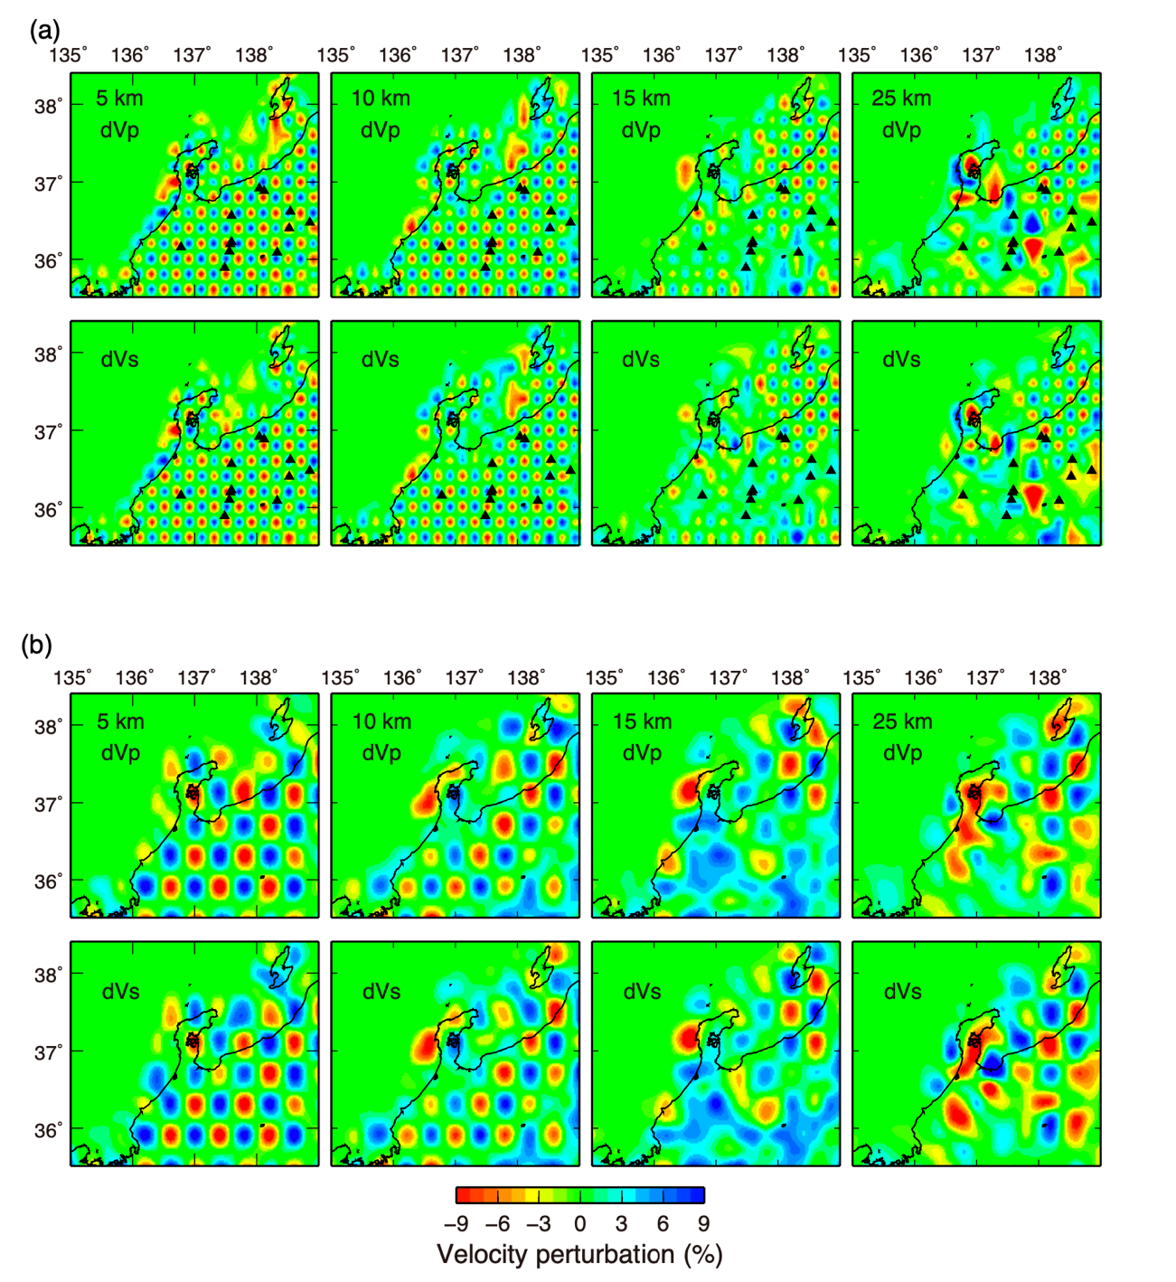

Figure S1. Results of checkerboard resolution tests of P and S waves at depths of 5, 10, 15, and 25 km. (a) Results of velocity anomalies that assigned to alternate grid nodes. (b) Results of velocity anomalies that assigned to every two grid nodes.
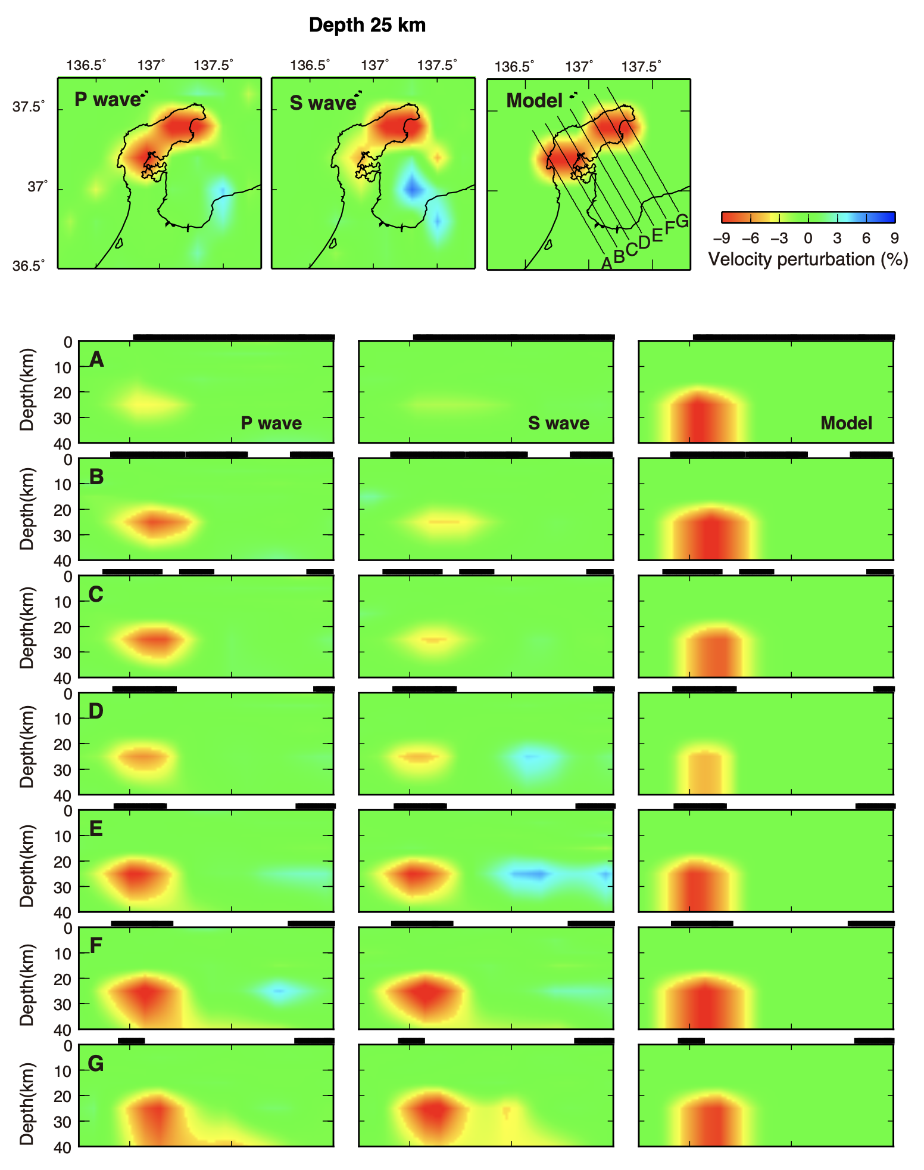

Figure S2. Results of sensitivity test of P and S waves at a depth of 25 km and along 7 profiles. The model panels show the distribution of a velocity anomaly that assigned to the synthetic model (see text for details). 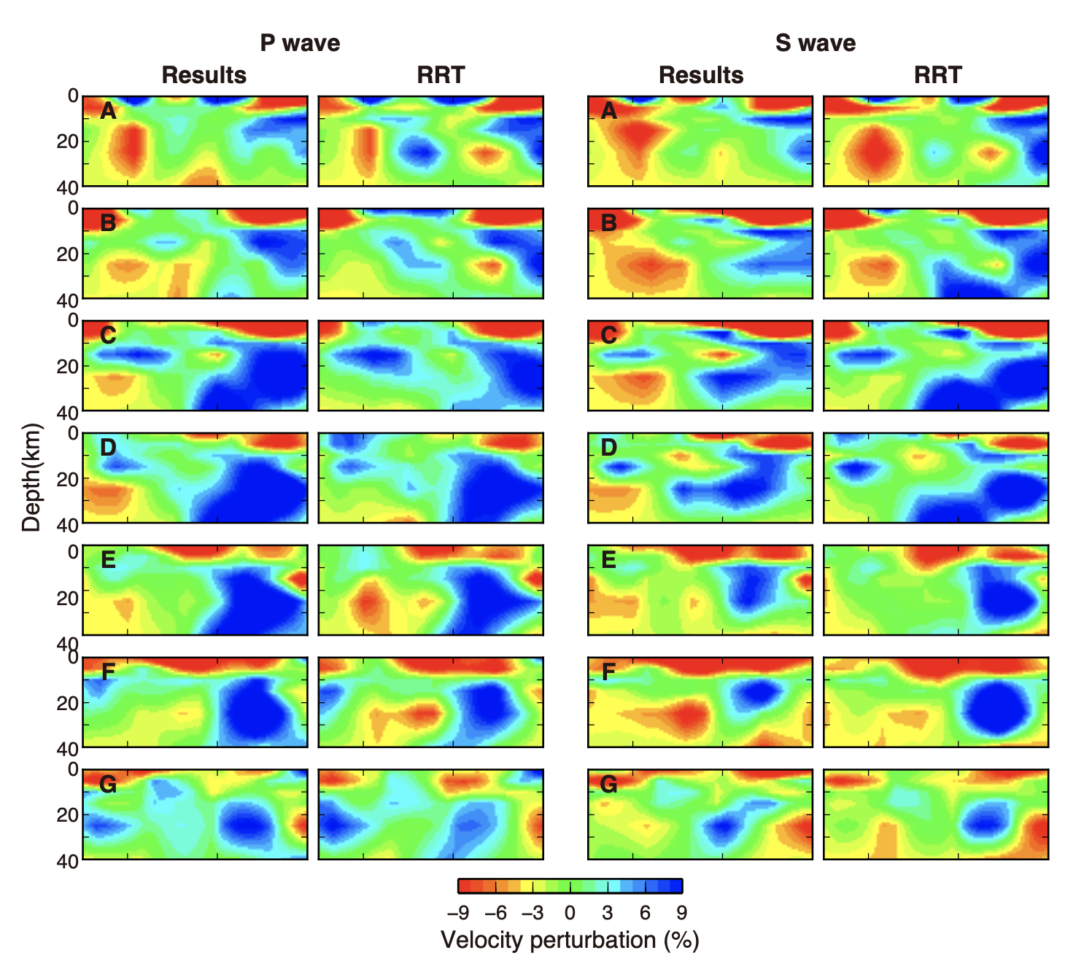

Figure S3. Results of the real inversion and restoring resolution test of (left) P and (right) S waves along 7 profiles shown in Figure S2.
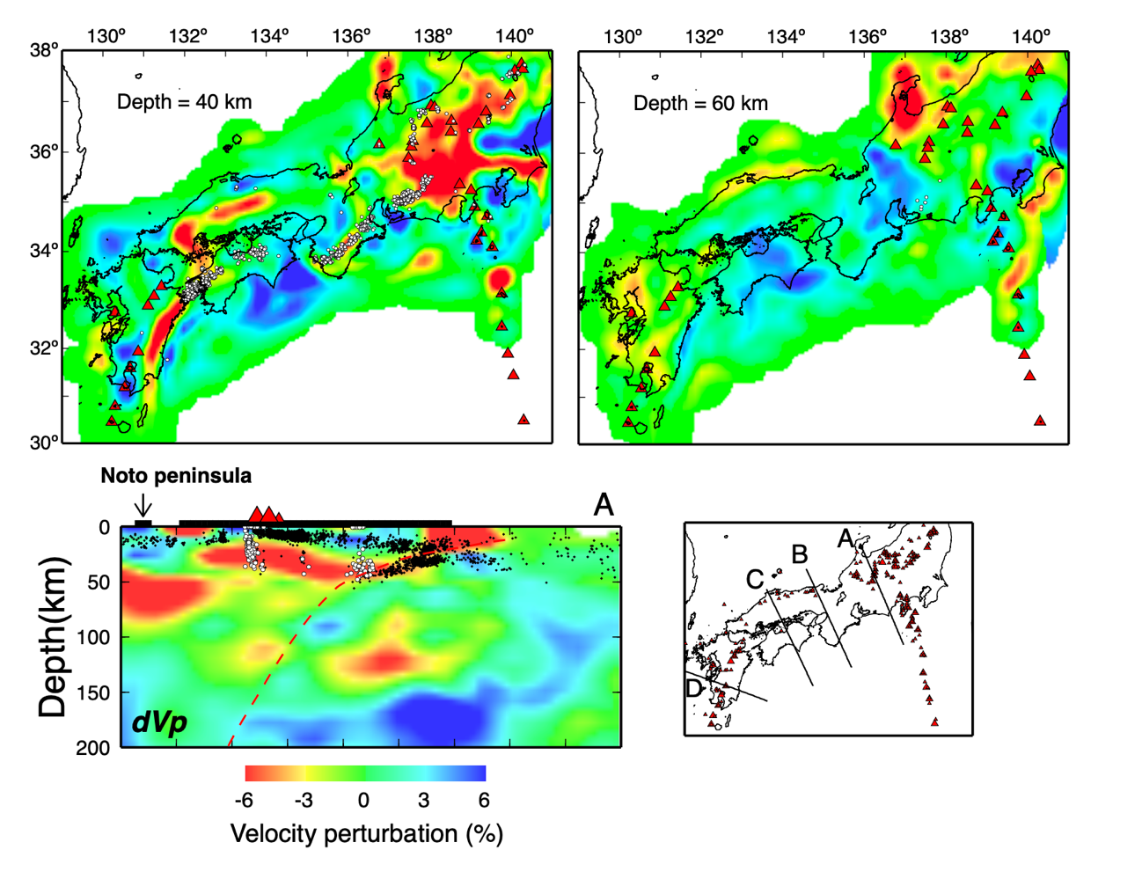
Figure S4. Examples of regional tomographic study (modified from Nakajima and Hasegawa, 2007). Two top panels show the distribution of P-wave velocity at a depth of 40 and 60 km. The bottom panel shows a vertical cross section of P-wave velocity structure along profile A in the inset map. The location of the Noto peninsula is indicated by an arrow.

