Supplementary Materials

Figure S1. Neural network architectures. The top row represents architecture for Disentangling autoencoder (DisentglAE), the middle row represents architecture for supervised Neural Network (NN), and the bottom row represents Adversarial learning (Adv). For all the networks except Adv Critic (bottom row, right), the genotype data is presented to the network as the first input data with dimension (input dim) of 3892 for the ADSP and 4967 for the UKB. For Adv Critic, the input dimension is the output of the FC₂ layer of Adv Backbone. Linear Layer represents multi-layer perceptron, and ReLU represents Rectified Linear Unit, a nonlinear activation function. For DisentglAE, $z_{d}$ dim and $z_{a}$dim represents latent dimensions respectively for phenotype-specific representation and ancestry-specific representation.
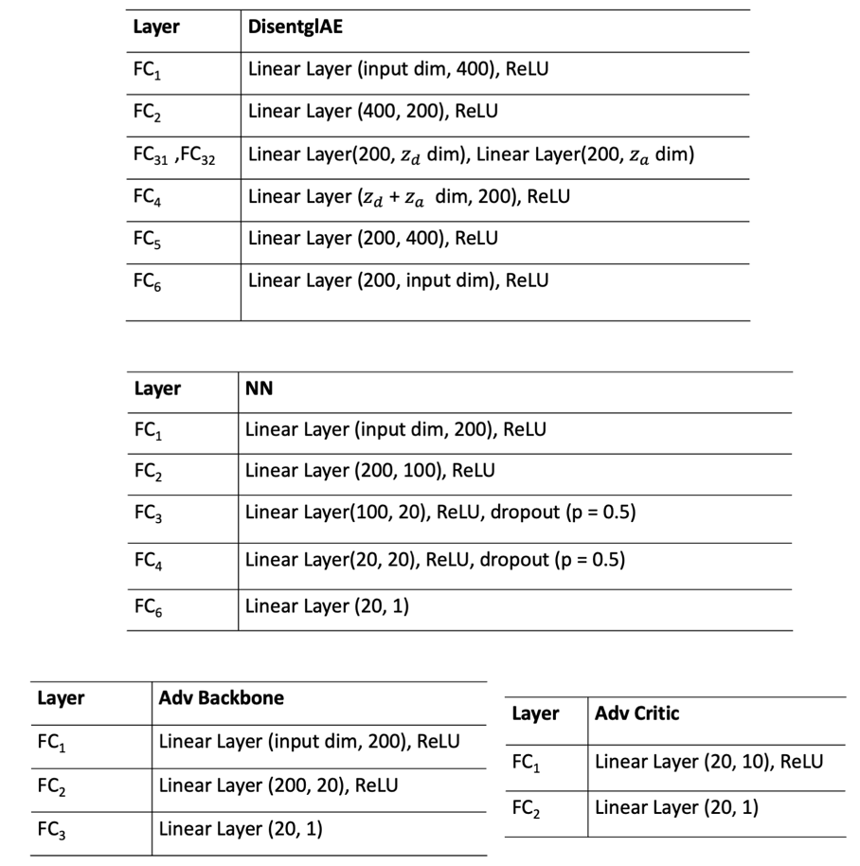

Figure S2. Test data distribution for the ADSP and the UKB cohorts (A). In the pie chart, we present the proportion of admixed participants compared to the European participants and other dominant non-European participants, i.e., African American (AFR) for the ADSP and South Asian (SAS) for the UKB. Prediction accuracy (AUC) for different models (PRS trained on European (PRS-EUR), Lasso trained on African American (Lasso-AFR), Lasso trained on European (Lasso-EUR), Neural Network trained on African American (NN-AFR), Neural Network trained on European (NN-EUR), Adversarial Neural Network trained on all data (Adv), Disentangling Autoencoder (Disentgl-AE), and DisPred trained on all data) on different subsets of the test dataset: all participants (B), EUR participants (C), admixed participants (D), and participants from non-European ancestries (E) in the test dataset for the ADSP and the UKB cohorts.
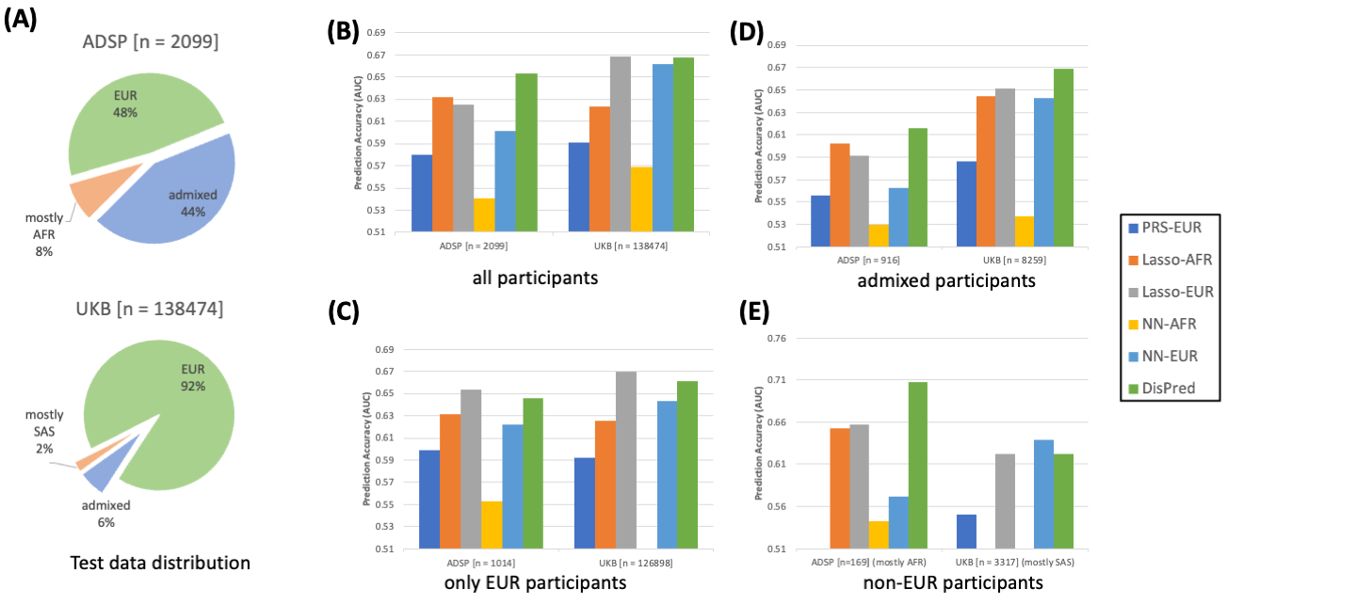

Figure S3. Prediction accuracy of participants in the test data who are below given estimated ancestry cut-offs. The left panel presents results for EUR participants using methods trained on EUR participants, and the right panel shows results for AFR participants using methods trained on AFR participants, compared to the proposed DisPred.
