Supplementary Information
Phase-transition-cycle-induced recrystallization of FAPbI₃ film in an open environment toward excellent photodetectors with high reproducibility
Meng Wang¹, Fengren Cao¹, Linxing Meng¹, Min Wang¹, Liang Li*¹
Email: lli@suda.edu.cn

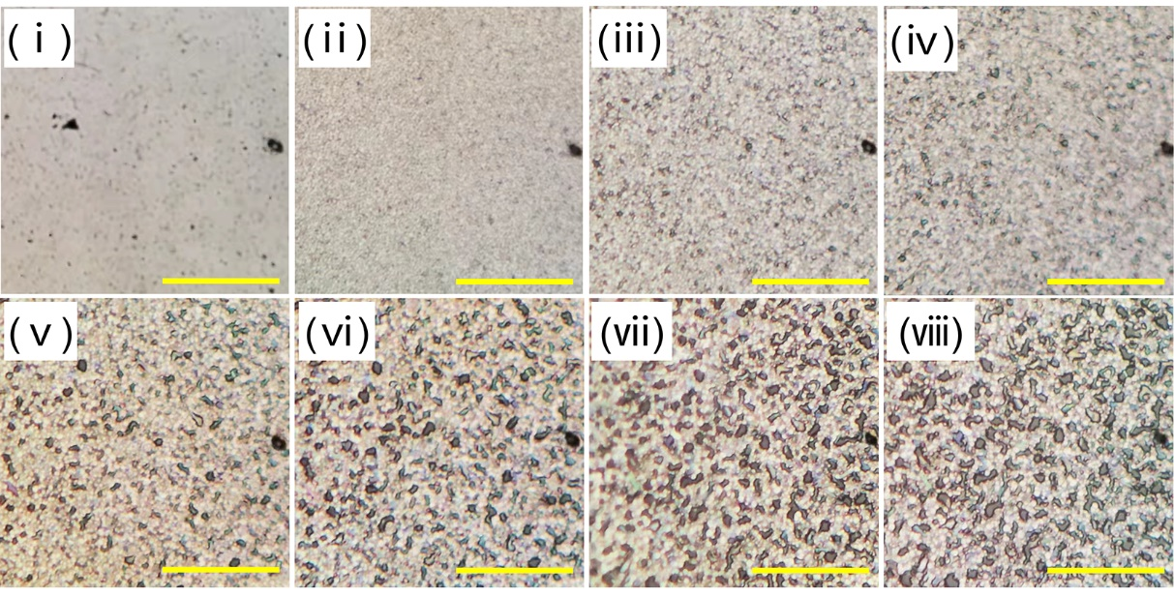
Supplementary Figure 1. The BFOM images of the (ⅰ) Pristine-FAPbI₃ film and the x-min FAPbI₃ film from (ⅱ) 0 minutes to (ⅷ) 60 minutes. The scale bar is 50 μm.

Supplementary Figure 2. Color map of the XRD intensity of the x-min FAPbI₃ film. (a) The details at 14° and corresponding FWHM. (b) The intensity ratio between the peaks at 14° and 20°.

Supplementary Figure 3. (a) PL and (b) XRD pattern of the Pristine-FAPbI₃ film at 0 minute and 60 minutes.

Supplementary Figure 4. XRD pattern of the FAPbI₃ film treated by FAI of 10 mg mL⁻¹ in IPA.

Supplementary Figure 5. The time-dependent XRD characterizations on the FAPbI₃ film treated with MASCN of (a) 20, (b) 10, (c) 5 and (d) 2.5 mg mL⁻¹, respectively.

Supplementary Figure 6. XRD pattern of the FAPbI₃ film treated with different concentrations of FASCN.

Supplementary Figure 7. The narrow-scanning XRD pattern of the MASCN-treated film from 13.9° to 14.2°.

Supplementary Figure 8. The FTIR spectra of the MASCN-treated FAPbI₃ film before and after IPA washing.

Supplementary Figure 9. XPS pattern of (a) Pb and (b) I with different etching depths in a washed 0-min FAPbI₃ film.

Supplementary Figure 10. Effect of IPA washing on (a) 0 min-FAPbI₃ and (b) 10 min-FAPbI₃.

Supplementary Figure 11. XPS spectra of (a) Pb and (b) I with different etching depths in a washed 10-min FAPbI₃ film.

Supplementary Figure 12. The FTIR spectra of the 0-min FAPbI₃ and 10 min FAPbI₃ films after IPA washing.

Supplementary Figure 13. Schematic of the behavior of MA⁺ and SCN⁻ ions. (a) Initial state, (b) diffusion process of MA⁺, and (c) resulting phase-transition-cycle process.

Supplementary Figure 14. XRD pattern of the FAPbI₃ film treated with 10 mg mL⁻¹ MASCN.

Supplementary Figure 15. The transmittance and Δtran. of the MASCN-treated FAPbI₃ film (a, b) sealing in CB and (c, d) under open air environment.

Supplementary Figure 16. The transmittance variation of the MASCN-treated FAPbI₃ film under different RH of (a) 0~5%, (b) 20~25%, (c) 50~55% and (d) 80~85%.

Supplementary Figure 17. Schematic of the fabrication process.

Supplementary Figure 18. The transmittance spectra of the IPA-washed film after 0 and 60 minutes.

Supplementary Figure 19. The I-t curves of the photodetector based on the x-min FAPbI₃, where x is from 0 to 60, respectively. The applied voltage is 1 V, and the wavelength of incident light is 650 nm.

Supplementary Figure 20. The I-V curve in the dark of the device based on the Pristine- and MASCN-FAPbI₃ films.

Supplementary Figure 21. (a) Rise and (b) decay time of the device based on MASCN-FAPbI₃.

Supplementary Figure 22. The stability of the Pristine-FAPbI₃ and IPA washed x-min FAPbI₃ film under a high RH over 90%.

Supplementary Figure 23. The stability of devices based on Pristine-FAPbI₃ and MASCN-FAPbI₃ film. The RH is controlled within 50% to 55%.

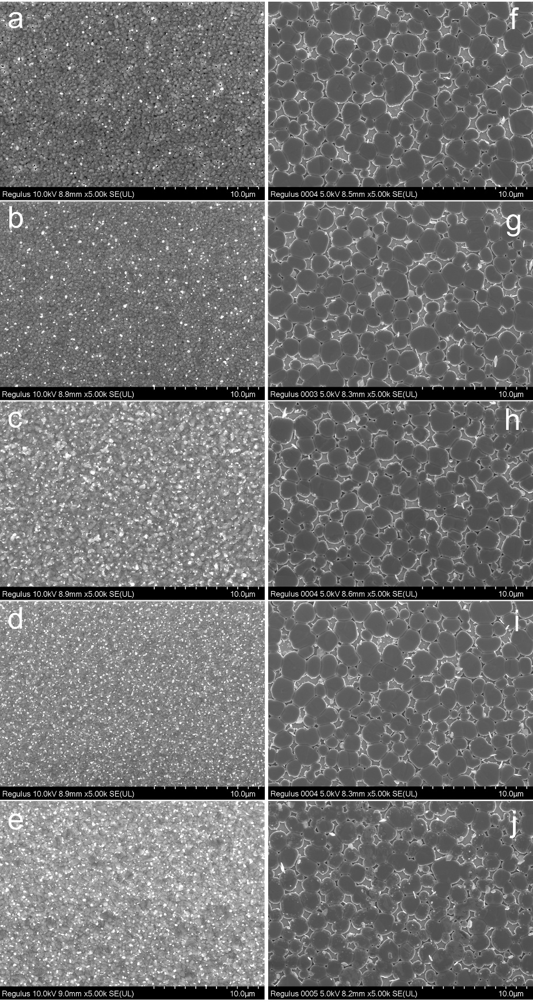
Supplementary Figure 24. (a-e) SEM images of the film fabricated with different antisolvent parameters from (14 s)- to (22 s)-FAPbI₃. (f-j) SEM images of the MASCN-treated film corresponding to the film in the left line of (a-e).

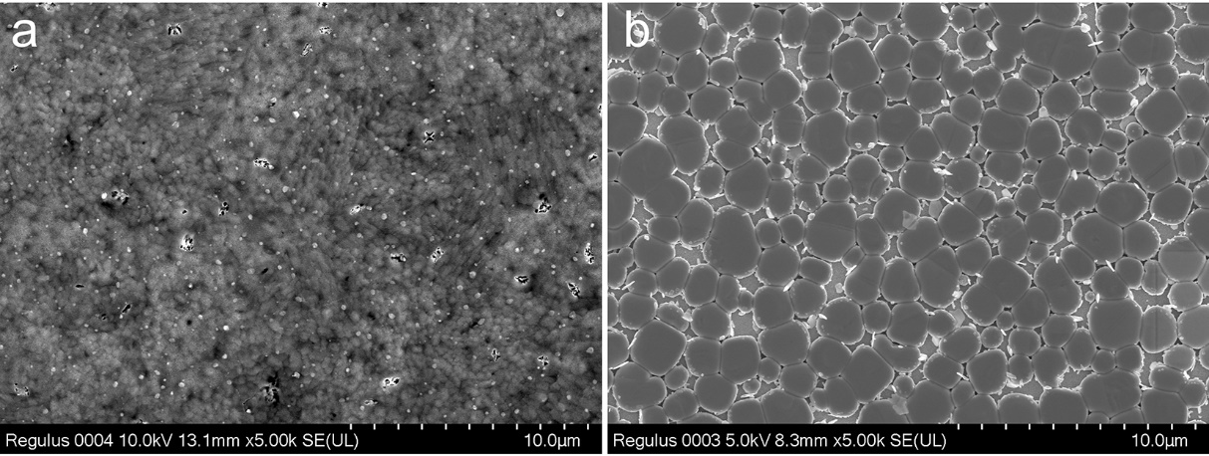
Supplementary Figure 25. SEM images of the (a) initial and (b) MASCN-modified FAPbI₃ films fabricated by the two-step method.

Supplementary Figure 26. SEM image of the (a) decomposed and (b) saved FAPbI₃ films.

Supplementary Figure 27. The statistics of (a) I_{dark} and (b) D* of the device based on Pristine-FAPbI₃ and MASCN-FAPbI₃ with 100 devices each.

Supplementary Note 1: The PL spectra of the MASCN-treated perovskite film
In Fig. 1d, the time-dependent PL spectra of the MASCN-treated film under an open environment is shown. The PL intensity obviously increases with time, and there is also a tiny redshift of the intensity peaks. In Fig. 2, we have proven that it is the MA group that dopes into the FAPbI₃ crystal, and normally, the dopes of MA into FAPbI₃ crystal will cause a blueshift because the bandgap will increase. Here, such a shift is attributed to the quantum size effect rather than bandgap variation¹. Specifically, when the crystal size merges from a small crystal into a large crystal (Fig. 1b), the bandgap of perovskite tends to become small, thus causing a redshift in the PL spectra. In this situation, the variation in the crystal size dominates the peak shift rather than MA doping. This can also be confirmed by the front and back PL spectra, where the shift occurs simultaneously at the top and bottom of the film (Supplementary Fig. 28). The MA group diffuses from the surface first, which is not consistent with the PL spectra.
Supplementary Figure 28. The time-dependent PL variation of the MASCN-treated FAPbI₃ film characterized from the (a) front and (b) back sides.

Supplementary Note 2: The different phase transition behaviors caused by FASCN and MASCN
In our work, FASCN causes a phase transition from α- to δ-FAPbI₃, while MASCN causes the reverse phenomenon. Considering that the FA⁺ group has a tiny impact on the FAPbI₃ film, it is concluded that the SCN⁻ group will cause the phase transition from α- to δ-FAPbI₃, and the MA⁺ group reverses this impact. Grätzel et al. provided a molecular dynamic simulation to explain the impact of MASCN on the surface of FAPbI_{3,} and the results showed that surface interactions can also affect the crystal system energy². Here, we find that the surface SCN⁻ treatment will change the lattice strain in the FAPbI₃ film, where the strains in the out-of-plane direction are increased (Supplementary Fig. 29).
In detail, the α-FAPbI₃ film is treated with different concentrations of FASCN, and all of them turn into δ-FAPbI₃. Interestingly, a redshift in the signals of the resulting δ-FAPbI₃ is observed, and the shift is increased with higher FASCN concentrations. According to the Bragg diffraction formula:
2 d sin θ = n λ,
where d represents the interplanar spacing, θ represents the diffraction angle, n represents the diffraction series, and λ represents the wavelength of the X-ray. Thus, an increase in θ means a reduction in d, which means that the lattice plane in the out-of-plane is compressed by the interaction between FASCN and the perovskite crystal.
The space structure of the crystal phase is the result of the energy distribution, where the system energy is supposed to be minimized so that the structure can be stable. The strain introduced by the SCN⁻ group may change the balance in the FAPbI₃ phase and reduce the energy barrier in the phase transition, both α- to δ-type and δ- to α-type. When there is only an SCN group (FASCN), the α- to δ- transition occurs. However, when the MA group is involved, it has been widely reported that the doping of MA makes the α-phase more stable at room temperature³; thus, the δ- to α-transition occurs (MASCN).
Supplementary Figure 29. The XRD pattern of the resulting FAPbI₃ film fabricated with different FASCN treatment concentrations. The left graph shows the magnification of the diffraction angle from 11.7° to 12.1°.

Supplementary Note 3: The relationship between Δtran. and spectra wavelength
During the MASCN-induced recrystallization process, there is competition between the two inducements in the variation of transmittance, which can be observed in Fig. 4 and Supplementary Fig. 15. The first inducement is that when the film becomes mesoporous, its ability to reflect incident light will decrease, and transmittance will increase for the whole spectra. The second inducement is the change in the thickness of the film. For the initial state, the perovskite is a compact film with a thickness of approximately 450 nm. However, the recrystallization process will cause small crystals to merge into large crystals, with an increase in the thickness of the film. Cross-sectional SEM images show that the film after the recrystallization process can be up to several micrometers (Supplementary Fig. 30). The increase in thickness will strengthen the film absorption at the region around its absorption edge⁴. As a result, Δtran. exhibits an obvious boundary in Supplementary Fig. 15b. However, when the RH is high, the effect of the first inducement will dominate Δtran., and the absorption strength will terminate very quickly.
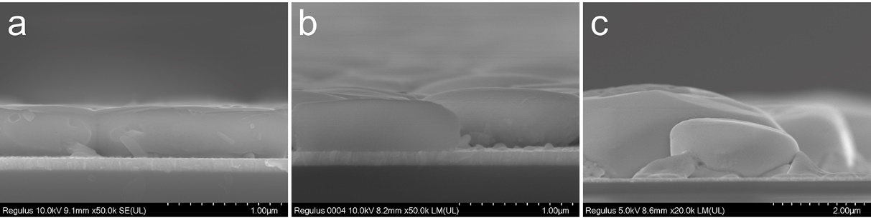
Supplementary Figure 30. The cross-sectional SEM images of (a) pristine FAPbI₃ film and after the recrystallization process for (b) 10 minutes and (c) 1 day.

Supplementary Note 4: The optoelectronic performance of D_{x-min}.
In Supplementary Fig. 19, the response current (I_{res}) of different D_{x-min} is compared, and D_{10-min} has the best performance. From D_{0-min} to D_{10-min}, there is a large improvement in I_{res}. Modification of the perovskite crystal contributes to such improvement, which can be observed in Fig. 5g. After this, from D_{10-min} to D_{60-min}, the I_{res} gradually decreases with a small magnitude. Considering that the perovskite crystal is still optimized by the recrystallization process, this variation is caused by the gradually decreasing perovskite covering area, which can be observed in the absorption or transmittance spectra characterization and Supplementary Fig. 1.

Supplementary Note 5: The temperature-dependent SCLC characterization
The temperature-dependent SCLC characterization is an effective method to extract the intrinsic distribution of the energy state in semiconductors⁵⁻⁸. The basic theory is Ohm’s law and the Poisson equation, and the relationship between the energy state (N_{s}) and Fermi level (E_{F}) has been deduced in previous works as follows:
$\frac{dN_{s}}{dE_{F}}$ = $\frac{1}{k_{B}T}$ $\frac{εε_{0}}{eL^{2}}$ $\frac{(2m-1)}{m}$ (1 + C), (1)
where k_{B} is the Boltzmann constant, T is the temperature, ε is the dielectric constant of FAPbI₃, ε₀ is the permittivity of vacuum, e is the elementary charge, and L is the length of the film. m = $\frac{d In J}{d In V}$ is the logarithmic curve of J-V. and C is depicted as:
C = $\frac{B\left(2m-1\right)+B\left(3m-2\right)+d \left[In\left(1+B\right)\right]/d InU }{1+B(m-1)}$, (2)
where B contains higher ordered derivatives of J-V as follows:
B = - $\frac{[d m/d In U]}{m(m-1)(2m-1)}$. (3)
Normally, Equation (1) can be calculated by measuring the J-V curve at a certain temperature, and C and B can be derived from the curve. However, it is also necessary to build the relationship between V and the energy level. This can be derived from the Arrhenius plot of the SCLC curves at a given V. In detail,
E_{A} = $\frac{d In J}{d {(k_{B}T)}^{-1}}$, (4)
where T is the setting temperature, and J is the characterized at each given V. Equation (2) can be deconvolved with Equation (4) to extract the density of state (DOS).

References
- Li, B. et al. Surface passivation engineering strategy to fully-inorganic cubic CsPbI₃ perovskites for high-performance solar cells. Nat. Commun. 9, 1076 (2018).
- Lu, H. et al. Vapor-assisted deposition of highly efficient, stable black-phase FAPbI₃ perovskite solar cells. Science 370, 74-81 (2020).
- Kim, M. et al. Methylammonium chloride induces intermediate phase stabilization for efficient perovskite solar cells. Joule 3, 2179-2192 (2019).
- Wang, J. et al. Self-driven perovskite narrowband photodetectors with tunable spectral responses. Adv. Mater. 33, 2005557 (2021).
- Adinolfi, V. et al. The in-gap electronic state spectrum of methylammonium lead iodide single-crystal perovskites. Adv. Mater. 28, 3406-3410 (2016).
- Krellner, C. et al. Density of bulk trap states in organic semiconductor crystals: discrete levels induced by oxygen in rubrene. Phys. Rev. B 75, 245115 (2007).
- Dacuña, J. & Salleo, A. Modeling space-charge-limited currents in organic semiconductors: extracting trap density and mobility. Phys. Rev. B 84, 195209 (2011).
- Schauer, F., Novotny, R. & Nešpůrek, S. Space-charge-limited-current spectroscopy: possibilities and limitations. J. Appl. Phys. 81, 1244-1249 (1997).

