<Supporting Information>
Control of maleic acid-propylene diepoxide hydrogel for 3D printing application for flexible tissue engineering scaffold with high resolution by end capping and graft polymerization

Hao Nguyen Tran¹, Ingul Kim², Jong Heon Kim³, Eun-Jae Chung², Insup Noh^{1,3}

¹ Department of Chemical and Biomolecular Engineering, Seoul National University of Science and Technology, Seoul 01811, Republic of Korea

²Department of Otorhinolaryngology, College of Medicine, Seoul National University Hospital, Seoul 03080, Republic of Korea

³ Convergence Institute of Biomedical Engineering and Biomaterials, Seoul National University of Science and Technology, Seoul 01811, Republic of Korea

Correspondence to Insup Noh (insup@seoultech.ac.kr)

(Submitted to Biomaterials Research, July 05, 2022)

Methods
Stretchability test: The stretchability of MPLE gel was evaluated by twisting the gel sample (2 mm x 8 mm x 40 mm) in air. Both sides of the samples were manually hold by using tweezers. Afterwards, the upper side was twisted and pulled upward gradually until breakage.
Self-healing test: The self-healing nature of both MPLE gels and LP-capped gel were evaluated by physical observation. The gel samples were cut into small pieces and thereafter brought into contact at 25℃. After self-healing for different intervals at 30 min, 4 hours, and 24 hours, the samples were manually extended to evaluate the self-healing property as well as fiber forming ability.
Gel fiber formation: The surface morphologies of the LP-capped gel fibres was investigated using scanning electron microscope (SEM; Tescan Vega 3, Czech Republic) with an accelerating voltage of 15 kV. For the gel fibre test, the LP-capped gel was manually stretched into very thin wire/fibres, then plunged in a liquid nitrogen slush for 20 min. Afterwards, the frozen samples were freeze-dried in a lyophilizer at -80 °C for 3 days.
Degree of conversion (DC) characterized by FTIR spectrometry: In this test, FTIR was utilized to examine the content of residual of C=C bonds in the MPLE gel (1:0.3) at different photo-crosslinking times (0, 1, 5, 10 mins). The degree of conversion (DC) was calculated based on the percentage of the remaining concentration of the aliphatic C=C double bonds (in 1642 cm⁻¹) and the highly adsorbed C=O bands (1731 cm⁻¹) as a reference peak before and after radical polymerization. All the experiments were performed in triplicate for each sample. The equation (1) was used by adopting previous publications [1-4]:
DC (%) = (1 - $\frac{R_{cured}}{R_{uncured}}$) x 100 (%)
Where R_{cured} is the absorbance ratio of polymerized aliphatic C=C double bonds and highly adsorbed C=O bands (C=O_{polymer}) after exposure to the UV light, while R_{uncured} is the absorbance ratio of unpolymerized aliphatic C=C double bonds and highly adsorbed C=O bands (C=O_{unpolymer}) before exposure to the UV light.
Photorheology measurement: The photorheological study was conducted at room temperature (25°C) in parallel-plate mode with 25 mm diameter and 1 mm gap under the presence of UV light exposure. The unpolymerized inks were prepared in different ratios of LP-capped gel and PEGDA (1:0.1, 1:0.2, and 1:0.3 w/v) along with Irgacure 2959 (3% w/w) to obtain the photocurable inks, which were examined by shear rate of γ’ = 0.1 s⁻¹. The irradiation started after 120 s and all samples were exposed to UV-light (365 nm, 30 mW/cm2) for a total of 480 seconds.

Results and discussion
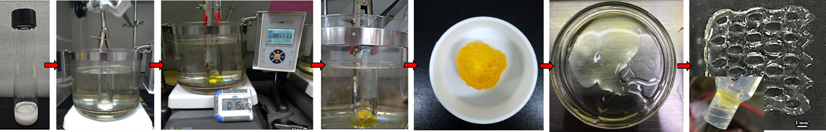
Fig. S1: Step by step fabrication process of MPLE gel and its 3D printed sample.
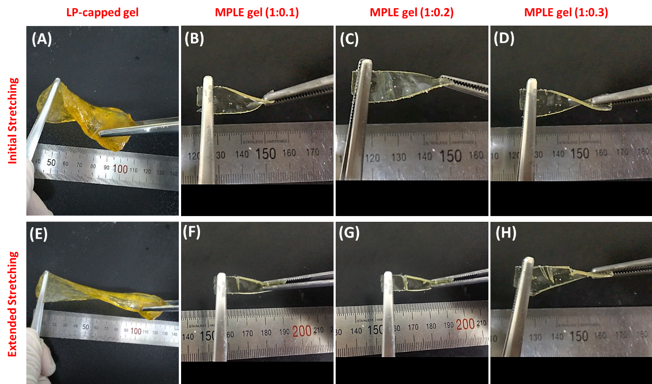
Fig. S1: Stretchability of MPLE gels at initial stage (A-C) and after extension testing (D-F).
Both MPLE gels and LP-capped gel exhibited good flexible properties at early stage; however, the MPLE gels showed an obvious breakage when increasing the stretching force on the samples which indicates their limited stretchability when comparing to LP-capped gel.

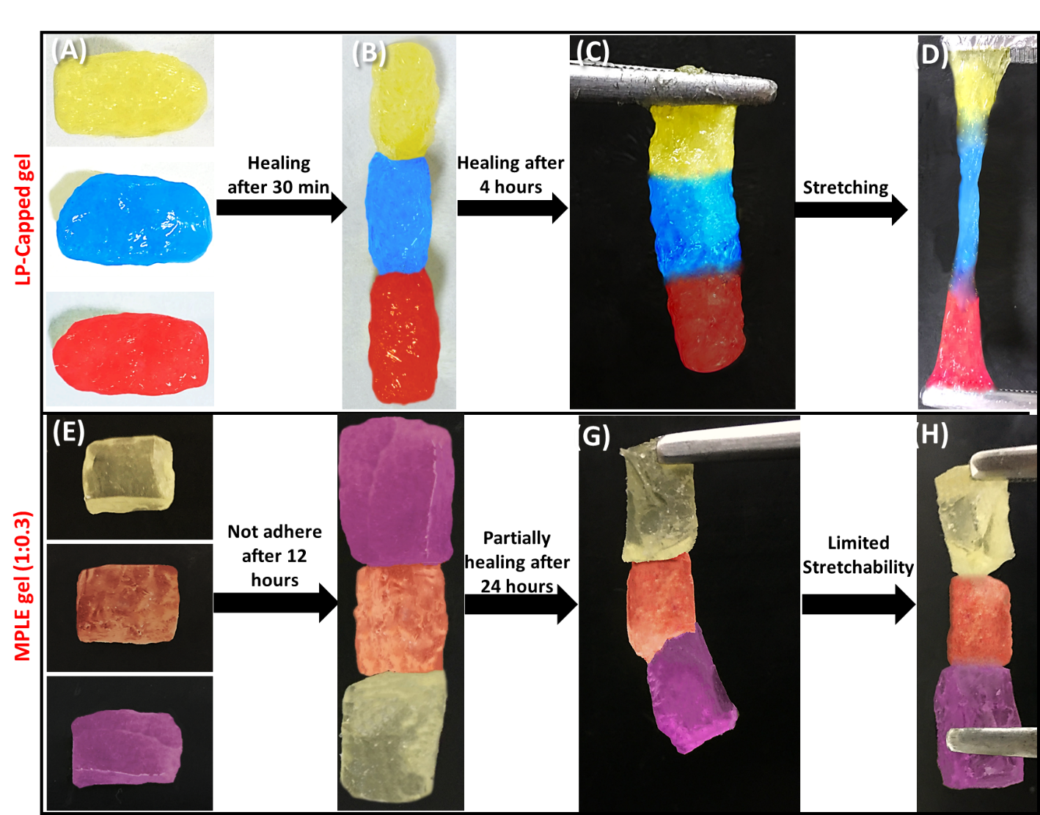
Fig. S2: Self-healing test of LP-capped gel (A-D) with full heal-ability after 4 hours; and MPLE gel (1:0.3) (E-H) with partially recover after 24 hours.

The self-healability was tested for both LP-capped gel and MPLE gel (1:0.3) under ambient conditions. As displayed in Fig. S2, the hydrogel samples were cut into three small pieces, followed by dying in yellow, blue, and red colors (LP-capped gel) and yellow, orange, and pink colors [MPLE gel (1:0.3)]. After that, the cutting sections were attached together at the fresh surface. After 30min, the LP-capped gel started to adhere partially with the lines between the interfaces while the MPLE gel (1:0.3) was not adherent after 12 hours. Then the testing time was continued to 4 hours for LP-capped gel showing that the polymer matrix can be rearranged and repaired the damaged interfaces as fully recovery; however, the MPLE gel (1:0.3) exhibited limited healing property and stretchability.
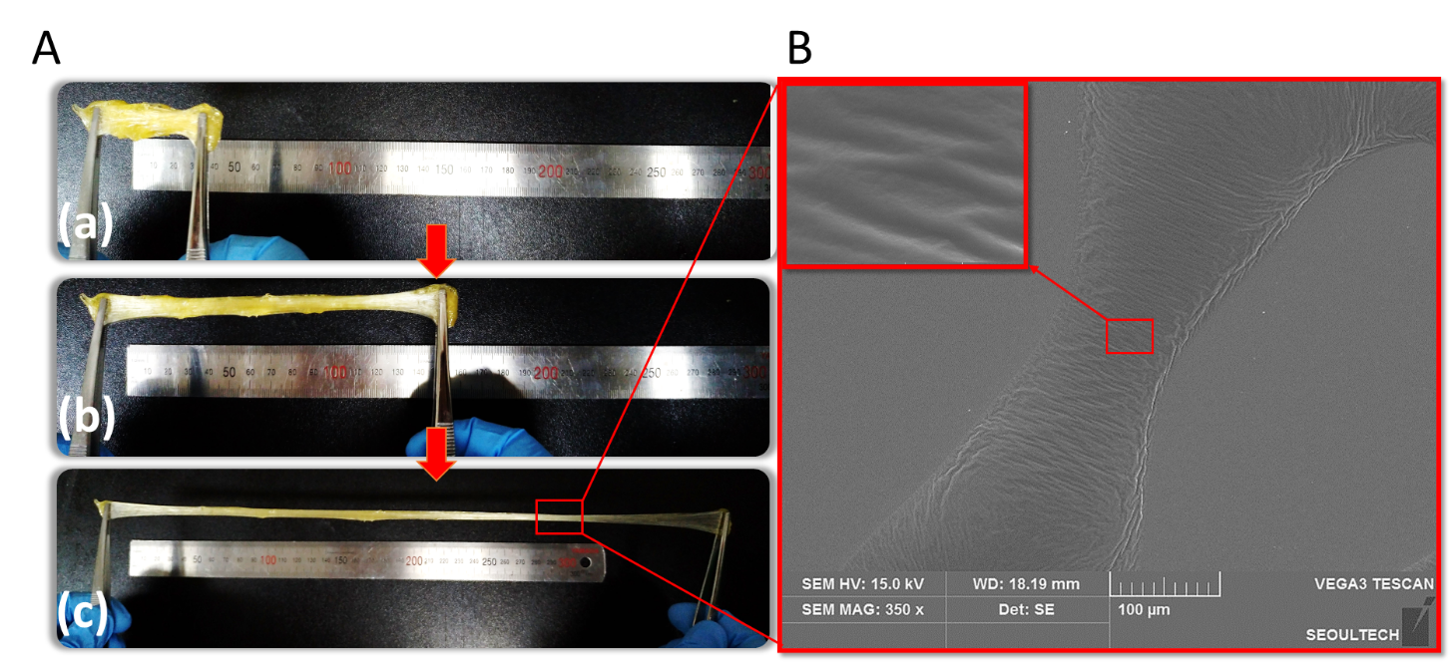
Fig. S3: (A-a, A-b, A-c) Photographs of fibers formed by extension of LP-capped gel. (B) SEM images of the gel fiber at low and high magnification.
The optical Fig.s represent fiber formulation from LP-capped gel (Fig. S3A.a-c) where the fiber can be obtained by stretching manually. Fig. 3B reveals the fiber thicknesses ranging from 100-150 µm with rough surface. This is due to the shrinkage on the surface during the freeze-drying process. Furthermore, the outstanding elongation properties from LP-capped gel can be attributed to the combination between the hydrogen bonding and strong ionic interactions in the 3D crosslinked network.
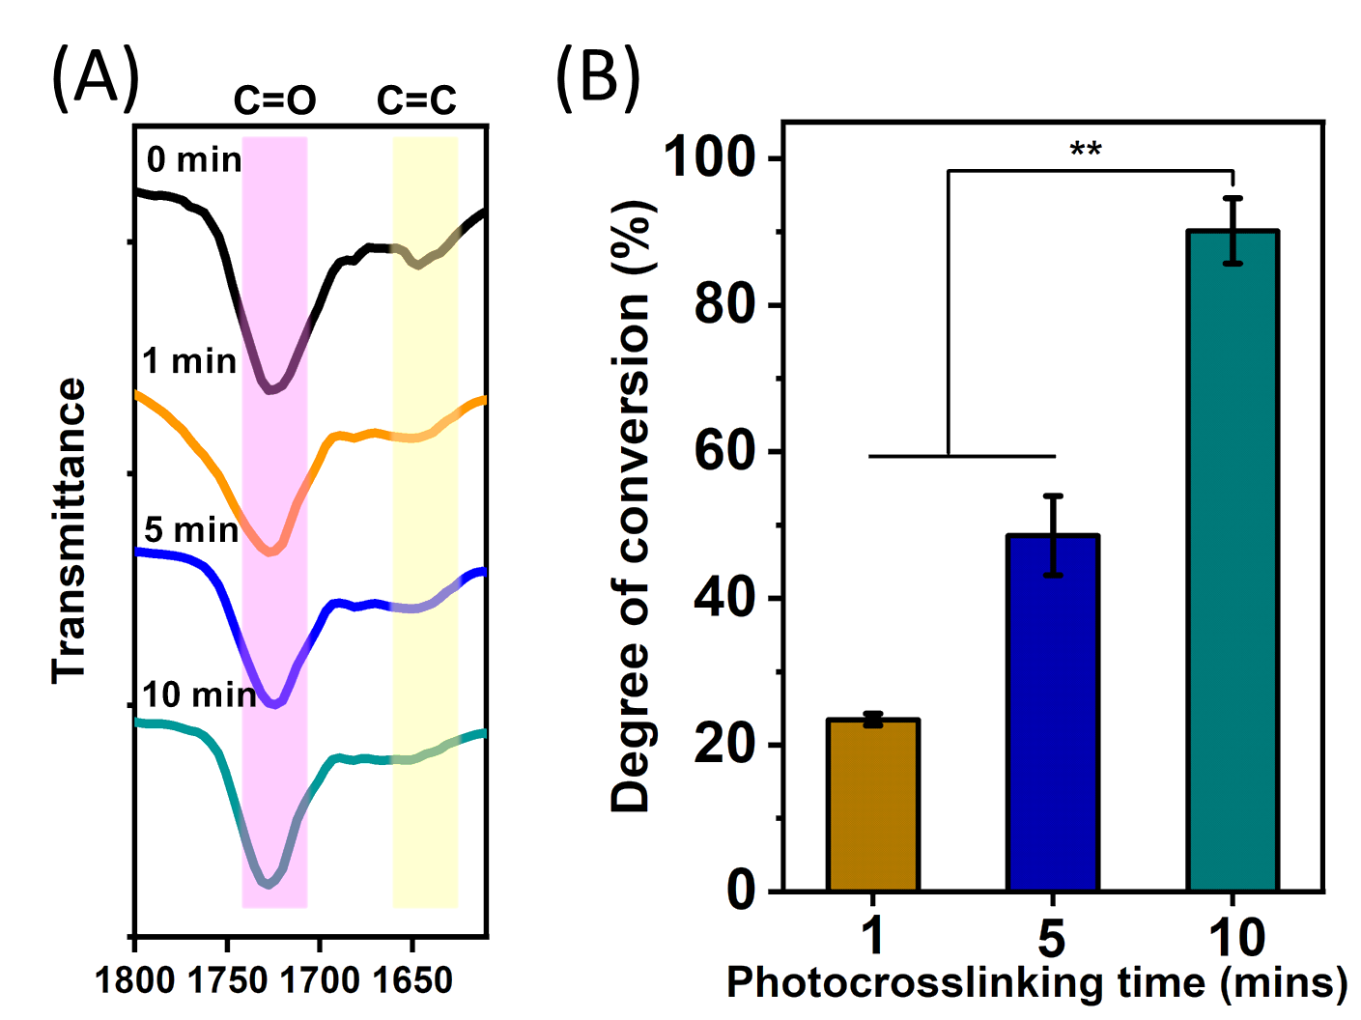
Fig. S4. (A) FTIR spectra of MPLE (1:0.3) gel at different photo-crosslinking times and (B) their C=C bonds degree of conversion.
As shown in the Fig. S4-(A), the significant decrease of the C=C peak at 1642 cm⁻¹ (yellow band) referring to C(=O) peaking was clearly observed over time (1, 5, and 10 mins) which confirmed the graft polymerization of PEGDA to the LP-capped copolymers under UV exposure. This result was consistent with the data presented in the Fig. S4-(B), where the degrees of conversions at 1, 5 and 10 mins were 23.47 ± 0.8%, 48.56 ± 5.4%, and 90.12 ± 4.5%, respectively.

3. References
[1]. Chen, H., Lee, S. Y., & Lin, Y. M. (2020). Synthesis and formulation of PCL-based urethane acrylates for DLP 3D printers. Polymers, 12(7), 1500.
[2]. Askari, F., Zandi, M., Shokrolahi, P., Tabatabaei, M. H., & Hajirasoliha, E. (2019). Reduction in protein absorption on ophthalmic lenses by PEGDA bulk modification of silicone acrylate-based formulation. Progress in Biomaterials, 8(3), 169-183.
[3]. Ashjari, H. R., Ahmadi, A., & Dorraji, M. S. S. (2018). Synthesis and employment of PEGDA for fabrication of superhydrophilic PVDF/PEGDA electrospun nanofibrous membranes by in-situ visible photopolymerization. Korean Journal of Chemical Engineering, 35(1), 289-297.
[4]. Belqat, M., Wu, X., Gomez, L. P. C., Malval, J. P., Dominici, S., Leuschel, B., ... & Mougin, K. (2021). Tuning nanomechanical properties of microstructures made by 3D direct laser writing. Additive Manufacturing, 47, 102232.

