Figure S1. Metabolic alterations driven by high pressure exposure of 400msw heliox saturation environment and across different brain regions. Principal component analysis (PCA) scores plot of PC1/PC2 obtained from ¹H NMR data and colored according to groups of CONC and HSDC (A, R2X= 0.40, Q2 = -0.02), CONH and HSDH (B, R2X= 0.50, Q2 = 0.16), and CONS and HSDS (C, R2X= 0.43, Q2 = 0.05), ; scaling was done to unit variance; Partial least squares discriminant analysis (PLS-DA) scores plot from ¹H NMR spectra of extracts from the cortex (A’, R2X= 0.38, Q2 = 0.54), the hippocampus (B’ ’, R2X= 0.37, Q2 = 0.35), and striatum (C’ ’, R2X= 0.39, Q2 = 0.42) from CON and HSD groups; scaling was done to unit variance.
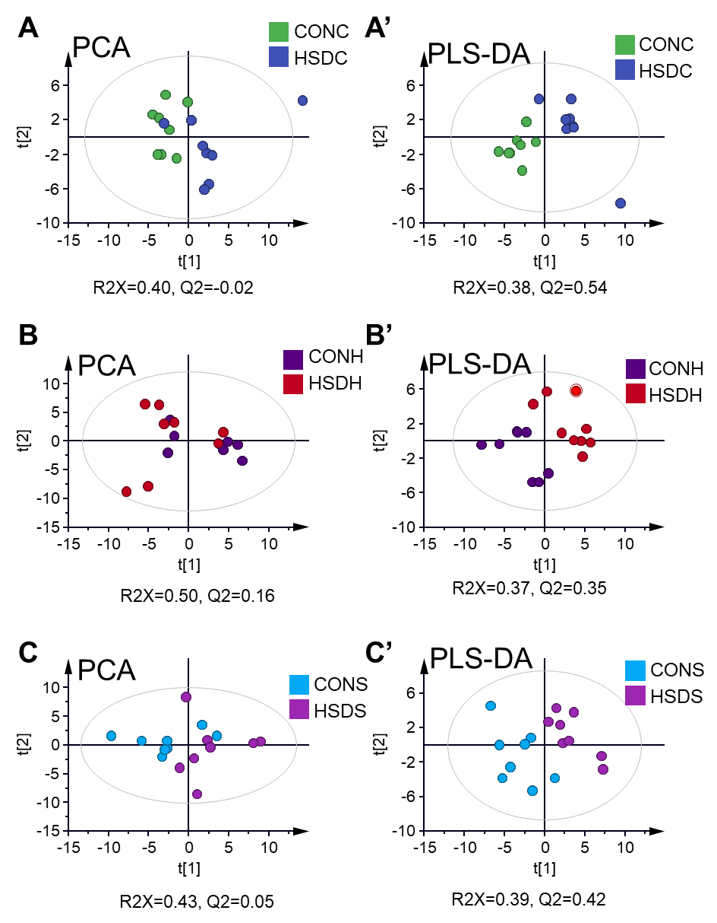
Table S1. NMR Resonance assignments of 55 aqueous metabolites in ¹H NMR spectra of brain samples.
Metabolite (abbreviation) | Groups | δ¹H(ppm) in PBS buffer (pH=7.2) #
2-aminobutyrate (2AB) | α-CH, β-CH₂, g-CH₃ | 3.71(t), 1.90(m), 0.97(t)
2-dimethylamine (DMA) | CH₃ | 2.72(s)
2-hydroxybutyrate (2HB) | α-CH, half β-CH₂, half β-CH₂, g-CH₃ | 3.99(m), 1.73(m), 1.66(m), 0.90(t)
2-hydroxyisobutyrate (2HIB) | 2 X β-CH3 | 1.35(s)
5'-monophosphate (AMP) | ²CH, ⁸CH, NH₂ | 8.59(s), 8.26(s), 6.13(d)
Acetate (Ace) | CH3 | 1.90(s)
Adenosine (Ade) | adenine moity: ²CH, ⁸CH, NH₂ | 8.34(s), 8.25(s), 6.07(d)
Adenosine triphosphate (ATP) | adenine moity: ²CH, ⁸CH, NH2 | 8.50(s), 8.23(s), 6.14(d)
Analine (Ala) | α-CH, β-CH₃ | 3.78(q), 1.47(d)
Asparagine (Asn) | α-CH, half β-CH₂, half β-CH₂ | 3.99(dd), 2.94(dd), 2.86(dd)
Aspartate (Asp) | α-CH, half β-CH₂, half β-CH₂ | 3.89(dd), 2.80(dd), 2.68(dd)
Ascorbate (Asc) | α-CH, half β-CH₂, half β-CH₂ | 3.89(dd), 2.80(dd), 2.68(dd)
Carnitine (Car) | CH₃ | 3.22(s)
Choline (Cho) | ¹CH₂-OH, ²CH₂-N, N(CH₃)₃ | 4.04(m), 3.50(m), 3.19(s)
Creatine phosphate (Pcr) | CH₂, CH₃ | 3.03(s), 3.96(s)
Creatine (Cre) | α-CH₂, N-CH₃ | 3.92(s), 3.02(s)
Cytidine (Cyt) | cytosine moity: α-CH, β-CH | 7.83(d), 6.05(d)
Formate (For) | CH | 8.46(s)
Fumarate (FMA) | 2×CH | 6.50(s)
Glutamate (Glu) | α-CH, half β-CH₂, half β-CH₂, half γ-CH₂, half γ-CH₂ | 3.76(t), 2.13(m), 2.05(m), 2.33(m), 2.35(m)
Glutamine (Gln) | α-CH, half β-CH₂,half β-CH2, half γ-CH₂ , half γ-CH₂ | 3.77(t), 2.46(m), 2.44(m), 2.14(m), 2.10(m)
Glutathione (GSH) | Glutamate moity: α-CH, β-CH₂, γ-CH₂. Cystein moity: β-CH2, α-CH. Glycine moity: α-CH2 | 3.79(t), 2.16(m), 2.55(m), 2.98(dd), 4.21(m) , 3.79(m)
Glycine (Gly) | α-CH₂ | 3.55(s)
Hypoxanthine (Hyx) | γ-CH, β-CH, | 8.18(s), 8.20(s)
Inosine (Ino) | Hypoxanthine moity: α-CH, α'-CH | 8.23(s), 8.33(s)
inosine monophosphate (IMP) | Hypoxanthine moity:α-CH, α'-CH | 8.23(s), 8.57(s)
Isobutyrate (IB) | α-CH, 2×β-CH₃ | 2.38(m), 1.06(d)
Isoleucine (Ile) | α-CH, β-CH, g-CH₃, half g-CH₂, half g-CH₂, d-CH₃ | 3.66(d), 2.00(m), 1.24(d), 1.44 (m), 1.00(d), 0.94(t)
Lactate (Lac) | α-CH, β-CH3 | 4.10 (q), 1.32(d)
Leucine (Leu) | α-CH, half β-CH₂, half β-CH₂, g-CH, d-CH₃, d'-CH₃ | 3.73(m), 1.73(m), 1.70(m),1.67(m), 0.95(d), 0.94(d)
Lysine (Lys) | α-CH, half β-CH₂, half β-CH₂, g-CH, d-CH₃, d'-CH₃ | 3.00(t), 1.90(m), 1.91(m), 1.50(m), 1.42(m), 1.70(m), 3.75(t)
Malate (Mal) | α-CH, β-CH₂ | 2.66(dd), 2.37(dd)
Malonate (Maln) | CH₂ | 3.14(s)
myo-inositol (MI) | 1CH, 2CH, 3CH, 4CH, 5CH, 6CH | 3.53(dd), 4.06(t), 3.53(dd), 3.62(t), 3.28(t), 3.62(t)
N-acetyl-aspartate (NAA) | Acetyl moity: CH₃ | 2.01(s)
Nicotinamide adenine dinucleotide (NAD+) | Nicotinamide moity: α’-CH, α-CH, γ-CH, β-CH | 9.33(s), 8.82(d), 8.17(q), 9.13(d)
Nicotinamide adenine dinucleotide (reduced)(NADH) | Nicotinamide moity: α’-CH, α-CH | 6.92(s), 5.97(d),
Nicotinuric acid (Nic) | α’-CH, α-CH, γ-CH, β-CH | 8.93(d), 8.69(dd), 7.59(q),
O-acetylcholine (ACh) | N(CH₃)₃, α-CH₂, β-CH₂, CH₃(CO) | 3.20(s), 4.53(s), 3.71(m), 2.08(s)
O-Phosphocholine (PCho) | ¹CH₂, ²CH₂, N(CH₃)₃ | 4.17(m), 3.59(t), 3.21(s)
O-phosphoethanolamine (PEA) | N-CH₂, O-CH₂ | 3.22(t), 4.01(t)
Phenylalanine (Phe) | phenyl moity: α-CH, β-CH, γ-CH, half β-CH₂, half β-CH₂, α-CH | 7.33(d), 7.43(t), 7.37(t), 3.98(dd), 3.27(dd), 3.12(dd)
Pyruvate (Pyr) | CH₃ | 2.36(s)
Serine (Ser) | α-CH, β-CH, g-CH₃, g-CH₃ | 3.98(q), 3.94(q), 3.84(q)
sn-glycero-3-phosphocholine (GPC) | glycerol moity: ¹CH₂, ²CH₂, N(CH₃)₃, half ¹CH₂, half ¹CH₂, ²CH, half ³CH₂, half ³CH₂ | 4.32(m), 3.67(m), 3.22(s), 3.59(dd), 3.68(dd), 3.90(m), 3.87(m), 3.94(m)
Taurine (Tau) | ¹CH₂, ²CH₂ | 3.40(t), 3.26(t)
Threonine (Thr) | α-CH, β-CH, γ-CH₃ | 3.58(d), 4.26(m), 1.34(d)
Tyrosine (Tyr) | phenyl moiety(α-CH, β-CH), α-CH, half β-CH₂, half β-CH₂ | 7.19(d), 6.90(d), 3.93(q), 3.05(dd), 3.19(dd)
UDP-galactose (UDPGa) | nucleobase uracil moity:α-CH, β-CH | 7.94(d), 5.98(d)
UDP-glucuronate (UDPGu) | nucleobase uracil moity:α-CH, β-CH | 7.95(d), 5.99(d)
Uracil (Ura) | α-CH, β-CH | 7.54(d), 6.80(d)
uridine 5'-monophosphate (UMP) | nucleobase uracil moity:α-CH, β-CH | 8.12(d), 5.99(d)
Uridine (Uri) | ¹CH, ²CH, ³CH, ⁴CH, half CH₂, half CH₂, α-CH, β-CH | 5.93(d), 4.34(t), 4.22(t), 4.12(m), 3.90(dd), 3.80(dd), 7.88(d), 5.91(d)
Valine (Val) | α-CH, β-CH, g-CH₃, g-CH₃ | 3.61(d), 2.27(m), 1.02(d), 0.98(d)
γ-aminobutyric acid (GABA) | α-CH₂, β-CH₂, γ-CH₂ | 2.28(t), 1.89(m),3.00(t)
Note: # s, singlet；d, doublet；t, triplet；q, quartet；m, multiplet.
Table S2. The buckets mean of peak height from discriminative aqueous metabolites in ¹H NMR spectra acquired on the cerebral, hippocampus, striatum samples of HSD rats comparted to that of CON rats.
Primary ID | Cortex |  | Hippocampus |  | striatum
Primary ID | CON | HSD | CON | HSD | CON | HSD
ATP | 1.63±0.43 | 1.42±0.47 | 1.95±0.45 | 1.41±0.44 | 2.33±1 | 1.45±0.38
Ala | 16.67±1.32 | 15.52±1.5 | 20.6±2.2 | 18.39±2.06 | 17.98±2.49 | 16.41±2.18
AMP | 10.98±1.91 | 14.39±1.39 | 7.45±0.45 | 8.17±0.85 | 13.35±4.25 | 13.04±2.29
Asc | 16.86±1.44 | 15.67±1.73 | 17.82±2.01 | 15.49±2 | 11.19±1.83 | 11.69±2.52
Asn | 1.27±0.26 | 1.09±0.07 | 1.45±0.36 | 1.29±0.17 | 1.35±0.27 | 1.52±0.11
Asp | 14.56±1.13 | 13.99±0.97 | 11.46±0.38 | 11.7±0.67 | 11.37±0.72 | 10.53±0.93
Car | 3.13±0.3 | 2.56±0.56 | 2.56±0.11 | 2.62±0.32 | 2.96±0.29 | 2.64±0.36
Cho | 14.98±4.14 | 9.55±2.8 | 13.06±3.29 | 10.45±2.63 | 25.85±4.69 | 16.21±3.39
Cyt | 0.27±0.04 | 0.22±0.05 | 0.33±0.08 | 0.22±0.06 | 0.35±0.03 | 0.22±0.1
DMA | 3.34±0.73 | 4.15±1.71 | 16.16±7.81 | 6.34±2.21 | 16.61±13.26 | 12.07±11.42
FMA | 0.57±0.09 | 0.71±0.2 | 0.45±0.08 | 0.43±0.18 | 0.41±0.25 | 0.41±0.07
GABA | 15.88±1.64 | 14.2±1.41 | 18.03±1.04 | 16.54±0.71 | 18.1±2.58 | 15.57±1.8
Gln | 27.05±2.14 | 26.36±2.22 | 24.17±2.42 | 22.4±2.71 | 26.13±2.45 | 23.5±2.64
Gly | 20.71±1.08 | 23.36±6.21 | 28.67±2.28 | 25.58±2.58 | 23.21±2.89 | 19.93±3.25
GSH | 1.31±0.27 | 0.99±0.1 | 1.52±0.34 | 1.24±0.14 | 1.33±0.28 | 1.59±0.75
Ile | 3.12±0.23 | 3.34±0.36 | 2.82±0.21 | 3±0.74 | 3.78±0.41 | 4.21±0.26
IMP | 3.61±0.52 | 3.2±0.76 | 3.48±0.31 | 2.74±0.5 | 3.48±0.39 | 2.86±0.89
Ino | 1.36±0.3 | 0.71±0.2 | 0.96±0.38 | 0.8±0.31 | 1.02±0.37 | 0.69±0.27
Lac | 192.39±15.68 | 169.73±17.57 | 228.41±24.25 | 197.69±24.25 | 149.03±11.27 | 140.13±34.74
Leu | 5.36±0.34 | 5.51±0.4 | 5.36±0.19 | 5.7±1.12 | 6.96±0.56 | 7.56±0.26
Lys | 3.67±0.15 | 3.83±0.24 | 3.68±0.17 | 3.81±0.53 | 4.79±0.26 | 5.02±0.29
NAA | 213.76±30.27 | 231.42±28.32 | 211.42±17.31 | 195.81±39.11 | 165.63±18.6 | 144.57±27.22
NAD | 0.95±0.06 | 0.89±0.12 | 0.66±0.07 | 0.67±0.1 | 0.76±0.09 | 0.64±0.11
NADP | 0.07±0.02 | 0.09±0.02 | 0.06±0.03 | 0.06±0.02 | 0.21±0.09 | 0.13±0.09
Nic | 0.2±0.03 | 0.27±0.05 | 0.38±0.07 | 0.37±0.08 | 0.59±0.12 | 0.53±0.09
Pcho | 42.47±4.43 | 37.55±5.44 | 45.38±3.29 | 43.48±4.53 | 67.27±6.94 | 58.72±10.9
Phe | 0.26±0.03 | 0.31±0.05 | 0.31±0.04 | 0.29±0.05 | 0.45±0.11 | 0.42±0.08
Suc | 27.63±4.03 | 28.2±4.45 | 27.29±5.24 | 21.42±3.5 | 25.48±5.04 | 21.21±4.07
Tau | 77.55±8.48 | 74.98±6.59 | 79.97±8.04 | 73.45±11.53 | 99.69±13.25 | 78.42±15.03
Thr | 5.67±0.28 | 5.76±0.32 | 5.26±0.32 | 5.74±0.31 | 6.33±0.18 | 6.38±0.43
Tyr | 0.8±0.08 | 0.62±0.15 | 0.67±0.09 | 0.61±0.09 | 0.74±0.2 | 0.55±0.13
Ura | 0.15±0.03 | 0.12±0.04 | 0.11±0.04 | 0.04±0.06 | 0.32±0.08 | 0.22±0.12
Uri | 0.56±0.08 | 0.38±0.07 | 0.41±0.09 | 0.32±0.11 | 0.23±0.15 | 0.19±0.08
Val | 3.86±0.28 | 3.98±0.33 | 3.74±0.17 | 3.89±0.62 | 4.63±0.41 | 5.05±0.33

