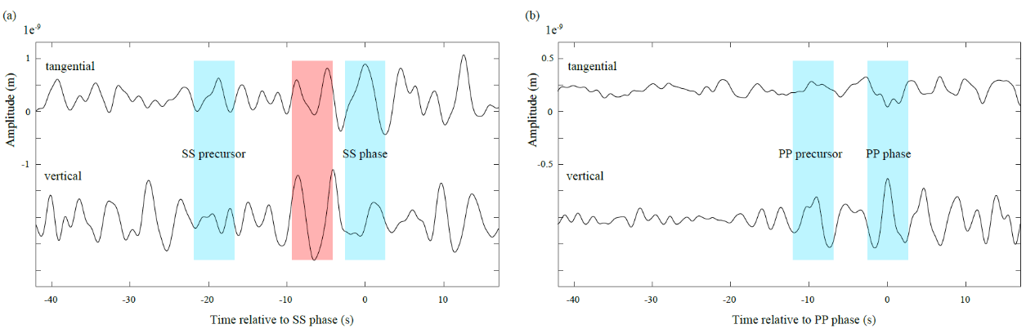

Extended Data Figure 1
(a) The traces at the top and bottom correspond to the raw displacement waveform filtered between 1.5 s and 6 s on the tangential and vertical components, respectively. The shaded blue regions mark the SS phase and its precursor with almost no energy on the vertical component. The signal in the shaded red region is less likely to be a SS precursor due to the large energy on the vertical component.
(b) Similar to (a) but the shaded blue regions mark the PP phase and its precursor with almost no energy on the tangential component

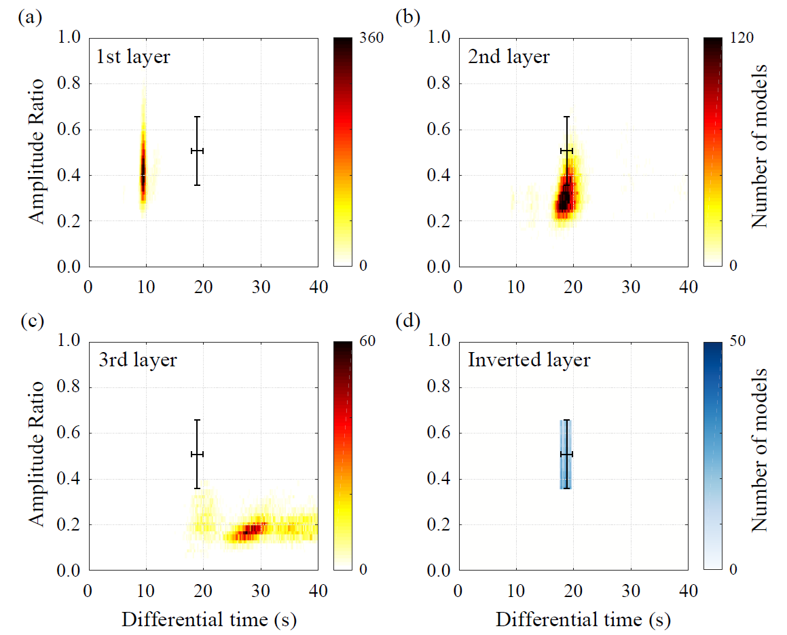

Extended Data Figure 2
Predicted differential arrival time and amplitude ratio between the SS phase and the SS precursor generated from the first (or top) layer (a), second (or middle) layer (b), and the third (or bottom) layer (c) in the receiver-function-derived models.
(d) Similar to (a-c), but for the inverted crustal layer in Fig. 4.

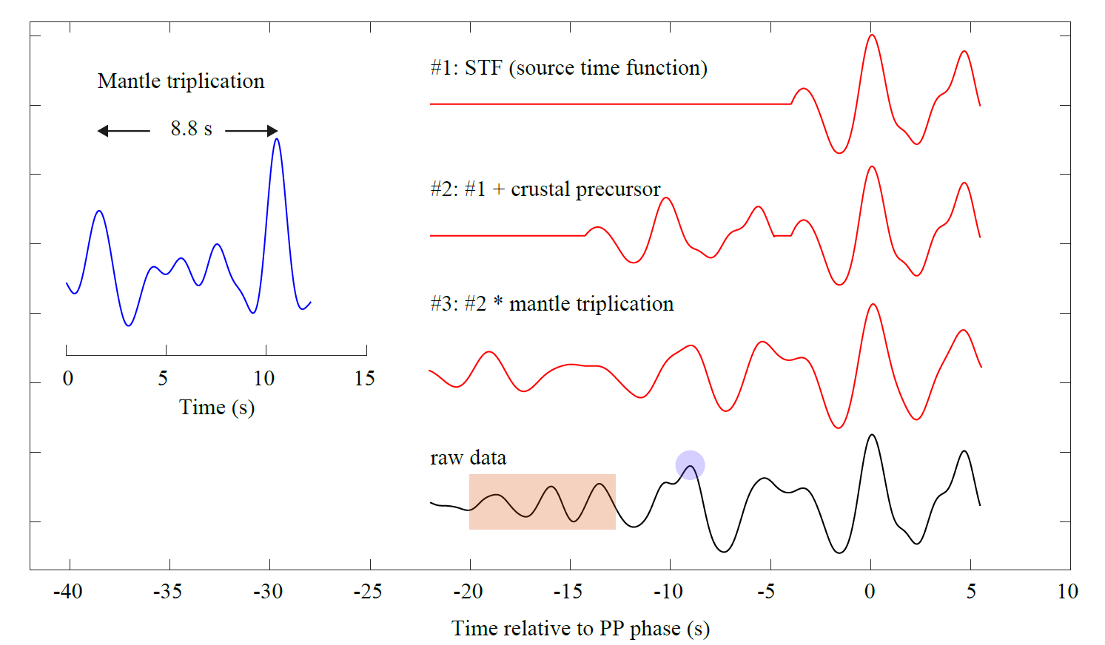

Extended Data Figure 3
On the right panel, trace #1 is the source time function extracted from the raw data (the trace on the bottom) from -4 to +5 s. Trace #2 is the synthetic waveform using one of the acceptable crustal models from the PP inversion (Fig. 4c) and the source time function (trace #1). Trace #3 is the convolution of trace #2 and a synthetic mantle triplication operator (the blue waveform in the left panel). Trace #4 show the raw displacement data. In trace #4, the shaded blue circle and the shaded red box mark the second positive phase and another wave train which are not observed in the synthetics only with crustal precursor (trace #2). Those two features are better fitted when considering mantle triplications (trace #3). The synthetic mantle triplication operator is shown in the left panel, where there is another early arrival before the main phase with a differential arrival time of 8.8s and an amplitude ratio of 50% (generated by a mantle discontinuity at around 1000 km depth).

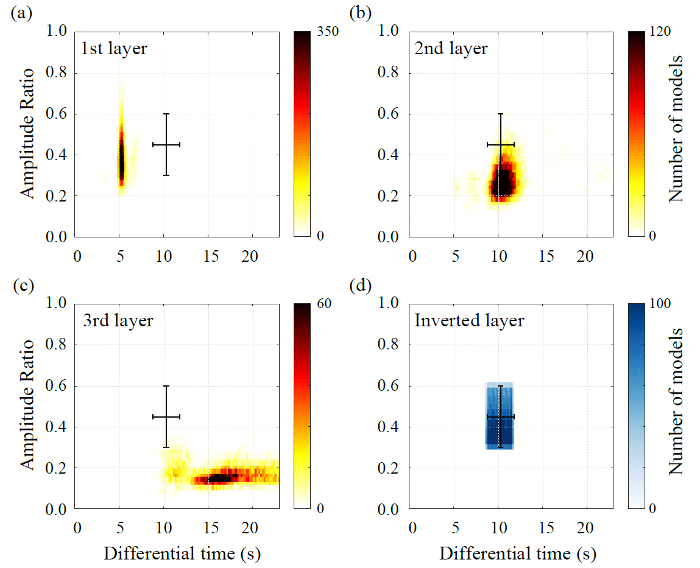

Extended Data Figure 4
Predicted differential arrival time and amplitude ratio between the PP phase and the PP precursor generated from the first layer (a), second layer (b), and the third layer (c) in the receiver-function-derived models.
(d) Similar to (a-c), but for the inverted crustal layer in Fig. 5.

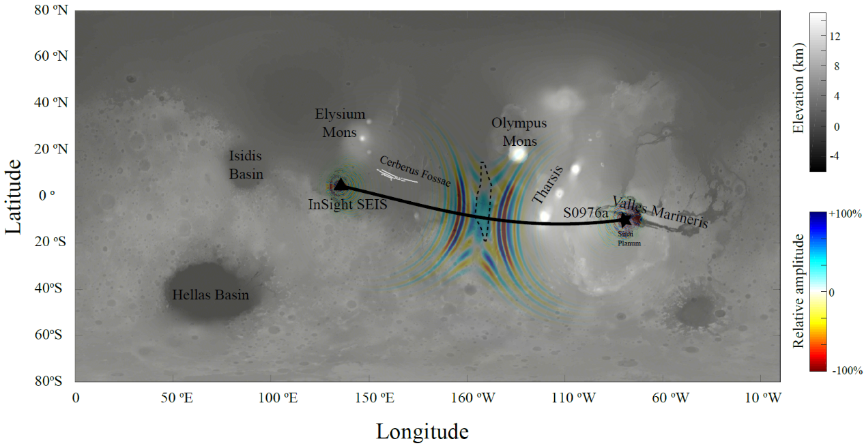

Extended Data Figure 5
The sensitivity kernel of the PP precursor was calculated at the shortest period of 5 s. The most sensitive region (i.e., the blue region of 12º wide and 20º long) is close to the bounce point, and its size is comparable to the uncertainty of the location of the bounce point (i.e., marked as the dashed black region). Note that due to the computation cost of the 3-D simulation, the sensitivity kernel here is only calculated at the shortest period of 5 s. For the seismic signal utilized in this study with higher frequencies (i.e., the half durations of PP and SS phases are less than 2 s and 3 s, respectively), the size of the corresponding sensitivity region will be smaller.

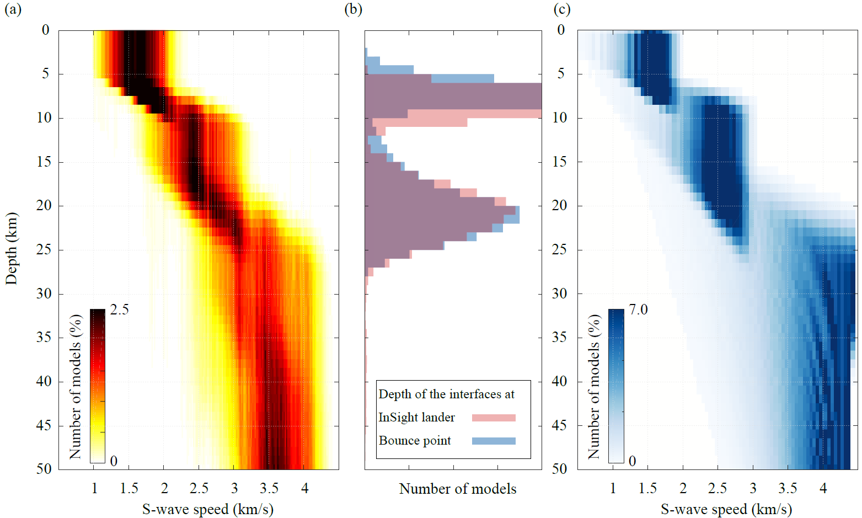

Extended Data Figure 6
Similar to Fig. 4 but for the inversion with two layers in the crust.

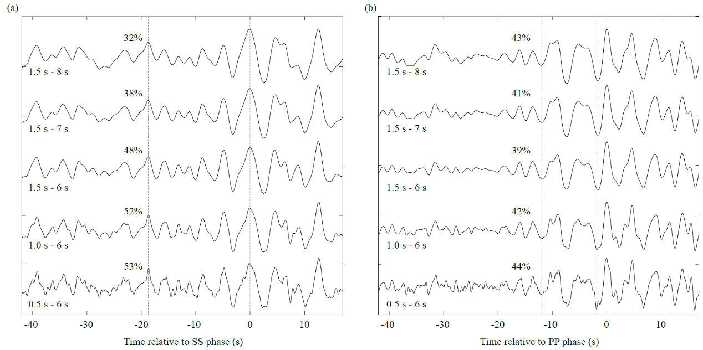

Extended Data Figure 7
(a) The black traces are the raw displacement waveforms with different filtering bands (labeled to the left of each trace). The dashed lines mark the arrival of the SS phases and the precursors. The amplitude ratio between the precursor and the main phase at each frequency band is also annotated.
(b) Similar to (a) but on the vertical component near the arrival of the PP phase.

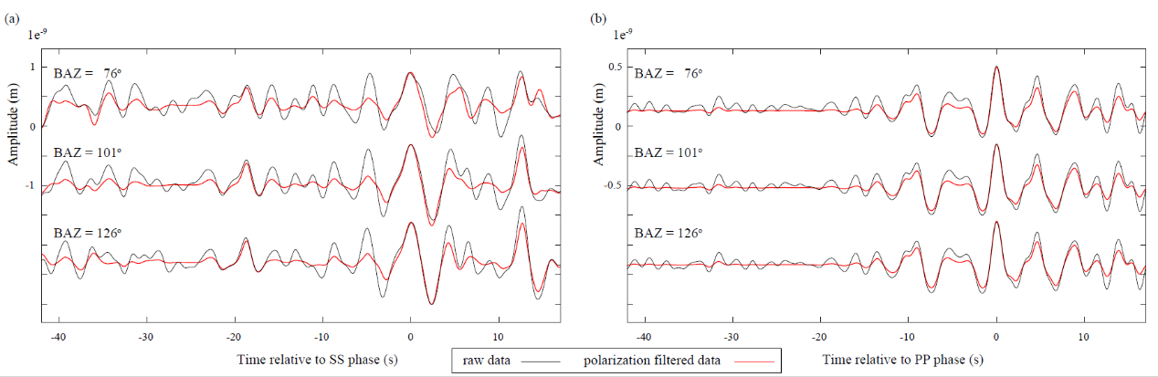

Extended Data Figure 8
(a) The black waveforms from the top to the bottom are the raw displacement data (filtered from 1.5 s to 6 s) on the tangential component near the arrival of the SS phase, assuming a back azimuth of 76º, 101 º, and 126 º, respectively. The red waveforms are traces after polarization filtering with the same back azimuths.
(b) Similar to (a) but on the vertical component near the arrival of the PP phase.

