Supplemental data
Supplemental materials and methods
Flow cytometry
Cells were washed with PBA (PBS, 0.5% BSA and 0.02% Sodium Azide) and stained using fluorescently labelled antibodies for 20 minutes on ice. The following mouse antibodies were used: B220 APC (eBioscience), BCL-6 PerCPefl710 (eBioscience), BLIMP1 BV421 (BD Biosciences), CD3 APC (eBioscience), CD3 PE (eBioscience), CD4 BUV395 (BD Biosciences), CD4 FITC (BD Biosciences), CD4 PeCy7 (eBioscience), CD5 PercPCy5.5 (eBioscience), CD5 APC efl780 (eBioscience), CD8 APC efl780 (eBioscience), CD8 BV785 (Biolegend), CD8 PerCP Cy5.5 (eBioscience), CD8 FITC (eBioscience), CD19 efl450 (eBioscience), CD19 PECy7 (eBioscience), CD19 FITC (eBioscience), CD44 af700 (eBioscience), CD44 APC efl780 (eBioscience), CD45.1 APC (eBioscience), CD45.1 PECy7 (eBioscience), CD45.2 PerCPCy5.5 (eBioscience), CD62L FITC (eBioscience), CD62L BV510 (Biolegend), CD62L PECy7 (eBioscience), CD101 monoclonal antibody (eBioscience), CD107a APC (Biolegend), CD127 BV650 (Biolegend), CD127 PE (eBioscience), CD200R PerCPefl710 (eBioscience), CTLA4 APC (eBioscience), EOMES PE (eBioscience), EOMES PECy7 (eBioscience), Granzyme B FITC (eBioscience), IFNγ APC (eBioscience), IFNγ PE (eBioscience), IL-2 FITC (eBioscience), KLRG1 FITC (eBioscience), KLRG1 FITC (eBioscience), KLRG1 PerCPefl710 (eBioscience), PD-1 FITC (eBioscience), PD-1 PE (Biolegend), T-BET PerCPCy5 (eBioscience), T-BET PeCy7 (eBioscience), TNFα FITC (eBioscience). The following human antibodies were used: CD3 BUV496 (BD Biosciences), CD4 APC (BD Biosciences), CD8 BV786 (Biolegend), CD8 V450 (BD Biosciences), CD25 PE (BD Biosciences), CD27 PerCPefl710 (eBioscience), CD28 APC-R700 (BD Biosciences), CD45RA BV650 (BD Biosciences), CD127 BV605 (Biolegend), CCR7 BUV395 (BD Biosciences), KLRG1 PE-Dazzle 594 (Biolegend), EOMES PECy7 (eBioscience), T-BET BV421 (Biolegend). To exclude dead cells, Fixable Viability Dye eFluor 780 was used according to manufacturer’s instructions. For staining of intracellular cytokines, cells were fixed and permeabilized using the Fixation/Permeabilization Solution Kit (BD Biosciences). For staining of transcription factors FOXP3 / Transcription Factor Staining Buffer Set (eBioscience) was used. After antibody staining, samples were washed using PBA prior to measuring.

Nanostring assay and data analysis
Raw counts were extracted from the nCounter analysis software and used as input in DESeq2 1.28.1(1). Patient ID was added to the design model before condition and significantly differentially expressed genes were determined with a cutoff of FDR < 0.1. Gene set enrichment analysis (GSEA) was performed on a matrix of normalized counts using DESeq2 default normalization. With the GSEA desktop application version 4.1.0 our data was compared against 8 curated gene sets (Supplemental Table 2) using 1000 permutations and including gene sets with a maximum size of 1000(2).

ATAC sequencing and data analysis
50,000 FACS-sorted OT-I cells were lysed using ATAC-Resuspension buffer (Tris-HCl, NaCl, MgCl2 and water) with 0.1% NP40 (Sigma-Aldrich/Roche), 0.1% Tween-20 (Sigma-Aldrich/Roche), and 0.01% Digitonin (Promega). Pelleted nuclei were resuspended in 50 µl transposase mixture containing TD buffer (Illumina), transposase (Illumina), PBS, 1% Digitonin, 10% Tween-20 and water. After 30 minutes incubation at 37°C, the transposased DNA was purified using the DNA Clean and Concentrator kit (Zymo Research). Libraries were generated using primers (Table S7; Sigma-Aldrich) and the NEBNext High Fidelity master mix (New England Biolabs). Amplified libraries were purified using AMPure XP beads (Beckman Coulter) and sequenced using an Illumina HiSeq, 50 bp single-end reads.
Sequencing reads were trimmed and aligned to the GRCm38v93 reference genome using HISAT2 v2.1.0(3). Pre-processing of the data was done using the ENCODE pipeline (https://www.encodeproject.org/atac-seq/) followed by peak-calling with MACS2 v2.2.7.1(4) (bandwidth=300, p-value cut-off=0.01). For differential accessibility analysis, peak files of all replicates were input to DiffBind v3.0.14(5). Principal component analysis was done by using DiffBind’s dba.plotPCA function on raw data using default parameters. Differential accessibility analysis was based on consensus peaks in at least 2 samples, a peak width of 500 bp, blacklisted peaks for mm10 were removed and data was normalized based on reads in peaks. A cut-off of FDR < 0.05 was used to determine significance.
Comparison to ATACseq data from Scott-Browne et al. (6) was done by downloading normalized counts data from GEO accession number GSE88987 and extracting regions that were either significantly more accessible in OT-I from WT or more accessible in OT-I from TCL1 mice.
Transcription factor motif enrichment was calculated using HOMER v4.11(7) on the differentially accessible regions using mm10 as background. The known motifs analysis strategy was performed using default parameters. To find the regions containing an enriched motifs, annotatePeaks.pl was used and promoters containing an enriched motif were selected; the corresponding genes were considered targets of the transcription factor.
All plots were generated with ggplot2(8) (Bioconductor) and gplots (CRAN) in R v4.0(9), Bioconductor v3.11(10) and Rstudio v1.2(11).

RNA sequencing and data analysis
Sequencing libraries were generated with the NEBNext Single Cell/Low input RNA library prep kit (New England Biolabs) and sequenced on an Illumina NovaSeq6000, 150bp paired-end. Sequencing reads were trimmed and aligned to the GRCm38v93 reference genome using STAR v2.5.4(12). Count matrices were created with HTSeq v0.11.0(13), these served as input for DESeq2 1.28.1(1) to calculate differential expression. A cutoff of FDR < 0.05 and a fold change > 2 was used to determine significance. Plots were generated with ggplot2(8) (Bioconductor) and gplots (CRAN) in R v4.0(9), Bioconductor v3.11(10) and Rstudio v1.2(11).
Genesets from Hanna et al.(14) were generated using the GEO2R tool by NCBI on GEO accession GSE102149. Gene set enrichment analysis (GSEA) was performed on a matrix of normalized counts using DESeq2 default normalization. With the GSEA desktop application version 4.1.0 our data was compared against Immunological Signatures (c7.all.v7.4) gene sets or the genesets from Hanna et al.(14) using 1000 permutations and including gene sets with a maximum size of 1000.

Supplemental figures
Supplemental figure 1
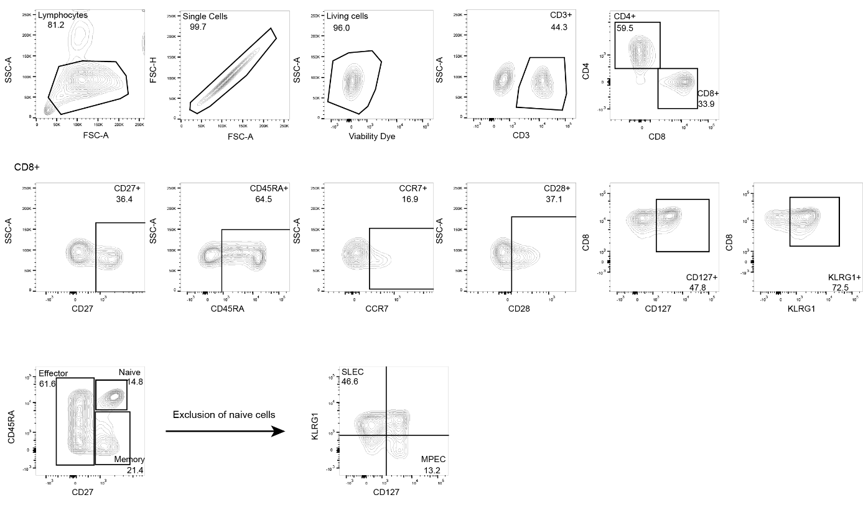
Supplemental figure 1. Gating strategy. Gating strategy for differentiation of human CD8⁺ T cells into different effector and memory subsets.

Supplemental figure 2
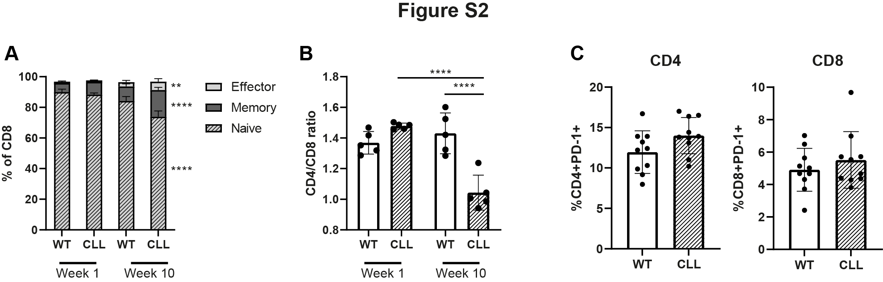
Supplemental figure 2. Mice develop CLL-like disease after adoptive transfer of TCL1 cells (A) Differentiation of T cells in WT and CLL mice at week 1 and 10 after adoptive transfer (AT) of TCL1 cells. Cells were gated as naïve CD8⁺CD62L⁺CD44⁻; effector CD8⁺CD62L⁻CD44⁺; and memory CD8⁺CD62L⁺CD44⁺. (B) CD4/CD8 ratio in WT and CLL mice at week 1 and 10 after AT of TCL1 cells. (C) PD-1 expression on CD4⁺ (left) and CD8⁺ (right) T cells at week 10. (n=5 per group). The P value was calculated by unpaired t test (A, B, C). Data are presented as mean ± SD. *P < .05; **P < .01; ***P<0.001 ****P < 0.0001.

Supplemental figure 3
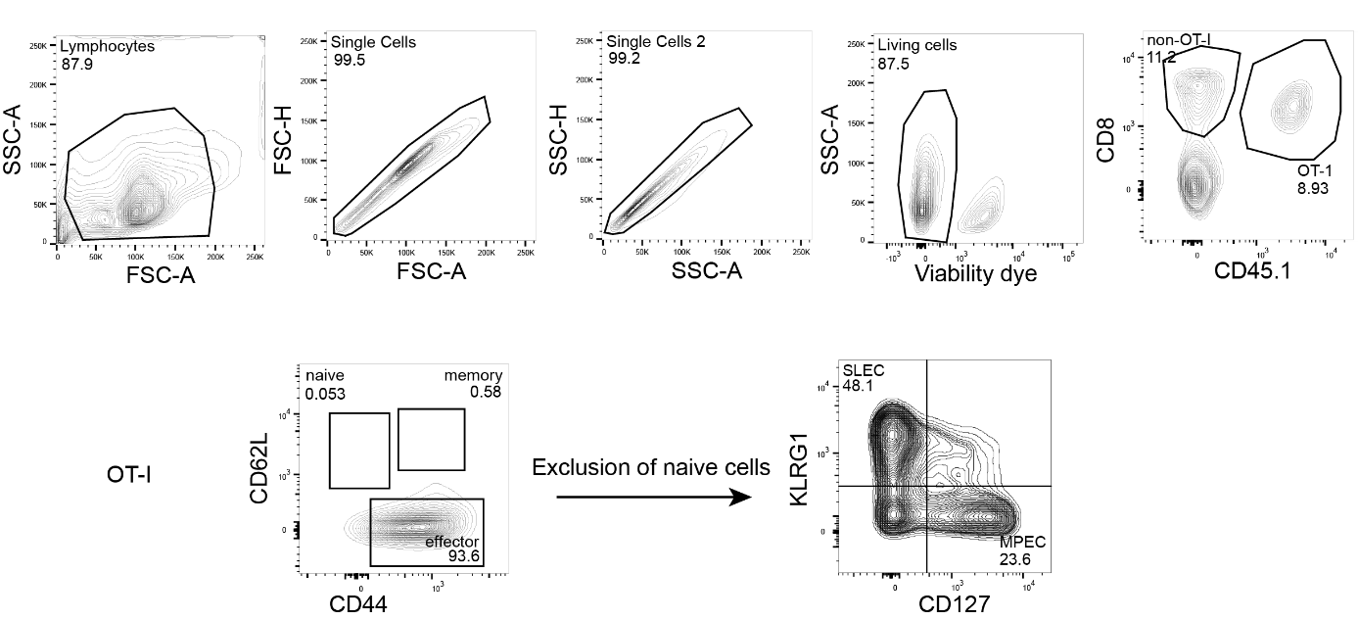
Supplemental figure 3. Gating strategy. Gating strategy for differentiation of OT-I from spleen on day 7 after infection.

Supplemental figure 4
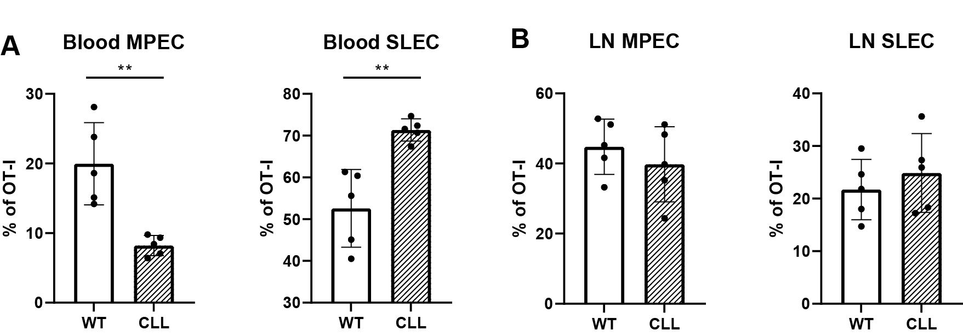
Supplemental figure 4. SLEC skewing of OT-I cells in CLL mice (A & B) Differentiation of OT-I cells into MPECs (left panel) and SLECs (right panel) in blood (A) or lymph node (B) on day 7. (n=5 per group). The P value was calculated by unpaired t test (A, B, C). Data are presented as mean ± SD. **P < .01

Supplemental figure 5
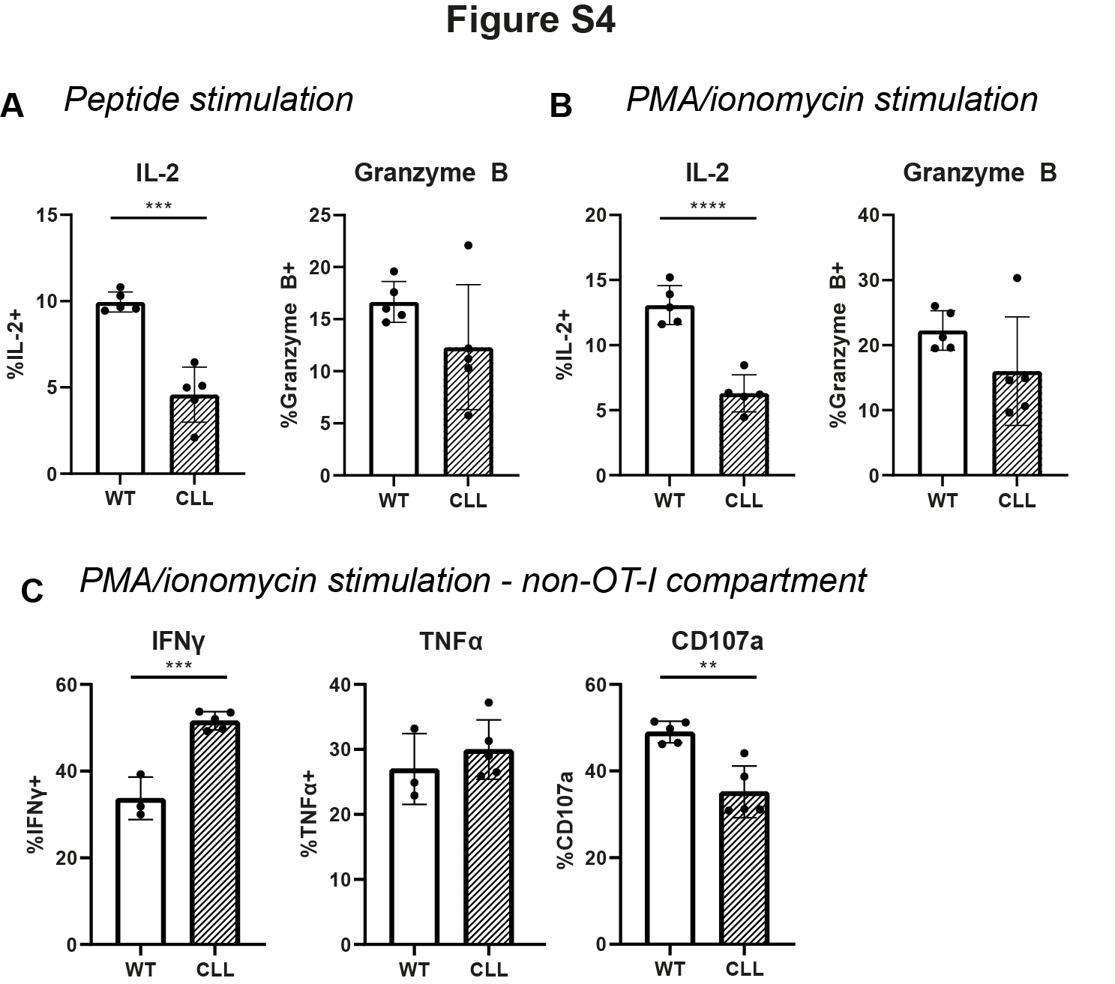

Supplemental figure 5. Cytokine expression of WT and CLL derived OT-I cells upon restimulation (A-B) Expression of IL-2 (left panels) or Granzyme B (right panels) in OT-I cells after restimulation with (A) 10ng/mL SIINFEKL peptide or (B) PMA/ionomycin (C) Expression of IFNγ, TNFα and degranulation (CD107a) of non-OT-I CD8⁺ T cells after PMA/ionomycin stimulation (n=5 per group). The P values were calculated using unpaired t test. Data are presented as mean ± SD. ***P<0.001 ****P <0 .0001.

Supplemental figure 6
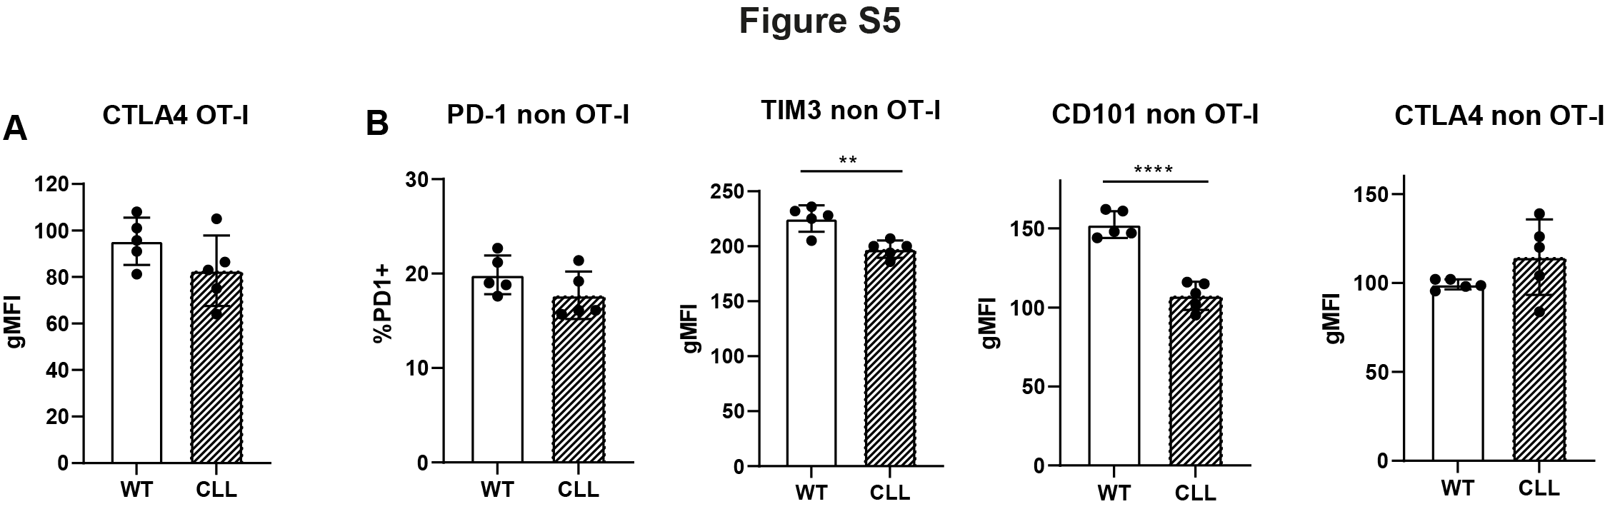
Supplemental figure 6. Exhaustion marker expression of WT and CLL derived (non) OT-I cells (A) gMFI of CTLA4 in OT-I cells (B) %PD1 expression and gMFI of TIM3, CD101 and CTLA4 in the non-OT-I compartment (n=5 per group). The P values were calculated using unpaired t test. Data are presented as mean ± SD. **P < .01; ****P <0 .0001.

Supplemental figure 7

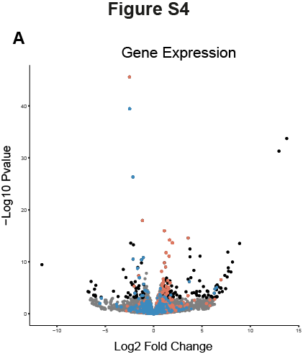
Supplemental figure 7. Overlap between chromatin accessibility and gene expression results (A) A volcano plot of the gene expression results. Black dots are genes that are significantly different in CLL vs WT OT-I cells (adjusted p-value < 0.05 and a fold change > 2) and grey dots are genes that do not pass the significance threshold. Red colored dots are genes that are significantly more accessible (FDR < 0.05) and blue dots are genes that are significantly less accessible in CLL OT-I cells.

Supplementary tables
Supplemental table 1. Patient characteristics
ID | Sex | Age | Rai stage | Mutation status | ALC (×10⁹/L) | %CD5⁺  CD19⁺ | Cytogenetics | TP53 mutation | Treatment
1 | F | 80 | 0 | Mutated | 38.34 | 91.8 | NA | NA | None
2 | F | 81 | 0 | Mutated | 80.93 | 94.6 | Del(13q14) | NA | None
3 | M | 68 | 0 | Mutated | 65.04 | 95.6 | NA | NA | None
4 | F | 81 | I | Mutated | 89 | 94.6 | NA | NA | None
5 | F | 54 | NA | Mutated | 76.84 | 94.5 | NA | NA | None
6 | M | 75 | NA | Unmutated | 102.38 | 92.5 | NA | NA | None
7 | F | 69 | 0 | NA |  |  | NA | NA | None
8 | F | 81 | NA | Mutated | 37.95 | 81 | del(11q22) / del(13q14) | NA | None
9 | M | 66 | NA | Mutated | 49.6 | 93.9 | NA | NA | None
10 | F | 70 | NA | Mutated | 19.3 | 86.4 | NA | NA | None
11 | F | 81 | I | Unmutated | 35.8 | 80.1 | NA | NA | None
12 | M | 69 | NA | Mutated | 118 | 96.5 | NA | NA | None
13 | F | 77 | NA | Unmutated | 58.83 | 91.96 | NA | NA | None
14 | M | 84 | 0 | Mutated | 49.27 | 92.58 | NA | NA | None
15 | M | 66 | I | Mutated | 59.71 | 92.89 | NA | NA | None
16 | M | 70 | 0 | Mutated | 70.24 | 93.56 | NA | NA | None
ALC=Absolute leukocyte count, F = female, M = male, NA = not available. Treatment indications were in accordance with IWCLL criteria. Patients with no treatments were in a steady-state under a ‘watch and wait’ regimen. Deletion of 17p was determined by CGH-array. TP53 mutations were determined by Sanger sequencing.

Supplemental table 2. Curated gene sets
 | Effector | Memory | TCR Pathway | Co-stimulation | Inhibitory and exhaustion | Synapse and adhesion | Cytokines and receptors | Chemokines and receptors
1 | IFNG | IL2 | LCK | CD27 | PDCD1 | ITGB2 | IFNG | CCL5
2 | IL2 | CCL5 | ZAP70 | CD28 | CD160 | ITGAX | IL2 | CXCR3
3 | TNF | IL10RA | LAT | LCK | EOMES | ITGA4 | TNF | CCL4
4 | CCL5 | EOMES | FYN | GRB2 | BCL2 | ITGAM | IL2RA | CCR7
5 | KLRG1 | CCL4 | MAP3K8 | GSK3B | TCF7 | CDC42 | IL10RA | CCR2
6 | FASLG | SELL | MAPK14 | ITK | LAG3 | VAV1 | IL18R1 | CCR5
7 | TNFSF10 | TNFSF8 | GRB2 | PIK3CA | CD244 | VAV2 | IL18RAP | CCL3
8 | KLRC1 | CD27 | GSK3B | AKT1 | CTLA4 | VAV3 | IL12RB2 | XCL1
9 | KLRK1 | CD28 | ITK | AKT2 | TOX | NCAM1 | STAT1 | XCL2
10 | PDCD1 | IL7R | FOS | AKT3 | TIGIT | ICAM1 | STAT5a | CXCL10
11 | CD160 | IL2RB | JUN | TNFSF14 | DNMT3A | TRAF3 | JAK1 | CXCL8
12 | IL2RA | IL4R | JUNB | TNFSF4 | BCL2L11 | RAB35 | STAT3 | CCL1
13 | IL10RA | IL6R | KRAS | ICOS | BATF | RAB22A | IL4 | CCL17
14 | IL18R1 | IL21R | RHOA | TNFRSF9 | CD200 | RASGRP2 | IL6 | CCL18
15 | IL18RAP | CCR7 | NFATC1 | TNFRSF14 | CD200R1 | CAPZB | IL7 | CCL19
16 | IL12RB2 | CCR2 | NFATC2 | TNFRSF18 | BTLA | FLNA | IL10 | CCL21
17 | CXCR3 | CCR5 | NFATC3 | GRAP2 | HAVCR2 | ARPC1B | IFNA1 | CCL22
18 | ITGAL | STAT3 | NFATC4 | PIK3R1 |  | ARAP3 | IFNA2 | CCL23
19 | ITGB2 | SOCS3 | NFKB1 | PTPN11 |  | FMNL1 | TGFB1 | CXCL1
20 | ITGAD | BCL2 | NFKBIA | PDK1 |  | SPTB | TGFBR1 | CXCL9
21 | ITGAX | TCF7 | NFKBIB |  |  | FMNL2 | STAT5b | CXCL11
22 | ITGA4 | ID3 | NFKBIE |  |  | FNBP4 | STAT6 | CXCL12
23 | ITGAM | BCL6 | CDC42 |  |  | VAMP2 | IL17A | CXCL16
24 | STAT4 | FOXO1 | CD3D |  |  | MYO9B | IL17RA | CXCR4
25 | STAT1 | RUNX1 | CD3E |  |  | AP2B1 | JAK2 | CXCR5
26 | STAT2 |  | CD3G |  |  | PAK4 | JAK3 | CCR1
27 | STAT5a |  | PIK3CA |  |  | ITGA5 | IL12A | CCR3
28 | JAK1 |  | PIK3CB |  |  | ITGB3 | IL12B | CCR4
29 | GZMB |  | PIK3CD |  |  | ITGA2B | IL18 | CCR6
30 | GZMA |  | PIK3CG |  |  | MYH9 | IL12RB1 | CCR8
31 | PRF1 |  | PAK1 |  |  | MYH10 | IL15 | CCR9
32 | GNLY |  | PAK3 |  |  | ACTB | IL15RA | CCR10
33 | GZMH |  | PAK6 |  |  | CD14 | IL1B | CX3CR1
34 | GZMK |  | MAPK1 |  |  | ICAM2 | IL1R1 | CXCR6
35 | PRDM1 |  | MAPK3 |  |  | ARHGEF3 | IL1R2
36 | TBX21 |  | MAPK11 |  |  | MYL5 | LTB
37 | ID2 |  | MAPK9 |  |  | ARPC5 | LTA
38 | ZNF683 |  | MAPK13 |  |  | ARPC5L | IL5
39 | IRF4 |  | MAP2K1 |  |  | ARPC4 | IL21
40 | IRF8 |  | MAP2K2 |  |  | ARPC3 | IL22
41 | EOMES |  | MAP2K7 |  |  | ARPIN | IL9
42 | CX3CR1 |  | SOS1 |  |  | PFN2 | IL13
43 |  |  | SOS2 |  |  | RAC2
44 |  |  | NCK1 |  |  | ARHGEF6
45 |  |  | NCK2 |  |  | CDC42BPB
46 |  |  | AKT1 |  |  | ARHGEF9
47 |  |  | AKT2 |  |  | CDC42EP4
48 |  |  | AKT3 |  |  | PDGFD
49 |  |  | CDK4 |  |  | HRAS
50 |  |  | DUSP6 |  |  | ACTN1
51 |  |  |  |  |  | ACTN2
52 |  |  |  |  |  | ACTN4
53 |  |  |  |  |  | CORO1B
54 |  |  |  |  |  | DCTN2
55 |  |  |  |  |  | DCTN4
56 |  |  |  |  |  | DCTN6
57 |  |  |  |  |  | DCTN5

Supplemental table 3. Genes significantly more accessible in CLL OT-I that contain an ETS1 motif in the promoter (<= 3kB)
Gene Name
AA467197
Acot7
Adap1
Afg3l1
Agfg2
Ago2
Ahnak
Anxa2
Arhgap25
Arhgef3
Arl8b
Asb2
Atg7
Atp13a1
Atxn1
Bard1
BC035044
Bhlhe40
Birc3
Btbd19
Btla
Ccl4
Ccl5
Ccr2
Ccr5
Cd27
Cd28
Cd47
Cd82
Chd7
Chn2
Chst5
Clec9a
Cmklr1
Crybg2
Cx3cr1
Dock2
Dohh
Dpy19l1
Dynlt1f
Enthd1
Epas1
Eps8
Esm1
Etv3
F2rl2
Fcgr2b
Fcho1
Fgl2
Fos
Fosb
Fth1
Furin
Gadd45g
Gas7
Gatad2a
Gcnt4
Gm15511
Gm19589
Gm26839
Gm29684
Gm33104
Gm33104
Gpc1
Gpnmb
Gramd1a
Gsap
Havcr2
Hilpda
Hmgcr
Hpf1
Hpn
Ica1
Id2
Ifit1bl1
Ifng
Il12rb1
Il18r1
Il3ra
Inf2
Kbtbd11
Kcnj8
Kcnt1
Keap1
Kif17
Klhl8
Klra1
Klra5
Klra9
Klre1
Klrg1
Ksr1
Lair1
Lamp1
Lilr4b
Lilrb4a
Lmo7
Lpcat1
Lrrfip1
Lst1
Mapkapk3
Mapre2
Marveld1
Mbnl1
Mbp
Mir146
Mir3109
Mir6361
Mir7001
Morrbid
Mta3
N4bp1
Nabp1
Ncf4
Nfkbia
Osbpl3
P2rx7
P2ry10b
P2ry13
Pde4d
Pfkp
Pheta2
Phf11a
Pik3ap1
Pla2g6
Plek
Plk1
Plxnc1
Prss16
Rbm38
Rfx5
Rps27rt
Rubcnl
Runx3
S100a10
Samsn1
Sema4d
Sema7a
Serpina3g
Serpinb10
Sgms1
Shroom3
Sla
Slamf7
Slc35c2
Slc38a2
Slc9a2
Smad3
Spcs2
Srgn
Srgn
St3gal6
St6galnac6
Stimate
Stk17b
Synj2
Tex2
Tk2
Tmsb4x
Traf5
Trim5
Trpm1
Ttc39c
Ttll11
Tubb3
Txndc5
Vars
Vwa3b
Zfp407

Supplemental table 4. Genes significantly more accessible in CLL OT-I that contain an TCF1 motif in the promoter (<= 3kB)
Gene Name
Abhd15
Adh1
Adk
Ankrd12
Arid5a
Axin2
Babam2
Bambi-ps1
Ccnt2
Cd101
Cd5
Chad
Cox7a2
Crem
Csnk1g2
Emb
Farp1
Foxn3
Gm10814
Gm12596
Gm5148
Gtf2i
Ifngas1
Isy1
Kcnc1
Kntc1
Mir6371
Mmab
Mogat1
Morc1
Nedd4l
Nipa2
Npff
Nsg2
Pcdhgc4
Pea15a
Plcg1
Pou6f1
Prkacb
Rab11b
Reps1
Rnf125
Rnf32
Rps6ka5
Runx3
Shld1
Slc37a3
Slc43a1
Smad7
Srpk1
Ss18
Stk17b
Tnfrsf19
Tnni1
Tnrc6c
Tox
Trpm1
Ttc27
Usp7
Vezf1
Zfp12

Supplemental table 5. Genes significantly more accessible and higher expressed in CLL OT-I
Gene name
Entpd1
Dusp1
Gzmb
Ccl4
Ccr2
F2rl2
Tigit
Bhlhe40
Ccr5
Id2
Cypp11a1
Fgl2
Cdk6
Coro2a
Havcr2
Osbpl3
Gzmk
0610040F04Rik
Ifng
Rora
F2r
Zbtb38
Ccl3
Pim1
Rapgef2
Chn2
Lair1
Cd38
Zeb2
Esm1
Klrg1
Slc2a3
Nr4a1
Klra3
Cchcr1
Fos
Rrm2
Gm33104

Supplemental table 6. Genes significantly less accessible and lower expressed in CLL OT-I.
Gene name
Dapl1
Nsg2
Tcf7
Tnfsf8
Adk
Ccr7
Actn1
Rgs10
Bend4
Inpp4b
Tspan13
St8sia1
Aff3
Car2

Supplemental table 7. ATAC sequencing barcoding primers
Primer name | primer sequence
Ad1_noMX | AATGATACGGCGACCACCGAGATCTACACTCGTCGGCAGCGTCAGATGTG
Ad2.9_GCTACGCT | CAAGCAGAAGACGGCATACGAGATAGCGTAGCGTCTCGTGGGCTCGGAGATGT
Ad2.10_CGAGGCTG | CAAGCAGAAGACGGCATACGAGATCAGCCTCGGTCTCGTGGGCTCGGAGATGT
Ad2.11_AAGAGGCA | CAAGCAGAAGACGGCATACGAGATTGCCTCTTGTCTCGTGGGCTCGGAGATGT
Ad2.12_GTAGAGGA | CAAGCAGAAGACGGCATACGAGATTCCTCTACGTCTCGTGGGCTCGGAGATGT
Ad2.13_GTCGTGAT | CAAGCAGAAGACGGCATACGAGATATCACGACGTCTCGTGGGCTCGGAGATGT
Ad2.14_ACCACTGT | CAAGCAGAAGACGGCATACGAGATACAGTGGTGTCTCGTGGGCTCGGAGATGT
Ad2.15_TGGATCTG | CAAGCAGAAGACGGCATACGAGATCAGATCCAGTCTCGTGGGCTCGGAGATGT

Supplementary references
1. Love MI, Huber W, Anders S. Moderated estimation of fold change and dispersion for RNA-seq data with DESeq2. Genome Biol. 2014;15(12):550.
2. Hofland T, de Weerdt I, Endstra S, Jongejan A, Platenkamp L, Remmerswaal EBM, et al. Functional Differences Between EBV- and CMV-Specific CD8(+) T cells Demonstrate Heterogeneity of T cell Dysfunction in CLL. Hemasphere. 2020;4(2):e337.
3. Kim D, Paggi JM, Park C, Bennett C, Salzberg SL. Graph-based genome alignment and genotyping with HISAT2 and HISAT-genotype. Nat Biotechnol. 2019;37(8):907-15.
4. Zhang Y, Liu T, Meyer CA, Eeckhoute J, Johnson DS, Bernstein BE, et al. Model-based Analysis of ChIP-Seq (MACS). Genome Biology. 2008;9(9):R137.
5. Ross-Innes CS, Stark R, Teschendorff AE, Holmes KA, Ali HR, Dunning MJ, et al. Differential oestrogen receptor binding is associated with clinical outcome in breast cancer. Nature. 2012;481(7381):389-93.
6. Scott-Browne JP, Lopez-Moyado IF, Trifari S, Wong V, Chavez L, Rao A, et al. Dynamic Changes in Chromatin Accessibility Occur in CD8(+) T Cells Responding to Viral Infection. Immunity. 2016;45(6):1327-40.
7. Heinz S, Benner C, Spann N, Bertolino E, Lin YC, Laslo P, et al. Simple combinations of lineage-determining transcription factors prime cis-regulatory elements required for macrophage and B cell identities. Molecular Cell. 2010;38(4):576-89.
8. Wickham H. ggplot2: Elegant Graphics for Data Analysis. New York: Springer-Verlag; 2009 2009.
9. Team RC. R: A language and environment for statistical computing.: R Foundation for Statistical Computing, Vienna, Austria; 2020.
10. Huber W, Carey VJ, Gentleman R, Anders S, Carlson M, Carvalho BS, et al. Orchestrating high-throughput genomic analysis with Bioconductor. Nature Methods. 2015;12(2):115-21.
11. Team R. RStudio: Integrated Development for R.: RStudio, PBC, Boston, MA; 2020.
12. Dobin A, Davis CA, Schlesinger F, Drenkow J, Zaleski C, Jha S, et al. STAR: ultrafast universal RNA-seq aligner. Bioinformatics. 2013;29(1):15-21.
13. Anders S, Pyl PT, Huber W. HTSeq--a Python framework to work with high-throughput sequencing data. Bioinformatics. 2015;31(2):166-9.
14. Hanna BS, Llaó-Cid L, Iskar M, Roessner PM, Klett LC, Wong JKL, et al. Interleukin-10 receptor signaling promotes the maintenance of a PD-1(int) TCF-1(+) CD8(+) T cell population that sustains anti-tumor immunity. Immunity. 2021;54(12):2825-41.e10.

