Supplemental Material

Appendix 1
There were 63 respondents including 1.11% (n=7) from city level government, 15.87% (n=10) engineering and design firms, 3.17% (n=2) environmental authority or utility, 15.87% (n=10) local and county level government, 19.05% (n=12) neighborhood association, 22.22%(n=14) non-profit organization and there were 7 people who didn’t specify their positions.
Table 1 Study demographics
Variable |  | Total
Type of stakeholder | City level government | 7
 | Local and county level government | 10
 | Environmental utility | 5
 | Non-profit organization | 14
 | Engineering and design | 12
 | Neighborhood association | 12
Role in the office | Head of the department | 15
 | Not the head | 41
Employment duration | Less than 2 years | 13
 | 2-5 years | 13
 | 5-10 years | 12
 | More than 10 years | 17
Main office field of work* | Design | 21
(one office may have more than 1 field) | Plan | 38
 | Install | 11
 | Maintain | 16
Office requirement for MS4s | Yes | 12
 | No | 37
Period of time living in Tucson region | Less than a year | 6
 | 1-5 years | 6
 | 5-10 years | 7
 | 10-15 years | 5
 | 15-20 years | 6
 | More than 20 years | 26
Period of time living in Southwest | Less than a year | 5
 | 1-5 years | 2
 | 5-10 years | 6
 | 10-15 years | 5
 | 15-20 years | 5
 | More than 20 years | 33
Degree | Bachelor’s | 15
 | Master’s | 26
 | PhD | 12
Major | Ecology | 6
 | Biology | 2
 | Agriculture | 3
 | Landscape architecture | 9
 | Engineering | 6
 | Hydrology | 14
Participation in LID conference | Yes | 25
 | No | 32
Member of Pima County LID working group | Currently member | 21
 | Member in the past | 10
 | Not a member | 20
Gender | Male | 21
 | Female | 31
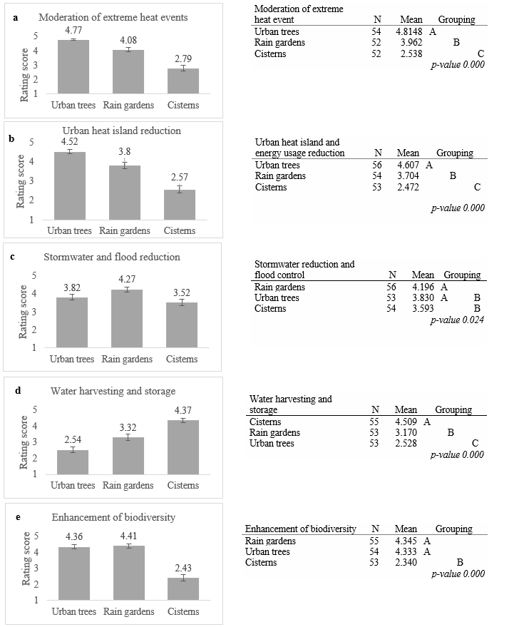
Figure 1 Column charts showing ecosystem services supply by urban trees, rain gardens, and cisterns as rated by stakeholders in Tucson, AZ. (a) moderation of extreme heat events, (b) urban heat island reduction, (c) stormwater reduction, (d) water harvesting and storage (e) enhancement of biodiversity—Five top ecosystem services supply by stakeholder selected to compare and group green infrastructure. Tukey pairwise comparison is done to compare green infrastructure

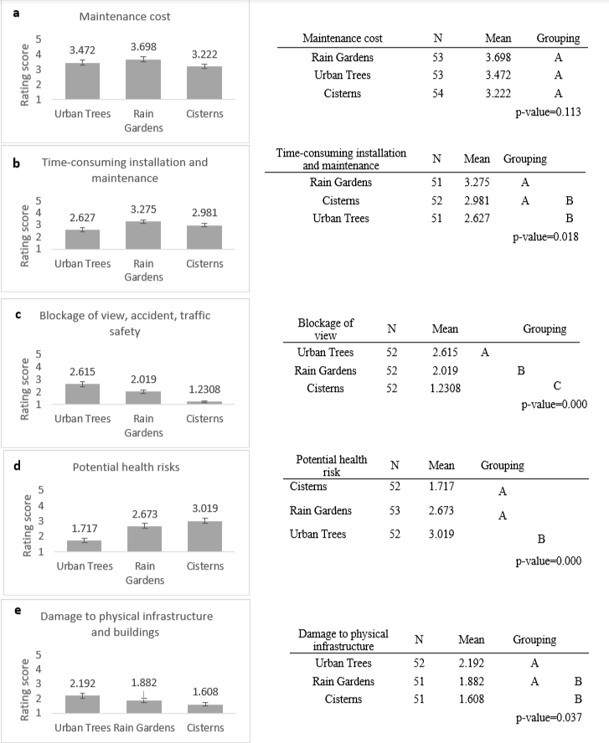
Figure 2 Column charts showing environmental concerns of urban trees, rain gardens, and cisterns as rated by stakeholders in Tucson, AZ. (a) maintenance cost, (b) time consuming installation and maintenance, (c) blockage of view, accident, and traffic safety, (d) tree leaves as litter, and (e) damage to physical infrastructure and buildings—Five top concerns by stakeholder selected to compare and group green infrastructure. Tukey pairwise comparison is done to compare green infrastructure.

Figure 3 Ecosystem services priorities from green infrastructure ranked by stakeholders and its connection to their degree. A cumulative weighted score was used to compare ranking ecosystem services perceived by stakeholders with various demographics and background. Cumulative weighted average is the average of a set of scores where each set carries a different amount of importance regarding the score each stakeholder allocated to ecosystem services (from 1-15).

Figure 4 Ecosystem services priorities from green infrastructure ranked by stakeholders and its connection to their Major. A cumulative weighted score was used to compare ranking ecosystem services perceived by stakeholders with various demographics and background. Cumulative weighted average is the average of a set of scores where each set carries a different amount of importance regarding the score each stakeholder allocated to ecosystem services (from 1-15).

Figure 5 Ecosystem services priorities from green infrastructure ranked by stakeholders and its connection to their profession. A cumulative weighted score was used to compare ranking ecosystem services perceived by stakeholders with various demographics and background. Cumulative weighted average is the average of a set of scores where each set carries a different amount of importance regarding the score each stakeholder allocated to ecosystem services (from 1-15).

Table 2 Non-parametric statistical tests to assess relationships between demographic variables stakeholder and environmental and water issues knowledge
 |  | There is a need to substitute other sources for fresh water | There is a need to control stormwater | Groundwater extraction and water table depletion is a critical issue in Tucson | There is a need to recharge groundwater | There is a need to enhance the water quality of receiving water bodies | Delivery of water from the Colorado River by the Central Arizona Project is a sustainable way to deal with water supply issues | There are already enough ways to handle water-related issues in Tucson | Rainfall harvesting can be used as a supplementary or even primary water source at a household or small community level | Population growth and increasing demand will be a challenge in Tucson in future | Climate change will have significant effect on water supply and water availability | Green infrastructures can help for future challenges
 | df | P-value
Sector | 5 | 0.678 | 0.780 | 0.732 | 0.835 | 0.385 | 0.474 | 0.064 | 0.283 | 0.554 | 0.896 | 0.469
Major | 6 | 0.764 | 0.837 | 0.663 | 0.342 | 0.689 | 0.501 | 0.454 | 0.286 | 0.866 | 0.589 | 0.825
Degree | 3 | 0.279 | 0.916 | 0.127 | 0.947 | 0.628 | 0.219 | 0.835 | 0.229 | 0.465 | 0.129 | 0.900
Role in the office | 1 | 0.576 | 0.850 | 0.117 | 0.764 | 0.303 | 0.226 | 0.793 | 0.449 | 0.133 | 0.982 | 0.982
Duration of employment | 3 | 0.773 | 0.850 | 0.965 | 0.872 | 0.782 | 0.542 | 0.714 | 0.945 | 0.408 | 0.518 | 0.766
Duration/Tucson | 5 | 0.916 | 0.984 | 0.393 | 0.689 | 0.465 | 0.427 | 0.872 | 0.637 | 0.890 | 0.888 | 0.938
Duration/ Southwest | 5 | 0.951 | 0.851 | 0.214 | 0.761 | 0.870 | 0.847 | 0.976 | 0.901 | 0.884 | 0.753 | 0.982
LID Member | 2 | 0.212 | 0.259 | 0.803 | 0.119 | 0.448 | 0.500 | 0.190 | 0.403 | 0.129 | 0.555 | 0.273
LID Conference | 1 | 0.181 | 0.298 | 0.912 | 0.609 | 0.810 | 0.384 | 0.758 | 0.733 | 0.019 | 0.320 | 0.539
Gender | 3 | 0.946 | 0.675 | 0.971 | 0.893 | 0.710 | 0.538 | 0.669 | 0.662 | 0.682 | 0.868 | 0.884
Green cells show statistically significant level p < 0.05

Table 3 Non-parametric statistical tests to assess relationships between demographic variables and ecosystem services supply of rain gardens
 |  | Air Quality regulation | Carbon sequestration and storage | Moderation of extreme heat events | Urban heat island and energy usage reduction | Water quality and nutrient retention | Stormwater reduction and flood control | Groundwater recharge | Water harvesting and storage for future use | Soil formation and soil quality improvement | Pollinator support | Enhancement of biodiversity and wildlife habitat | Aesthetic values | Enhanced property values | Education opportunities | Mental health and wellbeing
Rain Garden | df | P-Value
Sector | 5 | 0.035 | 0.256 | 0.074 | 0.009 | 0.189 | 0.071 | 0.007 | 0.250 | 0.074 | 0.252 | 0.120 | 0.369 | 0.063 | 0.012 | 0.527
Major | 6 | 0.694 | 0.163 | 0.678 | 0.710 | 0.903 | 0.747 | 0.609 | 0.388 | 0.532 | 0.772 | 0.546 | 0.655 | 0.415 | 0.820 | 0.268
Degree | 3 | 0.849 | 0.936 | 0.808 | 0.547 | 0.768 | 0.218 | 0.198 | 0.961 | 0.840 | 0.135 | 0.558 | 0.566 | 0.340 | 0.917 | 0.438
Role in the office | 1 | 0.851 | 0.708 | 0.398 | 0.556 | 0.607 | 0.451 | 0.380 | 0.500 | 0.964 | 0.386 | 0.315 | 0.392 | 0.170 | 0.344 | 0.576
Duration of employment | 3 | 0.074 | 0.023 | 0.025 | 0.115 | 0.363 | 0.568 | 0.003 | 0.316 | 0.887 | 0.794 | 0.720 | 0.721 | 0.967 | 0.452 | 0.557
Duration/Tucson | 5 | 0.525 | 0.532 | 0.848 | 0.796 | 0.658 | 0.944 | 0.789 | 0.809 | 0.477 | 0.929 | 0.557 | 0.833 | 0.705 | 0.856 | 0.442
Duration/ Southwest | 5 | 0.501 | 0.907 | 0.955 | 0.750 | 0.455 | 0.607 | 0.939 | 0.127 | 0.853 | 0.402 | 0.739 | 0.778 | 0.239 | 0.413 | 0.992
LID Member | 2 | 0.404 | 0.358 | 0.698 | 0.588 | 0.383 | 0.304 | 0.573 | 0.960 | 0.062 | 0.461 | 0.080 | 0.191 | 0.081 | 0.220 | 0.514
LID Conference | 1 | 0.283 | 0.611 | 0.827 | 0.690 | 0.505 | 0.930 | 0.018 | 0.783 | 0.903 | 0.536 | 0.986 | 0.420 | 0.934 | 0.576 | 0.950
Gender | 1 | 0.379 | 0.619 | 0.482 | 0.684 | 0.760 | 0.710 | 0.473 | 0.519 | 0.681 | 0.945 | 0.889 | 0.811 | 0.790 | 0.935 | 0.586
Green cells show statistically significant level p < 0.05

Table 4 Non-parametric statistical tests to assess relationships between demographic variables and ecosystem services supply of cisterns
 |  | Air Quality regulation | Carbon sequestration and storage | Moderation of extreme heat events | Urban heat island and energy usage reduction | Water quality and nutrient retention | Stormwater reduction and flood control | Groundwater recharge | Water harvesting and storage for future use | Soil formation and soil quality improvement | Pollinator support | Enhancement of biodiversity and wildlife habitat | Aesthetic values | Enhanced property values | Education opportunities | Mental health and wellbeing
Cistern | df | P-Value
Sector | 5 | 0.146 | 0.618 | 0.070 | 0.019 | 0.060 | 0.007 | 0.047 | 0.163 | 0.644 | 0.214 | 0.383 | 0.039 | 0.018 | 0.455 | 0.021
Major | 6 | 0.355 | 0.166 | 0.713 | 0.768 | 0.526 | 0.208 | 0.282 | 0.764 | 0.243 | 0.492 | 0.526 | 0.593 | 0.066 | 0.222 | 0.347
Degree | 3 | 0.597 | 0.273 | 0.796 | 0.575 | 0.882 | 0.945 | 0.622 | 0.568 | 0.252 | 0.320 | 0.219 | 0.531 | 0.489 | 0.291 | 0.698
Role in the office | 1 | 0.801 | 0.857 | 0.876 | 0.345 | 0.526 | 0.015 | 0.673 | 0.178 | 0.303 | 0.797 | 0.433 | 0.686 | 0.500 | 0.056 | 0.527
Duration of employment | 3 | 0.651 | 0.384 | 0.313 | 0.292 | 0.891 | 0.703 | 0.585 | 0.520 | 0.535 | 0.689 | 0.716 | 0.033 | 0.709 | 0.178 | 0.190
Duration/Tucson | 5 | 0.706 | 0.550 | 0.500 | 0.093 | 0.768 | 0.350 | 0.867 | 0.718 | 0.542 | 0.107 | 0.368 | 0.878 | 0.593 | 0.377 | 0.818
Duration/ Southwest | 5 | 0.415 | 0.613 | 0.592 | 0.245 | 0.264 | 0.392 | 0.521 | 0.571 | 0.493 | 0.355 | 0.352 | 0.942 | 0.344 | 0.567 | 0.533
LID Member | 2 | 0.600 | 0.451 | 0.628 | 0.866 | 0.510 | 0.330 | 0.570 | 0.942 | 0.539 | 0.967 | 0.508 | 0.761 | 0.119 | 0.274 | 0.545
LID Conference | 1 | 0.799 | 0.815 | 0.379 | 0.992 | 0.486 | 0.781 | 0.135 | 0.291 | 0.482 | 0.956 | 0.592 | 0.752 | 0.581 | 0.247 | 0.505
Gender | 2 | 0.531 | 0.452 | 0.160 | 0.267 | 0.571 | 0.319 | 0.469 | 0.650 | 0.333 | 0.321 | 0.271 | 0.237 | 0.671 | 0.805 | 0.541
Green cells show statistically significant level p < 0.05

Table 5 Non-parametric statistical tests to assess relationships between demographic variables and ecosystem services supply of urban trees
 |  | Air Quality regulation | Carbon sequestration and storage | Moderation of extreme heat events | Urban heat island and energy usage reduction | Water quality and nutrient retention | Stormwater reduction and flood control | Groundwater recharge | Water harvesting and storage for future use | Soil formation and soil quality improvement | Pollinator support | Enhancement of biodiversity and wildlife habitat | Aesthetic values | Enhanced property values | Education opportunities | Mental health and wellbeing
Urban tree | df | P-Value
Sector | 5 | 0.577 | 0.690 | 0.751 | 0.711 | 0.801 | 0.511 | 0.019 | 0.113 | 0.139 | 0.181 | 0.165 | 0.727 | 0.829 | 0.424 | 0.563
Major | 6 | 0.203 | 0.605 | 0.141 | 0.608 | 0.318 | 0.291 | 0.239 | 0.718 | 0.950 | 0.403 | 0.566 | 0.949 | 0.610 | 0.227 | 0.191
Degree | 3 | 0.514 | 0.653 | 0.440 | 0.628 | 0.876 | 0.583 | 0.853 | 0.633 | 0.402 | 0.171 | 0.818 | 0.877 | 0.705 | 0.588 | 0.603
Role in the office | 1 | 0.073 | 0.028 | 0.166 | 0.583 | 0.305 | 0.434 | 0.360 | 0.800 | 0.925 | 0.206 | 0.630 | 0.235 | 0.039 | 0.219 | 0.137
Duration of employment | 3 | 0.825 | 0.981 | 0.822 | 0.954 | 0.579 | 0.583 | 0.707 | 0.172 | 0.616 | 0.706 | 0.941 | 0.881 | 0.752 | 0.720 | 0.869
Duration/Tucson | 5 | 0.413 | 0.384 | 0.773 | 0.725 | 0.605 | 0.272 | 0.391 | 0.498 | 0.190 | 0.376 | 0.995 | 0.843 | 0.792 | 0.617 | 0.681
Duration/ Southwest | 5 | 0.576 | 0.457 | 0.756 | 0.886 | 0.615 | 0.672 | 0.819 | 0.225 | 0.650 | 0.227 | 0.783 | 0.909 | 0.949 | 0.454 | 0.901
LID Member | 2 | 0.651 | 0.568 | 0.841 | 0.623 | 0.322 | 0.131 | 0.406 | 0.455 | 0.274 | 0.444 | 0.026 | 0.363 | 0.408 | 0.158 | 0.450
LID Conference | 1 | 0.153 | 0.143 | 0.669 | 0.606 | 0.343 | 0.886 | 0.015 | 0.535 | 0.732 | 0.760 | 0.441 | 0.337 | 0.170 | 0.547 | 0.211
Gender | 2 | 0.595 | 0.758 | 0.886 | 0.975 | 0.798 | 0.114 | 0.144 | 0.878 | 0.311 | 0.556 | 0.470 | 0.828 | 0.965 | 0.668 | 0.971
Green cells show statistically significant level p < 0.05

Table 6 Non-parametric statistical tests to assess relationships between demographic variables and environmental concerns perceived by stakeholders
 |  | Maintenance costs | Potential health risks- mosquitos and allergens | Presence of disturbing wildlife | Tree leaves and fruits as litter | Security issues | Time-consuming installation and maintenance | Groundwater contamination due to pollution build-up | Damage to physical infrastructure and buildings | Blockage of view, accidents, traffic safety | Blockage of sunlight
Rain Garden | df | P-value
Sector | 5 | 0.213 | 0.658 | 0.405 | 0.222 | 0.562 | 0.279 | 0.148 | 0.135 | 0.276 | 0.268
Major | 6 | 0.198 | 0.552 | 0.598 | 0.165 | 0.468 | 0.351 | 0.775 | 0.728 | 0.086 | 0.187
Degree | 3 | 0.546 | 0.201 | 0.660 | 0.504 | 0.641 | 0.263 | 0.550 | 0.477 | 0.345 | 0.090
Role in the office | 1 | 0.046 | 0.650 | 0.886 | 0.989 | 0.451 | 0.207 | 0.859 | 0.787 | 0.746 | 0.341
Duration of employment | 3 | 0.590 | 0.632 | 0.373 | 0.656 | 0.575 | 0.692 | 0.829 | 0.759 | 0.343 | 0.463
Duration/Tucson | 5 | 0.843 | 0.396 | 0.669 | 0.431 | 0.228 | 0.318 | 0.335 | 0.110 | 0.334 | 0.531
Duration/ Southwest | 5 | 0.972 | 0.177 | 0.131 | 0.094 | 0.947 | 0.947 | 0.659 | 0.378 | 0.675 | 0.840
LID Member | 2 | 0.238 | 0.538 | 0.580 | 0.959 | 0.266 | 0.784 | 0.970 | 0.317 | 0.014 | 0.510
LID Conference | 1 | 0.446 | 0.460 | 0.970 | 0.798 | 0.157 | 0.596 | 0.741 | 0.027 | 0.008 | 0.480
Gender | 1 | 0.497 | 0.318 | 0.304 | 0.413 | 0.273 | 0.299 | 0.419 | 0.777 | 0.100 | 0.712
Green cells show statistically significant level p < 0.05

Appendix 2
Methods: Ranking and priorities
In this study we have a group of stakeholders that rank the indicators under each category (Table 1-5 each table represents one category). To find out the level of importance in each category, we asked experts to rank those indicators. As the ranking of each expert is different, we used the Cook and Seiford (1978) method to come up with a consensus ranking. We have a group of experts selecting among various alternatives (indicators).
Table 1 Experts ranking on the indicators related to policy category
 |  | Experts ranking
Indicator | E1 | E2 | E3 | E4 | E5 | E6 | E7
Q1_1 | 3 | 1 | 2 | 1 | 3 | 6 | 2
Q1_2 | 4 | 3 | 4 | 3 | 4 | 1 | 3
Q1_3 | 2 | 2 | 1 | 7 | 2 | 3 | 4
Q1_4 | 5 | 4 | 3 | 8 | 5 | 4 | 7
Q1_5 | 1 | 5 | 7 | 5 | 1 | 7 | 6
Q1_6 | 6 | 6 | 6 | 2 | 6 | 5 | 5
Q1_7 | 7 | 7 | 8 | 6 | 7 | 8 | 8
Q1_8 | 8 | 8 | 5 | 4 | 8 | 2 | 1

E= Expert
Q1= Indicators related to policy category
Q1_1= Cost-share policy for retrofit
Q1_2= Policy for more integrated system
Q1_3= Policy to recognize and prioritize co-benefits
Q1_4= Coordination on regulation for co-benefits
Q1_5= Policy for consideration of climate change in design
Q1_6= Policy for considering stormwater as a resource
Q1_7= Policy for considering carbon footprint in the life cycle
Q1_8= Policy in place to coordinate with other agencies

Table 2 -Experts ranking on the indicators related to design category
Experts ranking
Indicator | E1 | E2 | E3 | E4 | E5 | E6
Q2_1 | 11 | 5 | 6 | 11 | 9 | 3
Q2_2 | 4 | 6 | 5 | 4 | 8 | 7
Q2_3 | 10 | 7 | 8 | 10 | 7 | 8
Q2_4 | 7 | 2 | 4 | 7 | 2 | 6
Q2_5 | 9 | 3 | 9 | 9 | 10 | 9
Q2_6 | 8 | 8 | 7 | 8 | 5 | 5
Q2_7 | 3 | 4 | 3 | 3 | 3 | 4
Q2_8 | 1 | 1 | 2 | 1 | 4 | 1
Q2_9 | 5 | 9 | 10 | 5 | 11 | 10
Q2_10 | 6 | 10 | 11 | 6 | 6 | 11
Q2_11 | 2 | 11 | 1 | 2 | 1 | 2
E= Expert
Q2= Indicators related to design category
Q2_1= Plant/soil design for climate change
Q2_2= Consider right balance of plant diversity
Q2_3= Standard for soil replacement
Q2_4= Presence of a design checklist (i.e. location hierarchy, soil, management of invasive, etc.)
Q2_5= Check for soil profile change (to get to the reference soil condition)
Q2_6= Resilient plant pallet for drought/salt/wildlife tolerance
Q2_7= Check GI for being in/out of the flow path
Q2_8= Codify design criteria based on current and future needs
Q2_9= Measure co-benefits
Q2_10= Check for the linkage of site features to intended design
Q2_11= hydrologic capacity of features (how they will handle large events)

Table 3 Experts ranking on the indicators related to maintenance category
Experts ranking
Indicator | E1 | E2 | E3 | E4 | E5 | E6
Q3_1 | 1 | 8 | 6 | 1 | 4 | 6
Q3_2 | 2 | 9 | 7 | 2 | 5 | 7
Q3_3 | 3 | 10 | 4 | 3 | 2 | 4
Q3_4 | 4 | 11 | 8 | 4 | 6 | 8
Q3_5 | 5 | 12 | 5 | 5 | 3 | 5
Q3_6 | 6 | 4 | 1 | 6 | 7 | 9
Q3_7 | 7 | 6 | 9 | 7 | 12 | 10
Q3_8 | 8 | 7 | 11 | 8 | 9 | 11
Q3_9 | 9 | 5 | 10 | 9 | 10 | 12
Q3_10 | 10 | 2 | 2 | 10 | 8 | 2
Q3_11 | 11 | 1 | 12 | 11 | 11 | 3
Q3_12 | 12 | 3 | 3 | 12 | 1 | 1

E= Expert
Q3= Indicators related to maintenance category
Q3_1= Plants are healthy/alive
Q3_2= consistent plant cover
Q3_3= Dewatering/permeability
Q3_4= Invasive presence
Q3_5= Sedimentation
Q3_6= Customize maintenance plan for individual feature
Q3_7= Documents are readily available in field to allow maintenance staff response
Q3_8= Plant lists are updated with maintenance staff actively
Q3_9= Planting plans are on record and updated
Q3_10= Appropriate lag time between installation and initiation of maintenance
Q3_11= Consider appropriate condition of green infrastructure for maintenance
Q3_12= Maintenance capacity (funding, personnel, training)

Table 4 Experts ranking on the indicators related to economic factors category
 | Experts ranking
Indicator | E1 | E2 | E3 | E4 | E5 | E6
Q4_1 | 3 | 4 | 3 | 3 | 3 | 1
Q4_2 | 4 | 3 | 4 | 4 | 1 | 4
Q4_3 | 2 | 2 | 2 | 2 | 2 | 2
Q4_4 | 1 | 1 | 1 | 1 | 4 | 3

E= Expert
Q4= Indicators related to economic factors category
Q4_1= Cost per area for life cycle
Q4_2= Dedicated funding
Q4_3= Sufficient budget for frequent maintenance
Q4_4= Understating of maintenance funding requirement

Table 5 Experts ranking on the indicators related to social factors category
 | Experts ranking
Indicator | E1 | E2 | E3 | E4 | E5 | E6
Q5_1 | 6 | 6 | 5 | 6 | 5 | 2
Q5_2 | 4 | 1 | 4 | 4 | 3 | 1
Q5_3 | 7 | 5 | 2 | 7 | 4 | 5
Q5_4 | 1 | 4 | 1 | 1 | 2 | 3
Q5_5 | 3 | 2 | 3 | 3 | 1 | 4
Q5_6 | 8 | 7 | 6 | 8 | 6 | 7
Q5_7 | 10 | 8 | 7 | 10 | 7 | 8
Q5_8 | 2 | 10 | 10 | 2 | 8 | 9
Q5_9 | 9 | 9 | 9 | 9 | 9 | 10
Q5_10 | 5 | 3 | 8 | 5 | 10 | 6

E= Expert
Q5= Indicators related to social factors category
Q5_1=Equitable distribution of green infrastructure
Q5_2= Affordability (installation for residents)
Q5_3= Level of outreach (prior to the design, during the construction, and during the maintenance)
Q5_4= Public knowledge
Q5_5= Public acceptance and preference
Q5_6= Curriculum building/ check for existence of curriculum
Q5_7= Student knowledge/ curriculum effectiveness
Q5_8= Signage
Q5_9= Volunteerism
Q5_10= Job development

Cook and Seiford used the median ranking, which minimizes the total ordinal distance measure between the group of experts and individual expert preference ranking. The group result is highly in agreement with the expert’s individual view. In the next step, we created a m$×$m matrix (m=the number of indicators) (Table 6-10). If n is the number of experts, the ranking of i toward an indicator is r_{ij.} In that matrix, r_{ij} is the distance of i^{th} indicator from the j^{th} rank. To calculate r_{ij}, we used the formula shown as follow:
$d=\sum_{i=1}^{n}{ }\sum_{j=1}^{m}{\left|r_{ij}-r_{j}^{c}\right|}$.
In the former formula, $r_{j}^{c}$ is a ranking number k (k = 1, 2, …, m) if we let $r_{j}^{c}=K$. Then d_{jk} is the total distance of n experts when the consensus ranking of indicator j is k,
$$d_{k}=\sum_{i=1}^{n}{\left|r_{ij}-d_{k}\right|}$$
thus,
$$d_{k}=\sum_{j=1}^{m}{d_{ji} , k=1,2,…,m.}$$
In the m*m matrix, columns indicate ranks and rows indicate indicators. In each column we selected the minimum number and assign the rows number to that rank. Thus, we could determine indicator’s rank (Tzeng and Huang 2011). For example, in the table 6, number 13 is the minimum of first column which is the distance of Q1-1 indicator from the first rank. As 13 is located in the top of the column, the Q1-1 has the first rank. For the second column there are two minimums (number 9). However, as Q1-1 already placed in the first rank, we should consider the second 9 in the column. Therefore, Q1_3 has the second minimum number and is considered as the second rank. The red cells represent the minimum distance of each indicator from the corresponding priority which determin rank of each indicator.
Table 6 Distance matrix- Selecting the best rank in policy category using the assignment algorithm
Indicator | Priority
 | 1 | 2 | 3 | 4 | 5 | 6 | 7 | 8
Q1_1 | 13 | 9 | 9 | 15 | 21 | 27 | 35 | 43
Q1_2 | 18 | 12 | 6 | 6 | 14 | 22 | 30 | 38
Q1_3 | 15 | 9 | 11 | 15 | 21 | 27 | 33 | 41
Q1_4 | 33 | 25 | 17 | 11 | 9 | 13 | 17 | 23
Q1_5 | 25 | 23 | 21 | 19 | 17 | 19 | 23 | 31
Q1_6 | 34 | 26 | 20 | 14 | 8 | 6 | 14 | 22
Q1_7 | 50 | 42 | 34 | 26 | 18 | 10 | 4 | 6
Q1_8 | 36 | 30 | 26 | 22 | 20 | 20 | 20 | 20

Q1= Indicators related to policy category
- Q1_1= Cost-share policy for retrofit
- Q1_3= Policy to recognize and prioritize co-benefits
- Q1_2= Policy for more integrated system
- Q1_4= Coordination on regulation for co-benefits
- Q1_8= Policy in place to coordinate with other agencies
- Q1_5= Policy for consideration of climate change in design
- Q1_6= Policy for considering stormwater as a resource
- Q1_7= Policy for considering carbon footprint in the life cycle

Table 7 Distance matrix- Selecting the best rank in design category using the assignment algorithm
Indicator | Priority
 | 1 | 2 | 3 | 4 | 5 | 6 | 7 | 8 | 9 | 10 | 11
Q2_1 | 39 | 33 | 27 | 23 | 19 | 17 | 17 | 17 | 17 | 19 | 21
Q2_2 | 28 | 22 | 16 | 10 | 8 | 8 | 10 | 14 | 20 | 26 | 32
Q2_3 | 44 | 38 | 32 | 26 | 20 | 14 | 8 | 6 | 8 | 10 | 16
Q2_4 | 22 | 16 | 14 | 12 | 12 | 12 | 14 | 20 | 26 | 32 | 38
Q2_5 | 43 | 37 | 31 | 27 | 23 | 19 | 15 | 11 | 7 | 11 | 17
Q2_6 | 35 | 29 | 23 | 17 | 11 | 9 | 7 | 7 | 13 | 19 | 25
Q2_7 | 14 | 8 | 2 | 4 | 10 | 16 | 22 | 28 | 34 | 40 | 46
Q2_8 | 4 | 6 | 10 | 14 | 20 | 26 | 32 | 38 | 44 | 50 | 56
Q2_9 | 44 | 38 | 32 | 26 | 20 | 18 | 16 | 14 | 12 | 12 | 16
Q2_10 | 44 | 38 | 32 | 26 | 20 | 14 | 14 | 14 | 14 | 14 | 16
Q2_11 | 13 | 11 | 15 | 19 | 23 | 27 | 31 | 35 | 39 | 43 | 47

Q2= Indicators related to design category
- Q2_10= Check for the linkage of site features to intended design
- Q2_4= Presence of a design checklist (i.e. location hierarchy, soil, management of invasive, etc.)
- Q2_6= Resilient plant pallet for drought/salt/wildlife tolerance
- Q2_3= Standard for soil replacement
- Q2_8= Codify design criteria based on current and future needs
- Q2_5= Check for soil profile change (to get to the reference soil condition)
- Q2_2= Consider right balance of plant diversity
- Q2_1= Plant/soil design for climate change
- Q2_9= Measure co-benefits
(10) Q2_7= Check GI for being in/out of the flow path
(11) Q2_11= hydrologic capacity of features (how they will handle large events)

Table 8 Distance matrix- Selecting the best rank in maintenance category using the assignment algorithm
Indicator | Priority
 | 1 | 2 | 3 | 4 | 5 | 6 | 7 | 8 | 9 | 10 | 11 | 12
Q3_1 | 20 | 18 | 16 | 14 | 14 | 14 | 18 | 22 | 28 | 34 | 40 | 46
Q3_2 | 26 | 20 | 18 | 16 | 14 | 14 | 14 | 18 | 22 | 28 | 34 | 40
Q3_3 | 20 | 14 | 10 | 10 | 14 | 18 | 22 | 26 | 30 | 34 | 40 | 46
Q3_4 | 35 | 29 | 23 | 17 | 15 | 13 | 13 | 13 | 17 | 21 | 25 | 31
Q3_5 | 29 | 23 | 17 | 13 | 9 | 13 | 17 | 21 | 25 | 29 | 33 | 37
Q3_6 | 27 | 23 | 19 | 15 | 13 | 11 | 13 | 17 | 21 | 27 | 33 | 39
Q3_7 | 45 | 39 | 33 | 27 | 21 | 15 | 11 | 11 | 11 | 13 | 17 | 21
Q3_8 | 48 | 42 | 36 | 30 | 24 | 18 | 12 | 8 | 8 | 10 | 12 | 18
Q3_9 | 49 | 43 | 37 | 31 | 25 | 21 | 17 | 13 | 9 | 9 | 13 | 17
Q3_10 | 28 | 22 | 22 | 22 | 22 | 22 | 22 | 22 | 24 | 26 | 32 | 38
Q3_11 | 43 | 39 | 35 | 33 | 31 | 29 | 27 | 25 | 23 | 21 | 19 | 23
Q3_12 | 26 | 24 | 22 | 24 | 26 | 28 | 30 | 32 | 34 | 36 | 38 | 40

Q3= Indicators related to maintenance category
- Q3_1= Plants are healthy/alive
- Q3_5= Sedimentation
- Q3_2= Consistent plant cover
- Q3_6= Customize maintenance plan for individual feature
- Q3_3= Dewatering/permeability
- Q3_4= Invasive presence
- Q3_7= Documents are readily available in field to allow maintenance staff response
- Q3_8= Plant lists are updated with maintenance staff actively
- Q3_9= Planting plans are on record and updated
- Q3_11= Consider appropriate condition of green infrastructure for maintenance
- Q3_10= Appropriate lag time between installation and initiation of maintenance
- Q3_12= Maintenance capacity (funding, personnel, training)

Table 9 Distance matrix- Selecting the best rank in economic factors using the assignment algorithm
Indicator | Priority
 | 1 | 2 | 3 | 4
Q4_1 | 11 | 7 | 3 | 7
Q4_2 | 14 | 10 | 6 | 4
Q4_3 | 6 | 0 | 6 | 12
Q4_4 | 5 | 7 | 9 | 13
Q4= Economic factors
- Q4_3= Sufficient budget for enough frequent maintenance
- Q4_4= Understating of maintenance funding requirement
- Q4_2= Dedicated funding
- Q4_1= Cost per area for life cycle

Table 10 Distance matrix- Selecting the best rank in social factors category using the assignment algorithm
Indicator | Priority
 | 1 | 2 | 3 | 4 | 5 | 6 | 7 | 8 | 9 | 10
Q5_1 | 24 | 18 | 14 | 10 | 6 | 6 | 12 | 18 | 24 | 30
Q5_2 | 11 | 9 | 7 | 7 | 13 | 19 | 25 | 31 | 37 | 43
Q5_3 | 24 | 18 | 14 | 10 | 8 | 10 | 12 | 18 | 24 | 30
Q5_4 | 6 | 6 | 8 | 12 | 18 | 24 | 30 | 36 | 42 | 48
Q5_5 | 10 | 6 | 4 | 8 | 14 | 20 | 26 | 32 | 38 | 44
Q5_6 | 36 | 30 | 24 | 18 | 12 | 6 | 4 | 6 | 12 | 18
Q5_7 | 44 | 38 | 32 | 26 | 20 | 14 | 8 | 6 | 8 | 10
Q5_8 | 35 | 29 | 27 | 25 | 23 | 21 | 19 | 17 | 17 | 19
Q5_9 | 49 | 43 | 37 | 31 | 25 | 19 | 13 | 7 | 1 | 5
Q5_10 | 31 | 25 | 19 | 15 | 11 | 11 | 13 | 15 | 19 | 23

Q5= Indicators related to social factors category
Q5_5= Public acceptance and preference
Q5_3= Level of outreach (prior to the design, during the construction, and during the maintenance)
Q5_4= Public knowledge/ education
Q5_1=Equitable distribution of green infrastructure
Q5_2= Affordability (installation for residents)
Q5_6= Curriculum building/ check for existence of curriculum
Q5_7= Student knowledge/ curriculum effectiveness
Q5_9= Volunteerism
Q5_8= Signage
Q5_10= Job development

